**R Code for Examples in the book**

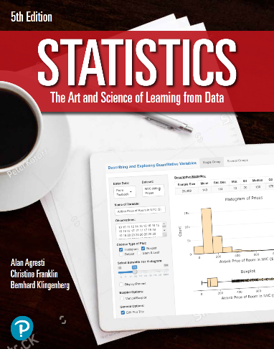

***“Statistics: The Art and Science of Learning from Data”***

**by Agresti, Franklin and Klingenberg, 5th edition**

**Chapter 11**

**Example 5: Headache from Flu Vaccine – Testing Homogeneity**

## Reading in data

data <- read.csv(file='https://img1.wsimg.com/blobby/go/bbca5dba-4947-4587-b40a-db346c01b1b3/downloads/HeadacheRaw.csv?ver=1657293808775')  
attach(data) # so we can refer to variable names

## To make a table from the raw data

mytable <- table(drug, outcome)  
mytable # viewing the table

## outcome  
## drug mild moderate severe  
## active 486 113 16  
## placebo 355 80 5

## To perform a chi-squared test for homogeneity

chisq.test(mytable)

##   
## Pearson's Chi-squared test  
##   
## data: mytable  
## X-squared = 2.8601, df = 2, p-value = 0.2393