**R Code for Examples in the book**

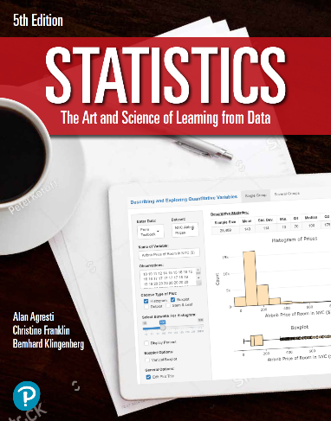

***“Statistics: The Art and Science of Learning from Data”***

**by Agresti, Franklin and Klingenberg, 5th edition**

**Chapter 12**

**Example 10: The Strength Study – The Squared Correlation Coefficient *r*2**

## Reading in data

data <- read.csv(file='https://img1.wsimg.com/blobby/go/bbca5dba-4947-4587-b40a-db346c01b1b3/downloads/High_School_Female_Athletes_Strength.csv?ver=1657874961226')  
attach(data) # so we can refer to variable names

## To obtain correlation between maxBP and BP60

r <- cor(maxBP..lbs., BP60)  
r_squared <- r ** 2  
r_squared

## [1] 0.6432443

## Alternatively, you can fit a regression and check the summary

lin.reg <- lm(maxBP..lbs. ~ BP60, data = data)  
summary(lin.reg)$r.squared

## [1] 0.6432443