**R Code for Examples in the book**

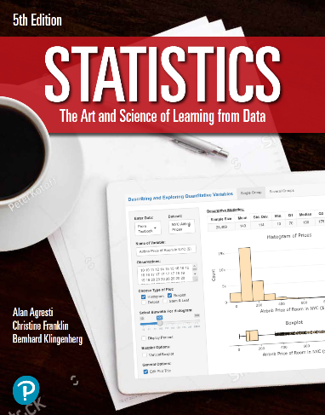

***“Statistics: The Art and Science of Learning from Data”***

**by Agresti, Franklin and Klingenberg, 5th edition**

**Chapter 12**

**Example 12: Underachieving College Students – Standardized Residuals**

## Reading in data:

data <- read.csv(file='https://raw.githubusercontent.com/artofstat/data/master/Chapter12/ga_student_survey.csv')  
colnames(data) # check column names

## [1] "Height" "Gender" "Haircut" "Job"   
## [5] "Studytime" "Smokecig" "Dated" "HSGPA"   
## [9] "CGPA" "HomeDist" "BrowseInternet" "WatchTV"   
## [13] "Exercise" "ReadNewsP" "Vegan" "PoliticalDegree"  
## [17] "PoliticalAff"

## Fitting regression model

lin.reg <- lm(CGPA ~ HSGPA, data = data)

## To obtain raw residuals

myres <- residuals(lin.reg)  
head(myres)

## 1 2 3 4 5 6   
## -0.37392451 -0.47386048 0.49932659 -0.17392451 0.01715919 0.52193746

## To obtain standardized residuals

mystdres <- rstandard(lin.reg)  
head(mystdres)

## 1 2 3 4 5 6   
## -1.1921565 -1.5092691 1.7105551 -0.5545109 0.0548887 1.7297650