**R Code for Examples in the book**

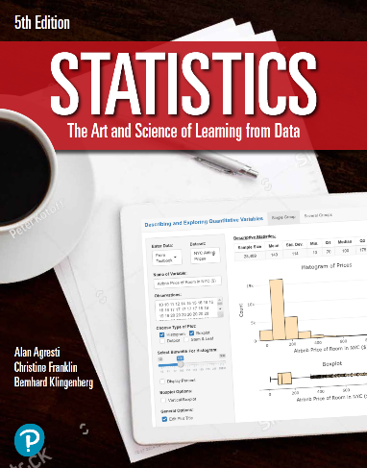

***“Statistics: The Art and Science of Learning from Data”***

**by Agresti, Franklin and Klingenberg, 5th edition**

**Chapter 13**

**Example 2: Predicting House Prices – Multiple Regression**

## Reading in data

data <- read.csv(file='https://raw.githubusercontent.com/artofstat/data/master/Chapter13/house_selling_prices_or.csv')  
colnames(data) #check column names

## [1] "House.Price..USD." "HP.in.thousands" "House.Size"   
## [4] "Acres" "Lot.Size" "Bedrooms"   
## [7] "T.Bath" "Age" "Garage"   
## [10] "Condition" "Age.Category"

## Fitting in multiple regression model

lin.reg <- lm(House.Price..USD. ~ House.Size + Bedrooms, data = data)  
lin.reg

##   
## Call:  
## lm(formula = House.Price..USD. ~ House.Size + Bedrooms, data = data)  
##   
## Coefficients:  
## (Intercept) House.Size Bedrooms   
## 60102.14 62.98 15170.41

## To predict the selling price of the given home and find its corresponding 95% confidence interval

new <- data.frame(House.Size = 1679, Bedrooms = 3)  
predict(lin.reg, newdata = new, interval = 'confidence')

## fit lwr upr  
## 1 211361.3 197605.3 225117.3