**R Code for Examples in the book**

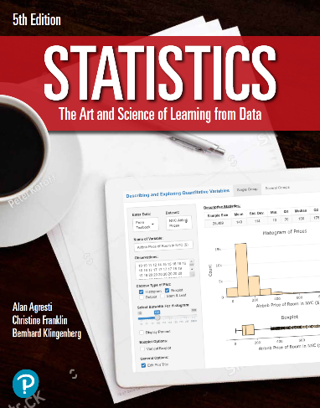

***“Statistics: The Art and Science of Learning from Data”***

**by Agresti, Franklin and Klingenberg, 5th edition**

**Chapter 13**

**Example 3: Predicting House Prices – Multiple Correlation Coefficient and *R*2**

## Reading in data

data <- read.csv(file='https://raw.githubusercontent.com/artofstat/data/master/Chapter13/house_selling_prices_or.csv')

# Fitting in multiple regression model

lin.reg <- lm(HP.in.thousands ~ House.Size + Bedrooms, data = data)  
lin.reg

##   
## Call:  
## lm(formula = HP.in.thousands ~ House.Size + Bedrooms, data = data)  
##   
## Coefficients:  
## (Intercept) House.Size Bedrooms   
## 60.10214 0.06298 15.17041

# To get the ANOVA table for the regression model

aov <- anova(lin.reg)  
aov

## Analysis of Variance Table  
##   
## Response: HP.in.thousands  
## Df Sum Sq Mean Sq F value Pr(>F)   
## House.Size 1 1347323 1347323 209.1019 < 2.2e-16 ***  
## Bedrooms 1 52202 52202 8.1016 0.004891 **   
## Residuals 197 1269345 6443   
## ---  
## Signif. codes: 0 '***' 0.001 '**' 0.01 '*' 0.05 '.' 0.1 ' ' 1

# To compute R squared using sum of squares

tss <- sum(aov$`Sum Sq`)  
rss <- aov$`Sum Sq`[3]  
r_squared <- (tss - rss) / tss  
r_squared

## [1] 0.5243884

# To find the multiple correlation coefficient

r <- sqrt(r_squared)  
r

## [1] 0.7241467

# To verify that the output for R Squared is correct using the manual computation, you can use the summary() function on our model; the R squared is shown there as well

summary(lin.reg)

##   
## Call:  
## lm(formula = HP.in.thousands ~ House.Size + Bedrooms, data = data)  
##   
## Residuals:  
## Min 1Q Median 3Q Max   
## -306.92 -35.16 -0.75 30.47 376.81   
##   
## Coefficients:  
## Estimate Std. Error t value Pr(>|t|)   
## (Intercept) 60.102140 18.622905 3.227 0.00146 **   
## House.Size 0.062983 0.004753 13.250 < 2e-16 ***  
## Bedrooms 15.170411 5.329806 2.846 0.00489 **   
## ---  
## Signif. codes: 0 '***' 0.001 '**' 0.01 '*' 0.05 '.' 0.1 ' ' 1  
##   
## Residual standard error: 80.27 on 197 degrees of freedom  
## Multiple R-squared: 0.5244, Adjusted R-squared: 0.5196   
## F-statistic: 108.6 on 2 and 197 DF, p-value: < 2.2e-16