**R Code for Examples in the book**

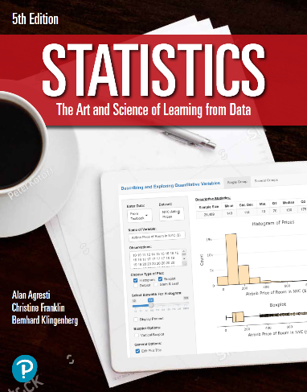

***“Statistics: The Art and Science of Learning from Data”***

**by Agresti, Franklin and Klingenberg, 5th edition**

**Chapter 13**

**Example 6: Hypothesis Test for Multiple Regression Parameter β**

## Reading in data

data <- read.csv(file='https://raw.githubusercontent.com/artofstat/data/master/Chapter13/college_female_athletes.csv')

## To obtain the summaries for the variables

summary(data$TBW)

## Min. 1st Qu. Median Mean 3rd Qu. Max.   
## 96.0 119.8 131.5 133.0 143.2 185.0

summary(data$HGT)

## Min. 1st Qu. Median Mean 3rd Qu. Max.   
## 56.00 63.00 65.00 65.55 68.06 75.00

summary(data$BF)

## Min. 1st Qu. Median Mean 3rd Qu. Max.   
## 0.1120 0.1520 0.1850 0.1844 0.2150 0.2760

summary(data$AGE)

## Min. 1st Qu. Median Mean 3rd Qu. Max.   
## 17.00 18.00 20.00 20.02 22.00 23.00

## Fitting in multiple regression model

lin.reg <- lm(TBW ~ HGT + BF + AGE, data = data)

## 

## To obtain a summary of the regression model which includes the test statistic and corresponding p-value for a hypothesis test

summary(lin.reg)

##   
## Call:  
## lm(formula = TBW ~ HGT + BF + AGE, data = data)  
##   
## Residuals:  
## Min 1Q Median 3Q Max   
## -20.724 -5.439 1.096 5.660 32.865   
##   
## Coefficients:  
## Estimate Std. Error t value Pr(>|t|)   
## (Intercept) -97.6938 28.7852 -3.394 0.00123 **   
## HGT 3.4285 0.3679 9.319 2.88e-13 ***  
## BF 136.4265 31.2553 4.365 5.10e-05 ***  
## AGE -0.9601 0.6483 -1.481 0.14384   
## ---  
## Signif. codes: 0 '***' 0.001 '**' 0.01 '*' 0.05 '.' 0.1 ' ' 1  
##   
## Residual standard error: 10.11 on 60 degrees of freedom  
## Multiple R-squared: 0.6693, Adjusted R-squared: 0.6528   
## F-statistic: 40.48 on 3 and 60 DF, p-value: 1.977e-14