**R Code for Examples in the book**

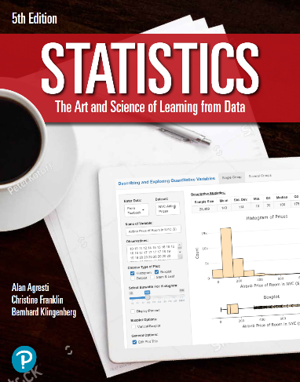

***“Statistics: The Art and Science of Learning from Data”***

**by Agresti, Franklin and Klingenberg, 5th edition**

**Chapter 13**

**Example 7: Female Athletes’ Weight – Confidence Interval for β**

## Reading in data

data <- read.csv(file='https://raw.githubusercontent.com/artofstat/data/master/Chapter13/college_female_athletes.csv')

## Fitting in multiple regression model

lin.reg <- lm(TBW ~ HGT + BF + AGE, data = data)  
lin.reg

##   
## Call:  
## lm(formula = TBW ~ HGT + BF + AGE, data = data)  
##   
## Coefficients:  
## (Intercept) HGT BF AGE   
## -97.6938 3.4285 136.4265 -0.9601

## To obtain confidence intervals for the regression coefficients

round(confint(lin.reg), 1)

## 2.5 % 97.5 %  
## (Intercept) -155.3 -40.1  
## HGT 2.7 4.2  
## BF 73.9 198.9  
## AGE -2.3 0.3