**R Code for Examples in the book**

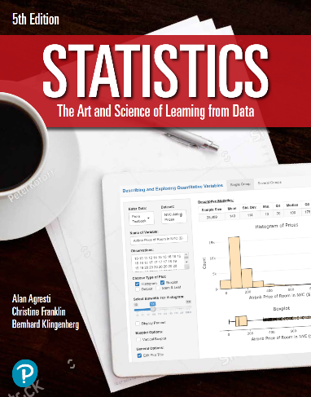

***“Statistics: The Art and Science of Learning from Data”***

**by Agresti, Franklin and Klingenberg, 5th edition**

**Chapter 14**

**Example 10: Estimate and Compare Corn Yield – Regression Modeling**

## Reading in data

data <- read.csv(file='https://raw.githubusercontent.com/artofstat/data/master/Chapter14/corn_yield.csv')  
head(data, 3)

## fertilizer manure yield  
## 1 high high 13.7  
## 2 high high 15.8  
## 3 high high 13.9

## Fitting in regression model

lin.reg <- lm(yield ~ fertilizer + manure, data = data)

## To view the regression coefficients

summary(lin.reg)

##   
## Call:  
## lm(formula = yield ~ fertilizer + manure, data = data)  
##   
## Residuals:  
## Min 1Q Median 3Q Max   
## -2.95 -1.35 0.16 1.18 2.87   
##   
## Coefficients:  
## Estimate Std. Error t value Pr(>|t|)   
## (Intercept) 15.4900 0.6470 23.941 1.55e-14 ***  
## fertilizerlow -1.8800 0.7471 -2.516 0.0222 *   
## manurelow -1.9600 0.7471 -2.624 0.0178 *   
## ---  
## Signif. codes: 0 '***' 0.001 '**' 0.01 '*' 0.05 '.' 0.1 ' ' 1  
##   
## Residual standard error: 1.671 on 17 degrees of freedom  
## Multiple R-squared: 0.4374, Adjusted R-squared: 0.3712   
## F-statistic: 6.608 on 2 and 17 DF, p-value: 0.007532