**R Code for Examples in the book**

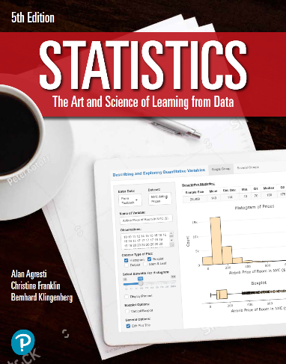

***“Statistics: The Art and Science of Learning from Data”***

**by Agresti, Franklin and Klingenberg, 5th edition**

**Chapter 14**

**Example 12: Corn Yield Data – Testing for Interaction**

## Reading in data

data <- read.csv(file='https://raw.githubusercontent.com/artofstat/data/master/Chapter14/corn_yield.csv')  
head(data, 3)

## fertilizer manure yield  
## 1 high high 13.7  
## 2 high high 15.8  
## 3 high high 13.9

## Fitting in regression model

lin.reg <- lm(yield ~ fertilizer + manure + fertilizer:manure, data = data)

## To get the two-way ANOVA

aov <- anova(lin.reg)  
round(aov, 3)

## Analysis of Variance Table  
##   
## Response: yield  
## Df Sum Sq Mean Sq F value Pr(>F)   
## fertilizer 1 17.672 17.672 6.368 0.023 *  
## manure 1 19.208 19.208 6.922 0.018 *  
## fertilizer:manure 1 3.042 3.042 1.096 0.311   
## Residuals 16 44.400 2.775   
## ---  
## Signif. codes: 0 '***' 0.001 '**' 0.01 '*' 0.05 '.' 0.1 ' ' 1