**R Code for Examples in the book**

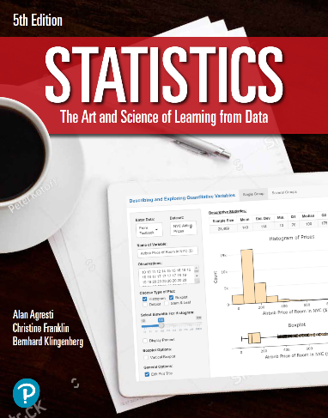

***“Statistics: The Art and Science of Learning from Data”***

**by Agresti, Franklin and Klingenberg, 5th edition**

**Chapter 14**

**Example 5: Friends and Happiness – Fisher Method**

## Reading in data

data <- read.csv(file='https://raw.githubusercontent.com/artofstat/data/master/Chapter14/gss_1998_happy_numfriends.csv')  
head(data)

## NumFriends X1.VERY.HAPPY X2.PRETTY.HAPPY X3.NOT.TOO.HAPPY  
## 1 1 8 33 10  
## 2 2 35 82 17  
## 3 3 38 79 15  
## 4 4 36 75 7  
## 5 5 28 57 10  
## 6 6 30 35 5

## To convert the data into long format, you can use the pivot_longer() function from the tidyverse library

library(tidyverse)  
data <-   
 data %>%   
 rename_at(2:4, ~ c('very_happy', 'pretty_happy', 'not_too_happy')) %>%   
 pivot_longer(2:4, names_to = 'Happiness', values_to = 'Count') %>%   
 uncount(Count) %>%   
 relocate(Happiness)  
attach(data)  
tapply(NumFriends, Happiness, summary)

## $not_too_happy  
## Min. 1st Qu. Median Mean 3rd Qu. Max.   
## 1.000 2.000 4.000 6.271 6.000 50.000   
##   
## $pretty_happy  
## Min. 1st Qu. Median Mean 3rd Qu. Max.   
## 1.000 2.500 4.000 5.667 6.000 60.000   
##   
## $very_happy  
## Min. 1st Qu. Median Mean 3rd Qu. Max.   
## 1.000 3.000 5.000 7.577 10.000 75.000

## To get the ANOVA

myAnova <- aov(NumFriends ~ Happiness)  
summary(myAnova)

## Df Sum Sq Mean Sq F value Pr(>F)   
## Happiness 2 617 308.32 6.023 0.00253 **  
## Residuals 808 41362 51.19   
## ---  
## Signif. codes: 0 '***' 0.001 '**' 0.01 '*' 0.05 '.' 0.1 ' ' 1