**R Code for Examples in the book**

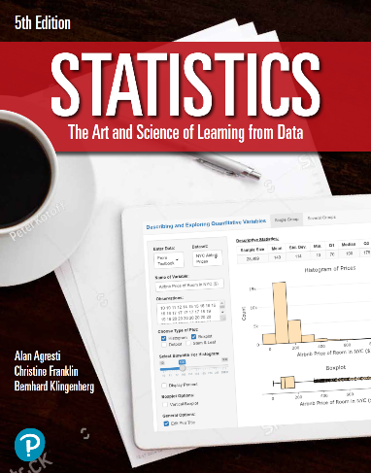

***“Statistics: The Art and Science of Learning from Data”***

**by Agresti, Franklin and Klingenberg, 5th edition**

**Chapter 14**

**Example 7: Telephone Holding Times – Regression Analysis**

## Reading in data

y <- c(5, 1, 11, 2, 8, 0, 1, 4, 6, 3, 13, 9, 8, 15, 7)  
group <- rep(c('A', 'M', 'C'), times = c(5, 5, 5))

## Fitting in regression model with advertisements as the baseline

lin.reg <- lm(y ~ group)  
summary(lin.reg)

##   
## Call:  
## lm(formula = y ~ group)  
##   
## Residuals:  
## Min 1Q Median 3Q Max   
## -4.4 -2.6 -0.4 2.6 5.6   
##   
## Coefficients:  
## Estimate Std. Error t value Pr(>|t|)   
## (Intercept) 5.400 1.523 3.545 0.00403 **  
## groupC 5.000 2.154 2.321 0.03868 *   
## groupM -2.600 2.154 -1.207 0.25068   
## ---  
## Signif. codes: 0 '***' 0.001 '**' 0.01 '*' 0.05 '.' 0.1 ' ' 1  
##   
## Residual standard error: 3.406 on 12 degrees of freedom  
## Multiple R-squared: 0.5173, Adjusted R-squared: 0.4369   
## F-statistic: 6.431 on 2 and 12 DF, p-value: 0.01264

## To obtain ANOVA table

anova(lin.reg)

## Analysis of Variance Table  
##   
## Response: y  
## Df Sum Sq Mean Sq F value Pr(>F)   
## group 2 149.2 74.6 6.431 0.01264 *  
## Residuals 12 139.2 11.6   
## ---  
## Signif. codes: 0 '***' 0.001 '**' 0.01 '*' 0.05 '.' 0.1 ' ' 1

## Note that R sets up the reference category alphabetically, so the baseline here is advertisements. You can change the reference category by using the relevel() function

group <- relevel(as.factor(group), ref = 'C')

## Fitting in regression model with classical as the baseline

lin.reg <- lm(y ~ group)  
summary(lin.reg)

##   
## Call:  
## lm(formula = y ~ group)  
##   
## Residuals:  
## Min 1Q Median 3Q Max   
## -4.4 -2.6 -0.4 2.6 5.6   
##   
## Coefficients:  
## Estimate Std. Error t value Pr(>|t|)   
## (Intercept) 10.400 1.523 6.828 1.83e-05 ***  
## groupA -5.000 2.154 -2.321 0.03868 *   
## groupM -7.600 2.154 -3.528 0.00416 **   
## ---  
## Signif. codes: 0 '***' 0.001 '**' 0.01 '*' 0.05 '.' 0.1 ' ' 1  
##   
## Residual standard error: 3.406 on 12 degrees of freedom  
## Multiple R-squared: 0.5173, Adjusted R-squared: 0.4369   
## F-statistic: 6.431 on 2 and 12 DF, p-value: 0.01264

## You can verify that the ANOVA table output should be the same regardless of which reference category is used

anova(lin.reg)

## Analysis of Variance Table  
##   
## Response: y  
## Df Sum Sq Mean Sq F value Pr(>F)   
## group 2 149.2 74.6 6.431 0.01264 *  
## Residuals 12 139.2 11.6   
## ---  
## Signif. codes: 0 '***' 0.001 '**' 0.01 '*' 0.05 '.' 0.1 ' ' 1