**R Code for Examples in the book**

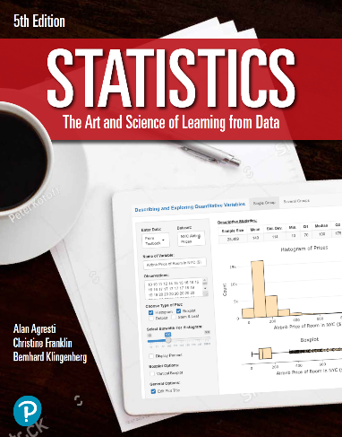

***“Statistics: The Art and Science of Learning from Data”***

**by Agresti, Franklin and Klingenberg, 5th edition**

**Chapter 3**

**Example 13: Global Warming – Exploring Extrapolation**

## Reading in the data

temps <- read.csv(file='https://raw.githubusercontent.com/artofstat/data/master/Chapter3/central_park_yearly_temps.csv')  
attach(temps) # so we can refer to variable names

## Basic scatterplot

plot(x = YEAR, y = ANNUAL, pch = 16, col = 'darkred',  
 xlab = 'Year', ylab = 'Average Annual Temperature (F)',  
 main = 'Average Annual Temperature in \n Central Park, New York, from 1869 - 2019')

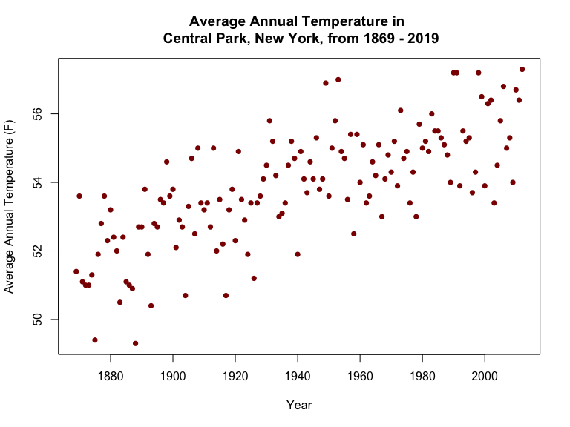

## Fitting in regression model

lin.reg <- lm(ANNUAL ~ YEAR)  
lin.reg

##   
## Call:  
## lm(formula = ANNUAL ~ YEAR)  
##   
## Coefficients:  
## (Intercept) YEAR   
## -2.68943 0.02915

## Predicting annual average temp for years 2025 and 3000

new <- data.frame(YEAR = c(2025, 3000))  
predict(lin.reg, newdata = new)

## 1 2   
## 56.33523 84.75451