**R Code for Examples in the book**

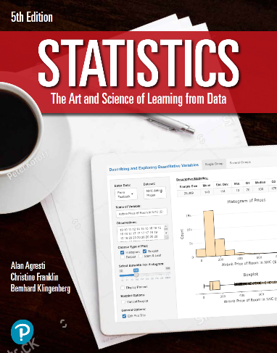

***“Statistics: The Art and Science of Learning from Data”***

**by Agresti, Franklin and Klingenberg, 5th edition**

**Chapter 3**

**Example 2: Pesticides – Categorical Explanatory and Response Variables**

## Reading in the data:

counts <- c(29, 98, 19485, 7086)  
pesticide <- matrix(counts, nrow = 2, ncol = 2, byrow = TRUE,   
 dimnames = list('Food Type' = c('Organic', 'Conventional'),   
 'Pesticides'= c('Present', 'Absent')))

## Adding row and column totals

addmargins(pesticide)

## Pesticides  
## Food Type Present Absent Sum  
## Organic 29 98 127  
## Conventional 19485 7086 26571  
## Sum 19514 7184 26698

## To find the conditional proportions for pesticide status (i.e. row proportions)

pesticide_row_proportions <- prop.table(pesticide, 1)

## Rounding off for easier readability

round(pesticide_row_proportions, 3)

## Pesticides  
## Food Type Present Absent  
## Organic 0.228 0.772  
## Conventional 0.733 0.267