**R Code for Examples in the book**

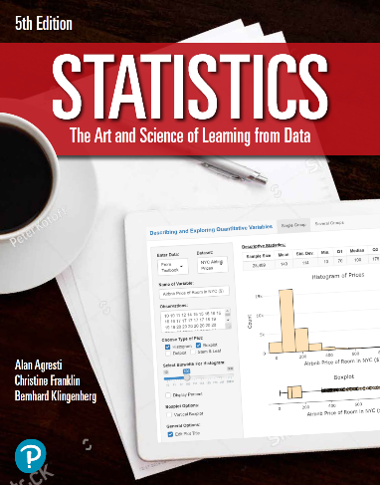

***“Statistics: The Art and Science of Learning from Data”***

**by Agresti, Franklin and Klingenberg, 5th edition**

**Chapter 3**

**Example 3: Pesticide Residues – Graphing Conditional Proportions**

## Reading in the data:

counts <- c(29, 98, 19485, 7086)  
pesticide <- matrix(counts, nrow = 2 , ncol = 2, byrow = TRUE,   
 dimnames = list('Food Type' = c('Organic',   
 'Conventional'),   
 'Pesticides'= c('Present',   
 'Absent')))

## To find the conditional proportions for pesticide status

cond.props <- prop.table(pesticide, 1)

## 

## Bar graph of conditional proportions on pesticide status for organic foods

barplot(cond.props[1,], xlab='Pesticide', ylab='Proportion', ylim=c(0,1),   
 main = 'Organic Foods',   
 col = c('green4', 'darkseagreen'))

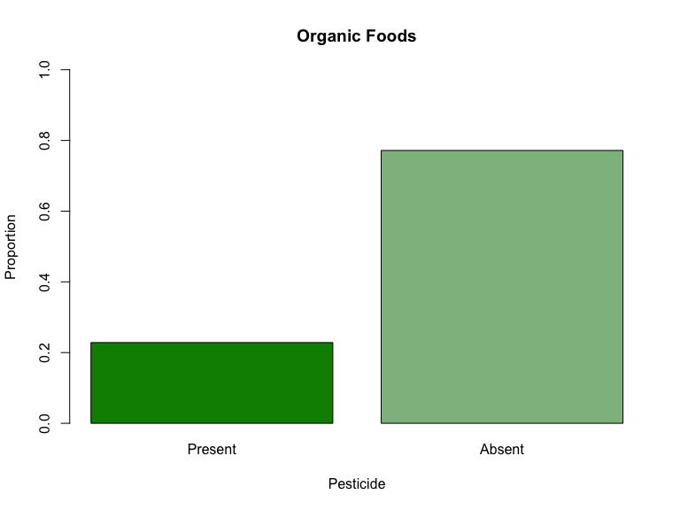

## 

## Bar graph of conditional proportions on pesticide status for conventionally foods

barplot(cond.props[2,], xlab='Food Type', ylab='Proportion', ylim=c(0,1),   
 main = 'Conventionally Grown Foods',   
 col = c('orange2', 'antiquewhite2'))

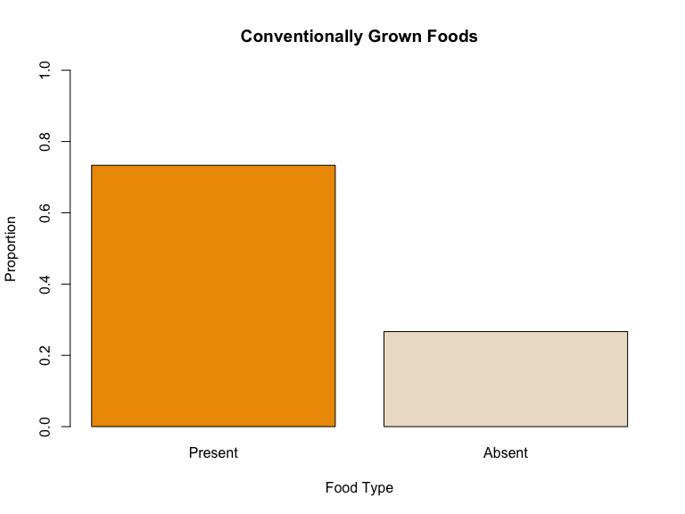

## 

## Bar graph of proportion of food samples with pesticide present

barplot(cond.props[,1], xlab = 'Food Type', ylab = 'Proportion', ylim = c(0,1),   
 main = 'Proportion of Food samples \n with Pesticide Present',   
 col = c('green4', 'orange2'))

