**R Code for Examples in the book**

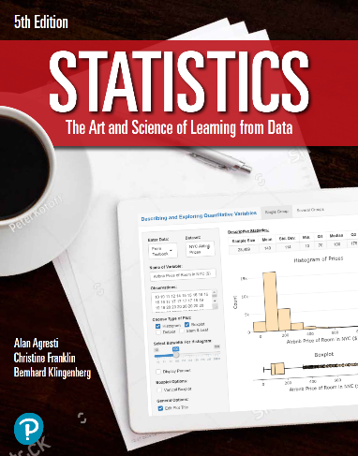

***“Statistics: The Art and Science of Learning from Data”***

**by Agresti, Franklin and Klingenberg, 5th edition**

**Chapter 6**

**Example 11: Test Scores that Use Different Scales – Comparing z-Scores**

## Reading in SAT data

mean_SAT <- 500  
sd_SAT <- 100

## To compute the z-Score of an SAT score of 650

z_SAT <- (650 - mean_SAT) / sd_SAT  
z_SAT

## [1] 1.5

## Reading in ACT data

mean_ACT <- 21.0  
sd_ACT <- 4.7

## To compute the z-Score of an ACT score of 30

z_ACT <- (30 - mean_ACT) / sd_ACT  
z_ACT

## [1] 1.914894