**R Code for Examples in the book**

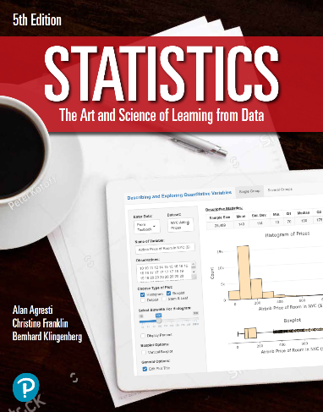

***“Statistics: The Art and Science of Learning from Data”***

**by Agresti, Franklin and Klingenberg, 5th edition**

**Chapter 6**

**Example 13: Normal Approximation of the Binomial Distribution**

## To compute the mean of the binomial distribution

mu <- 500000 * 0.554  
mu

## [1] 277000

## To compute the standard deviation of the binomial distribution

sigma <- round(sqrt(500000 * 0.554 * (1 - 0.554)))  
sigma

## [1] 351

## To compute an interval of 3 standard deviations within the mean

mu + c(-1, 1) * 3 * sigma

## [1] 275947 278053