**R Code for Examples in the book**

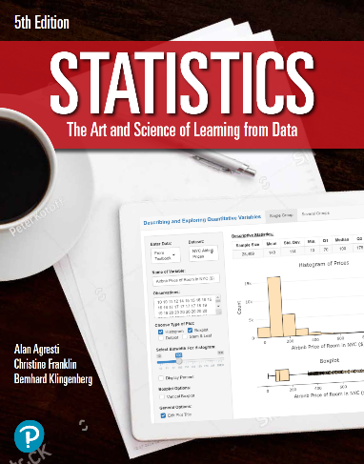

***“Statistics: The Art and Science of Learning from Data”***

**by Agresti, Franklin and Klingenberg, 5th edition**

**Chapter 6**

**Example 5: Risk Taking – Standard Deviation of a Probability Distribution**

## Reading in the data for the sure strategy

gains_sure <- 500  
probs_sure <- 1

## To compute the variance

variance_sure <- sum(((gains_sure - mean(gains_sure)) ** 2) * probs_sure)  
variance_sure

## [1] 0

## To compute the standard deviation

sqrt(variance_sure)

## [1] 0

## Reading in the data for the risk-taking strategy

gains_risk <- c(0, 1000)  
probs_risk <- c(0.5, 0.5)

## To compute the variance

variance_risk <- sum(((gains_risk - mean(gains_risk)) ** 2) * probs_risk)  
variance_risk

## [1] 250000

## To compute the standard deviation

sqrt(variance_risk)

## [1] 500