**R Code for Examples in the book**

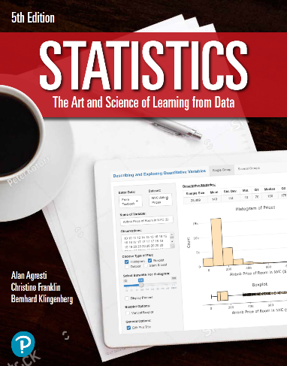

***“Statistics: The Art and Science of Learning from Data”***

**by Agresti, Franklin and Klingenberg, 5th edition**

**Chapter 8**

**Example 10: Estimating Mean Education in South Africa – Finding *n***

# Reading in sample data

s <- 3

# Setting 95% confidence level

zscore = qnorm(0.975)

# Setting the margin of error to what we need

me <- 1

# To compute the number of samples required to acquire our wanted margin of error

n <- (s ** 2) * (zscore ** 2) / (me ** 2)  
round(n)

## [1] 35