**R Code for Examples in the book**

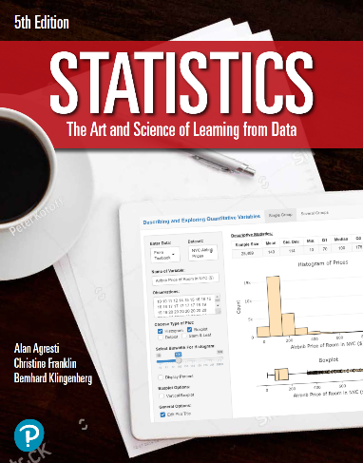

***“Statistics: The Art and Science of Learning from Data”***

**by Agresti, Franklin and Klingenberg, 5th edition**

**Chapter 8**

**Example 11: Flight Departure Delays – Percentile Confidence Interval**

## Reading in the data

data <- read.csv(file='https://raw.githubusercontent.com/artofstat/data/master/Chapter7/atl_departure_delay.csv')

## To make 10,000 bootstrap samples and compute each sample mean

bootmean <- c()  
for (i in 1:10000) {  
 bootmean[i] <- mean(sample(data$minutes, replace = TRUE))  
}

## To obtain the 2.5th and 97.5th percentiles of the bootstrapped means

quantile(bootmean, c(0.025, 0.975))

## 2.5% 97.5%   
## 62.8400 107.6547