**R Code for Examples in the book**

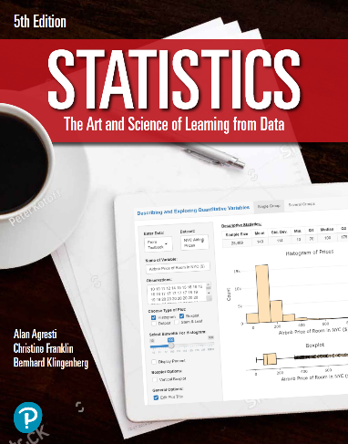

***“Statistics: The Art and Science of Learning from Data”***

**by Agresti, Franklin and Klingenberg, 5th edition**

**Chapter 8**

**Example 12: Median Departure Delay – Confidence Interval for a Median**

## Reading in the data

data <- read.csv(file='https://raw.githubusercontent.com/artofstat/data/master/Chapter7/atl_departure_delay.csv')

## To make 10,000 bootstrap samples and compute median of each sample

bootmedian <- c()  
for (i in 1:10000) {  
 bootmedian[i] <- median(sample(data$minutes, replace = TRUE))  
}

## To obtain the 2.5th and 97.5th percentiles of the bootstrapped medians

quantile(bootmedian, c(0.025, 0.975))

## 2.5% 97.5%   
## 30 64