**R Code for Examples in the book**

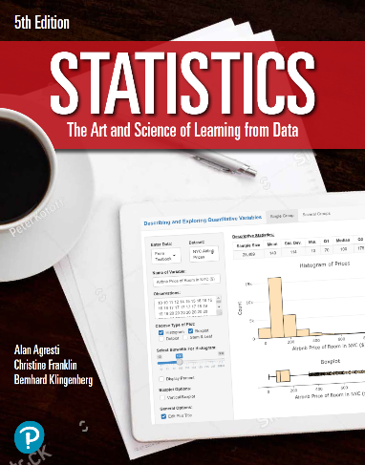

***“Statistics: The Art and Science of Learning from Data”***

**by Agresti, Franklin and Klingenberg, 5th edition**

**Chapter 9**

**Example 6: Car Stopping – Significance Test About A Population Proportion**

## To make a one-sided significance test about a population proportion, you can use

prop.test(x = 76, n = 126, p = 0.75, alternative = 'less',  
 conf.level = 0.95, correct = FALSE)

##   
## 1-sample proportions test without continuity correction  
##   
## data: 76 out of 126, null probability 0.75  
## X-squared = 14.487, df = 1, p-value = 7.057e-05  
## alternative hypothesis: true p is less than 0.75  
## 95 percent confidence interval:  
## 0.0000000 0.6719722  
## sample estimates:  
## p   
## 0.6031746

## Alternatively, you can also do the manual computation

x <- 76  
n <- 126  
phat <- x / n  
p_0 <- 0.75 # the value that p takes in the null hypothesis  
se_0 <- sqrt(p_0 * (1 - p_0) / n)  
z <- (phat - p_0) / se_0

## To compute the p value for a one-sided alternative hypothesis

pnorm(z)

## [1] 7.05736e-05