**R Code for Examples in the book**

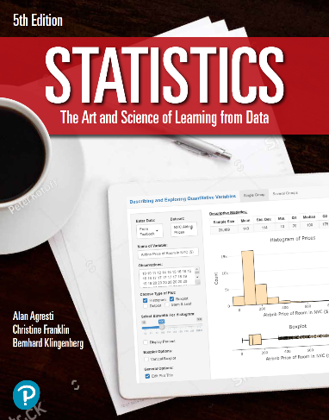

***“Statistics: The Art and Science of Learning from Data”***

**by Agresti, Franklin and Klingenberg, 5th edition**

**Chapter 9**

**Example 8: Weight Change – One-Sided Significance Test about the Mean**

## Reading in the data

data = read.csv(file='https://raw.githubusercontent.com/artofstat/data/master/Chapter9/anorexia.csv')  
attach(data) # so we can refer to variable names

## To perform a one-sided significance test about the mean

t.test(x = cogchange, mu = 0, alternative = 'greater')

##   
## One Sample t-test  
##   
## data: cogchange  
## t = 2.2156, df = 28, p-value = 0.01751  
## alternative hypothesis: true mean is greater than 0  
## 95 percent confidence interval:  
## 0.6981979 Inf  
## sample estimates:  
## mean of x   
## 3.006897

## Alternatively, you can also do the manual computation

x <- cogchange  
n <- length(cogchange)  
xbar <- mean(x)  
se <- sd(x) / sqrt(n)  
mu_0 <- 0 # the value that mu takes in the null hypothesis  
t_statistic <- (xbar - mu_0) / se

## To compute the p value for a one-sided significance test

pt(t_statistic, df= n - 1, lower.tail = FALSE)

## [1] 0.0175113