**ROOMS**

**Aquarium Room**

Cichlids TL & BC

Sharks/Barbs BL & BR

Catfish & Plecos TC & TR

**Riparium Room**

Livebearers TL

Labyrinth Fishes BL & BR

Schooling Fishes TR

Shrimp TC & BC

**Paludarium Room**

Turtles TR & BL

Salamanders TL & TC

Axolotls BR

Crickets CC & BBL

**Terrarium Room**

Budgies/Love Birds.Cockatiels TL, TR, CL, CR, BR

Reptiles TC, CC, BL, BR

Marmosets (missing!)

**CLOCKWISE PHOTOS**

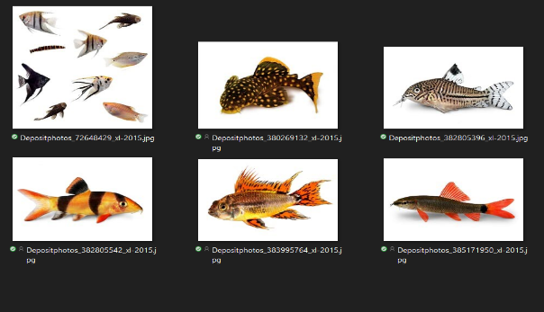

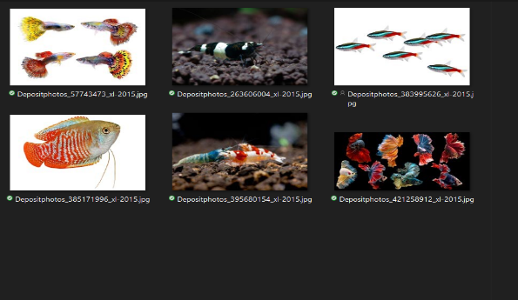

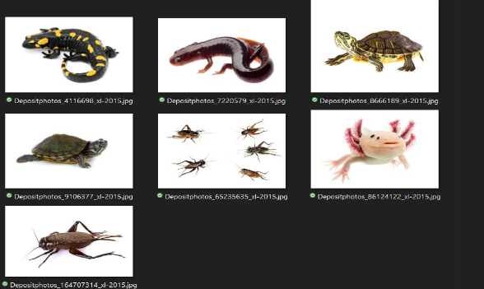

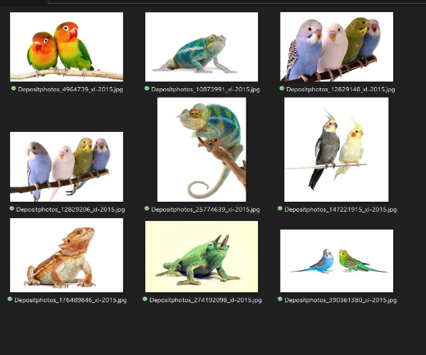

**MEET OUR ANIMALS**

**ROOMS**

**Aquarium Room**

Cichlids TL & BC: Did you know that Cichlids are classified in 5th edition of Fishes of the World. They are primarily found in Africa and South America with Africa alone estimating around 1600 different species! Cichlids are actually carnivores, omnivores, planktivores and detritivores so when it comes to a nice, delicious meal like the ones you’ll find at our Café, they really have nothing to worry about!

Sharks/Barbs BL & BR: Barbs are a very active fish that like to live in groups of five or more! Depending on the kind of Barb they can grow anywhere from 2.5-13 inches and live up to 5 years. They are not a very aggressive fish so you are able to have them with other schools of fish. Also, they add a vibrant color to any aquarium!

Catfish & Plecos TC & TR: Not only are these some of the coolest looking fish they also have some cool nicknames to suit, like: “mud cat”, “polliwogs” or “chuckleheads”. More than half of the catfish species live in the Americas and in some areas have become an invasive species. Fun Fact: the largest catfish ever caught was a Giant Mekong Catfish that weighed 646lbs!

**Riparium Room**

Livebearers TL : Livebearers are aquarium fish who actually don’t lay their eggs but keep the eggs inside their bodies and give a live birth! One of the best factors of having livebearers are the babies are typically larger than fish born from the eggs and have a higher chance of survival making them a more suitable aquarium fish!

Labyrinth Fishes BL & BR: Labyrinth are a tropical fish found in the fresh waters of Asia and Africa. There are around 70 different types of species for the labyrinth fishes and have a cool supplemental breathing structure which is called the labyrinth, who would have guessed! Meaning they can actually remove oxygen through the water they consume in their mouth as well as through their gills!

Schooling Fishes TR

Shrimp TC & BC: Shrimp, some may say they look like water aliens, however their more than just that! There are thousands of different species and widespread throughout the world. They play a very important role in the food chain from fish to whales and even the occasional human! On average they get to be about 2cm long but have been recorded to be as large as 25cm, however the larger species are more commonly found in Britain.

**Paludarium Room**

Turtles TR & BL: No, were not talking about Franklin the Turtle, but those really cool reptiles that carry their homes on their back! There are 360 different species of Turtles however some of these species are highly endangered. Turtles are a cold blooded and are one of the oldest reptile groups dating back to the Middle Jurassic!

Salamanders TL & TC: It’s a snake, is a lizard, NO…it’s a Salamander! Surprise! Some cool features of the Salamander is the fact that it’s able to regenerate lost limbs, can live underwater as well as on land but likes the cool damp surroundings! Some species contain a poison in their skin called tetrodotoxin which is a very powerful poison.

Axolotls BR: One of the coolest looking amphibian, in my opinion, has also one of the coolest nicknames: the Mexican walking fish! As of 2010 axolotls were near extinction due to water pollution and invasive species but “axolotl shelters” are being created to try and save the species. As of 2020, it was announced that the Axolotls will be featured in the new design for the Mexico’s 50-peso banknote.

Crickets CC & BBL

**Terrarium Room**

Budgies/Love Birds.Cockatiels TL, TR, CL, CR, BR: Budgerigar, more commonly know as the budgie, are typically a green and yellow bird with black markings on the nape, back and wings. The first record of the budgie is from 1805 and are one of the most common house pets for the bird species. Typically, budgies weigh around 1.1-1.4 oz and are around 7 inches long.

Reptiles TC, CC, BL, BR: One common reptile is the Bearded Dragon. With the coolest beard known to mankind, they also make a great family member. Bearded Dragons are an omnivore reptile and live up to 10 years old! They like to live in the warm climates with low humidity. They can be aggressive and tend to be knows as territorial but typically only with another male.

Marmosets (missing!): These tiny little monkeys grow to be about 8” in height. These little guys like to keep very active hopping through the tops of the trees and eating what little critters, fruit, leaves, gum, sap and tack they can find along the way. They have slowly become a pet for some people but need very specific living conditions.