Cahier des charges – Hack in the Woods - Gamification data visualisation

# Introduction

We are building a tool/web-application which translates data about energy, water, waste in a child-friendly manner. What we are looking for is a way of making the dry data understandable for the children in a nice , playful, interactive way and to introduce a level of gamification in the data presentation.

# Projet

*[Décrivez ici votre projet, son objectif et son contexte]*

With GoodPlanet we are a sustainable educative organisation and reach about 500 000 children per year. We are building an online tool which shows real data about energy, water, waste, mobility and food of their own school-life in a child-friendly manner. This way we can start sustainable education in workshops with real data which will increase their knowledge and level of interest in the sustainable topics we discuss. The school will also use them on their own. The tool will be used in hundreds or even thousands of schools. Energie-ID is our partner ([https://www.energieid.be](https://www.energieid.be/?lang=fr-BE)) and collects and stores the data. What we propose is for you to design several ways of converting the different dry data sets (litres of water per year, kwh of electricity per month, …) in a nice, understandable, simple, playful, interactive way and to introduce a level of gamification in the data presentation.

Let your creative and smart programming minds go wild in finding original, creative visual ways of getting the message to the children!

# Porteur de projet

*[Décrivez-vous ici en quelques lignes]*

Le projet est porté par GoodPlanet Belgium.

Responsable de projet Clément Magos, [c.magos@goodplanet.be](mailto:c.magos@goodplanet.be), +32470100665 (Or me ?)

# Résumé de la solution

*[Décrivez ici un résumé de la solution attendue]*

*To have a more clear ides of this project here some mockups which have been created so far regarding the water:*

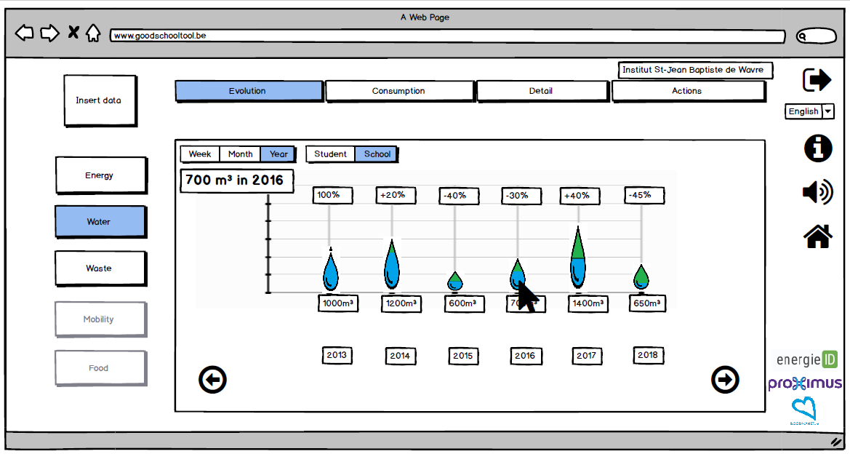

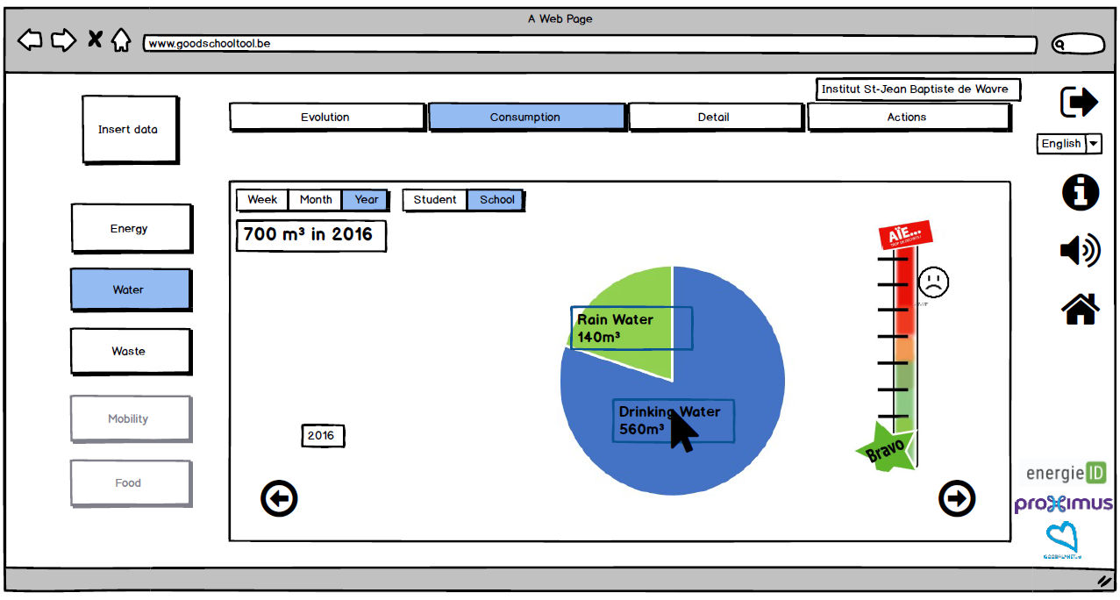

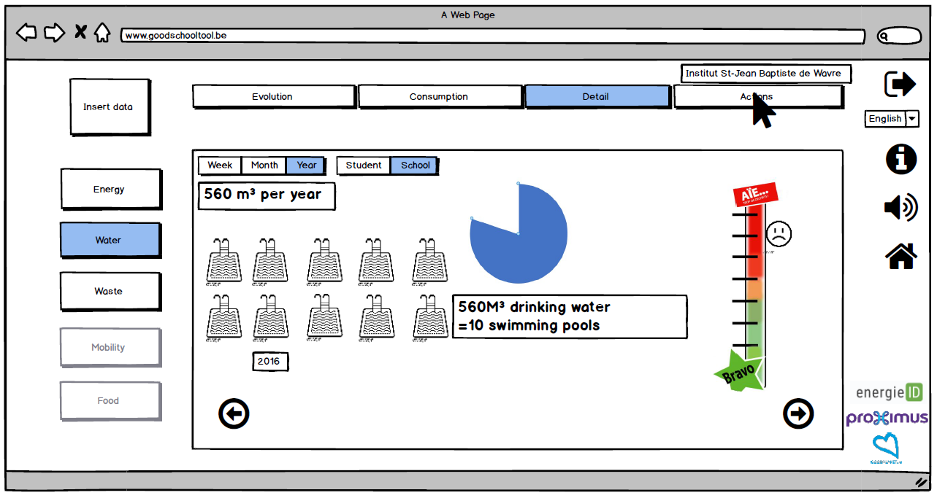

There are more in the document *GoodSchool DigiTool Mockups* in annexe. For this project we propose to design examples of gamification options, to start from a data set and to transform it in an interesting something which attracts their attention but also gets the message across.

**If you agree I will send you more dry data sets with some more explanation to use as a base for the visualisation.**

The Mock-ups are self-explanatory but hereunder an example is shown of visualisation of the amount of waste in a school. It is presented in different steps. These visualizations so far are an idea from us, how we see it, feel free to find your own (better) way of implementing this visualisation process! This are just base ideas from our minds which have no programming/ gamification/ visualisation experience!

* Ex. of fractions in a timeline
  + 14,5 kg Residual waste (Bad! This one is the worst and should be reduced)
  + 10 kg of PMC/PMD (Ok, better fewer than more)
  + 19 kg of Compostable waste (Good! This makes it go away from the residual waste.)
  + Visual:

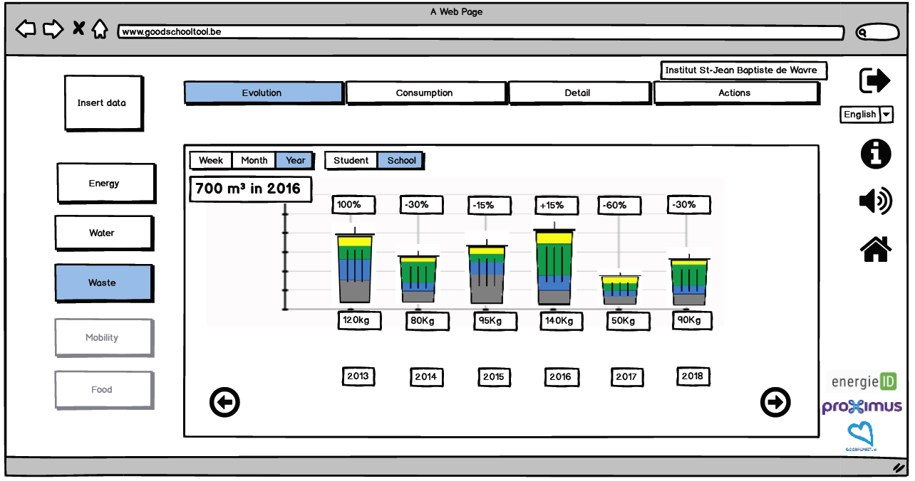

* The consumption pattern can be checked in more detail by going into the container:

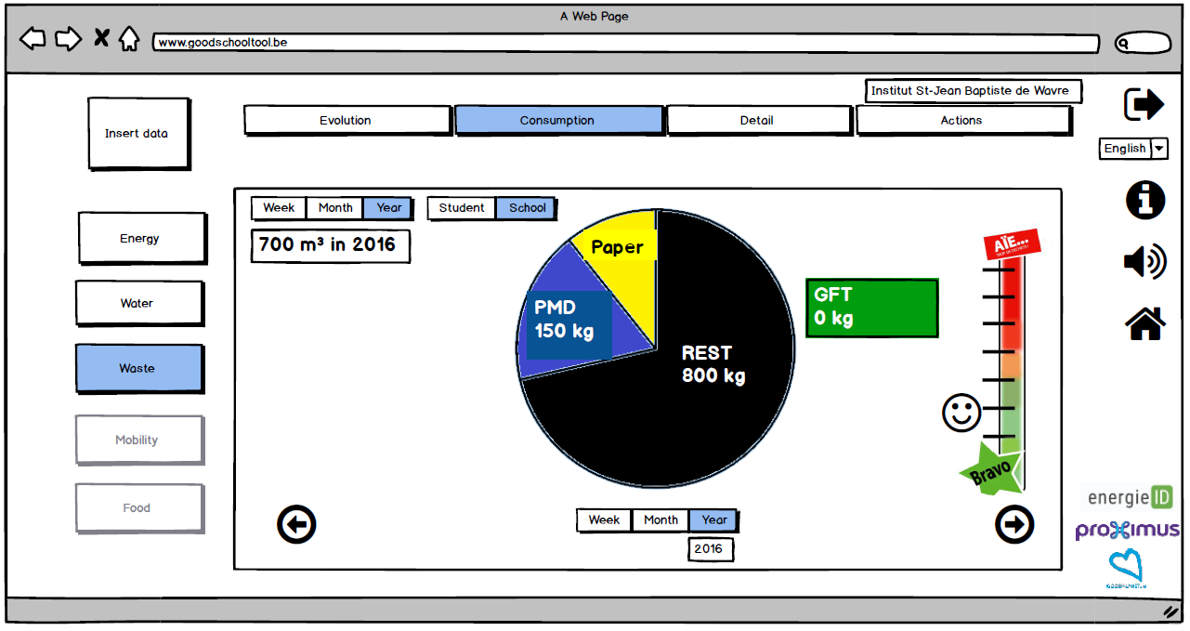

Here the comparison of the different fractions can be seen in more detail, it becomes clear what’s the main fraction as well as how well this is compared to other schools (see barometer at the right).

* To go even further in detail, by e.g. clicking on “Rest”, one finds this in even more detail and “feels” how much this is. This can be expressed per week, per month, per year:

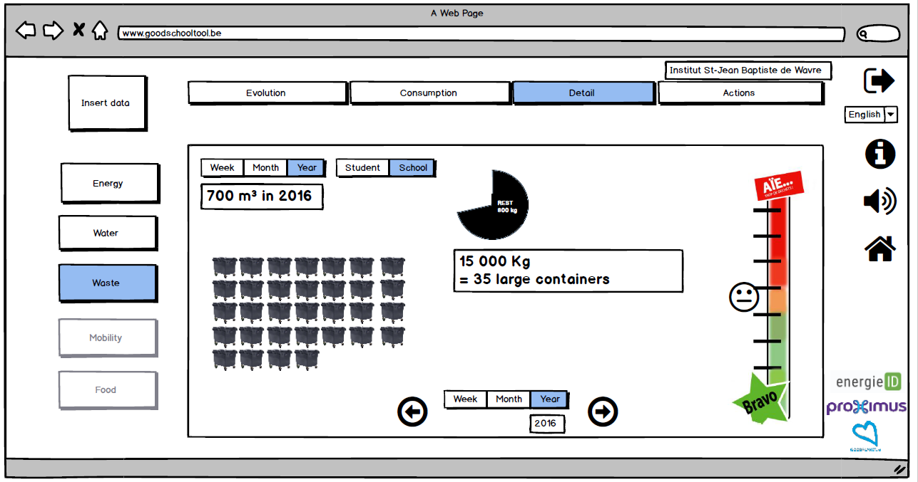

# Contraintes technologiques

*[Décrivez ici les différentes contraintes du projet]*

*Our developer works within Javascript so to easily introduce your designs in the tool it would be handy and efficient if you design them in Javascript too.*