LAB ASSIGNMENT V : HUERISTIC EVALUATION
SYSTEM EVALUATED : Singapore Airlines Online Booking Application
Groups members NAME : Adriel , Vinayak , Reuben – Airline Booking Website
**Evaluation to be done by other Group
PART I : HUERISTIC EVALUATION BASED ON NIELSEN'S 10 GENERAL PRINCIPLES FOR INTERACTION DESIGN. (0 is lowest and 10 is highest)
S.No. | Heuristic Evaluation Parameter | Mention Violation if any | Severity 0-10 (0- minimum and 10 is maximium) | Ways to improve
1 | User Control: Interface will allow the user to perceive that they are in control | You can go back, but you can't clear all your seats in one click or skip seat selection. | 3 | Add a "Clear seats" button and a "Skip" option.
2 | Human Limitations: Interface will not overload the users cognitive, auditory and motor skills | A lot of the text is tiny and light grey, and the seats are small to tap. The payment page feels crowded. | 3 | Make the text bigger and darker, and make the seats larger.
3 | Accommodation: The interface will fit the way each user group works and thinks (personas) | It only works for one person paying in rupees. There are no options for more passengers, other languages or special needs. | 4 | -Add a passenger count, a language/currency choice and accessibility info.
4 | Linguistic Clarity: Interface will communicate as efficiently as possible | Most words are easy to understand. The button says "NEXT: ADD-ONS" but takes you to Payment, which is confusing. | 3 | Rename the button "NEXT: PAYMENT".
5 | Aesthetic Integrity :The interface will have an attractive and appropriate design | It looks good. The colours, fonts and photos feel like a real Singapore Airlines site. | 1 | Barely needs changes. Just check that small text is easy to read.
6 | Simplicity: The interface will have a simple design | Each page has one clear main button and a clean layout. The side summary is a bit busy. | 2 | Hide the less important details until someone wants them.
7 | Predictability :The interface will behave in such a manner that the user can accurately predict what will happen next | The button label doesn't match where it goes. Several links look clickable but do nothing. | 5 | Make labels match their pages, and remove links that don't work.
8 | Accuracy: Interface will be free from errors | The summary always says "No seat selected, INR 0", even after you pick a seat. | 6 | Update the summary and total when a seat is picked. Block payment until the terms are accepted.
9 | Technical Clarity: Interface will have the highest possible fidelity. | It looks very realistic, but it doesn't fully work. The forms don't check anything and seats have no prices. | 4 | Add form checks and seat prices.
10 | Fulfillment : The interface will provide a satisfying user experience | You can go from search to payment, but then it just stops. There's no "Booking confirmed" page. | 5 | Add a confirmation screen at the end.
11 | Consistency: Interface will be consistent | Colours, fonts and buttons match well. The Back buttons look different on different pages. | 2 | Use the same Back button style everywhere.
12 | User Support: Interface will provide additional assistance as needed or requested | There's no help link, no explanation of seat types and no hints on form fields. | 5 | Add a help link, short seat-type explanations and field hints.
13 | Precision: The interface will allow the users to perform a task exactly | Picking a seat is exact. But you can pick as many seats as you like for one passenger, and prices aren't shown. | 4 | Limit seats to the number of passengers and show each seat's price.
14 | Forgiveness: Interface will make action recoverable | You can click a seat again to unselect it. If you go Back and return, your seats are probably lost. | 4 | Make the app remember your seats when you move between pages.
15 | Responsiveness: The interface will inform users about the results of their actions and their interface status | When you click SEARCH, SELECT or MAKE PAYMENT, nothing shows that something is happening. | 6 | Add a loading spinner on search and a message after payment.
 | Total Score |  | 3.8

Screenshots :
- Part 1(#8) & Part2(#4)
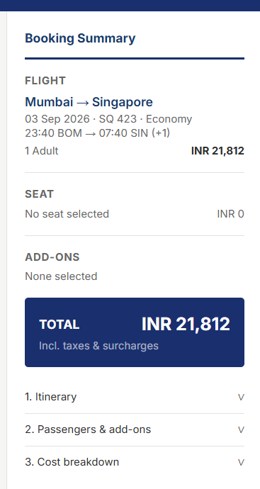
- Part 1 (#13 & #8)
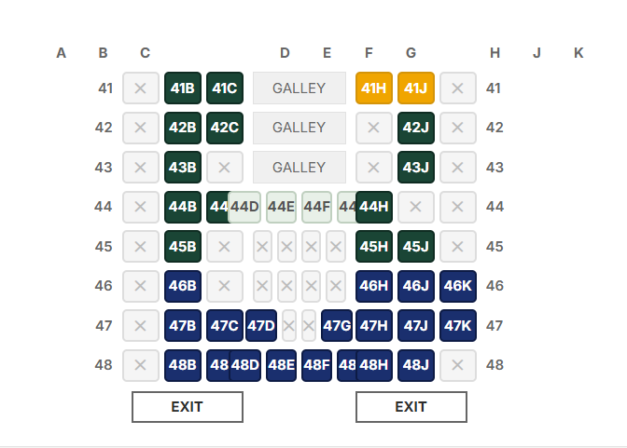
- Part 1(#4 & #7)
- Part 1 (#8) & Part 2(#3)
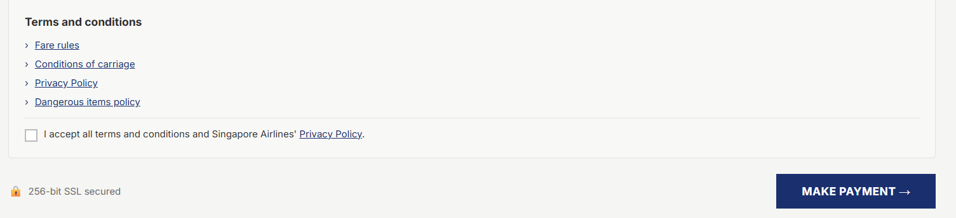
- Part 2 (#3)
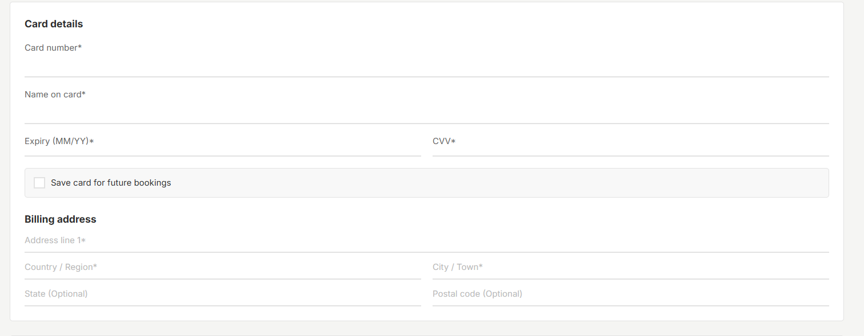

- Part 1 (#5)
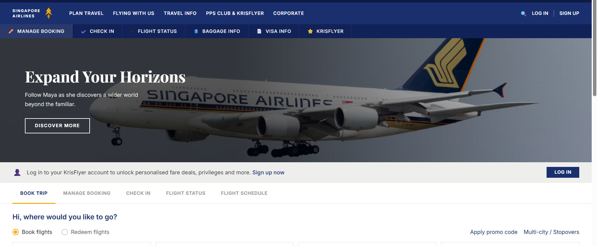
- Part 1 (#6 & #11)
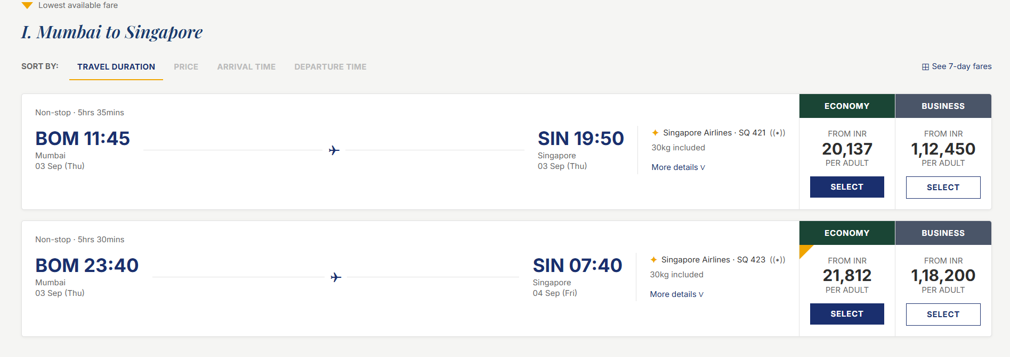
PART II : List out any other points that you may have missed out . (Other than Nielsen’s Principles)

S.NO | OBSERVATIONS | COMMENTS
1 | Small light-grey text on white | It's hard to read for many people, especially those with weak eyesight.
2 | Some links do nothing (footer, "Fare rules") | People will click them and get no reaction.
3 | The payment form doesn't check what you type | You could enter anything and it wouldn't warn you.
4 | The side summary doesn't change when you pick a seat | It keeps showing "No seat selected, INR 0", so users can't confirm their choice before paying.

Students Evaluation Team : group that is evaluation : Hussein , Amal , Dheer – Job Search Platform

