PROJECT REPORT
CINECONNECT:
MOVIE TICKET BOOKING SYSTEM
PBCST304 Mini Project
MDL25CS018 ADRIEL JACOB AJAI
MDL25CS027 ALFRED SUNIL VEMBULLY
MDL25CS045 ASLAM MUHAMMED HAKIM
MDL25CS071 DIYA JINS
MDL25CS089 HAYA ELIZABETH RENJITH
MDL25CS098 JAYARAM A
MDL25CS101 JOE FRANCY
MDL25CS108 KARTHIK KIRAN
LMDL25CS213 SANKEERTH A K
B. Tech Computer Science & Engineering

Department of Computer Engineering
Model Engineering College, Ernakulam
Thrikkakara, Kochi 682021
Phone: +91.484.2575370
http://www.mec.ac.in
hodcs@mec.ac.in
02-11-2026

Model Engineering College, Thrikkakara
Department of Computer Engineering
CERTIFICATE
This is to certify that, this report titled CINECONNECT: MOVIE TICKET BOOKING SYSTEM is a bonafide record of the work done by
MDL25CS018 ADRIEL JACOB AJAI
MDL25CS027 ALFRED SUNIL VEMBULLY
MDL25CS045 ASLAM MUHAMMED HAKIM
MDL25CS071 DIYA JINS
MDL25CS089 HAYA ELIZABETH RENJITH
MDL25CS098 JAYARAM A
MDL25CS101 JOE FRANCY
MDL25CS108 KARTHIK KIRAN
LMDL25CS213 SANKEERTH A K

Third semester B.Tech Computer Science & Engineering students for the course work in PBCST 304 Mini Project, under our guidance and supervision in partial fulfillment of the requirements for the award of the degree, B.Tech, Computer Science & Engineering of APJ Abdul Kalam Technological University.

Guide  Ms.Sinu Tinson  Associate Professor  Computer Science | Head of Department  Dr. Sindhu L  Associate Professor  Computer Science
Date: 02-11-2026
ACKNOWLEDGEMENTS
This project would not have been possible without the kind support and help of many individuals. We would like to extend our sincere thanks to all of them.
First of all, we would like to thank our esteemed Principal, Dr. Jayachandran E. S, for his guidance and support in maintaining a calm and refreshing environment to work in and also for providing the facilities that this work demanded.
We are highly indebted to our Head of the Department, Dr. Sindhu L for her guidance, support, and constant supervision throughout the duration of the work as well as for providing all the necessary information and facilities that this work demanded.
We would like to thank our Project Guide, Sinu Tinson for her support and valuable insights and also for helping us out in correcting any mistakes that were made during the course of the work.
We offer our sincere gratitude to all our friends and peers for their support and encouragement that helped us get through the tough phases during the course of this work.
Last but not least, we thank the Almighty God for guiding us through and enabling us to complete the work within the specified time.

MDL25CS018 ADRIEL JACOB AJAI
MDL25CS027 ALFRED SUNIL VEMBULLY
MDL25CS045 ASLAM MUHAMMED HAKIM
MDL25CS071 DIYA JINS
MDL25CS089 HAYA ELIZABETH RENJITH
MDL25CS098 JAYARAM A
MDL25CS101 JOE FRANCY
MDL25CS108 KARTHIK KIRAN
LMDL25CS213 SANKEERTH A K

ABSTRACT
CineConnect is a desktop movie ticket booking system built with Java, a Java Swing graphical interface and a MySQL database accessed through JDBC. It replaces manual and counter-based ticketing, where long queues, double-booked seats and the lack of real-time occupancy information are common problems.
The system has two user roles. Customers can register, log in, search upcoming shows, choose seats on a colour-coded seat map, ask the system to suggest the best seats together, hold the seats for two minutes, confirm the booking (payment is simulated), view their booking history and cancel a booking before the show starts. Administrators can add movies, theatres and shows (all seats of a show are generated automatically with premium and weekend pricing) and view a dashboard with total revenue, overall occupancy, an occupancy table for every show, the busiest show timings and revenue by movie.
The core of the system is a concurrency-safe seat reservation mechanism. A seat is first held for two minutes using a single atomic SQL update, then converted to booked inside an all-or-nothing database transaction. A background thread releases expired holds. The project applies object-oriented principles throughout: abstraction, inheritance, encapsulation, polymorphism and interfaces, along with the Singleton, Factory, Strategy and Observer design patterns.
Keywords: Movie Ticket Booking, Java, Java Swing, MySQL, JDBC, Seat Reservation, Concurrency, Design Patterns, Desktop Application.

CONTENTS
ABSTRACT 3
CONTENTS 4
Chapter 1: Introduction 8
1.1 Proposed Project 8
1.1.1 Problem Statement 8
1.1.2 Proposed Solution 8
1.2 Objectives 8
1.3 Motivation 9
1.4 Organisation of the Report 9
Chapter 2: Software Requirement Specification 10
2.1 Introduction 10
2.1.1 Purpose 10
2.1.2 Intended Audience 10
2.1.3 Project Scope 10
2.2 Overall Description 10
2.2.1 Product Perspective 10
2.2.2 Product Functions 10
2.2.3 User Classes and Characteristics 10
2.2.4 Operating Environment 11
2.2.5 Design and Implementation Constraints 11
2.3 Hardware and Software Requirements 11
2.4 Functional Requirements 11
2.4.1 Login and Registration 11
2.4.2 Customer Functions 11
2.4.3 Admin Functions 11
2.5 Non-functional Requirements 12
2.5.1 Performance Requirements 12
2.5.2 Scalability 12
2.5.3 Security Requirements 12
2.5.4 Reliability 12
2.6 Other Requirements 12
2.7 Numbered Functional Requirements 12
2.8 Assumptions and Dependencies 13
Chapter 3: System Design 15
3.1 System Architecture 15
3.2 Package Structure 16
3.3 Use Case and Activity Diagrams 17
3.3.1 Use Case Diagram 17
3.3.2 Activity Diagram - Customer 18
3.3.3 Activity Diagram - Admin 19
3.4 Object-Oriented Design 20
3.5 Design Patterns 20
3.6 Database Design 21
3.6.1 Tables 21
3.6.2 Relationships (foreign keys) 21
3.6.3 Design choices 22
3.7 Class Descriptions 22
3.7.1 Model classes 22
3.7.2 Service classes 22
3.7.3 Interfaces and exceptions 23
3.8 Seat Status Life Cycle 23
3.9 Booking Sequence 23
Chapter 4: Data Flow Diagram 25
4.1 Level 0 DFD 25
4.2 Level 1 DFD 25
Chapter 5: Implementation 27
5.1 Algorithms 27
5.1.1 Seat hold and booking 27
5.1.2 Double-booking prevention 27
5.1.3 Best-seat recommendation 27
5.1.4 Cancellation 28
5.1.5 Show creation and pricing 28
5.2 Dataset 28
5.3 Data Access Layer 28
5.4 Development Tools 29
5.5 Key SQL Statements Explained 29
5.6 Concurrency and Threads 30
5.7 Exception Handling 30
5.8 Security Measures 31
Chapter 6: Testing 32
6.1 Testing Methodologies 32
Test environment and data 32
6.2 Unit Testing 32
6.3 Integration Testing 33
6.4 Concurrency Testing 34
6.5 System Testing 34
Chapter 7: Graphical User Interface 35
7.1 Introduction 35
7.2 GUI Design Objectives 35
7.3 Customer Interface 35
7.4 Admin Interface 35
7.5 GUI Workflow and Navigation 36
7.6 Screen-by-Screen Description 36
7.7 Colour Coding and Feedback 37
7.8 Screenshots 38
Chapter 8: Results 42
8.1 Functional Results 42
8.2 Concurrency and Data Consistency 42
8.3 Test Case Results 42
8.4 Observations 42
Chapter 9: Conclusion 44
Chapter 10: Future Scope 45
References 46

List of Figures
Figure 3.1: Architecture Diagram 15
Figure 3.2: Use Case Diagram 17
Figure 3.3: Activity Diagram - CUSTOMER (Booking Flow) 18
Figure 3.4: Activity Diagram - ADMIN (Management Flow) 19
Figure 4.1: DFD Level 0 25
Figure 4.2: DFD Level 1 26

Chapter 1: Introduction

1.1 Proposed Project

1.1.1 Problem Statement
Manual ticket booking at cinemas relies on counters and paper records. This leads to long queues during peak hours, human errors while recording seats and payments, and, most seriously, double booking, where two customers are sold the same seat. Cancellations and refunds are slow to process, and the management has no real-time view of revenue or how full each show is.

1.1.2 Proposed Solution
The proposed solution is CineConnect, a digital platform that automates show listing, seat selection, seat holding, booking confirmation and cancellation. Every seat of every show is stored in the database with a status of available, held or booked. Seats are locked temporarily while a customer completes the booking, so no two customers can obtain the same seat. The administrator gets live revenue and occupancy reports, which supports better scheduling and pricing decisions.

1.2 Objectives
The project was planned around the following objectives:
- To build a complete ticket booking workflow, from choosing a show to a confirmed booking, that a customer can finish in a few steps without help from a counter clerk.
- To guarantee that a seat is never sold twice, even when two customers click the same seat at the same moment.
- To give customers a short, fair window (two minutes) to confirm the seats they have chosen, and to release those seats automatically if they do not.
- To give the administrator an easy way to add movies and theatres and to schedule shows, with all seats and prices generated automatically instead of being entered one by one.
- To give the administrator live figures on revenue and seat occupancy so that popular and unpopular shows can be identified.
- To apply object-oriented programming concepts (abstraction, inheritance, polymorphism, interfaces, exceptions, multithreading) and common design patterns in a real, working application.
- To keep the code organised in separate layers so that each team member can own, explain and test their own part.

1.3 Motivation
Ticketing is a good problem for object-oriented design because it combines several kinds of users, shared data that many people change at the same time, money, and rules about time. Most simple student projects ignore the hardest part, which is what happens when two users compete for the same resource. CineConnect treats this as the central problem and solves it at the database level as well as in Java code, so the same ideas apply to any system that sells limited items, such as train seats, event tickets or appointment slots.

1.4 Organisation of the Report
Chapter 2 lists the requirements. Chapter 3 describes the architecture, object-oriented design, design patterns and database design. Chapter 4 shows how data flows through the system. Chapter 5 explains the main algorithms and the data access layer. Chapter 6 describes the testing carried out. Chapter 7 presents the user interface. Chapter 8 gives the results, Chapter 9 the conclusion and Chapter 10 the future scope.

Chapter 2: Software Requirement Specification

2.1 Introduction

2.1.1 Purpose
This chapter defines the functional and non-functional requirements of CineConnect. It is a reference for developers, testers and evaluators and gives a unified view of the system’s objectives.

2.1.2 Intended Audience
Cinema administrators use the system to manage movies and shows and to monitor revenue and occupancy. Customers use it to book and cancel tickets. Developers and testers use this document to build and verify the system.

2.1.3 Project Scope
CineConnect covers user registration and login, movie, theatre and show management, seat selection with temporary holds, simulated payment (the Pay & confirm step), booking history, cancellation, and admin reporting. Payment is simulated and always succeeds, and no payment details are collected. E-tickets, refunds, real payment gateways, online access and mobile apps are outside the current scope.

2.2 Overall Description

2.2.1 Product Perspective
CineConnect is a standalone desktop application connected to a MySQL database through JDBC. It is lightweight and runs on an ordinary desktop or laptop.

2.2.2 Product Functions
Secure login with hashed passwords, role-based dashboards, browsing and searching of upcoming shows, a seat map with best-seat recommendation, a two-minute seat hold, simulated payment, booking history, cancellation, movie, theatre and show management, and revenue, occupancy and show-timing reporting.

2.2.3 User Classes and Characteristics
- Administrator: manages the catalogue and views reports. Basic computer literacy is enough.
- Customer: the largest group, needs no technical knowledge. Uses the system to find a show and book seats.

2.2.4 Operating Environment
Desktop operating systems such as Windows or Linux with Java JDK 17 or higher, MySQL Server and the MySQL JDBC driver (managed through Maven).

2.2.5 Design and Implementation Constraints
The user interface must use Java Swing and the database must be MySQL. The code must follow the layering ui, service, db, so screens never contain SQL. Referential integrity must be maintained through foreign keys.

2.3 Hardware and Software Requirements
Hardware: Intel i3 or higher, 4 GB RAM minimum, 2 GB free storage.
Software: Java JDK 17 or higher, MySQL Server and MySQL Workbench, Maven, and an IDE such as IntelliJ IDEA.

2.4 Functional Requirements

2.4.1 Login and Registration
Users log in with a username and password. New customers register with a full name, a username and a password. The form is validated (all fields are required and the password must have at least 4 characters) and duplicate usernames are rejected. After login, the user is redirected to the Admin or Customer window according to the role.

2.4.2 Customer Functions
- Browse shows: view upcoming shows with movie, genre, theatre, screen, date and time and base price, and search by movie, genre or theatre.
- Select seats: colour-coded seat map (regular, premium, selected, your hold, held by others, booked) and a “Recommend best seats” option for a chosen number of adjacent seats.
- Hold and pay: “Hold selected seats” reserves the seats and starts a two-minute countdown; “Pay & confirm” completes the booking. Payment is simulated.
- Booking confirmation: a message shows the booking ID, movie, show time, seats and total amount once the booking is confirmed.
- Booking history and cancellation: list all bookings and cancel a confirmed booking before the show starts; its seats become available again.

2.4.3 Admin Functions
- Add movie: title, genre, duration and rating.
- Add theatre: name and city.
- Add show: choose movie, theatre, screen, start date and time, number of rows and columns and base price. All seats are generated automatically.
- Reports: total revenue, overall occupancy, an occupancy and revenue table for every show, the busiest show timings and revenue by movie.

2.5 Non-functional Requirements

2.5.1 Performance Requirements
Seat maps, bookings and reports should respond quickly on a single desktop installation. Seat availability must always reflect the database.

2.5.2 Scalability
New movies, theatres and shows can be added without code changes. New pricing rules or seat-recommendation methods can be added by implementing an interface.

2.5.3 Security Requirements
Passwords are stored as salted PBKDF2-HMAC-SHA256 hashes (65,536 iterations), never in plain text. All SQL uses prepared statements to prevent SQL injection. Customers can only be registered with the CUSTOMER role, and role-based windows prevent customers from using admin screens.

2.5.4 Reliability
Booking and cancellation are database transactions: they either complete fully or are rolled back. Two customers can never hold or book the same seat, even when they act at the same instant.

2.6 Other Requirements
The application should be easy to install by following the README steps. The tables are created automatically from schema.sql the first time the application starts, and the database can be recreated at any time by dropping it.

2.7 Numbered Functional Requirements
ID | Requirement | Role
FR1 | The system shall let a new customer register with a full name, a username and a password. | Customer
FR2 | The system shall reject registration when a field is invalid or the username already exists. | Customer
FR3 | The system shall authenticate a user by username and hashed password and open the window that matches the role. | Both
FR4 | The system shall list all shows with movie, genre, theatre, screen, start time and base price, and let the customer search them. | Customer
FR5 | The system shall display every seat of a show with its type and current status. | Customer
FR6 | The system shall suggest a block of adjacent seats near the centre of the hall for a requested number of seats. | Customer
FR7 | The system shall hold the selected seats for two minutes, all or none. | Customer
FR8 | The system shall confirm a booking only if every held seat is still held by the same customer and the hold has not expired. | Customer
FR9 | The system shall release held seats when the customer releases them or the two minutes run out. | Customer
FR10 | The system shall show the booking ID, movie, show time, seats and total when a booking is confirmed. | Customer
FR11 | The system shall list a customer’s bookings and allow a confirmed booking to be cancelled before the show starts, freeing its seats. | Customer
FR12 | The system shall allow the administrator to add a movie and a theatre. | Admin
FR13 | The system shall allow the administrator to schedule a show, generating all its seats and prices automatically. | Admin
FR14 | The system shall show the administrator total revenue, overall occupancy, per-show occupancy and revenue, busiest show timings and revenue by movie. | Admin

2.8 Assumptions and Dependencies
- A MySQL server is running locally. The application creates the cineconnect database and its tables on first start.
- The database username and password are set correctly in db.properties.
- Each screen is a rectangular grid of seats. Seats are named by row letter and seat number, such as C4, and the last third of the rows (at least one) of every show are premium rows.
- A customer holds seats for at most two minutes, and the hold is released automatically afterwards.
- Payment is simulated: clicking Pay & confirm always succeeds, and no payment details are collected or stored.
- Only one administrator account is needed, and it is created automatically together with the demo data.

Chapter 3: System Design

3.1 System Architecture
CineConnect follows a layered (multi-tier) architecture with strict separation of concerns: the user interface calls the service classes, and the service classes obtain connections from the Database class and run SQL through JDBC. Screens never contain SQL.
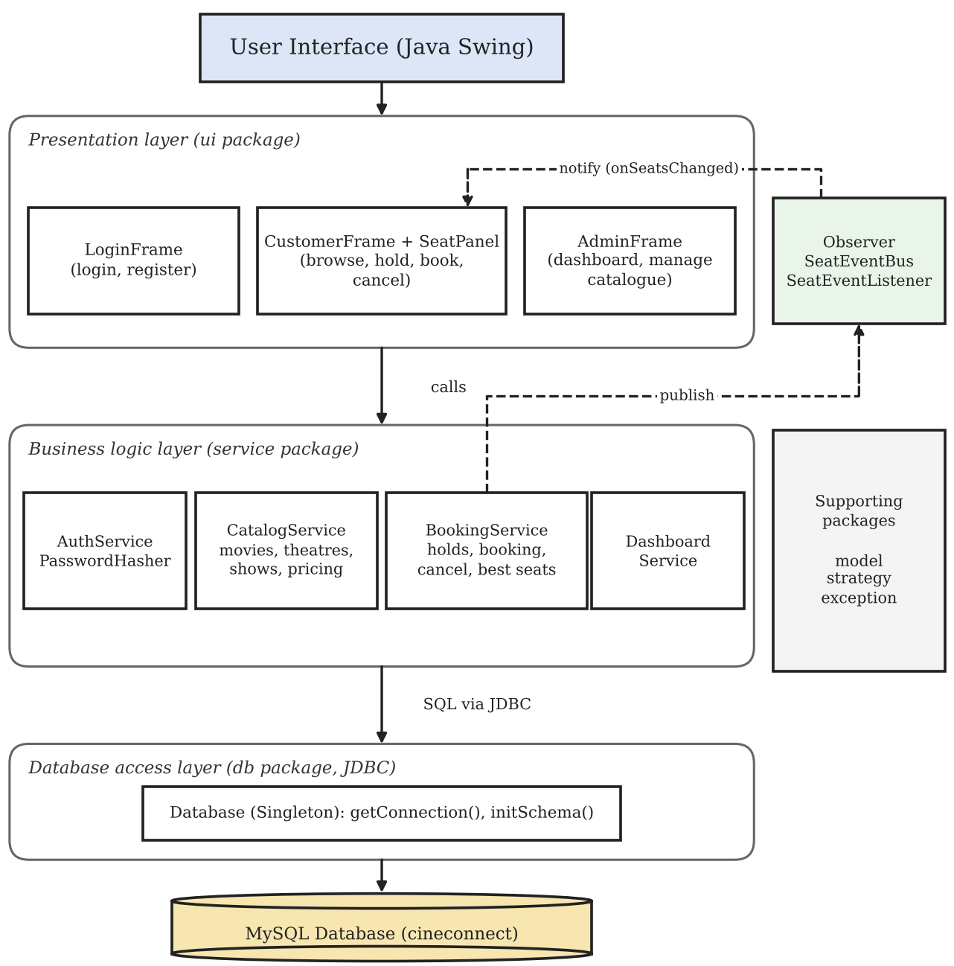
Figure 3.1: Architecture Diagram
The user interface only calls service classes. Services hold the business logic (holds, transactions, timers, recommendations and pricing). The Database class is a Singleton that supplies JDBC connections, and BookingService publishes seat events on the SeatEventBus, to which the customer screen subscribes.

3.2 Package Structure
Package | Contents
com.cineconnect | Main, AppContext, SeedData
model | Role, SeatStatus, User, Admin, Customer, Movie, Theatre, Show, Seat, RegularSeat, PremiumSeat, SeatFactory, Booking
service | AuthService, CatalogService, BookingService, DashboardService, SeatHoldManager, PasswordHasher, Bookable, Cancellable
strategy | PricingStrategy, StandardPricing, WeekendPricing, SeatRecommendationStrategy, CentreFocusStrategy
observer | SeatEventBus, SeatEventListener
db | Database (Singleton, JDBC connections, schema creation)
exception | CineConnectException, SeatAlreadyBookedException, HoldExpiredException, AuthenticationException, DataAccessException
ui | LoginFrame, CustomerFrame, SeatPanel, AdminFrame, Dialogs, Fmt

3.3 Use Case and Activity Diagrams

3.3.1 Use Case Diagram
The use case diagram shows the two actors of the system and the actions each of them can perform. Both actors log in. The customer can register, view and search shows, select seats, get a best-seat suggestion, hold seats, confirm the booking (simulated payment), view the booking history and cancel a booking. The admin can add a movie, add a theatre, add a show, view revenue and occupancy, view the busiest show timings and view revenue by movie.
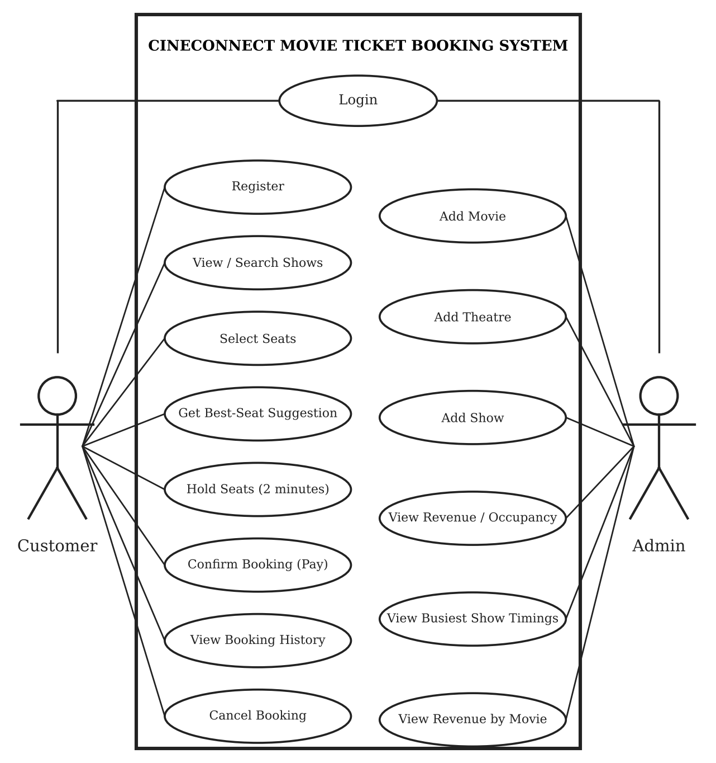
Figure 3.2: Use Case Diagram

3.3.2 Activity Diagram - Customer
This diagram shows the steps a customer follows, from opening the application and logging in to choosing seats, holding them, confirming the booking within the two-minute hold and optionally cancelling the booking afterwards.
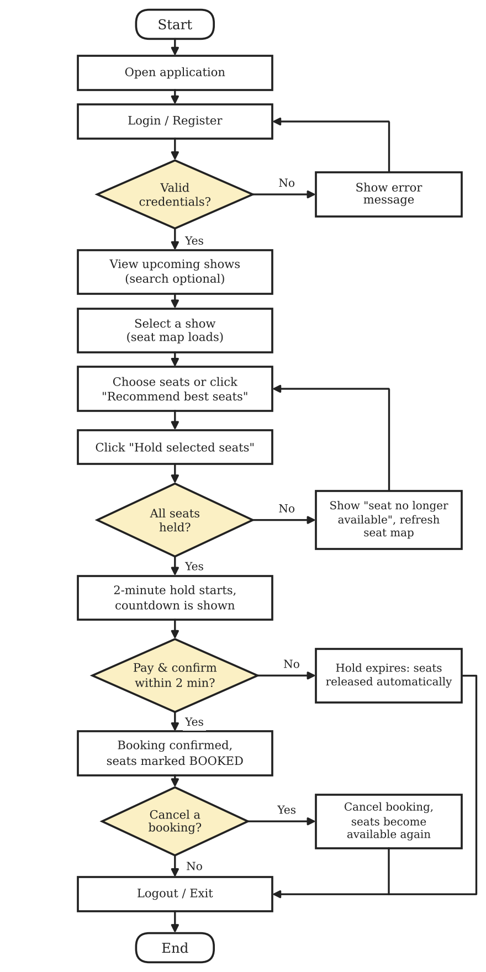
Figure 3.3: Activity Diagram - CUSTOMER (Booking Flow)

3.3.3 Activity Diagram - Admin
The admin flow covers logging in and then choosing between adding a movie, adding a theatre, adding a show and viewing the reports. Adding a show validates the input and generates all seats with their prices.
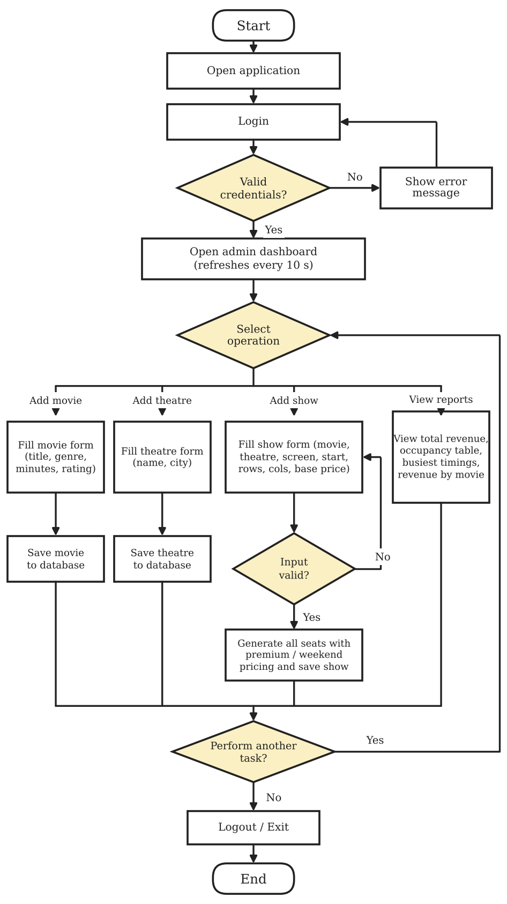
Figure 3.4: Activity Diagram - ADMIN (Management Flow)

3.4 Object-Oriented Design
Concept | Where it is used
Abstraction | User and Seat are abstract classes with abstract methods. BookingService hides all JDBC and SQL behind methods such as bookSeat() and getAvailableSeats().
Inheritance | Admin and Customer extend User. RegularSeat and PremiumSeat extend Seat. WeekendPricing extends StandardPricing. SeatAlreadyBookedException and the other custom exceptions extend CineConnectException.
Encapsulation | Model fields are private and exposed through getters.
Polymorphism | Overriding: getRole(), getDashboardTitle() and getWelcomeMessage() in Admin and Customer, getPriceMultiplier() in the seat classes. AuthService returns a User whose real type depends on the database row, and LoginFrame opens the matching window. Overloading: searchMovies(), listShows(), bookSeat()/bookSeats() and cancelBooking().
Interfaces | Bookable, Cancellable, PricingStrategy, SeatRecommendationStrategy and SeatEventListener. BookingService implements Bookable and Cancellable.
Exception handling | Custom unchecked exceptions that extend CineConnectException: SeatAlreadyBookedException, HoldExpiredException, AuthenticationException and DataAccessException.
Multithreading | A background seat-hold-sweeper thread, Swing timers, and a thread-safe CopyOnWriteArrayList of listeners.

3.5 Design Patterns
- Singleton: Database holds the database settings once and provides JDBC connections through getInstance().
- Factory: SeatFactory.create() builds a RegularSeat or PremiumSeat from the type stored in the database.
- Strategy: PricingStrategy with StandardPricing and WeekendPricing; CatalogService.addShow() picks the strategy by day of the week. SeatRecommendationStrategy with CentreFocusStrategy is used for best-seat suggestions.
- Observer: SeatEventListener is implemented by the customer screen. BookingService publishes on SeatEventBus after every change to seats (hold, release, expiry, booking, cancellation) and all subscribed screens refresh their seat map. Because the bus lives inside one running application, the seat map also re-reads the database every five seconds so that changes made from other copies of the application appear.

3.6 Database Design

3.6.1 Tables
Table | Purpose | Key columns
users | Admins and customers | PK id, unique username, password_hash, full_name, role
movies | Movie catalogue | PK id, title, genre, duration_min, rating
theatres | Cinemas | PK id, name, city
shows | A screening | PK id, FK movie_id, FK theatre_id, screen, start_time, row_count, col_count, base_price
show_seats | One row per seat per show | Composite PK (show_id, seat_label), seat_type, price, status, held_by, hold_expires, booking_id
bookings | A confirmed or cancelled booking | PK id, FK user_id, FK show_id, total, created_at, status
booking_seats | Seats of a booking | Composite PK (booking_id, seat_label), price

3.6.2 Relationships (foreign keys)
movies <---- shows ----> theatres
^ ^
| +---- show_seats (show_id)
|
users <---- bookings ----> booking_seats
There are six foreign keys: shows to movies and theatres, bookings to users and shows, show_seats to shows and booking_seats to bookings. shows is the central table. The columns show_seats.held_by and show_seats.booking_id record who holds a seat and which booking owns it, but they are not declared as foreign keys.

3.6.3 Design choices
Roles, seat types, seat statuses and booking statuses are stored as short text values (VARCHAR) and are represented by Java enums and constants in the code. Money is stored as DOUBLE and rounded to two decimals in Java. Show start times and hold expiry times are stored as BIGINT epoch milliseconds, which behave the same on MySQL and on the H2 database used in the tests. Admin and customer share the users table and are told apart by the role column. Seat prices are copied into show_seats when a show is created, so later changes do not affect existing shows.

3.7 Class Descriptions

3.7.1 Model classes
- User (abstract): holds id, username and full name. It declares the abstract methods getRole() and getDashboardTitle() that each role must provide, and a getWelcomeMessage() method that subclasses may override.
- Admin: extends User. It returns the role ADMIN, the title “CineConnect - Admin Dashboard” and the welcome message “Administrator: name”.
- Customer: extends User. It returns the role CUSTOMER and the title “CineConnect - Book Tickets”.
- Movie and Theatre: a movie holds id, title, genre, duration and rating, and a theatre holds id, name and city. Their toString() methods are used by drop-down lists.
- Show: a screening with start time, screen name, number of rows and columns and base price, plus display fields (movie title, genre, theatre name) that come from a database join.
- Seat (abstract), RegularSeat, PremiumSeat: a seat has a label such as C4, a row and a column, a price and a status (SeatStatus: AVAILABLE, HELD or BOOKED). Each subclass returns its own type and price multiplier (1.0 and 1.5). SeatFactory creates the right subclass.
- Booking: holds booking id, user, show, movie title, theatre, show start, total, status (CONFIRMED or CANCELLED), creation time and the list of seat labels.
- Role and SeatStatus: enums that restrict the possible values of a user’s role and a seat’s status.

3.7.2 Service classes
- AuthService: validates registration, registers customers, creates the administrator and checks login by comparing PBKDF2 password hashes.
- CatalogService: adds and searches movies, adds theatres, lists and searches shows, and adds shows after choosing the pricing strategy. Creating a show also creates all of its seats.
- BookingService: the core of the system. It reads the seat map, holds and releases seats, confirms and cancels bookings, loads booking history, recommends seats and publishes seat events.
- DashboardService: returns revenue, overall occupancy, per-show statistics, the busiest time slots and revenue by movie.
- SeatHoldManager and AppContext: SeatHoldManager runs a background thread that releases expired holds every five seconds. AppContext creates one shared instance of every service and of the SeatEventBus, so there is only one hold timer thread.

3.7.3 Interfaces and exceptions
- Bookable: bookSeats(userId, showId, seatLabels).
- Cancellable: cancelBooking(bookingId, userId).
- SeatEventListener: onSeatsChanged(showId).
- CineConnectException: the base (unchecked) exception for any application problem.
- SeatAlreadyBookedException: thrown when a seat is already booked or held by another customer. HoldExpiredException, AuthenticationException and DataAccessException also extend CineConnectException.

3.8 Seat Status Life Cycle
Every row of show_seats moves through three states:
hold (2 min) confirm booking
AVAILABLE ----------------> HELD --------------------> BOOKED
^ | |
| release / timeout | |
+-------------------------+ |
+-----------------------------------------------------+
booking cancelled
A seat becomes HELD only if it is AVAILABLE, or its earlier hold has expired, or it is already held by the same customer. It becomes BOOKED only if it is still held by the paying customer and the hold has not expired. A cancelled booking returns its seats to AVAILABLE.

3.9 Booking Sequence
- The customer selects a show in the Book tickets tab, and CustomerFrame asks BookingService for the seat map.
- The customer chooses seats, or clicks Recommend best seats, and clicks Hold selected seats.
- BookingService.holdSeats() opens one transaction and runs the conditional UPDATE for each seat, in sorted order.
- If every seat is held, the screen shows them as “your hold” with a countdown starting at 2:00. If a seat is lost, the transaction is rolled back and the customer is told which seat is no longer available.
- When the customer clicks Pay & confirm, BookingService.confirmBooking() runs a second transaction that inserts the booking, converts the held seats to BOOKED and records the booking seats.
- BookingService publishes a seat event on the SeatEventBus, and the screen shows the booking confirmation and refreshes the seat map.
- If the customer releases the hold, or the two minutes pass, the seats become available again (releaseHolds() or the background releaseExpiredHolds()).

Chapter 4: Data Flow Diagram

4.1 Level 0 DFD
The context diagram shows CineConnect as a single process with two external entities:
- Customer sends registration details, login credentials, seat selections, hold and booking-confirmation requests and cancellation requests. It receives show listings, the seat map, booking confirmations and booking history.
- Admin sends login details and movie, theatre and show details. It receives revenue, occupancy and show-timing reports.
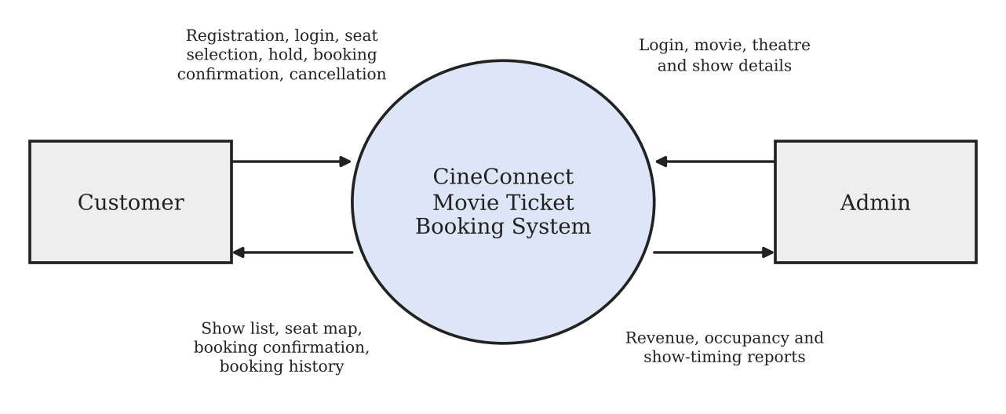
Figure 4.1: DFD Level 0

4.2 Level 1 DFD
The process is decomposed into the following sub-processes and data stores:
Process | Reads / writes
1. Authentication | users
2. Catalogue Management | movies, theatres, shows, show_seats
3. Seat Reservation | show_seats
4. Booking | show_seats, bookings, booking_seats
5. Cancellation | bookings, booking_seats, show_seats
6. Reporting | shows, movies, show_seats, bookings
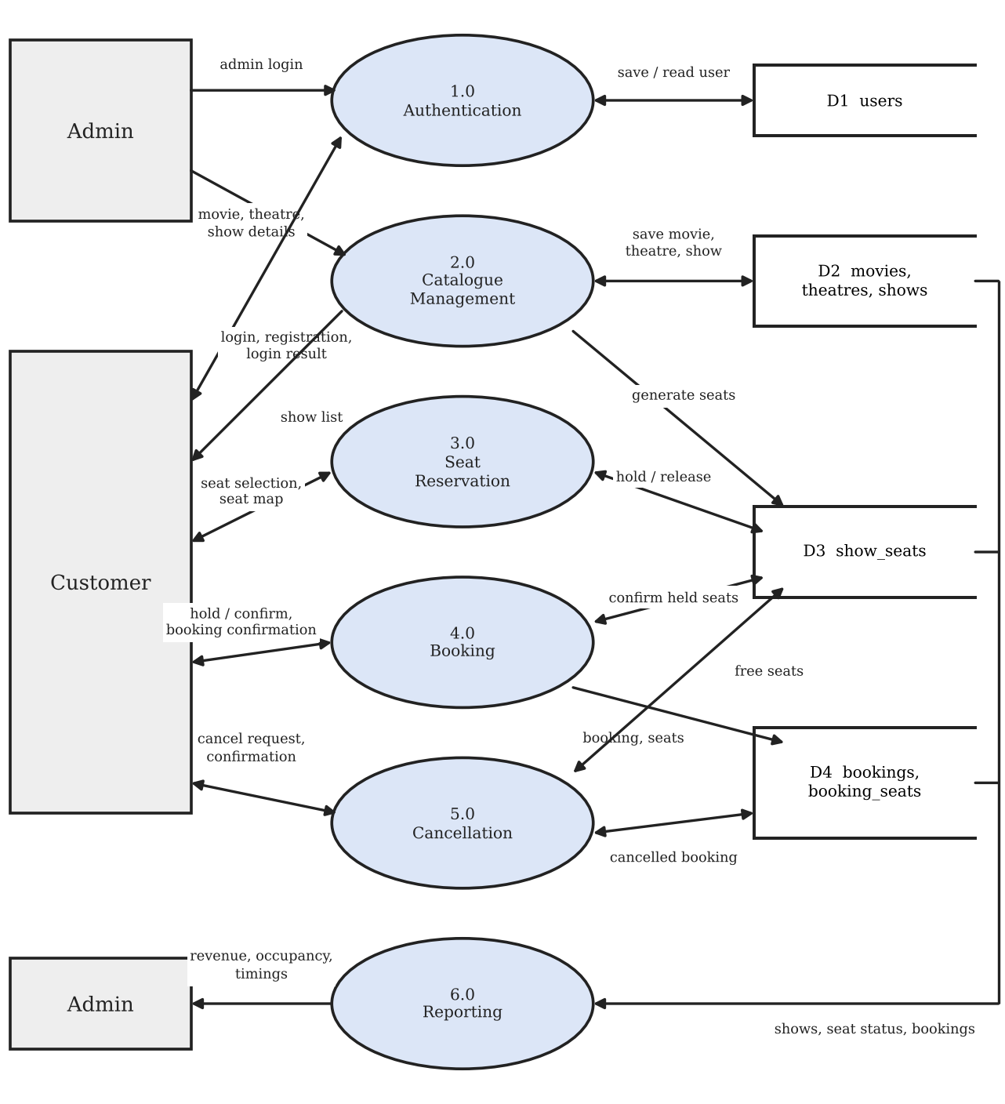
Figure 4.2: DFD Level 1

Chapter 5: Implementation

5.1 Algorithms

5.1.1 Seat hold and booking
- The customer selects seats and clicks Hold selected seats.
- BookingService.holdSeats() sorts the seat labels, so that two customers asking for overlapping seats always lock rows in the same order, and opens one database transaction.
- For each seat it runs one atomic SQL UPDATE that sets the seat to HELD for two minutes only if it is AVAILABLE, or its hold has expired, or it is already held by the same customer.
- If an update changes one row, the seat is held. If it changes zero rows, another customer has the seat: the transaction is rolled back, so no seat stays held, and SeatAlreadyBookedException is thrown (all or nothing).
- The screen shows a two-minute countdown for the held seats.
- On Pay & confirm, confirmBooking() runs one transaction: it selects the customer’s still-valid held seats, inserts the booking, converts those seats from HELD to BOOKED (only if still held by this customer and not expired), inserts the booking seats and commits. If the number of seats updated does not match, it throws HoldExpiredException and rolls back.
- If the customer releases the hold or the time runs out, the seats become available again.
- A background thread (SeatHoldManager) frees every expired hold every five seconds, and the seat map also shows expired holds as available.

5.1.2 Double-booking prevention
Double booking is prevented inside the database. Every hold and booking is a conditional UPDATE whose WHERE clause requires the seat to be available. MySQL locks the row while the statement runs, so when several customers click the same seat only one update changes the row and the others change none. Because the check and the change are one statement, this stays correct even if several copies of the application run against the same database, which a Java lock alone cannot guarantee. The automated test sameSeatCanOnlyBeBookedOnceUnderHeavyConcurrency starts 40 threads that try to book seat C5 of one show at the same instant. Exactly one succeeds and the other 39 receive a SeatAlreadyBookedException.

5.1.3 Best-seat recommendation
CentreFocusStrategy, called through BookingService.recommendSeats(), groups the seats by row and slides a window of the requested number of seats along each row, ignoring windows that contain an unavailable seat. Each seat is scored by its distance from a preferred row (60% of the way back, weighted 1.5) plus its distance from the centre column, and a window is scored by the average of its seats. The window with the lowest score is suggested. If no block of adjacent seats exists, the best individual seats are returned, and an empty list is returned if there are not enough free seats.

5.1.4 Cancellation
BookingService.cancelBooking() locks the booking row with SELECT ... FOR UPDATE, checks that the booking belongs to the customer, is still confirmed and that the show has not started, then marks the booking CANCELLED and sets its seats back to AVAILABLE, all in one transaction. Cancelled bookings are excluded from revenue and occupancy.

5.1.5 Show creation and pricing
CatalogService.addShow() inserts the show and generates every seat (A1 to H12 for 8 rows of 12 seats) in one batch insert inside a transaction. The last third of the rows (at least one) are premium rows. The price of each seat comes from the pricing strategy: premium seats cost 1.5 times the base price, and shows on a Saturday or Sunday cost a further 20 percent.

5.2 Dataset
On the first start the application creates the database cineconnect and its tables from schema.sql, and SeedData inserts demo data when there are no users:
- 2 users: one admin (admin / admin123) and one customer (customer / customer123).
- 4 movies: Stellar Run (Sci-Fi), The Last Monsoon (Drama), Laugh Riot (Comedy) and Night Shift (Thriller).
- 3 theatres: PVR Lulu Mall and Cinepolis Centre Square in Kochi, and Carnival Infopark in Thrikkakara.
- 12 shows (at 10:30, 14:00, 18:30 and 21:45 on each of three days, starting today), each with 8 rows of 12 seats, so 96 seats per show and 1,152 rows in show_seats. The base price is Rs. 180.
The application connects through JDBC. Database reads the URL, user and password from config/db.properties or from environment variables.

5.3 Data Access Layer
Class | Main methods | SQL concepts
Database | getInstance, getConnection, initSchema | JDBC DriverManager, running schema.sql
AuthService | register, createAdmin, login | SELECT, INSERT with generated key
CatalogService | addMovie, addTheatre, addShow, searchMovies, listShows | INSERT, batch insert, transaction, JOIN, LIKE
BookingService | getSeatMap, holdSeats, confirmBooking, cancelBooking, releaseExpiredHolds | Conditional atomic UPDATE, transactions, SELECT ... FOR UPDATE
DashboardService | getShowStats, getTotalRevenue, getBusiestTimeSlots | Sub-queries, COUNT, SUM, COALESCE
All queries use PreparedStatement with ? parameters and try-with-resources, so SQL injection is prevented and connections are always closed. There is no separate DAO layer: the service classes contain the SQL, and the screens never do.

5.4 Development Tools
- Java (JDK 17+): primary language, with object-oriented features and concurrency utilities.
- Java Swing: the graphical interface (JFrame, JPanel, JTable, JButton, layout managers and Swing timers).
- MySQL: relational database for all data.
- JDBC: connectivity between Java and MySQL.
- Maven: dependency management (MySQL driver, JUnit and H2) through pom.xml.
- JUnit 5 and H2: unit and integration tests; the tests run on an in-memory H2 database in MySQL compatibility mode.
- IntelliJ IDEA: IDE for coding and debugging.
- Git and GitHub: version control, managed by one team member.

5.5 Key SQL Statements Explained
Atomic seat hold (BookingService.holdSeats). One UPDATE sets the seat to HELD, records the customer in held_by and sets hold_expires to two minutes from now. Its WHERE clause allows the update only when the seat is AVAILABLE, or HELD with an expired timer, or HELD by the same customer. Because the check and the change are one statement, MySQL locks the row while it runs. When two customers click the same seat, one update changes one row (success) and the other changes none (failure).
Booking transaction (BookingService.confirmBooking). Automatic commit is switched off. A SELECT ... FOR UPDATE reads the customer’s valid held seats and their prices. The booking row is inserted, then one UPDATE turns those seats from HELD to BOOKED only if they are still held by this customer and the hold has not expired. If the number of updated rows is not the number of seats, the method throws HoldExpiredException and everything is rolled back. Otherwise the booking seat rows are inserted and the transaction is committed.
Effective status on the seat map (BookingService.getSeatMap). Every seat of the show is read in row and column order. A seat that is HELD but whose hold_expires time has passed is shown as AVAILABLE, even before the background thread clears it.
Booking history (BookingService.getBookingsForUser). The query joins bookings, shows, movies and theatres and reads the seat labels of each booking from booking_seats. The newest booking is listed first.
Cancellation (BookingService.cancelBooking). The booking row is selected with FOR UPDATE, which locks it so that two simultaneous cancel clicks cannot both succeed. The booking is marked CANCELLED and the seats with that booking_id are set back to AVAILABLE in the same transaction.
Dashboard (DashboardService). Occupancy counts the seats with status BOOKED and all seats of each show using sub-queries. Revenue is SUM(total) over bookings with status CONFIRMED, so cancelled bookings are not counted. The busiest show timings group the shows by start hour and add up their booked seats.

5.6 Concurrency and Threads
- Database-level locking. each hold or booking is a conditional UPDATE, and the database serialises competing updates on the same row. Seat labels are updated in sorted order to avoid deadlocks, and every request uses its own connection and transaction.
- Atomicity across copies. the conditional UPDATE remains correct even if two copies of the application run against the same database, which a Java lock alone cannot guarantee.
- Hold sweeper. SeatHoldManager runs a single daemon thread named seat-hold-sweeper every five seconds and calls releaseExpiredHolds(). Being a daemon thread, it never stops the application from exiting.
- Swing timers. CustomerFrame uses javax.swing.Timer objects: one ticks every second to update the countdown and another re-reads the seat map every five seconds. AdminFrame refreshes the dashboard every ten seconds. Updates that arrive from other threads are posted with SwingUtilities.invokeLater.
- Thread-safe collections. the listener list in SeatEventBus is a CopyOnWriteArrayList, so screens can subscribe or unsubscribe while an event is being published.

5.7 Exception Handling
SQL errors are caught in the service layer and wrapped in a DataAccessException with a readable message, so the interface never shows raw database errors without context. All-or-nothing behaviour is built into the code: every write runs inside inTransaction, which commits on success and calls rollback() on any failure. The custom exceptions extend the unchecked CineConnectException, and the user interface catches them in one place (Dialogs.error) and displays them in a dialog.

5.8 Security Measures
- Passwords are stored only as salted PBKDF2-HMAC-SHA256 hashes (random 16-byte salt, 65,536 iterations). PasswordHasher compares hashes in constant time.
- All queries that take user input use PreparedStatement with ? placeholders, which prevents SQL injection.
- Registration always creates the CUSTOMER role and no screen can create an administrator, so an administrator account cannot be created from the registration form.
- Cancelling a booking checks the customer id, so a customer cannot cancel another customer’s booking.
- The database password is kept in config/db.properties, which is listed in .gitignore so that it is not pushed to Git. Only db.properties.example is committed.

Chapter 6: Testing

6.1 Testing Methodologies
The following methodologies are applied: unit testing of individual classes, integration testing of services working with a real SQL database, concurrency testing of seat holding and booking, and system testing of the complete application through the screens. The automated tests are written with JUnit 5 and run with mvn test.

Test environment and data
The automated tests use an in-memory H2 database in MySQL compatibility mode that is created fresh for every test, and a controllable clock (MutableClock), so the two-minute hold expiry can be tested without waiting. The application itself was run against MySQL Server with the demo data (users admin / admin123 and customer / customer123, 4 movies, 3 theatres and 12 shows).

6.2 Unit Testing
ID | Test | Steps | Expected output | Status
U1 | Central block on an empty hall | Ask for 2 seats on an empty 8 x 12 hall | Two adjacent seats in the middle columns and in the middle-to-back rows | Passed
U2 | Skip taken seats | A row of 6 seats with seat 3 booked; ask for 3 seats together | Seats A4, A5 and A6 are suggested | Passed
U3 | Fallback to separate seats | A row of 5 seats with seats 2 and 4 booked; ask for 3 seats | Three separate available seats are returned | Passed
U4 | Not enough seats | A row of 3 seats with one booked; ask for 3 seats | An empty list is returned | Passed

6.3 Integration Testing
ID | Scenario | Expected output | Status
I1 | Register, then log in with the new account | Customer is stored in users and can log in; role is CUSTOMER | Passed
I2 | Create an administrator and log in | Role is ADMIN and the dashboard title contains “Admin” | Passed
I3 | Wrong password and unknown username | Both logins are rejected with AuthenticationException | Passed
I4 | Register a duplicate username | Registration is rejected | Passed
I5 | Admin adds a show of 6 x 10 seats at base price 100 | 60 seats are created; regular seats cost 100 and premium seats 150 | Passed
I6 | Hold two seats, then confirm | Booking has both seats and total 200; the seats cannot be held by another customer; booking appears in history | Passed
I7 | Hold blocks others, then expires | Another customer is rejected at 119 s; the seat is free at 121 s and can then be held | Passed
I8 | Pay after the hold expired | HoldExpiredException is thrown | Passed
I9 | Hold three seats when one is already taken | SeatAlreadyBookedException; none of the other seats stays held | Passed
I10 | Cancel a booking | Seats are free again; another customer cannot cancel it; a cancelled booking cannot be cancelled twice | Passed
I11 | Release a hold | Seats can be held by another customer at once | Passed
I12 | Hold a seat with a listener subscribed | The listener is told the show id | Passed
I13 | Recommend 3 seats on a real show | Three adjacent seats in one row | Passed
I14 | Book two seats, then read the dashboard | 12 seats, 2 booked, revenue 200, occupancy 16.7%, busiest slot has 2 seats | Passed
I15 | Book and cancel, then read the dashboard | Revenue is 0 and booked seats are 0 | Passed

6.4 Concurrency Testing
Two automated tests in BookingServiceTest exercise concurrency. In the first, 40 customers (40 threads released together by a CountDownLatch) try to book seat C5 of the same show. Expected: exactly one booking succeeds and 39 receive SeatAlreadyBookedException. In the second, 10 customers book 10 different seats at the same time. Expected: all 10 bookings succeed and the other 50 of the 60 seats stay available.
Execution status: both concurrency tests were executed in the final build (mvn test) and passed.

6.5 System Testing
End-to-end scenario: (1) Admin adds a movie and a show. (2) A customer registers and logs in. (3) The customer opens the seat map, uses Recommend best seats and holds the seats. (4) The customer clicks Pay & confirm. (5) The customer opens My bookings and cancels the booking. (6) The admin refreshes the dashboard and verifies revenue and occupancy.
Execution status: the scenario was run on the demo data in the Swing application. The seat map with booked seats and the updated admin dashboard are shown in Figures 7.5 to 7.7.

Chapter 7: Graphical User Interface

7.1 Introduction
The GUI is implemented with Java Swing and connects users with the system’s functions. Each role gets its own dashboard. The design follows Human-Computer Interaction practice and keeps the screens simple and consistent.

7.2 GUI Design Objectives
- Simplicity: only the necessary elements on each screen.
- Consistency: the same colour set and layout on every screen, through the shared Fmt and Dialogs helper classes.
- Feedback and validation: dialogs confirm success and explain errors.
- Role-based interface: different dashboards for admin and customer.
- Error prevention: input validation (numeric fields, date format, row and column limits), and seats that are not available are disabled on the seat map.
Swing components used include JFrame, JPanel, JTable, JButton, JComboBox, JSpinner, JTabbedPane, JSplitPane, JTextField and JOptionPane, together with javax.swing.Timer. Layout managers include BorderLayout, GridLayout, GridBagLayout and FlowLayout.

7.3 Customer Interface
- Login and Register: username and password login, and a registration dialog (full name, username and password).
- Show list and search: a table of upcoming shows (movie, theatre, screen, start time and base price) with a search box for movie, genre or theatre.
- Seat map: a grid of seats with a SCREEN bar and a legend. Green is regular, yellow is premium, blue is the customer’s selection, purple is the customer’s own hold, orange is held by another customer and red is booked. A line shows the selected seats and their total, and “Seats together” with “Recommend best seats” selects the best adjacent seats.
- Hold and pay: “Hold selected seats” starts a two-minute countdown, “Pay & confirm” completes the booking and “Release hold” frees the seats.
- Booking confirmation: a message with the booking ID, movie, show time, seats and total is shown after the booking is confirmed.
- My bookings: a table of the customer’s bookings (ID, movie, theatre, start time, seats, total, status) with Cancel selected booking and Refresh buttons.

7.4 Admin Interface
The admin dashboard uses a tabbed layout.
- Dashboard cards: total revenue, overall occupancy and the busiest show time.
- Dashboard tables: occupancy and revenue for each show, the busiest show timings (seats booked per start hour) and revenue by movie, refreshed every ten seconds.
- Manage catalogue tab: forms to add a movie, a theatre and a show.
- Buttons: Refresh now and Log out.

7.5 GUI Workflow and Navigation
- Login, then role identification, then redirect to the dashboard.
- Customer: Show list, Seat map, Hold seats, Pay & confirm, My bookings.
- Admin: Dashboard, Manage catalogue (add movie, theatre or show), Refresh.

7.6 Screen-by-Screen Description
Screen | Class | What it does
Login | LoginFrame | Takes the username and password, calls AuthService.login() and opens the Admin or Customer window according to the role returned. Has a Create account button.
Register | LoginFrame (dialog) | Collects full name, username and password and calls AuthService.register(). Shows an error if the username is taken or a field is invalid.
Customer window | CustomerFrame | Two tabs. Book tickets: show table with search, seat map, hold, pay and release buttons and the countdown. My bookings: the customer’s bookings with a cancel button.
Seat map | SeatPanel | Draws the grid of seats with a SCREEN bar and a legend. Seats that are not available are disabled. Hovering over a seat shows its type and price.
Admin window | AdminFrame | Two tabs, Dashboard and Manage catalogue, and a Log out button.
Dashboard tab | AdminFrame | Cards for total revenue, overall occupancy and busiest show time; tables for occupancy and revenue per show, busiest show timings and revenue by movie. Refreshes every ten seconds.
Manage catalogue tab | AdminFrame | Add movie, Add theatre and Add show forms. The show form takes the start time (yyyy-MM-dd HH:mm), rows, columns and base price; a note explains that premium seats cost 1.5 times and weekend shows 20 percent extra.
Messages | Dialogs | Shows errors and confirmations in dialogs.
Formatting | Fmt | Formats show times and amounts of money.
Start-up | Main, AppContext | Connects to MySQL, creates the tables, adds demo data on the first run, starts the hold sweeper and opens the login window.

7.7 Colour Coding and Feedback
The seat map uses one colour set defined in SeatPanel: light green for regular seats, yellow for premium seats, blue for the customer’s selection, purple for the customer’s own hold, orange for seats held by others and red for booked seats. The same colours appear in the legend under the map. Success and error messages appear in dialogs created by Dialogs.info() and Dialogs.error(), so messages look the same on every screen.

7.8 Screenshots
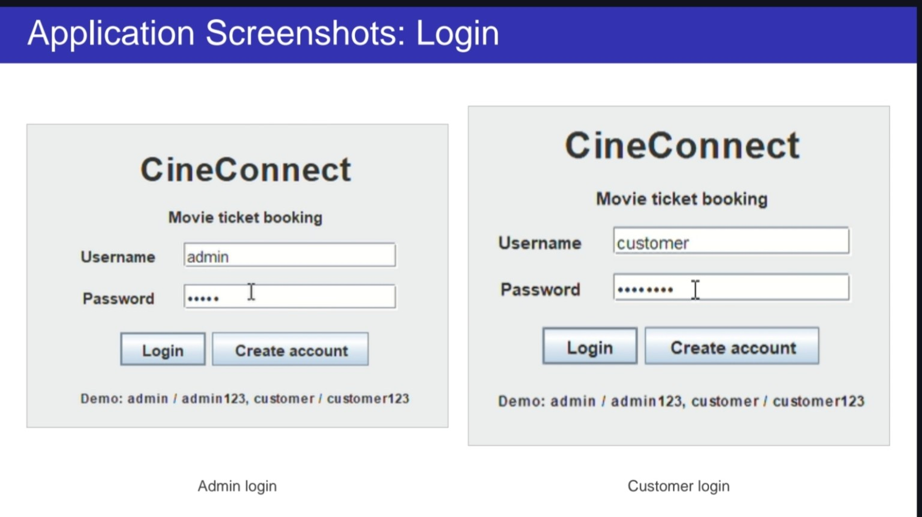
Figure 7.1: Login screens for administrator and customer
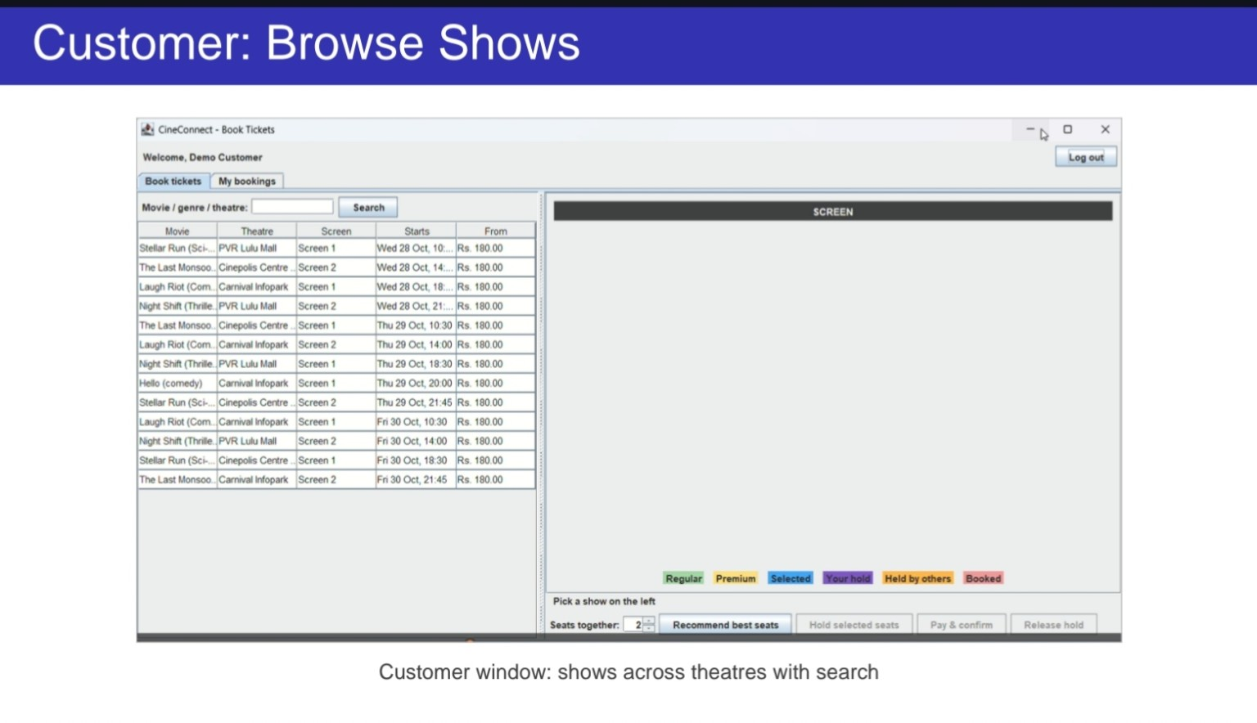
Figure 7.2: Customer window showing available shows across theatres
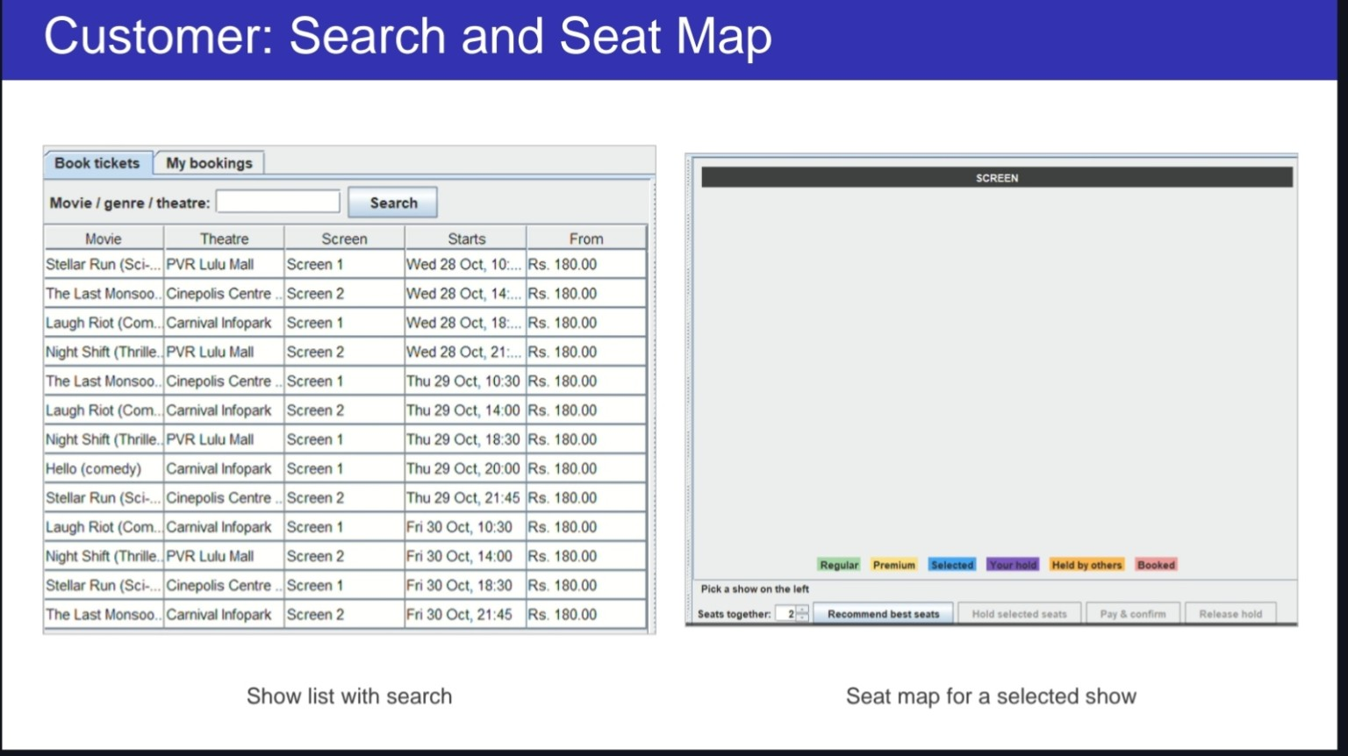
Figure 7.3: Customer show search and seat map
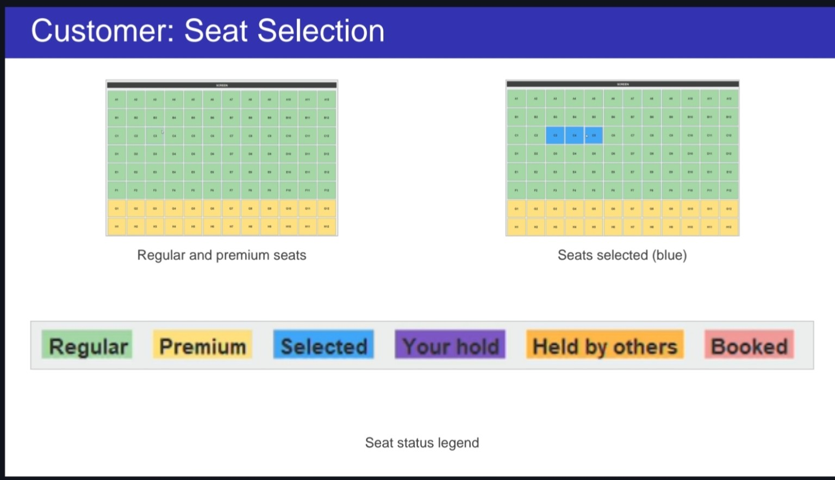
Figure 7.4: Seat selection with regular, premium and selected seat status
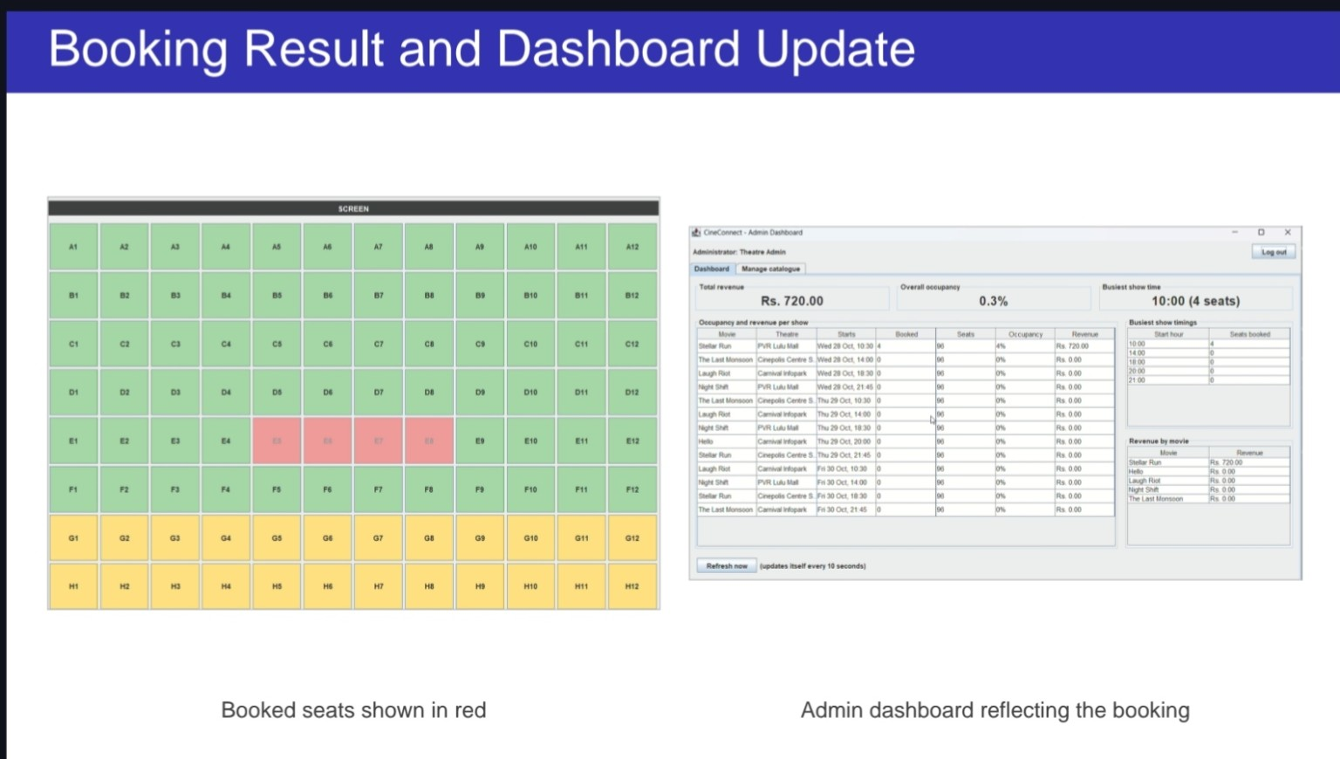
Figure 7.5: Booking result and corresponding admin dashboard update
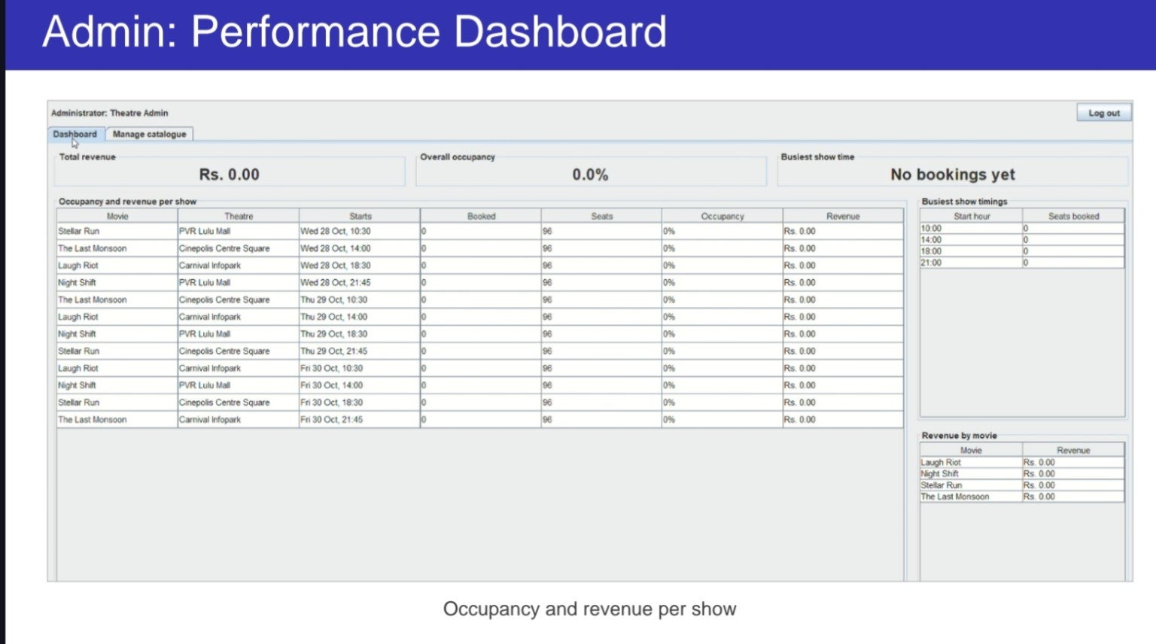
Figure 7.6: Administrator performance dashboard
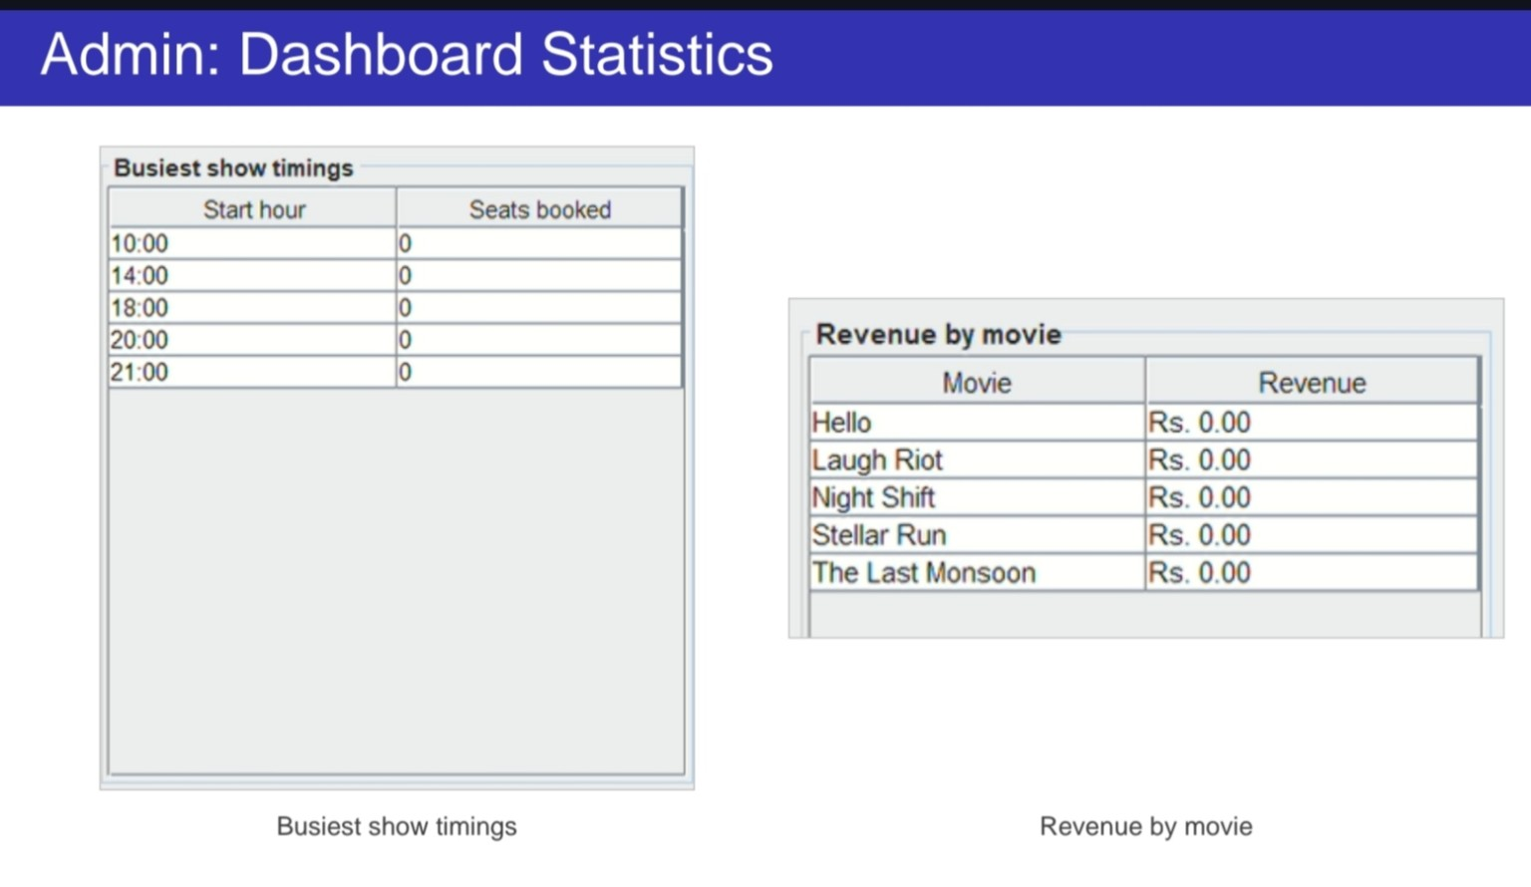
Figure 7.7: Dashboard statistics showing busiest show timings and revenue by movie
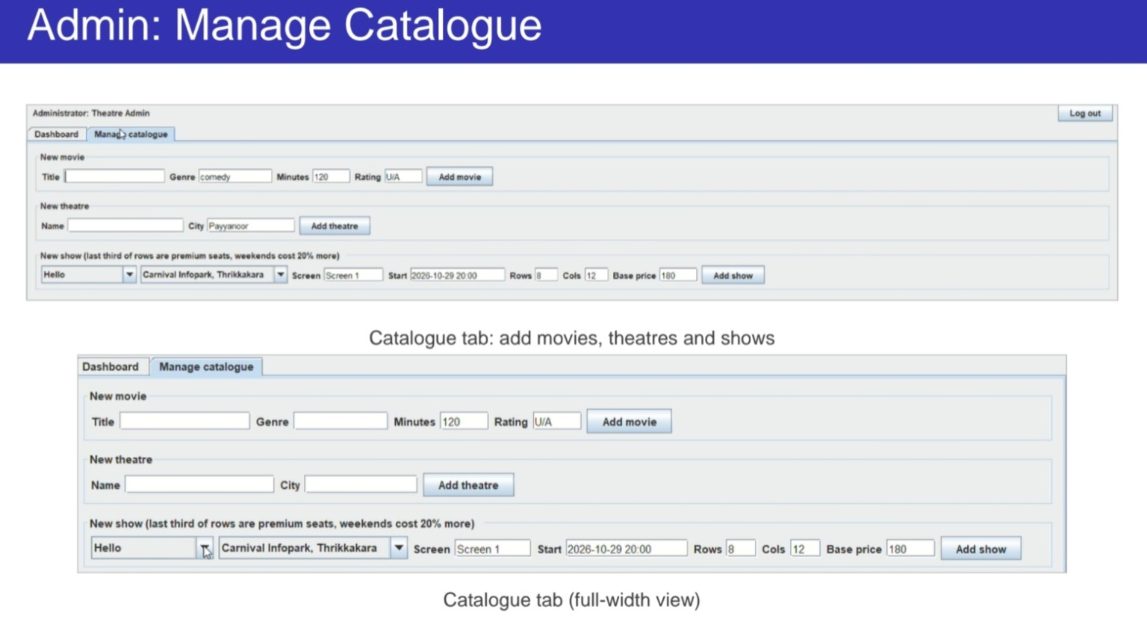
Figure 7.8: Manage catalogue screen for adding movies, theatres and shows

Chapter 8: Results
CineConnect was implemented and tested on a local installation with the demo dataset. The results below come from the final automated test run and from the screenshots in Chapter 7.

8.1 Functional Results
- Customers can register, log in, search shows, select seats, ask for the best seats, hold them and confirm the booking.
- Customers can view their history and cancel bookings before the show starts, which frees the seats.
- Admins can add movies, theatres and shows, and seats are generated automatically with correct pricing.
- The dashboard shows total revenue, overall occupancy, an occupancy and revenue table, the busiest show timings and revenue by movie, and it updates every ten seconds or on Refresh.

8.2 Concurrency and Data Consistency
- The automated concurrency test in which 40 threads competed for the same seat (C5) ended with exactly one successful booking and 39 rejected attempts (SeatAlreadyBookedException). A second test in which 10 customers booked 10 different seats at the same time succeeded for all of them.
- Hold expiry was verified with a simulated clock: a held seat stayed blocked at 119 seconds, became available at 121 seconds and could then be held by another customer, and paying after the expiry was rejected with HoldExpiredException.
- Booking and cancellation are single transactions: a multi-seat hold in which one seat was already taken left none of the seats held, and cancelling a booking made its seats bookable again and removed it from the revenue figures.

8.3 Test Case Results
All 21 automated tests passed in the final build: 4 unit tests, 15 integration tests and 2 concurrency tests (0 failures, 0 errors, 0 skipped, about 9 seconds in total). The automated tests run on an H2 database in MySQL compatibility mode, and the application was run on MySQL Server for the system test. The end-to-end system test was carried out manually through the screens, and its results are the screenshots in Chapter 7.

8.4 Observations
- Seat holding: a seat held by one customer is shown as held to the others and becomes available again when the hold is released or expires. Open seat maps update immediately for changes made inside the application and within five seconds for changes made by another copy of the application.
- Atomicity: because booking and cancellation are single transactions, the bookings, booking seats and seat statuses always agree with one another.
- Pricing: premium rows and weekend shows are priced automatically when a show is created, so the administrator enters only one base price.
- Reports: cancelled bookings are excluded from revenue and occupancy, so the dashboard shows only confirmed sales.

Chapter 9: Conclusion
The CineConnect project delivers a working desktop application that automates movie ticket booking with Java, Swing and MySQL. Its main achievement is a reliable seat reservation mechanism: an atomic conditional update for temporary holds, a two-minute timer with automatic release, and all-or-nothing database transactions for booking and cancellation. Together these prevent double booking and keep the data consistent.
The project applies object-oriented principles in a practical setting. Abstract classes, inheritance, polymorphism, interfaces, custom exceptions and multithreading are used throughout, together with the Singleton, Factory, Strategy and Observer patterns. The layered structure (ui, service, db) keeps SQL out of the screens, which makes the code easier to maintain and extend. The team also learned collaborative development, with each member owning specific classes and a shared Git workflow.
Working on CineConnect also gave the team practical experience that goes beyond coding. Students learned to design a database with keys and relationships, to write safe SQL with prepared statements, to reason about concurrent users, to separate an application into layers, and to apply design patterns for a reason rather than for show. Splitting the work so that each member owned specific classes, and merging it through a single Git maintainer, taught the importance of clear interfaces between parts written by different people.
The structure of the application was chosen so that it can be extended step by step. A real payment gateway, new pricing or seat-recommendation strategies, new listeners and editing screens can each be added by implementing an interface or adding a service method, without rewriting the rest of the application.

Chapter 10: Future Scope
- Real payment gateway: replace the simulated payment with UPI, card or wallet integration.
- Web and mobile versions: allow booking from anywhere with notifications.
- Edit and delete for movies and shows: complete the administrator’s catalogue management.
- E-tickets and refunds: generate a printable e-ticket for each booking, record payments and refund them when a booking is cancelled.
- Screen management: custom seat layouts for each screen, and editing or deleting theatres.
- Stronger security: role checks inside the service layer as well as in the screens, and encrypted storage of the database credentials.
- Connection pooling: reuse database connections for better performance.
- Advanced analytics: revenue per day or per theatre, charts and export of reports.
- Offers and loyalty: discounts, coupons and reward points.

References
- Oracle, “Java Platform, Standard Edition Documentation,” https://docs.oracle.com/en/java/.
- Oracle, “Java Swing Tutorial,” https://docs.oracle.com/javase/tutorial/uiswing/.
- Oracle Corporation, “MySQL 8.0 Reference Manual,” https://dev.mysql.com/doc/refman/8.0/en/.
- Oracle, “JDBC API Documentation,” https://docs.oracle.com/javase/8/docs/technotes/guides/jdbc/.
- JetBrains, “IntelliJ IDEA Documentation,” https://www.jetbrains.com/idea/documentation/.
- E. Gamma, R. Helm, R. Johnson and J. Vlissides, Design Patterns: Elements of Reusable Object-Oriented Software, Addison-Wesley, 1994.
- R. Elmasri and S. B. Navathe, Fundamentals of Database Systems, 7th ed., Pearson, 2015.
- I. Sommerville, Software Engineering, 10th ed., Pearson, 2015.
- B. Goetz et al., Java Concurrency in Practice, Addison-Wesley, 2006.

