

Version 20.1.0



Table of Contents

1. Summary 3

1.1 Company Overview 3

1.2 Integration Overview 3

1.3 Feature List 3

2. Component Overview 4

2.1 Functional Overview 4

2.2 Use Cases 4

2.3 Compatibility 4

2.4 Limitations/Constraints 4

2.5 Privacy, Payment 5

3. Integration Guide 5

3.1 Adding the cartridge in SFCC UX Studio 5

3.2 Business Manager Setup and Configuration 5

3.2.1 Activating the cartridges in Business Manager 5

3.2.2 Enable Cartridge Module 6

3.2.3 Importing Metadata 6

3.2.4 Type Extensions 7

3.2.5 Define the Open Commerce API settings 8

3.2.6 External Interfaces 9

4. Operation, Maintenance 9

4.1 Data Storage 9

4.2 Logs 10

4.3 Availability 10

4.4 Support 11

5. User Guide 11

5.1 Roles, Responsibilities 11

5.2 TextMaster account setup on Salesforce Commerce Cloud 11

5.2.1 API setup 11

5.2.2 Attribute setup 13

5.2.3 Language Mapping 14

5.2.4 Jobs setting 14

6. Testing 14

6.1 Send content for translation 15

6.2 Follow up translation projects in Business Manager 17

6.3 Import the translated content 18

6.4 Note on Project AutoLaunch 18

7. Storefront Functionality 18

8. Known Issues 19

9. Release History 19

# Summary

## Company Overview

[TextMaster](https://www.textmaster.com/) offers dedicated ecommerce translation services that enable businesses to easily expand their international reach. By combining advanced cloud translation technologies with a network of verified expert translators in over 50 languages, TextMaster is redefining how businesses handle translation. More than 10,000 companies, in 110 countries trust TextMaster to optimize their translation workflow including leading brands like LVMH, Kenzo, The Kooples and Foot Locker.

Our philosophy: building a global translation platform that simplifies workflows while making translators even more productive. Our core technology includes Memento™, the first real-time, cloud-based translation memory that is combined with advanced post-edited machine translation, which can reduce translation costs up to 80%.

The TextMaster cartridge on Salesforce Commerce Cloud gives you access to TextMaster’s verified translator network and technology, all in one place.

## Integration Overview

**Easily set up with minimal technical support, the TextMaster Cartridge allows you to manage and synchronize your translations within the Salesforce Cloud Commerce admin panel.**

Once installed, you can instantly connect to your TextMaster account and upload the content you want to translate on the TextMaster translation management platform. Before launching a translation project, you can receive a quote including a translation memory analysis to know the exact cost of your project. Once your translators have completed the jobs, translations are instantly available and ready to be published on your website. You can also get a real-time update on your project status, see the history of completed projects and either approve a translation or ask for revisions

## Feature List

* Certified Commerce Cloud Integration
* One-click export and import of catalog content
* All content types (product, categories, content assets) and attributes handled
* Batch or manual selection
* Advanced dynamic search and filtering of items
* Automatic change detection
* Automated quote capability with live translation memory analysis
* Seamless and automatic translation workflow
* Dashboard for real-time status tracking
* Assign to your team of preferred translators

# Component Overview

## Functional Overview

This cartridge export data to/from Salesforce Commerce Cloud to/fromTextMaster’s translation management platform. There two systems primarily sync the following types of data:

* Product
* Category
* Content asset

The cartridge has the following three parts:

* A Business Manager extension that provides a custom UI to search your content. It enables you to filter and select the data that will be sent for translation.
* An SFRA controllers cartridge to have storefront Job triggering logics for SFRA sites.
* Jobs that are responsible for exporting / importing the data.
* A storefront-based controller that works as an API to trigger these jobs externally by TextMaster.

## Use Cases

* Translation of all/some of the products assigned to a catalog.
* Translation of all/some of the content assets assigned to a website.
* Translation of all/some of the categories assigned to a catalog.

## Compatibility

The TextMaster cartridge is compatible with the latest Storefront Reference Architecture version, currently 4.4.1 and 19.10 compatibility mode.

## Limitations/Constraints

The new translation UI, provided as part of the Business Manager extension, can be resource extensive if all products are searched.

## Privacy, Payment

This cartridge does not access any credit card information. It imports/exports catalog, category and content asset data.

# Integration Guide

## Adding the cartridge in SFCC UX Studio

To upload the cartridges into the SFCC server, you first need to add the cartridges in SFCC UX Studio. In order to do this, follow these instructions.

1. In UX Studio, select in the menu File > Import.
2. In the import dialog, select General > Existing Projects in the workspace and click on 'Next'.
3. Ensure 'Select archive file' is selected and select the compressed cartridge file by clicking on the 'Browse' button.
4. Click on 'Finish' button to import the cartridges.
5. Studio will now ask you if you want to link the cartridge to your active DigitalServer connection. Click on yes or manually link the cartridge to your server by checking the project under project references in the server connection properties.

## Business Manager Setup and Configuration

For the TextMaster integration to work, the following needs to be configured in the Business manager.

### Activating the cartridges in Business Manager

Before the TextMaster functionality can become available to Site, the cartridges have to be added to the cartridge path of the Site. In order to do this, follow the following instructions:

1. Log into Business Manager.
2. Navigate to Administration > Sites > Manage Sites.
3. Click on the site name and on the next page go to the 'Settings' tab.
4. In the 'Cartridges' input field add int_textmaster_sfra:int_textmaster_core in front of base cartridge path.
5. Click on 'Apply' button.
6. To activate the cartridge for the Sandbox/Development/Production instances repeat steps 4 and 5 after selecting the appropriate instance from the 'Instance Type' dropdown menu.
7. Go to 'Manage the Business Manager site'.
8. In the Cartridges input field add bm_textmaster:int_textmaster_core.
9. Click on 'Apply' button.

### Enable Cartridge Module

To enable Cartridge module,

1. Go to Administration > Organization > Roles & Permissions.
2. Click on "Administrator" and click on "Business Manager Modules" tab.
3. In Select Context dialog, check your site ID checkbox and click on "Apply" button.
4. Find ‘TextMaster’ and check the checkbox to enable it.
5. Click on “Update” button.

**NOTE: Master properties file -** The cartridge has only one properties file. The “textmaster.properties” file contains all the static values and API endpoints used in the cartridge.

### Importing Metadata

For the TextMaster integration to work, the following object structures (metadata) needs to be imported and configured in the Business manager. Follow the below steps:

1. In the cartridge bundle find **metadata/textmaster-meta-import** folder.
2. In the cartridge bundle, inside **metadata** folder compress textmaster-meta-import folder to generate **textmaster -meta-import.zip** file.
3. Go to Business Manager Menu > Administration > Site Development > Site Import & Export
4. Under Import: Upload Archive: Ensure that the radio button with label **Local** is enabled (Else click on the radio button to enable it)
5. Click on Choose File input field, select the bolt-meta-import.zip file from open dialog box and click on upload button
6. After finishing the upload, from the Archives list click the radio button corresponding to **textmaster-meta-import.zip** and click on Import button
7. Click on OK button of the confirmation box asking “Are you sure that you want to import the selected archive?”

### Type Extensions

* **Custom site preference**

In Business Manager, navigate to Merchant Tools > Site Preferences > Custom Preferences. Custom site preference groups with the ID “TextMaster” is available.

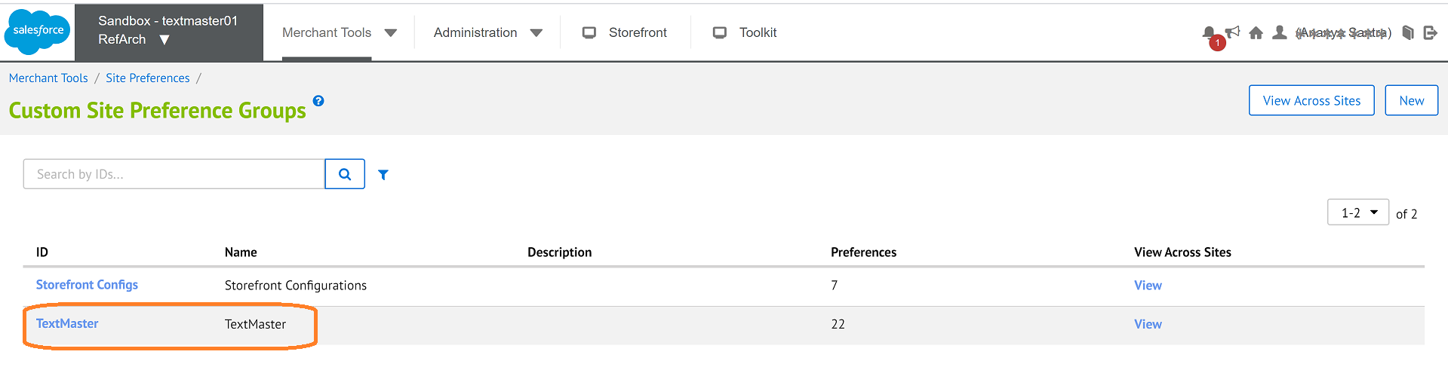

Please select it and edit the attributes according to your Bolt account data.

For each site, set the values for your site preferences.

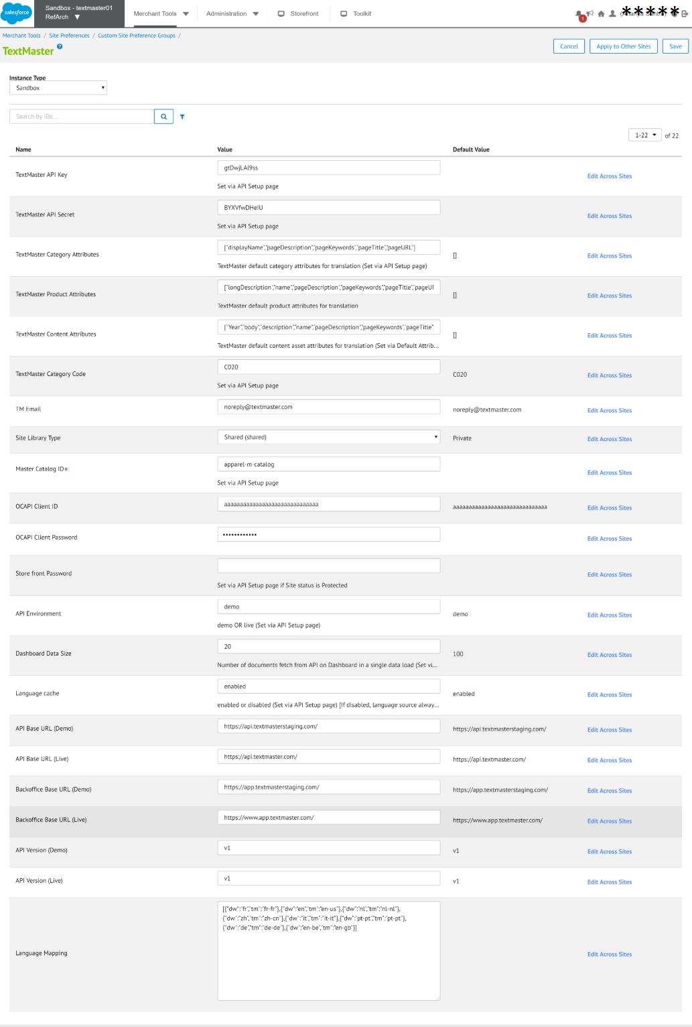

### *Define the Open Commerce API settings*

1. Go to Administration > Site Development > Open Commerce API Settings.
2. In ‘Select Type’ select "Data" in the dropdown list.
3. In ‘Select context’ select "Global (organization-wide)" in the dropdown list.
4. In the JSON content, ensure that the value for key "client_id" corresponds to your client ID in account.demandware.com
5. In the settings JSON content, inside "resources" array, add the following value:

**,{**

**"resource_id":"/jobs/*/executions",**

**"methods":["post"],**

**"read_attributes":"(**)",**

**"write_attributes":"(**)"**

**},**

**{**

**"resource_id":"/locale_info/locales",**

**"methods":["get"],**

**"read_attributes":"(**)",**

**"write_attributes":"(**)"**

**}**

Keep Client ID and Password for OCAPI in Site Preference.

### External Interfaces

No external interfaces are integrated with this cartridge.

# Operation, Maintenance

## Data Storage

This integration requires System Object Extension to store translated locale codes.

* **Product custom attribute**

1. TranslatedLanguages (String) – Store translated locale codes.

* **Category custom attribute**

1. TranslatedLanguages (String) – Store translated locale codes.

* **Catalog custom attribute**

1. TranslatedLanguages (String) – Store translated locale codes.

* **Custom Object**

This cartridge will create custom objects and store incoming parameters for the job triggering controllers. For Import job each new request will update the existing custom object instance instead of creating a new one. For Auto Launch job new custom object instance will be created for each project and then the Auto Launch API call triggers this object instance will be removed. This is to ensure any misuse of the functionality.

1. TMAutoLaunchDataHolder – Store data to trigger AutoLaunch job.
2. TMImportDataHolder – Store data to import translated data.
3. TMLanguageDataHolder – Store language details.
4. TextMasterProject – Store data to send quote.

## Logs

This integration introduces a few new custom logs:

**Textmaster Custom Log –** Such as the custom-textmaster-blade7-1.mon.demandware.net-0-appserver-20200221.log. This log file contains all errors related information in the int_textmaster_sfra, int_textmaster_core and bm_textmaster cartridges.

**Service communication Logs –** These logs contain every request and response to the TextMaster API endpoint. To enable these logs, go to Administration > Operations > Services > textmaster.http and check the Communication Log Enabled preference. Examples of service communication log –

service-textmaster-blade7-1.mon.demandware.net-0-appserver-20200221.log

All log files are located in the Logs folder (under Administration > Site Development > Development Setup > Logs).

## Availability

If the TextMaster service is unavailable, the user will not be able to get TextMaster language list and cannot send data for translation. The service availability can be tracked in SFCC using the Service Status in the Commerce Cloud Business Manager. (Go to Administration > Operations > Service Status > textmaster.http)

In case the cartridge doesn’t work appropriately, please contact [integrations@textmaster.com](mailto:integrations@textmaster.com).

## Support

The TextMaster team will be available for any suggestions or support request at [integrations@textmaster.com](mailto:integrations@textmaster.com)

# User Guide

## Roles, Responsibilities

The cartridge setup will typically be done by a SFCC developer.

TextMaster will provide API key and API secret key for be used with the API.

## TextMaster account setup on Salesforce Commerce Cloud

### *API setup*

You will find the API setup page in **Merchant Tools > TextMaster > API Setup**

This API setup page allows you to connect Salesforce Commerce Cloud to your TextMaster account. You can either use:

* The Live API environment: you will use it to connect Salesforce to your TextMaster account in order to launch your translation projects.
* The Demo API environment: you will use it to connect Salesforce to a test account or ‘TextMaster sandbox account’ in order to test the translation workflow before starting your first translation project. **If you want to use this Demo API environment, please contact us at** [**integrations@textmaster.com**](mailto:integrations@textmaster.com)**.** **We will help you create your testing account and guide you through the tests.**

Once you’ve selected the right API environment, you can enter your API key and API secret. You will find them on your TextMaster account as seen below:

If you don’t have an account yet, please create your own on <https://www.textmaster.com> or select “Enter TextMaster” as seen in the screenshot below. You will be redirected to TextMaster’s website in a new tab.

After entering your API key and secret, choose the appropriate Store Category and select your Master Catalog ID. It’s a mandatory field on this page: The Product Import feature needs it as there is no Demandware Script API to get it. No need to keep Storefront catalog ID here.

**Other values in the API Setup:**

Dashboard Data Size: It’s the number of items that will be displayed in the Translation Dashboard in order of creation. To fetch all the items you sent for translation, you have the option of loading more with the button 'Load more data' which is placed at last page of Dashboard need to be pressed.

Language list cache: On Export page cartridge calls two TextMaster APIs related to Languages (to fetch TextMaster supported language list and list of Source to Target language abilities) which deal with bulk amount of data. If Language list cache settings is Enabled, cartridge will not call these two APIs in each page loads but will take the data from cache.

Store Front protection password: If the status of your site is 'Online (Protected)' then you may set the password here as you set for your site under Administration > Sites > Manage Sites > <siteID> - Site Status

### *Attribute setup*

This page allows you to preselect the attributes that should apply to translation by default. It will allow you to gain some time when creating your translation projects.

To set up default attributes

1. Go to Merchant Tools > TextMaster > Attribute Setup
2. Select Item Type.
3. Check the attributes.
4. Click on ‘Save’ button.

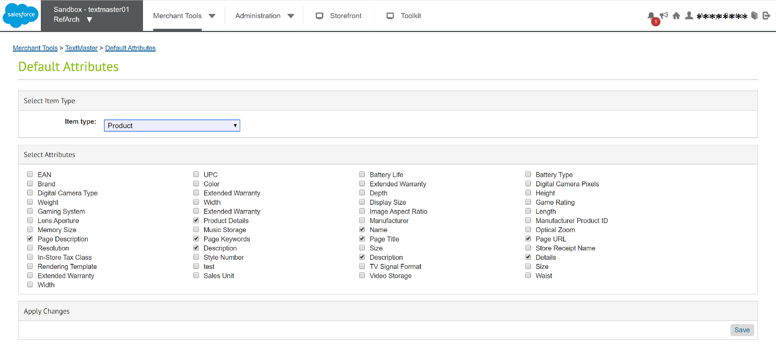

### *Language Mapping*

In order to be able to send content for translation from or to a given SFCC locale, add the locale in the list and configure it with a TextMaster language. When a locale is bolded, it means it is active on your storefront and it can be used as a source language.

To set up language mapping

1. Go to Merchant Tools > TextMaster > Language Mapping.
2. Click on ‘Add a language mapping’ button.
3. Select SFCC Language and TextMaster Language from selection drop down.
4. Click on ‘Save’ button.

### *Jobs setting*

The jobs need to be replicated for all the sites.

For example, the job **TextMasterAskForQuoteRefArch** is replicated so that the new job will have an ID with the format **TextMasterAskForQuote<siteID>**. If the site ID is XyZ, the new job will be "**TextMasterAskForQuoteXyZ**". Under the "Job Steps" for the job, the scope must be the site ID, say "XyZ" if site ID is XyZ and edit the Job Step id with siteId.

Follow the same steps for other jobs to replicate for all sites.

# Testing

Once the cartridge is installed and integrated based on instructions, please try to send content for translation.

Select a website, go to Merchant Tools and check if you can see the TextMaster Menu as seen below:

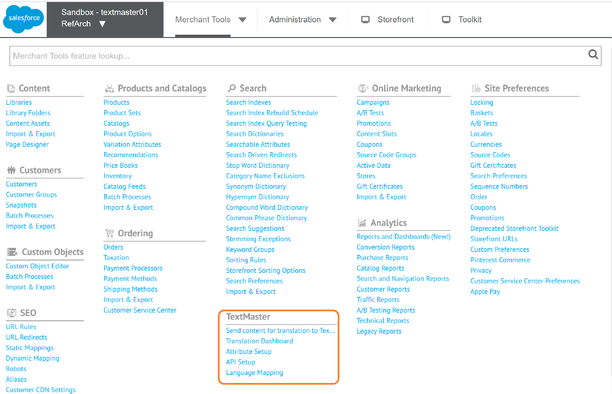

## Send content for translation

**Step 1:** **Select your translation content**

1. Select all the fields of your content search: content type, catalog, categories, source language, target language(s).
2. Launch your research
3. Select the content you want to send for translation. You can select up to 500 products. You can filter by ID, category, language(s), etc.
4. Select “Send to TextMaster”.

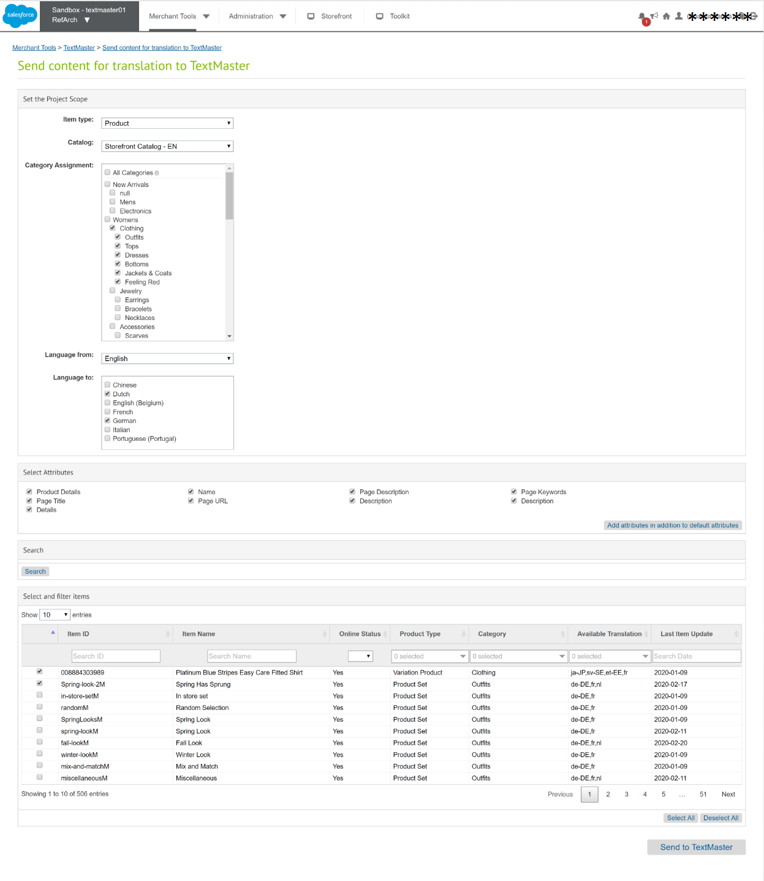

**Step 2: Select your translation templates**

1. Select the templates you’ve already created on TextMaster (for more information please contact the TextMaster team at [integrations@textmaster.com](mailto:integrations@textmaster.com)
2. Click on ‘Place Order’ button.

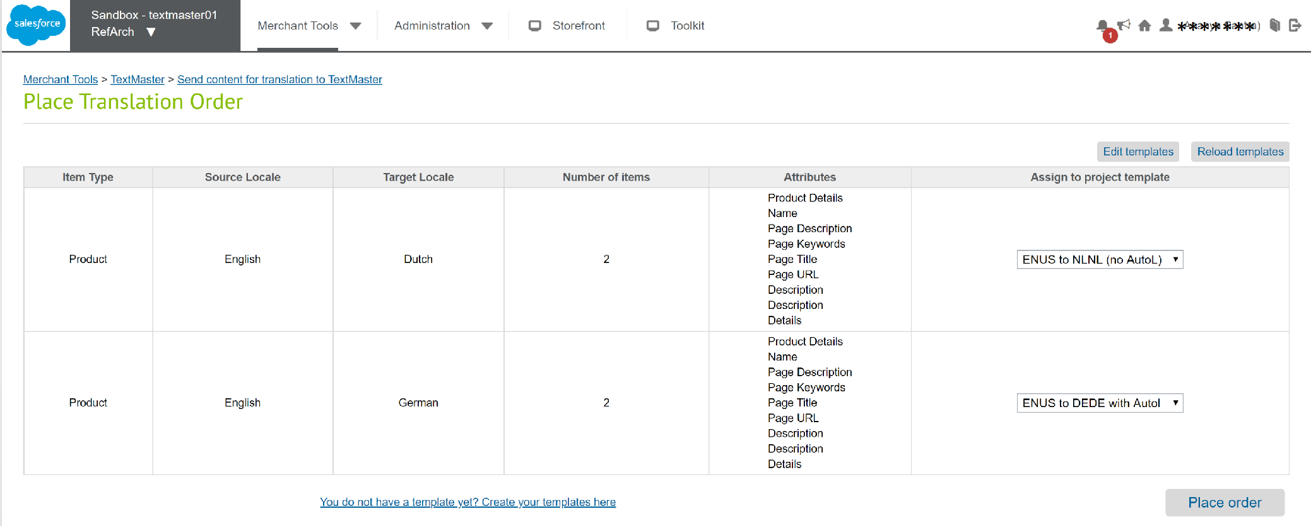

## Follow up translation projects in Business Manager

Find the documents you’ve sent to TextMaster in the Translation Dashboard that you will find in Merchant Tools > TextMaster > Translation Dashboard:

* In creation documents
* In progress documents
* In review documents
* Completed documents

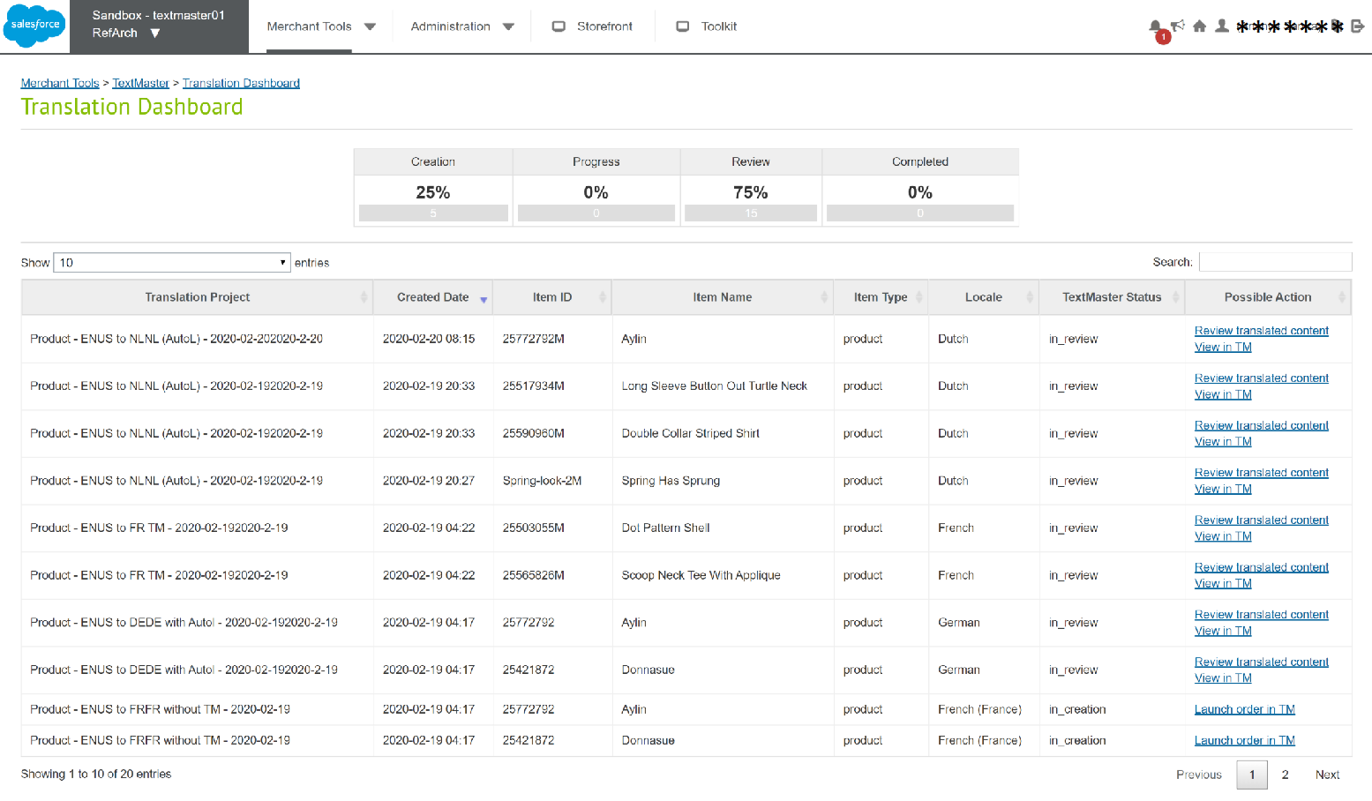

If you did not preselect the autolaunch option in your TextMaster API template, you can launch your project by clicking on “**View in TM**”.

## Import the translated content

As soon as the author finishes a translation, you can visualize the translation in context in your dashboard by selecting “**Review translated content**”.

Whenever the exported content is ready to be imported at TextMaster side, TextMaster backend will trigger the synchronizing URL and the import feature will be triggered. Merchant does not require to initiate the import feature. Synchronizing URL looks like as in following format:

***https://{sandbox_domain}/on/demandware.store/Sites-{SiteID}-Site/default/TMImport-Data?projectid={projectID}&documentid={documentID}***

If the storefront is protected with user name and password, in case of development or staging sandbox, merchant has to share the authentication credentials to TextMaster team so they can trigger the synchronizing URL including the login credentials as in following format:

***https://{login_user_name}:{login_password}@{sandbox_domain}/on/demandware.store/Sites-{SiteID}-Site/default/TMImport-Data?projectid={projectID}&documentid={documentID}***

## Note on Project AutoLaunch

If you choose a TextMaster template on Export UI which is Auto Launch enabled at TextMaster, then your project will be automatically launched by a Job (AutoLaunchTextMaster<siteID>).

But it may take some time to finish word counting of each documents in that project from TextMaster side. Whenever a document is finished its word count it will trigger a callback URL at SFCC sandbox to trigger the auto launch job. When all the Documents trigger its call back URLs then the job will be executed automatically to launch the project.

***https://{sandbox_domain}/on/demandware.store/Sites-{SiteID}-Site/default/TMAutoLaunch-Document?projectid={projectID}&documentid={documentID})***

But when there is huge traffic on callbacks, this single job is not auto triggered for all the projects. So we recommend to keep this AutoLaunchTextMaster<siteID> job to be scheduled to run on regular interval of time (say 1 hour) or manually triggered till all the projects those are supposed to be auto launched are getting auto launched.

# Storefront Functionality

There are a couple of storefront controllers that trigger backend jobs (Import and Auto Launch) as part of the cartridge. There are no customizations required to existing custom solutions. All the details are provided in the above section of External Interfaces.

# Known Issues

No known issues at the time.

# Release History

|  |  |  |
| --- | --- | --- |
| **Version** | **Date** | **Changes** |
|
| 20.1.0 | 05-Mar-2020 | Source Languages – Mapped languages  API Setup page – Clear cache button |
|
| 20.0.0 | 10-Jan-2020 | Language Mapping |
|
| 18.3.0 | 23-Jul-2019 | Source Languages - allowed languages  Target Languages - active languages |
|
| 18.2.0 | 26-Apr-2019 | Initial release |
|