|  |  |  |  |
| --- | --- | --- | --- |
|  | Document type : User Manual |  | |
|  | Protection class:  INTERNAL ☐ RESTRICTED ☐ CONFIDENTIAL ☐ | | Pages : |

**DECOUPLEUR USER MANUAL**

|  |
| --- |
| N° |
| REV. A PAGE 2 / x |

 **[PROTECTION CLASS]**

Short Title

**APPROVAL**

|  |  |  |  |  |  |  |  |
| --- | --- | --- | --- | --- | --- | --- | --- |
| REV | DATE | Version | Author | Checker | Modifications observations | Status | Approver |
| A | 26/01/2021 | 1.1 | Adrien DEBREUILLY et Nicola Bonichon |  |  | Start |  |
|  |  |  |  |  |  |  |  |
|  |  |  |  |  |  |  |  |
|  |  |  |  |  |  |  |  |
|  |  |  |  |  |  |  |  |
|  |  |  |  |  |  |  |  |

**REVISIONS**

|  |  |  |  |
| --- | --- | --- | --- |
| Rev. | Status | Paragraph | Scope of the revision |
| A | Start | All | First issue |
|  |  |  |  |
|  |  |  |  |

**SUMMARY**

Decoupler is a tool external to Dedale which is the EDVANCE cable list cutting tool. It is used to create Dedale Cable Lists with the appropriate template, from Cable List, Global Path, and Project Room List as inputs.  
The decoupleur also takes into account various corrections to the list of input cables, provided by other input documents, such as a pattern list for cables that would not be routed in project rooms.

**TABLE OF CONTENTS**

1. INPUTS

1.1 Cable List

1.2 Global Path

1.3 Decoupling Room list

1.4 Decoupling Pattern list

2. OUTPUT

2.1 Output

2.2 Output Folder

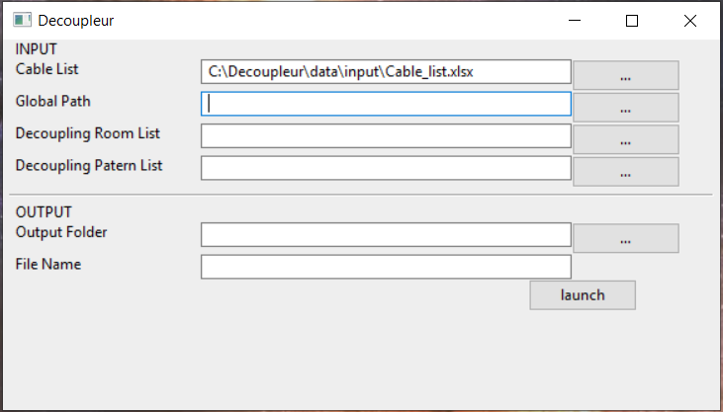

1. Inputs
   1. Cable List:

* This first file in input and the file of cable list,

This file “exl” must be format in “*file*.xlsx” and “*file*.xls”.

* 1. Global Path:
* This second file in input and the file of Global Path,

This file “exl” must be format in “*file*.xlsx” and “*file*.xls”.

* 1. Decoupling Room list:
* This third file in input and the file of the Room List target,

This file “csv” must be format in “*file*.csv”.

* 1. Decoupling Pattern list:
* This fourth file in input and the file of Patern List for the cables not routed

This file is only necessary in the need or the cables of the cable list are not routed and that you want to force them to place by an input and output path which will have to be put in the following format:

|  |  |  |  |  |  |
| --- | --- | --- | --- | --- | --- |
| ELECTRICAL TRAIN | VOLTAGE LEVEL | ROOM  ORINATING | ROOM  TERMINATING | ROOM  ORINATING  (Code) | ROOM  TERMINATING  (Code) |
| 1 ou | 1 ou | ?XX-* | ?XX-* | -XXX0000ZL- | -XXX0000ZL- |
| 2 ou | 2 ou | ?XXX* | ?XXX* |  |  |
| 3 ou | 3 ou | 0XXX* | ‘Chiffre’XXX* |  |  |
| 4 ou | 4 ou |  | ?XXX0000ZL- |  |  |
| * | 5 ou |  | ?XX-0000ZL- |  |  |
|  | * |  |  |  |  |

End this file has to be format “exl” must be format in “*file*.xlsx” and “*file*.xls”.

1. Output
   1. file output:

For this file he is choice the folder in which will be put the output file.

* 1. name file

and finally give the name of the output file after race.