# TODO VPMS ADDON

This is a nonextensive list of things that should be worked on in the vpms addon.

## Write Tests

No tests exist for this addon. At least the following tests should be implemented:

1. For each supported Diagram, check that the layer and its tools are available.
2. For each supported Diagram check styling. Are elements that should be greyed (conflicted) out really greyed out (conflicted)?
   1. Pre-exercise: Write a test that takes a DNode/DContainer/DEdge and checks that the node/edge/container has an expected color/line style/stroke/image.
   2. With that, we can write a test that finds elements named ‘included’, and checks if all other elements are greyed out.

## CDI diagrams:

* + ExchangeItems in disabled Interface should have gray label too.
  + Disabled ComponentPorts are scaled to the size of the original port
* 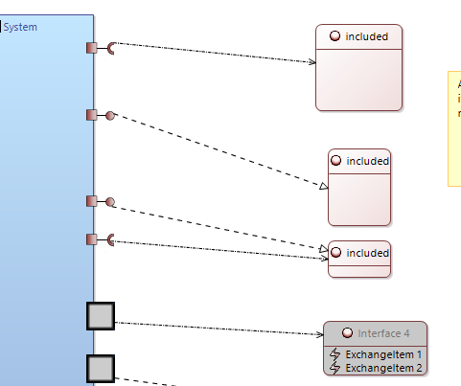

# Child configurations

* + IMO we should remove them. They are not exploited/used anywhere in the code, except on the diagrams:
    - Menu on diagrams

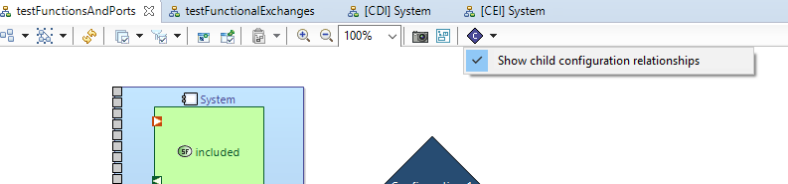

# Edge Styling

* Review Edge Styling for conflicting source/target configurations in combination with the ‘consistent inclusion’ preference

Currently edge styles are calculated by ‘merging’ their respective source/target styles, but I think that’s not correct.