1. Java:

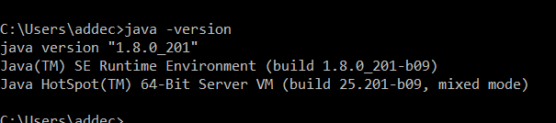

JavaC

Kattis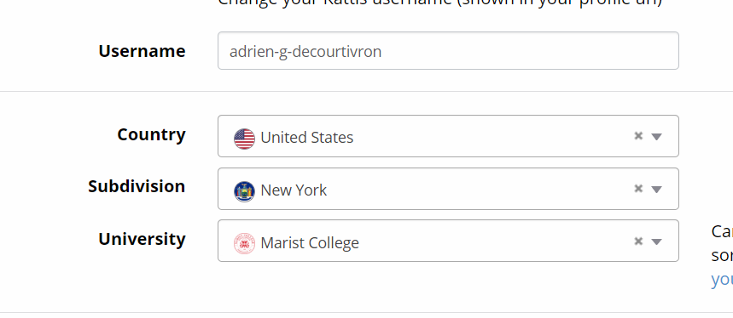

GitHub Acc:

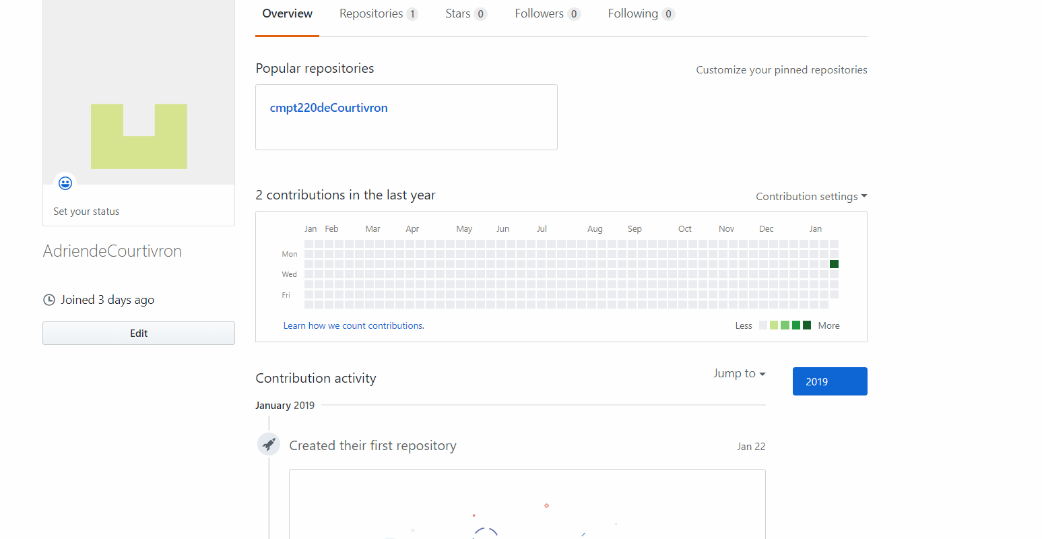

Github Repository:

https://github.com/AdriendeCourtivron/cmpt220deCourtivron