Upgrade report draft – Adrienne – 03/12/2018

|  |
| --- |
| **How does land-use change affect the functional diversity of vertebrate communities?**  **How do the ecological traits of terrestrial vertebrates influence their responses to land-use?** |

**Contents**

**Abbreviations**

LUCC: land-use and climate change

**Abstract**

**Introduction**

Anthropogenic activities are driving global biodiversity declines at unprecedented rates. Currently, habitat conversion and degradation – induced mainly by anthropogenic land-use change – are the primary causes of biodiversity loss (Pereira, Navarro and Martins, 2012; Newbold et al., 2015). Climate change is projected to be one of the biggest driver of biodiversity loss by 2070, matching or exceeding the deleterious impacts of land-use change on ecological communities (Newbold, 2018). Understanding how land-use and climate change (LUCC) act on biodiversity, separately and in combination, is key to project the future responses of species, and to consequently put into place efficient policies for biodiversity conservation. Furthermore, biodiversity losses affect ecosystem properties, and can adversely impact the delivery of ecosystem services (REF). Investigating if and how biodiversity decreases link to the loss of ecosystem functions is a key research area (Petchey and Gaston, 2006; Lefcheck *et al.*, 2015) and can help mitigate the impacts of anthropogenic activities on ecosystem processes and services.

It has now been established across diverse taxonomic groups that species traits mediate species responses to environmental changes, notably to LUCC (Newbold *et al.*, 2013; Pearson *et al.*, 2014; Pacifici *et al.*, 2017; Estrada *et al.*, 2018). McGill *et al.* (2006) defined traits as characteristics of organisms, measurable at the level of an individual across species. This definition can be broadened to include “ecological” traits, where species relation to their surrounding environment needs to be considered. Functional traits are those that particularly influence organismal fitness. Functional traits relate to species’ abilities to exploit their biotic and abiotic environment and as such, shape ecosystem processes. Functional traits underpin both species’ aptitudes to cope with environmental changes and their role in ecosystem functioning (Díaz *et al.*, 2013). Specifically, ‘response traits’ affect species responses to disturbances, while ‘effect traits’ shape ecosystem processes. Certain traits can act as both effect and response traits. Conceptually, these are particularly interesting for investigating the impact of environmental changes on ecosystem processes and services, as they provide a mechanistic understanding of how stressors affect both species’ responses and ecosystem processes (Luck *et al.*, 2012; Hevia *et al.*, 2017). Assessing the impacts of human activities on ecosystem functioning is increasingly important as pressures rise globally. Publications linking drivers of change and delivery of ecosystem services have increased exponentially since 2001 (Hevia *et al.*, 2017); nevertheless, how species traits influence their responses to land-use and climate change, and how this relates to the loss of important ecosystem functions, remains to be largely explored.

The aim of this PhD project is to investigate the effects of terrestrial vertebrate species’ traits on their responses to LUCC, at global scales. Specifically, my main goals are (1) to elucidate which traits are likely to put species at greater risk from land-use and climate change; (2) to investigate whether future biodiversity declines triggered by these anthropogenic threats are likely to disrupt important ecosystem functions. Unlike previous published studies, this work will investigate these questions at a global scale, and simultaneously across the four terrestrial vertebrate classes – amphibians, birds, reptiles and mammals.

This report synthetizes the work I have achieved throughout the first year. I start by briefly reviewing the literature to present the questions I have addressed in the context of the past and current ecological research. The second part exposes the work achieved so far. Finally, I present an outline of the questions that I plan to investigate in the upcoming years.

1. **Background**
   1. **Land-use and climate change, species traits and the functional composition of vertebrate communities**

Currently, terrestrial land-use change is the most important driver of biodiversity declines (Newbold *et al.*, 2015; Chaudhary and Kastner, 2016). With climate change projected to be catching up by 2070 (Newbold, 2018), it has become vital to understand how these threats will affect biodiversity, separately and in combination. By influencing species responses to environmental changes, response traits can provide a mechanistic understanding of how diverse threats shape ecological communities, an understanding particularly relevant for conservation policies.

There is now empirical evidence across taxonomic groups that species traits influence their responses to LUCC. For instance, response traits to LUCC have been identified in terrestrial plant (Díaz, Noy-Meir and Cabido, 2001), fungal (Koide et al 2013), invertebrate (Williams *et al.*, 2010; Hall *et al.*, 2019), and vertebrate assemblages (Table 1). Overall, these studies, conducted on different taxa and at different scales, tend to show that larger, longer-lived specialist species with a lower reproductive output are more likely to be impacted negatively by LUCC (Table 1). Nevertheless, it is important to point out that in some cases, contrasting results are found (REF); this highlights the fact that studies may be context-dependent, with contingent limitations.

As response traits determine whether a species is likely to be removed from a community due to the environmental filtering exerted by a pressure, changes in the distribution of trait values are expected in vertebrate communities that have faced LUCC. As such, some studies have documented changes in the trait composition of vertebrate communities that have faced climate change or alongside land-use gradients. Some studies summarise changes in the trait community composition using functional diversity indices (Flynn *et al.*, 2009), which describe the diversity and variation of trait values across organisms. Other studies document changes in the distribution of values for particular traits (Rapacciuolo *et al.*, 2017; La Sorte *et al.*, 2018), which can be seen as a particular use of functional diversity indices when only one trait is considered.

All these studies show that (1) anthropogenic LUCC is reshaping the functional composition of ecological assemblages, potentially disrupting important functions; (2) species sensitivity to LUCC depends on their traits. Nevertheless, despite this empirical evidence, there is still a need to refine our understanding of which traits significantly influence responses.As traits are commonly used to assess species vulnerability to threats or extinction risks (Pacifici *et al.*, 2015; Willis *et al.*, 2015; Bohm *et al.*, 2016), it is particularly important to be confident about how they act on species responses. The interest for trait-based approaches highlights their potential to inform conservation policies. Trend-based approaches require important field work effort to monitor species populations. Getting extensive information on all species population trends is virtually impossible. The appeal of trait-based approaches is that, by providing mechanistic insights, they diminish the amount of population information needed. If species’ responses to a threat consistently relate to certain traits, it is possible to generalise patterns across species for which data is less available (Verberk, van Noordwijk and Hildrew, 2013). Nevertheless, for several reasons that I now expose, how species traits influence their responses to LUCC remains unclear.

First, there is a lack of comprehensive understanding about which traits are important in shaping species responses to climate change. Wheatley *et al.* (2017) compared different published climate change vulnerability assessment frameworks, some of which trait-based, some trend-based, and some incorporating elements of both (hybrid). They found that the different frameworks, applied to the same set of species, did not yield consensual outputs and classified species inconsistently into different risk categories. Their work underlines that currently, trend-based vulnerability assessments perform better at identifying species at risks from climate change than trait-based approaches. This study highlights the current lack of unanimous understanding as to which traits to consider, and how, in vulnerability assessments. More broadly, their study stresses the need to clarify our understanding of how response traits to climate change act across different taxa. Wheatley *et al.* (2017)’s finding that there is no consensus across assessment frameworks might be explained by the fact that frameworks were initially designed and tested for a particular taxon – generally at the class level or lower ranks –, and do not hold when applied to other taxa. They nevertheless argue that frameworks should be universally applicable. Their findings put into question to our current ability to extrapolate the knowledge of response traits gathered for certain taxa to other taxonomic groups. To my knowledge, comparative studies looking at whether response traits to LUCC differ across taxonomic groups (at ranks higher than class), experiencing the same threat levels under similar conditions, are rare. The picture becomes even more complex when different studies find contradicting results within a taxon, such as was the case in some invertebrate species (larger body size having been found to influence species responses to land-use change both negatively (ref) and positively (ref)). The work by Bartomeus *et al.* (2018) further emphasises the idea that unless similar response traits to a threat are identified consistently across different systems and taxa, our ability to use traits as predictors of vulnerability or extinction risk remains limited. For these reasons, it is necessary to conduct comparative analyses across taxa, to identify response traits, verify whether they are conserved across species and whether they have the same importance in shaping responses across taxonomic groups and geographical areas.

Second, another difficulty when identifying response traits is that different threats can be acting on the studied ecological community, so that observed modifications stem from the interactions of diverse response traits (Gonzalez-Suarez, Gomez and Revilla, 2013). Response traits must be identified for a single threat while controlling for others, before investigating potential interacting effects. Nevertheless, this is difficult to achieve when using global empirical data. Moreover, the importance of response traits may vary geographically. To conclude, potential taxon-, threat- and geographical dependence of response traits to land-use or climate change makes it difficult to generalise patterns observed at local scales. This stresses the need to conduct global, cross-taxon studies to verify whether empirical evidence supports the generalisation of any response trait.

* 1. **Land-use and climate change, functional diversity and the disruption of ecosystem services**

Response traits allow to understand and predict how environmental pressures are likely to modify ecological assemblages (changes in species richness and abundance). These alterations can lead to modifications in functional diversity (the diversity and variability of traits in a community). Functional diversity indices are interesting for at least two reasons. First, they can inform on how disturbances affect trait community composition. Second, as functional traits relate to ecosystem functions, measures of functional diversity can relate to ecosystem functioning. I will develop these two points in more detail further down.

**1.2.1 Impact of land-use on the functional richness – species richness relationships**

Several indices have been developed in the recent years to estimate diverse components of functional diversity (Schleuter et al., 2010). Functional richness, functional divergence (or dispersion) and functional evenness constitute cornerstone metrics that each quantify different aspects of functional diversity. Functional richness is conceptually similar to species richness but aims at reflecting the number of individual functional units across species in a community rather than quantifying the number of singular species. In other words, functional richness metrics estimate the amount of niche space that species occupy (Carmona et al., 2016). Several metrics have been developed to quantity functional richness alone (Legras, Loiseau and Gaertner, 2018). In this work, I use the dendrogram-based index developed by Petchey and Gaston (2002).

*Other indices.*

Functional richness indices have been shown to covary with species richness. In experimental studies and natural communities, a positive correlation between these metrics is often found (Petchey and Gaston, 2002). For this reason, examining whether functional richness indices inform on community dynamics differently from species richness is an important question to elucidate. Indeed, if species richness is as informative as functional richness, the latter is not worth measuring: species richness is then a proxy for functional richness. This question was at the heart of the study conducted by Cadotte, Carscadden and Mirotchnick (2011). By reviewing the literature, they found that the relationship between functional richness and species richness is context dependent, and that the shape of the relationship notably depends on the amount of functional redundancy in the community. In communities with a high degree of functional redundancy, functions can be maintained despite species loss. On the other hand, the loss or gain of functionally diverse species can lead to marked variations in functional richness (Figure).

As anthropogenic land-uses globally negatively impact local species richness (Newbold *et al.*, 2015), decreases in functional richness of local ecological communities are likely to take place, particularly in communities with low functional redundancy. Flynn *et al.* (2009) showed that the functional richness of bird, mammal and plant communities located in the Western hemisphere decreased because of agricultural intensification. In other words, land-use intensification impacted the functional richness-species richness relationship. Mayfield et al. (2010) also showed that the relationship between species richness and functional richness could be affected in different ways by human land-uses. They proposed diverse mechanisms building upon community assembly processes to explain how land-uses may influence species richness – functional richness trajectories.

The recent development of functional indices, synthesising the diversity of functions in a community, reflects the importance of understanding how anthropogenic pressures will modify ecosystem processes. In the field of biodiversity-ecosystem functioning relationships, it is now well established that higher species diversity is associated with higher ecosystem productivity and stability, better use of limiting resource, as well as better resistance to biological invasions (Tilman at al 2014). I now explore the links between functional diversity indices and ecosystem functioning in more details.

**1.2.2 Functional diversity and ecosystem functioning**

Early experiments investigating the relationships between functional composition and ecosystem functioning classified species in broad functional groups; ecosystem functioning was measured in various ways, depending on the studied system. A higher number of functional groups was correlated to better ecosystem performance in several studies (References). The development of other functional diversity indices allowed for comparisons of diverse predictors of ecosystem functioning. Studies conducted on various systems showed that functional richness performed better at predicting ecosystem functioning than taxonomic richness (Díaz and Cabido, 2001; Flynn *et al.*, 2011; Abonyi, Horváth and Ptacnik, 2018). All these results led to functional diversity emerging as an important predictor of ecosystem functioning.

The use of functional diversity indices as predictors of ecosystem functioning raises two important points. First, ecosystem functioning should be clearly defined within the study system. Second, the functional traits, from which the processes of interest originate, should be identified and included in the calculation of functional indices. Cadotte, Carscadden and Mirotchnick (2011) underline that point; they highlight that traits should be linked with ecosystem functions for functional diversity indices to be useful. In other words, only relevant effect traits should be considered. Moreover, a larger number of effect traits can lead to higher functional differentiation among species, with potential impacts on the metrics. A careful selection of effect traits is thus vital for functional diversity indices to be informative on ecosystem processes.

If effect traits inform on ecosystem processes, response traits mediate species responses to environmental change. As such, the link between environmental pressures and ecosystem functioning is conceptually realised with both response and effect traits. Specifically, the purpose of the “response-effect” framework is to is to understand how environmental changes alter ecosystem functioning by disentangling traits that render species sensitive to a threat (response traits) from traits that impact functioning (effect traits). A modification in the composition of a community could affect ecosystem functioning in two ways: functions can be lost directly through the removal of species, triggered by response traits (nestedness); and indirectly, functions can be affected by the resulting shift in composition (turnover). The response-effect framework relies on identified response traits to provide a mechanistic understanding of how disturbances modify the trait composition of communities, and how these changes link to alterations in functioning. Changes in functioning are driven by changes in the effect trait composition (effect traits being those that are involved in ecosystem functioning). When response and effect traits are similar, changes in ecosystem functioning are predicted by changes in species composition (direct effects of species loss or gain). In that case, overall functional diversity correlates with ecosystem functioning. However, when response and effect traits are decoupled, changes in functioning are defined by the shifts in effect trait composition only (indirect effects of species loss or gain).

The application of the response-effect framework to real animal communities has been hindered by several issues (Luck et al 2012; Bartomeus). Luck et al. (2012) proposed a new trait-based framework to link environmental changes to ecosystem services in vertebrate species. They underline the need to develop robust and broadly applicable methods*.*

Efforts to link drivers of change and ecosystem function responses have been disparate across taxonomic groups, with a major focus on plants and invertebrates in the past years. Indeed, Hevia et al. (2017) showed in a metanalysis that most studies investigating how species traits mediate the impacts of stressors on ecosystem processes focused on plants and invertebrates, such that there is an existing taxonomic bias in this area. Vegetation and invertebrates both represented an approximate 40% of the sampled papers, whereas only 17% were dedicated to vertebrates. Their metanalysis also shed light on other biases, such as the spatial scale of the papers, with most sampled studies being conducted at local or national scales. Therefore, although terrestrial vertebrates have a major cultural, economic and functional importance (Hocking, Babbitt and Hocking, 2014; Whelan, Şekercioğlu and Wenny, 2015; Ratto et al., 2018) and are over-represented in the overall biodiversity literature compared to other taxa (Titley, Snaddon and Turner, 2017), how disturbances affect the services they provide has not been extensively explored compared to other taxa. Efforts to understand ecosystem services provided by terrestrial vertebrates have mainly focused on pest control, seed dispersion, and protein provisioning. To understand how anthropogenic pressures may impact ecosystem processes sustained by vertebrate communities at global scales, there is a need to assess whether LUCC significantly affects the functional diversity of vertebrate communities, and, in particular, the effect trait composition; and to verify whether effect trait composition predicts ecosystem processes, and is, as such, a relevant measure for conservation and mitigation.

To conclude, examining how vertebrate species traits influence their responses to LUCC is the first step to (1) elucidate which traits are likely to put species at greater risk, and find out whether it is possible to generalise patterns across vertebrate species; (2) investigate whether future biodiversity declines triggered by these anthropogenic changes are likely to disrupt important ecosystem functions. The work I have achieved so far focuses on land-use change at global scales and aims at investigating the questions detailed below.

* **Questions and hypotheses to be readapted and updated according to what I have achieved**
  1. **Research questions and hypotheses**

As underlined in the introduction, functional traits can provide a mechanistic understanding of how environmental stressors affect both ecological assemblages and ecosystem processes. As such, they convey information most relevant to conservation policies. According to Hekkala and Roberge (2018), global assessments of how land-use change affects vertebrate functional diversity may have been limited so far by the amount of ecological information required to conduct such analyses, notably by the availability of species traits. There exist published databases of species traits (e.g. Pantheria: Jones *et al.*, 2009; Myhrvold *et al.*, 2015; AmphiBIO: Oliveira *et al.*, 2017) but despite these collation efforts, some taxa remain under sampled (Newbold, *unpublished manuscript*). For this project, I will collate information on vertebrate traits prior to conducting any analysis, and I will impute missing values to increase the trait coverage across species.

Because obtaining longitudinal information on compositional changes can be difficult, the effects of land-use change throughout this project will be studied using a ‘space for time’ substitution, whereby a spatial gradient is used as a proxy for temporal dynamics (De Palma *et al.*, 2018). As such, the following analyses will build upon the PREDICTS database, a large collated dataset of species occurrence and abundance around the world across different land-uses (Hudson *et al.*, 2014, 2017). To date, this database constitutes the most comprehensive global collection of biodiversity samples across different land-uses.It comprises 666 studies,each of which recording the occurrence and/or abundance of species at different sites. Each site is classified into a land-use category; the land-use gradient encompasses primary vegetation, secondary vegetation, plantation forest, cropland, pasture and urban. Primary vegetation refers to native vegetation undisturbed since its development under current climatic conditions. Where primary vegetation was destroyed (either by human actions or natural causes), recovering vegetation forms are referred to as secondary vegetation. Plantation forest, cropland and pasture refer to agricultural areas (crop trees grown for human purposes, biofuels and herbaceous crops, and areas grazed by livestock). Using this database, I aim to address the two following questions.

**A.1. How does land-use affect the functional diversity of vertebrate communities?**

In this part of the project, I aim to investigate how land-use change affects the trait composition of vertebrate communities. I hypothesise that by reducing local habitat heterogeneity, human-dominated land-uses promote functional homogenisation, whereby the similarity in trait composition across assemblages increases through the loss of certain functions (**H.1**). This hypothesis relies on the idea that strong environmental filtering will disproportionately remove certain functional types. To test this hypothesis, I will use various indices of functional diversity and functional β-diversity.

First, I will calculate three cornerstone indices of functional diversity. For each PREDICTS site, I will measure functional richness, functional divergence and functional evenness. Specifically:

* I expect functional richness to decrease in more human-dominated land-uses, with habitat filtering reducing the amount of utilised trait space. Because functional richness is often correlated with species richness, I will investigate whether, for a given species richness SR, the functional richness FR is predicted to be lower for sites under higher human land-use intensity (**H.1.1**). Assuming SR and FR are positively correlated for each land-use type, I expect the slope of the relationship to be lower for sites located within human-dominated land-uses (**H.1.1**).
* I also expect functional evenness and divergence to decrease along the land-use gradient, with more species within human-dominated land-use communities over-utilising central parts of the functional trait space (**H.1.2**). I expect to observe a convergence of trait values.

I will test whether observed effects are consistent across vertebrate classes and contingent on the geographical area. These indices will give insights into how land-use alters overall functional diversity across PREDICTS studies. Nevertheless, such indices are insensitive to changes in functional composition. Indeed, a decrease in functional richness could be explained by either functional turnover, whereby certain trait values are replaced by others, or by functional nestedness, whereby certain functions are lost (Figure 1.). Functional diversity indices will therefore not be informative as to what drives changes in functional composition.

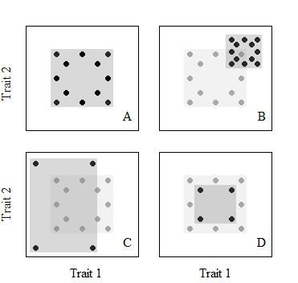

Figure 1: Representation of volume-based functional richness in a bi-dimensional trait space. Species are placed in the trait space according to their trait values. (A) Functional richness is represented here by the minimum surface encompassing all species. Decreases in functional richness can be due do to: (B) functional turnover; (D) nestedness. Increases in functional richness can happen despite loss of functions (C). See Mayfield et al. (2010) for mechanisms driving different species richness – functional richness trajectories.

To further investigate this point, I will use functional β-diversity measures. β-diversity indices allow to quantify the dissimilarity in functional composition across sites. Baselga (2010) developed an approach to partition total dissimilarity into one component accounting for functional turnover (potentially stemming from species turnover) and one component accounting for functional nestedness (potential loss or gain of functional trait space relating to the loss or gain of species). I expect nestedness to drive decreases in functional richness (**H.1.3**) with certain functions being disproportionally lost.

**+ do volume-based and dendrogram-based indices of functional richness correlate?**

**A.2. Which vertebrate traits confer sensitivity to land-use change?**

The goal of this second analysis is to identify response traits to land-use change in vertebrate species. As opposed to the previous analysis, species traits will be used as explanatory variables. I aim to assess the individual effects of traits or trait combinations on species’ sensitivity to land-use. Specifically, I hypothesize that, with increasing intensity of human land-use:

* Species with longer generation length are impacted more negatively than shorter-lived species. The rationale behind this hypothesis is that declining population trends in human-dominated land-uses could be compensated more rapidly in species with shorter generation lengths.
* Larger species (higher body masses) are impacted more negatively than smaller species. Indeed, a general ecological rule states that species with higher body masses have lower local population densities (Santini, Isaac and Ficetola, 2018); I hypothesize that higher body masses compromise species’ persistence in disturbed habitats as those species will tend to be rarer than species with lower body mass (but see Vermeij and Grosberg (2018)).
* Species with larger litter or clutch sizes respond less negatively to land-use change than species with smaller litter or clutch sizes. Indeed, declining population trends in human-dominated land-uses could be compensated more in species with larger reproductive outputs.
* Specialist species, that have stricter requirements either in their habitat preferences or in their diet, are impacted more negatively than generalists. Indeed, such species could be more dependent on particular food sources or habitats that may be impacted negatively by land-use changes.
* Narrowly distributed species are impacted more negatively than species with larger range sizes. I hypothesize that narrowly distributed species have stricter habitat requirements and lower breadth in the dimensions of their fundamental niche, making them less able to cope with altered habitats than more broadly distributed species.

**Tables and figures**

Table 1: *Some* *empirical evidence for response traits to LUCC in terrestrial vertebrates: studied taxa and scale of the studies.*

|  |  |  |  |  |
| --- | --- | --- | --- | --- |
| **Pressure** | **Reference** | **Broad trait category** | **Taxa** | **Study scale** |
| Land-use change | Newbold *et al.*, 2013 | Generation length  Body mass  Migratory activity  Diet  Habitat specialisation | Birds | Pan-tropical forests |
| Urbanisation | La Sorte *et al.*, 2018 | Body mass  Range size  Diet  Foraging strata  Habitat specialisation | Birds | Global (58 cities) |
| Habitat modification | Nowakowski *et al.*, 2017 | Range size  Habitat specialisation | Amphibians | Global |
| Land-use change | Flynn *et al.*, 2009 | Litter size  Diet | Mammals | America |
| Body mass  Diet  Foraging habits | Birds |
| Human pressure history (human population density and land-conversion history) | Rapacciuolo *et al.*, 2017 | Body mass | Tetrapods | Western Hemisphere |
| Land-use change | Tinoco, Santillán and Graham, 2018 | Body mass | Hummingbirds | Andes Mountains, southern Ecuador |
| Habitat loss | Pauline E. Quesnelle, Lindsay and Fahrig, 2014 | Reproductive rate | Wetland vertebrates | Global |
| Climate change – range filling proxy | Estrada *et al.*, 2018 | Habitat specialisation  Sexual maturity age | Mammals | Europe |
| Habitat specialisation  Reproductive output | Birds |
| Climate change | Pacifici *et al.*, 2017 | Habitat specialisation  Diet | Mammals | Global |
| Dispersal abilities  Generation length  Altitudinal range (non-breeding) | Birds |
| Climate change | Pearson *et al.*, 2014 | Occupied area  Generation length  Operational thermal range | Amphibians  Reptiles | USA |
| Climate change | Mccain and King, 2014 | Body mass  Activity time | Mammals | North America |
| Climate change | Schloss, Nunez and Lawler, 2012 | Dispersal ability | Mammals | Western Hemisphere |

**Draft draft**

**Methods**

Fr_dendro

This metric summarises the total distance across all functional units in a community. Higher distances reflect higher functional richness. The calculation of dendrogram-based richness requires an initial species×trait matrix, from which pairwise dissimilarities are computed into a distance matrix. This distance matrix is clustered, producing a functional dendrogram, where each tip represents a functional unit. The total branch length of the functional dendrogram is calculated and constitutes the functional richness index.

**Results**

**Discussion**

**Outline for the next analyses**

***Effect of vertebrate species’ traits on their responses to climate change***

*It is now widely acknowledged that species traits influence their responses to climate change.*

*Vulnerability assessments that consider species traits*

*Species distribution models: classically, the use of fundamental niches prevailed but now other factors are considered such as dispersal abilities and species movement, biotic interactions...*

*But still not clear which traits are the most important to consider / which traits play a major role in determining species sensitivity.*

***Linking drivers of change to ecosystem functions through effect and response traits***

*Functional diversity is often presented as an important predictor of ecosystem functioning. Although this idea is intuitively appealing, it is still unclear how functional diversity indices relate to ecosystem functioning* *(Hatfield, Harrison and Banks-Leite, 2018). One reason may be that functional diversity indices can incorporate traits that are only response traits, and not necessarily effect traits (though response traits can influence ecosystem services by modifying species abundance). Thus, identifying effect traits is the first step to understand how vertebrates influence ecosystem functions.*

*Ex: importance of body size for ecosystem functioning?*

*example Body mass – in food webs: Gravel et al 2016 Proceedings; Allhoff and Drossel 2016*

*Overall, lack of empirical evidence. Plus functional redundancy*

***Methods***

1. ***Trait compilation and imputations of missing trait values***

*Using published and unpublished data, I collated trait information across vertebrate classes. The coverage for each trait was increased by imputing missing trait values using several approaches.*

*Trait choice.*

*Tackling taxonomic synonymy. I gathered the data from different datasets in which similar species could appear under diverse binomial names, either accepted or synonymic. When merging datasets by binomial names, taxonomic redundancy for a species could create pseudoreplicates, inflating the amount of missing trait values and overall falsely increasing the total number of species. Using the rredlist and taxize packages in R (ref), I extracted recorded synonyms for all species entered under their accepted scientific name and extracted the accepted names for all species entered under a synonymic name. Information was queried from the IUCN Red List as well as ITIS. Manual checks and entries were applied when species were either entered under a vernacular name or when queried information was not available. Taxonomy across datasets was then normalised by replacing synonyms by accepted scientific names. Overall, this solution was not optimal as errors are likely to have occurred, notably when species were entered at the level of subspecies. Nevertheless, this effectively participated in reducing the amount of unique species across datasets.*

*Compiling trait information across species.*

*Compiling continuous traits: body mass, litter or clutch size, generation length, habitat breadth*

*Habitat breadth: calculation from IUCN habitat files.*

*In addition, species range sizes were extracted from IUCN range maps.*

*Compiling categorical traits*

*Imputing missing trait values.*

*Comparisons between phylopars and missForest*

*To account for phylogenetic relationships among species, phylogenetic eigenvectors will be included as predictors in random forest imputations. I will determine and include the number of eigenvectors that minimise the normalised mean root square error of imputations. Phylogenetic eigenvectors will be extracted from phylogenies using the PVR package in R* *(Santos, 2018).*

*Comparison between two methods for continuous traits: missForest VS phylogenetic imputations.*

***NB:*** *the trait compilation did not consider intraspecific variability. This is important to underline, as intraspecific variability in trait values can play important roles in shaping the responses of individuals to a threat (Gonzalez-Suarez and Revilla 2013).*

1. ***Question A.1: How does land-use affect the functional diversity of vertebrate communities?***

*The trait composition of each PREDICTS sites for which vertebrate species were sampled will be summarised with different measures of functional diversity.*

*The impact of land-use on these measures will be studied using mixed effect models, with land-use as a fixed effect and study identity as a random effect.*

* *Disentangling species richness and functional richness: methodology developed by Flynn 2009: given a species richness at a site, resample, calculate FR, 1000 times (or more…) to produce a distribution of expected FR under than species richness. Null expectation. Then see if the actual value of FR differs from null expectations.*
* *Indices: Jaccard and Sorensen indices: both nestedness and turnover*
* *Simpson index of dissimilarity: accounts for turnover*
* *Balsega 2010: proposed a method for partitioning total dissimilarity into 2 components accounting for the dissimilarity derived solely from turnover and the dissimilarity derived from nestedness.*
* *Betapart package in R*

***A.2. Which vertebrate traits confer sensitivity to land-use change?***

*The effects of species traits on their responses to land-use will be investigated using mixed effect models. Following the two-stage approach employed in* *Newbold et al. (2014), the occurrence of species will be modelled using generalised linear mixed-effect models with a binomial error distribution. Given species presence, species abundance will be modelled using mixed effect models. Species categorical traits will be included in each stage as fixed effects. Continuous traits will be incorporated in the analysis as having linear or quadratic effects on the parameters (following* *Newbold et al. (2014)). Study identity will be added as a random effect in the models to account for differences in study design.*

*NB:*

*Reptile studies: Todd et al, Berriozabal-Islas et al, Mendenhall et al 2014*

*Amphibian studies: Almeida-Gomes and Rocha 2015; Trimble and Van Aarde 2014*

*Assessing phylogenetic signal in traits*

*Revell et al 2008*

*High phylogenetic signal reflects a high degree of phylogenetic trait conservatism, where closely related species tend to share similar trait values, due to their common evolutionary history.*

*The phylogenetic signal in traits was assessed using Pagel’s lambda (λ). λ is estimated under the assumption of a pure Brownian motion of evolution, and usually takes values between 0 and 1. It is a scaling component that takes the value needed to transform the observed covariance matrix of species traits to the covariance matrix estimated under BM. Estimated values of λ close to 1 do not affect the covariance matrix much, meaning that traits are likely to follow a pure Brownian motion of evolution, where trait values follow a random walk along the branches of a tree (variance in the distribution of trait values being proportional to the branch lengths). In that case, closely related species are expected to share more similar trait values than non-closely related species.*

*For continuous and categorical traits respectively, λ was estimated using the functions fitContinuous and fitDiscrete in R (from the geiger package). + confidence intervals*

*B. Future research questions*

*B.1. Which vertebrate traits confer sensitivity to climate change?Are they the same as response traits to land-use change?*

*B.2. Projecting species responses under different scenarios*

*B.3. Linking species declines to loss of ecosystem functioning*

Plenty of studies have investigated how land-use change impacts biodiversity at various spatial scales, many of which using species richness or abundance as response variables, metrics that can be insensitive to compositional changes (Hekkala and Roberge, 2018; Hillebrand *et al.*, 2018).

**Results**

**How is functional richness affected by land-use?**

* **Dendrogram-based functional richness calculated across PREDICTS sites**. Included traits: Generation length; Body mass; Litter or clutch size; Trophic level; Habitat breadth (calculated from IUCN).
* Method: species x traits => Gower distance matrix => Cluster dendrogram with best method (method for with correlation between cophenetic distance and initial distances highest) => branch length summed for species in each site. Were excluded: studies for which there was only one species in the community (species richness of 1**) + FR=0**
* Results: excluding sites for which species richness was one; not calculated (NA); sites for which predominant land-use was unknown.

|  |  |  |  |  |
| --- | --- | --- | --- | --- |
| **Predominant land-use** | **Number of sites** | | | |
| **Total** | ***Minimal use*** | ***Light use*** | ***Intense use*** |
| Primary vegetation | 2411 | *1039* | *902* | *312* |
| Mature secondary vegetation | 161 | *39* | *65* | *0* |
| Intermediate secondary vegetation | 341 | *157* | *97* | *22* |
| Young secondary vegetation | 485 | *177* | *44* | *182* |
| Plantation forest | 1093 | *250* | *664* | *131* |
| Pasture | 728 | *46* | *164* | *11* |
| Cropland | 804 | *138* | *57* | *137* |
| Urban | 264 | *95* | *133* | *35* |

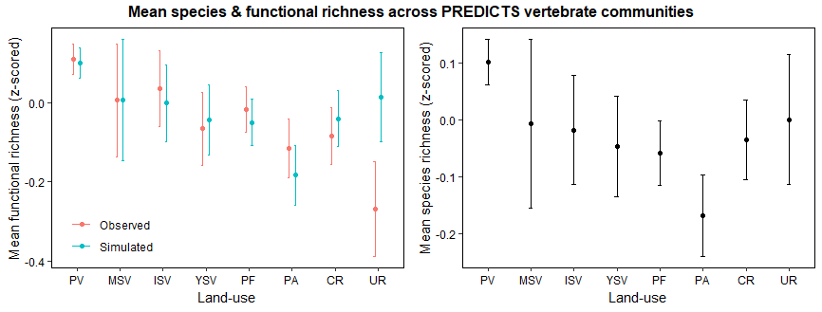

**Is functional diversity lower than expected across PREDICTS sites?**

* Disentangle decreases in functional richness from decreases in species richness
* **Simulation approach:** for each PREDICTS sites, simulating a null distribution of functional richness values by sampling randomly in the studies species pool to create 1000 simulated communities. For each site, the species richness of the simulated communities is the empirical species richness.

Results: after removing sites for which species richness is 1 and removing sites for which species richness and functional richness were NA: 6287 sites within 179 studies

**Results without use intensity: % of sites for which empirical functional richness is significantly lower, no different or significantly higher than expectations**

|  |  |  |  |
| --- | --- | --- | --- |
| **Predominant land-use** | **Lower** | **Expected** | **Higher** |
| Primary vegetation | 47.3 | 6.9 | 45.7 |
| Mature secondary vegetation | 44.1 | 6.2 | 49.7 |
| Intermediate secondary vegetation | 51.9 | 3.5 | 44.6 |
| Young secondary vegetation | 56.5 | 5.6 | 37.9 |
| Plantation forest | 55.5 | 5.9 | 38.6 |
| Pasture | 60.3 | 2.7 | 37.0 |
| Cropland | 60.3 | 2.9 | 36.8 |
| Urban | 50.8 | 1.5 | 47.7 |

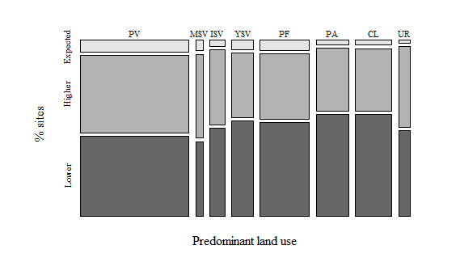

Are the proportions of expected values independent from land-use categories? Chi-square test of independence to test the null hypothesis that the expectations of FR are independent from land-use categories.

The proportions of expected values are not independent from land-use (Pearson’s chi-square test of independence: X2=103.57; p-value=9.8e-16). Hence knowing the level of land-use change does help predict FD expectations.

NB: Land-use X use intensity also not independent from FD expectations (X2=241.28; p-value<2.2e-16).

**Disentangling the effect of species richness versus land-use on functional diversity indices**

**Is there a correlation between dendrogram-based and volume based functional richness?**

***Dropping volume-based functional richness from the analysis?***

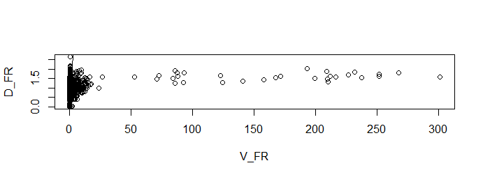

**Relationships between FD indices and species richness**

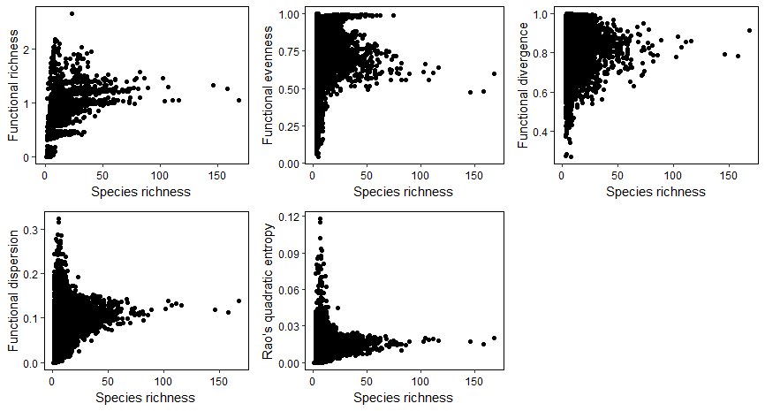

**How are the indices impacted by land-use?**

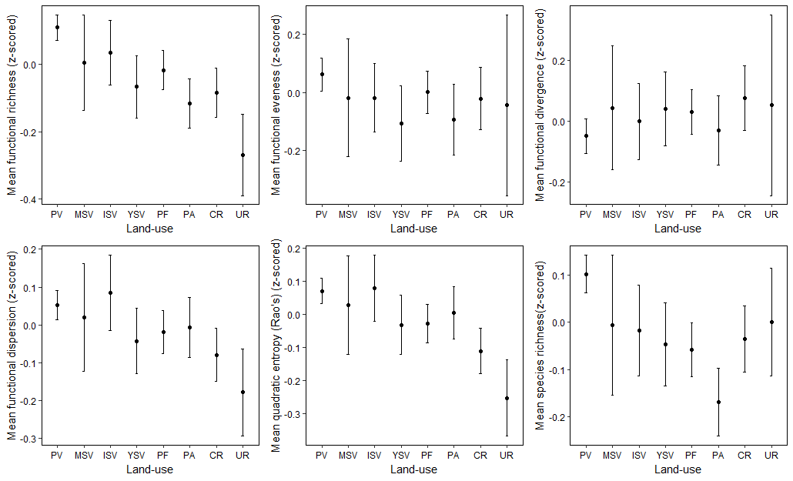

**How does land-use affect the species-richness-functional diversity indices relationship?**

Mixed effect models

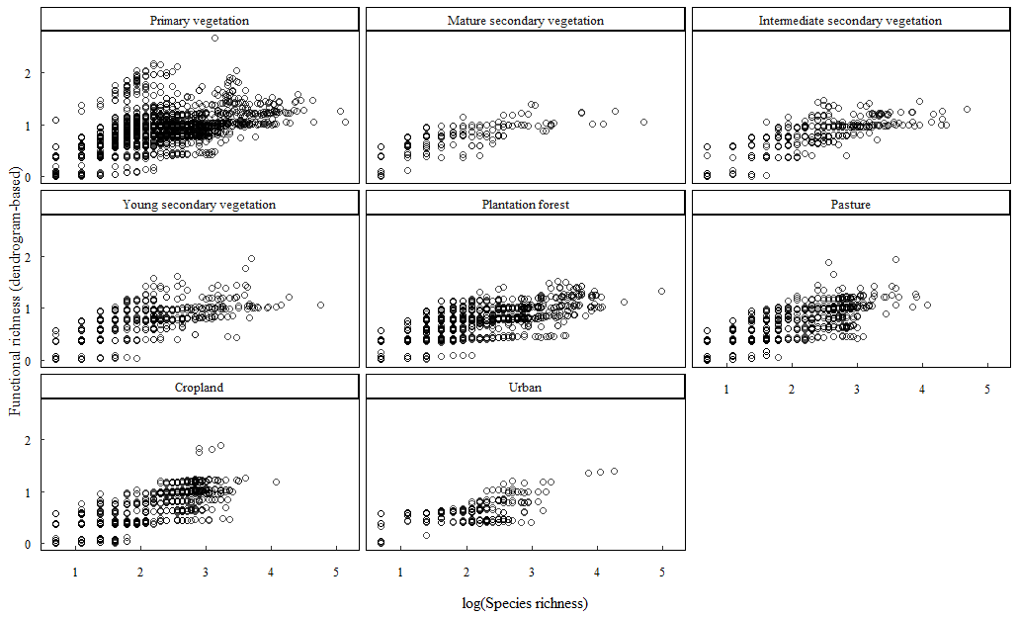

**Model without use intensity and with secondary vegetation pooled together**

* **getting rid of sites where SR=1 (FD=0)**

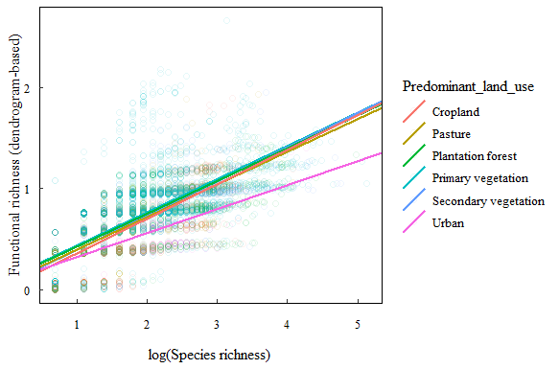

* **keeping the sites where SR=1**

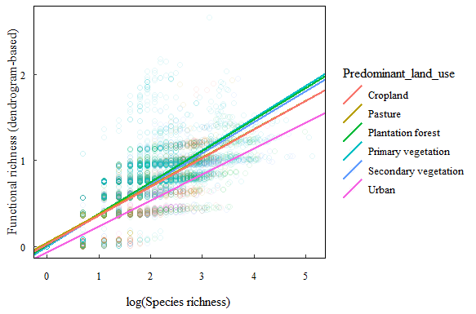

**Plotting predictions with confidence intervals ?**

**References**

Abonyi, A., Horváth, Z. and Ptacnik, R. (2018) ‘Functional richness outperforms taxonomic richness in predicting ecosystem functioning in natural phytoplankton communities’, *Freshwater Biology*. doi: 10.1111/fwb.13051.

Bartomeus, I. *et al.* (2018) ‘On the inconsistency of pollinator species traits for predicting either response to land-use change or functional contribution’, *Oikos*. doi: 10.1111/oik.04507.

Baselga, A. (2010) ‘Partitioning the turnover and nestedness components of beta diversity’, *Global Ecology and Biogeography*. doi: 10.1111/j.1466-8238.2009.00490.x.

Biswas, S. R. and Mallik, A. U. (2011) ‘Species diversity and functional diversity relationship varies with disturbance intensity’, *Ecosphere*. doi: 10.1890/ES10-00206.1.

Bohm, M. *et al.* (2016) ‘Hot and bothered: Using trait-based approaches to assess climate change vulnerability in reptiles’, *Biological Conservation*. doi: 10.1016/j.biocon.2016.06.002.

Cadotte, M. W., Carscadden, K. and Mirotchnick, N. (2011) ‘Beyond species: Functional diversity and the maintenance of ecological processes and services’, *Journal of Applied Ecology*. doi: 10.1111/j.1365-2664.2011.02048.x.

Carmona, C. P. *et al.* (2016) ‘Traits Without Borders: Integrating Functional Diversity Across Scales’, *Trends in Ecology and Evolution*, pp. 382–394. doi: 10.1016/j.tree.2016.02.003.

Chaudhary, A. and Kastner, T. (2016) ‘Land use biodiversity impacts embodied in international food trade’, *Global Environmental Change*. doi: 10.1016/j.gloenvcha.2016.03.013.

Díaz, S. *et al.* (2013) ‘Functional traits, the phylogeny of function, and ecosystem service vulnerability’, *Ecology and Evolution*. doi: 10.1002/ece3.601.

Díaz, S. and Cabido, M. (2001) ‘Vive la différence: Plant functional diversity matters to ecosystem processes’, *Trends in Ecology and Evolution*. doi: 10.1016/S0169-5347(01)02283-2.

Díaz, S., Noy-Meir, I. and Cabido, M. (2001) ‘Can grazing response of herbaceous plants be predicted from simple vegetative traits?’, *Journal of Applied Ecology*. doi: 10.1046/j.1365-2664.2001.00635.x.

Estrada, A. *et al.* (2018) ‘Equipped to cope with climate change: traits associated with range filling across European taxa’, *Ecography*. doi: 10.1111/ecog.02968.

Flynn, D. F. B. *et al.* (2009) ‘Loss of functional diversity under land use intensification across multiple taxa’, *Ecology Letters*, 12(1), pp. 22–33. doi: 10.1111/j.1461-0248.2008.01255.x.

Flynn, D. F. B. *et al.* (2011) ‘Functional and phylogenetic diversity as predictors of biodiversity- Ecosystem-function relationships’, *Ecology*. doi: 10.1890/10-1245.1.

Gonzalez-Suarez, M., Gomez, A. and Revilla, E. (2013) ‘Which intrinsic traits predict vulnerability to extinction depends on the actual threatening processes’, *Ecosphere*. doi: 10.1890/ES12-00380.1.

Hall, M. A. *et al.* (2019) ‘The response of wild bees to tree cover and rural land use is mediated by species’ traits’, *Biological Conservation*. Elsevier, 231(August 2018), pp. 1–12. doi: 10.1016/j.biocon.2018.12.032.

Hatfield, J. H., Harrison, M. L. K. and Banks-Leite, C. (2018) ‘Functional Diversity Metrics: How They Are Affected by Landscape Change and How They Represent Ecosystem Functioning in the Tropics’, *Current Landscape Ecology Reports*. doi: 10.1007/s40823-018-0032-x.

Hekkala, A. M. and Roberge, J. M. (2018) ‘The use of response measures in meta-analyses of land-use impacts on ecological communities: a review and the way forward’, *Biodiversity and Conservation*. Springer Netherlands, 27(11), pp. 1–17. doi: 10.1007/s10531-018-1583-1.

Hevia, V. *et al.* (2017) ‘Trait-based approaches to analyze links between the drivers of change and ecosystem services: Synthesizing existing evidence and future challenges’, *Ecology and Evolution*. doi: 10.1002/ece3.2692.

Hillebrand, H. *et al.* (2018) ‘Biodiversity change is uncoupled from species richness trends: Consequences for conservation and monitoring’, *Journal of Applied Ecology*. doi: 10.1111/1365-2664.12959.

Hocking, D. J., Babbitt, K. J. and Hocking, D. J. (2014) ‘Amphibian contributions to ecosystem services’, *Herpetological Conservation and Biology*. doi: 10.1016/S1607-551X(09)70215-3.

Hudson, L. N. *et al.* (2014) ‘The PREDICTS database: A global database of how local terrestrial biodiversity responds to human impacts’, *Ecology and Evolution*. doi: 10.1002/ece3.1303.

Hudson, L. N. *et al.* (2017) ‘The database of the PREDICTS (Projecting Responses of Ecological Diversity In Changing Terrestrial Systems) project’, *Ecology and Evolution*. doi: 10.1002/ece3.2579.

Jones, K. E. *et al.* (2009) ‘PanTHERIA: a species-level database of life history, ecology, and geography of extant and recently extinct mammals’, *Ecology*. doi: 10.1890/08-1494.1.

Lefcheck, J. S. *et al.* (2015) ‘Biodiversity enhances ecosystem multifunctionality across trophic levels and habitats’, *Nature Communications*. doi: 10.1038/ncomms7936.

Legras, G., Loiseau, N. and Gaertner, J. C. (2018) ‘Functional richness: Overview of indices and underlying concepts’, *Acta Oecologica*. doi: 10.1016/j.actao.2018.02.007.

Luck, G. W. *et al.* (2012) ‘Improving the application of vertebrate trait-based frameworks to the study of ecosystem services’, *Journal of Animal Ecology*. doi: 10.1111/j.1365-2656.2012.01974.x.

Mayfield, M. M. *et al.* (2010) ‘What does species richness tell us about functional trait diversity? Predictions and evidence for responses of species and functional trait diversity to land-use change’, *Global Ecology and Biogeography*. doi: 10.1111/j.1466-8238.2010.00532.x.

Mccain, C. M. and King, S. R. B. (2014) ‘Body size and activity times mediate mammalian responses to climate change’, *Global Change Biology*. doi: 10.1111/gcb.12499.

McGill, B. J. *et al.* (2006) ‘Rebuilding community ecology from functional traits’, *Trends in Ecology and Evolution*. doi: 10.1016/j.tree.2006.02.002.

Myhrvold, N. P. *et al.* (2015) ‘An amniote life-history database to perform comparative analyses with birds, mammals, and reptiles’, *Ecology*. doi: 10.1890/15-0846R.1.

Newbold, T. *et al.* (2013) ‘Ecological traits affect the response of tropical forest bird species to land-use intensity.’, *Proceedings. Biological sciences / The Royal Society*. doi: 10.1098/rspb.2012.2131.

Newbold, T. *et al.* (2014) ‘A global model of the response of tropical and sub-tropical forest biodiversity to anthropogenic pressures’, *Proceedings of the Royal Society of London Series B: Biological Sciences*. doi: http://dx.doi.org/10.1098/rspb.2014.1371.

Newbold, T. *et al.* (2015) ‘Global effects of land use on local terrestrial biodiversity’, *Nature*. doi: 10.1038/nature14324.

Newbold, T. (2018) ‘Future effects of climate and land-use change on terrestrial vertebrate community diversity under different scenarios’, *Proceedings of the Royal Society of London Series B, Biological Sciences*, p. 20180792. doi: 10.1098/rspb.2018.0792.

Nowakowski, A. J. *et al.* (2017) ‘Amphibian sensitivity to habitat modification is associated with population trends and species traits’, *Global Ecology and Biogeography*. doi: 10.1111/geb.12571.

Oliveira, B. F. *et al.* (2017) ‘AmphiBIO, a global database for amphibian ecological traits’, *Scientific Data*. doi: 10.1038/sdata.2017.123.

Pacifici, M. *et al.* (2015) ‘Assessing species vulnerability to climate change’, *Nature Climate Change*. doi: 10.1038/nclimate2448.

Pacifici, M. *et al.* (2017) ‘Species’ traits influenced their response to recent climate change’, *Nature Climate Change*. doi: 10.1038/nclimate3223.

De Palma, A. *et al.* (2018) ‘Challenges With Inferring How Land-Use Affects Terrestrial Biodiversity: Study Design, Time, Space and Synthesis’, in *Advances in Ecological Research*. doi: 10.1016/bs.aecr.2017.12.004.

Pearson, R. G. *et al.* (2014) ‘Life history and spatial traits predict extinction risk due to climate change’, *Nature Climate Change*. doi: 10.1038/nclimate2113.

Pereira, H. M., Navarro, L. M. and Martins, I. S. (2012) ‘Global Biodiversity Change: The Bad, the Good, and the Unknown’, *Annual Review of Environment and Resources*. doi: 10.1146/annurev-environ-042911-093511.

Petchey, O. L. and Gaston, K. J. (2002) ‘Functional diversity (FD), species richness and community composition’, *Ecology Letters*. doi: 10.1046/j.1461-0248.2002.00339.x.

Petchey, O. L. and Gaston, K. J. (2006) ‘Functional diversity: Back to basics and looking forward’, *Ecology Letters*. doi: 10.1111/j.1461-0248.2006.00924.x.

Quesnelle, P. E., Lindsay, K. E. and Fahrig, L. (2014) ‘Low reproductive rate predicts species sensitivity to habitat loss: A meta-analysis of wetland vertebrates’, *PLoS ONE*. doi: 10.1371/journal.pone.0090926.

Rapacciuolo, G. *et al.* (2017) ‘The signature of human pressure history on the biogeography of body mass in tetrapods’, *Global Ecology and Biogeography*. doi: 10.1111/geb.12612.

Ratto, F. *et al.* (2018) ‘Global importance of vertebrate pollinators for plant reproductive success: a meta-analysis’, *Frontiers in Ecology and the Environment*. doi: 10.1002/fee.1763.

Santini, L., Isaac, N. J. B. and Ficetola, G. F. (2018) ‘TetraDENSITY: A database of population density estimates in terrestrial vertebrates’, *Global Ecology and Biogeography*. doi: 10.1111/geb.12756.

Santos, T. (2018) ‘Package “ PVR ”. Phylogenetic Eigenvectors Regression and Phylogentic Signal-Representation Curve’.

Schleuter, D. *et al.* (2010) ‘A user’s guide to functional diversity indices’, *Ecological Monographs*. doi: 10.1890/08-2225.1.

Schloss, C. A., Nunez, T. A. and Lawler, J. J. (2012) ‘Dispersal will limit ability of mammals to track climate change in the Western Hemisphere’, *Proceedings of the National Academy of Sciences*, 109(22), pp. 8606–8611. doi: 10.1073/pnas.1116791109.

La Sorte, F. A. *et al.* (2018) ‘The phylogenetic and functional diversity of regional breeding bird assemblages is reduced and constricted through urbanization’, *Diversity and Distributions*. doi: 10.1111/ddi.12738.

Tinoco, B. A., Santillán, V. E. and Graham, C. H. (2018) ‘Land use change has stronger effects on functional diversity than taxonomic diversity in tropical Andean hummingbirds’, *Ecology and Evolution*. doi: 10.1002/ece3.3813.

Titley, M. A., Snaddon, J. L. and Turner, E. C. (2017) ‘Scientific research on animal biodiversity is systematically biased towards vertebrates and temperate regions’, *PLoS ONE*. doi: 10.1371/journal.pone.0189577.

Verberk, W. C. E. P., van Noordwijk, C. G. E. and Hildrew, A. G. (2013) ‘Delivering on a promise: integrating species traits to transform descriptive community ecology into a predictive science’, *Freshwater Science*. doi: 10.1899/12-092.1.

Vermeij, G. J. and Grosberg, R. K. (2018) ‘Rarity and persistence’, *Ecology Letters*. doi: 10.1111/ele.12872.

Wheatley, C. J. *et al.* (2017) ‘Climate change vulnerability for species—Assessing the assessments’, *Global Change Biology*. doi: 10.1111/gcb.13759.

Whelan, C. J., Şekercioğlu, Ç. H. and Wenny, D. G. (2015) ‘Why birds matter: from economic ornithology to ecosystem services’, *Journal of Ornithology*. doi: 10.1007/s10336-015-1229-y.

Williams, N. M. *et al.* (2010) ‘Ecological and life-history traits predict bee species responses to environmental disturbances’, *Biological Conservation*. doi: 10.1016/j.biocon.2010.03.024.

Willis, S. G. *et al.* (2015) ‘Integrating climate change vulnerability assessments from species distribution models and trait-based approaches’, *Biological Conservation*. doi: 10.1016/j.biocon.2015.05.001.