INSTITUTO MEXICANO NORTEAMERICANO DE CULTURA

First Examination: January-February.

Teacher’s Name: Adriana Felisa Chávez De la Peña

Student’s Name: _____________________________________

1.- **Countries and Nationalities**. Match the columns according to what we saw on class!

|  |  |
| --- | --- |
| a) Australia (__) | 1)Spanish |
| b) Brazil (__) | 2)Mexican |
| c) Canada (__) | 3)British |
| d) China (__) | 4)Polish |
| e) Colombia (__) | 5)Hungarian |
| f) France (__) | 6)American |
| g) Hungary (__) | 7)Italian |
| h) Ireland (__) | 8)French |
| i) Italy (__) | 9)Chinese |
| j) Mexico (__) | 10)Venezuelian |
| k) Peru (__) | 11)South african |
| l) Poland (__) | 12)Peruvian |
| m) South Africa (__) | 13)Australian |
| n) Spain (__) | 14)Turkish |
| o) Turkey (__)  p) USA (__)  q) UK (__)  r) Venezuela (__) | 15)Brazilian  16)Canadian  17)Irish  18)Colombian |

2.- **Brief conversation**. Look at the table below, and put A, B, C, or D next to each sentences depending on its role in a conversation.

Hello ____ Bye ____ Take care ____ Not bad ____

How are you? ____ Good morning____ What’s up? ____ See you later____

Hi ____ How’s everything? ___ I’m fine, and you? See you tomorrow____

Good afternoon ____ Have a nice day ____ Great! ____ Goodbye ____

|  |  |  |  |
| --- | --- | --- | --- |
| Greetings | Brief Questions | Brief answers | Goodbyes |
| A | B | C | D |

**3.- Numbers**. Write the name of the numbers below.

a) 8 _________________________ f) 5 _________________________

b) 17 _________________________ g) 19 _________________________

c) 50 _________________________ h) 20 _________________________

d) 749 _________________________ i) 423 _________________________ _________________________ _________________________

e) 2,865 _________________________ j) 7, 982 _________________________

_________________________ _________________________

4.- **Numbers**. Write the number.

a) Two ________ f) seven _________

b) Thirteen ________ g) Twelve _________

c) Sixty ________ h) Thirty-two _________

d) Five hundred ________ i) Six hundred and twenty-nine _________

e) Seven thousand ________ j) Nine thousand three hundred and eleven _________

5.- **Presentation.** Read the dialogue and complete the blank spaces choosing one of the two options showed below.

Jorge: Hello! _____ is your name?

a. What b. Where

Camila: Hi! ______________

a. My name is Camila b. I am 11 years old)

Jorge: My name is Jorge!

Camila: Nice to meet you! ___ old are you?

a. What b. How

Jorge: _______

a. My name is Jorge b. I am 10 years old

Camila: That’s nice. And _____do you live?

a. Where b. When

Jorge: Oh, _____________ my house

a. I live b. I love c. My birthday is

Camila: Me too! __________ your favorite food?

a. What is b. What are

Jorge: _____ favorite food is Chinese food.

a. You b. My c. I

6.- **That / This.** Look at the pictures and complete each sentence with This or That-

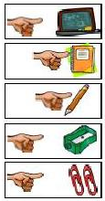

1. ____ is a board.
2. Look! ___ is a notebook.
3. Is ____ a pencil?
4. I want _____ sharpener.
5. Can you hand me ______clips, please?

7.- Dictation

a.

b.

c.

d.

e.

f.

g.

8.- **This-These / That-Those**. Look at the picture below and write under each arrow the correct form of This-These / That-Those.

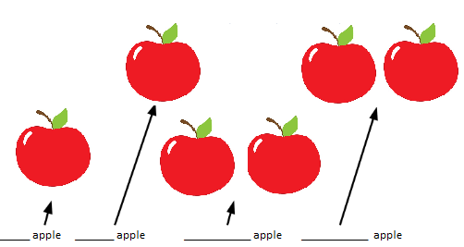

9.- **Oral examinations**. Ask to other partners what is/are the different objects located in the classroom.