Present Simple

|  |  |  |
| --- | --- | --- |
| + You are beautiful  -  ? | +  -  ? Do you know who I am? | + She likes potato chips  -  ? |
| +  - I don’t miss you anymore  ? | +  - I don’t want to exercise  ? | +  -  ? Does he smell good? |

Present Progressive

|  |  |  |
| --- | --- | --- |
| + She is watching TV  -  ? | +  -  ? Are they looking at us? | +  - You aren’t being polite  ? |
| +  - He isn’t taking care of you  ? | + I am buying new clothes  -  ? | +  -  ? Am I talking to you? |

Past Simple

|  |  |  |
| --- | --- | --- |
| + I slept all night  -  ? | +  -  ? Did he run in the park? | +  -  ? Did they tell a lie? |
| +  - She didn’t call yesterday  ? | +  - You didn’t visit your mom  ? | + They ate an apple  -  ? |

Future (Will)

|  |  |  |
| --- | --- | --- |
| + I will love you  -  ? | +  - They won’t look at her  ? | + She will come back  -  ? |
| +  - He won’t pay you  ? | +  -  ? Will we be friends? | +  -  ? Will he take a shower? |

Future (Going to)

|  |  |  |
| --- | --- | --- |
| + I am going to rest  -  ? | + He is going to visit her  -  ? | +  -  ? Is she going to come? |
| +  - She isn’t going to drive  ? | +  -  ? Am I going to see you? | +  - You aren’t going to pay  ? |

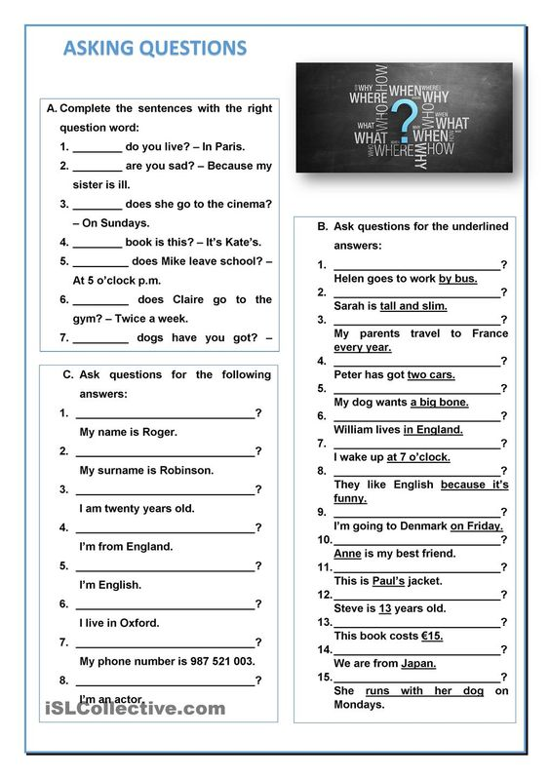

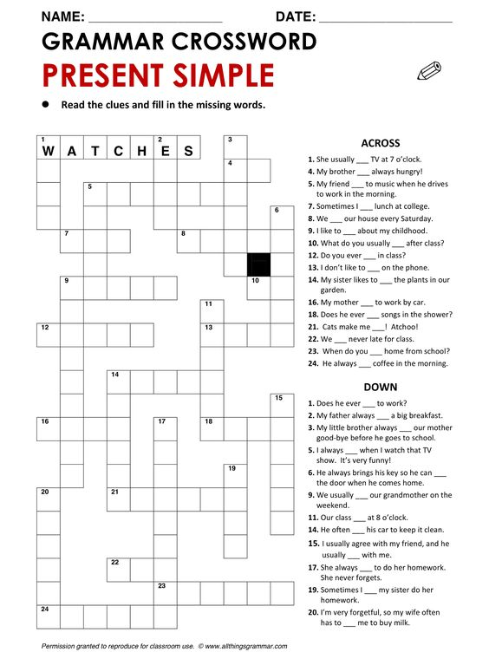

**Ejercicio de Repaso**

*Present Simple – Past Simple*

*Present Progressive – Past Progressive*

*Present Perfect Simple – Past Perfect Simpke*

*Present Perfect Progressive – Past Perfect Progressive*

1. Match the phrases in spanish with their most accurate translation in english.

|  |  |
| --- | --- |
| El es mi hermano  El era mi hermano  Nosotros hacemos el pastel  Nosotros estamos haciendo el pastel  Ellos han corrido un maratón  Ellos corrieron un maratón  Ella ha estado gritando mucho  Ella había estado gritando mucho  Ustedes dijeron la verdad  Ustedes estaban diciendo la verdad  Ustedes están diciendo la verdad  Yo vi Star Wars  Yo he visto Star Wars  Yo veo Star Wars  Yo bebo alcohol  Yo he bebido alcohol  Yo había estado bebiendo alcohol  Yo he estado bebiendo alcohol | He was my brother  He is my brother  We made the cake  We are making the cake  They ran in a marathon  They have run in a marathon  She had been screaming a lot  She has been screaming a lot  You told the truth  You were telling the truth  You are telling the truth  I see Star Wars  I saw Star Wars  I have seen Star Wars  I have drunk alcohol  I had been drinking alcohol  I drink alcohol  I have been drinking alcohol |

1. Underline the verbs shown in the following sentences and then, identify the verbal tense in which they were written (Present Simple, Progressive, Perfect Simple or Perfect Progressive, or Past Simple, Progressive, Perfect Simple or Perfect Progressive).

Sentece: Verbal Tense:

He is an undergrad student

We were watching youtube

They had been talking for hours!

You need a Passport.

She is being sarcastic.

We have been in france before.

I love cats

You are washing your car

She had been cleaning your room

We have learned from our mistakes

They walked into the bar

He lies in the floor

I played the piano yesterday

It had been rainning all day long

She has helped us before.

I am doing my homework

They enjoyed the cake