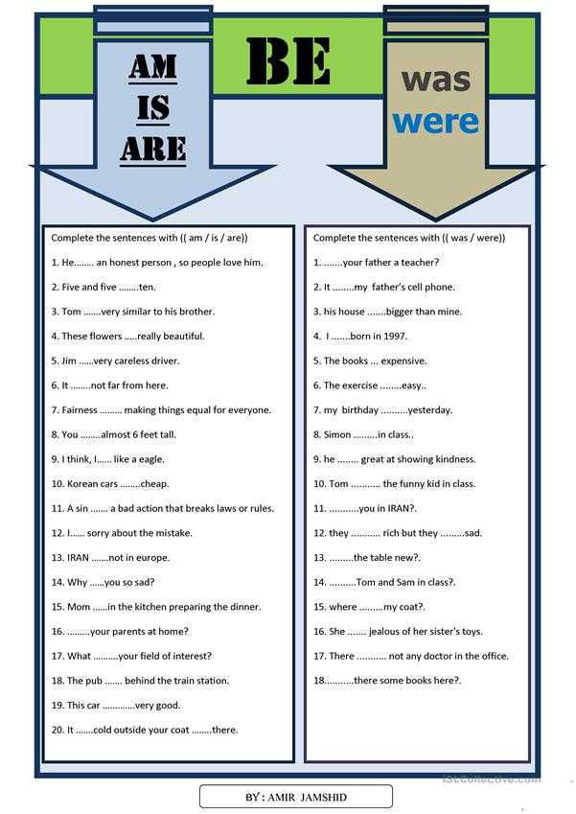

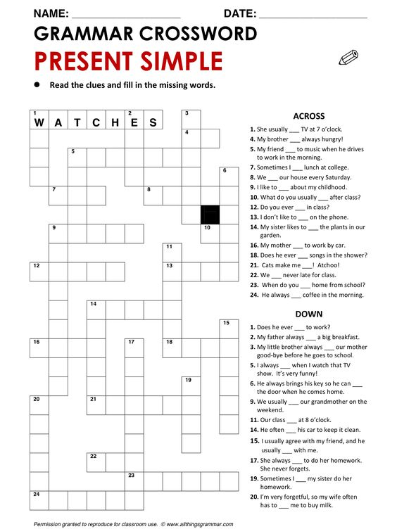

|  |  |  |  |
| --- | --- | --- | --- |
| W A T C H | W A T E R | G O | S T A R T |
| I S | T A L K | S I N G | ENCOUNTER |
| A R E | S L E E P | S N E E Z E | O P E N |
| A M | D O | A R R I V E | L A U G H |
| L I S T E N | T H I N K | D R I N K | K I S S |
| E A T | C L E A N | W A L K | B U Y |
| W A S H | A G R E E | REMEMBER | H E L P |
| REMIND |  | | |

|  |  |  |  |
| --- | --- | --- | --- |
| M I R A R | R E G A R | I R | COMENZAR |
| E S | H A B L A R | C A N T A R | ENCONTRAR |
| S O N | D O R M I R | ESTORNUDAR | A B R I R |
| S O Y | H A C E R | L L E G A R | R E I R |
| ESCUCHAR | P E N S A R | B E B E R | B E S A R |
| C O M E R | L I M P I A R | CAMINAR | COMPRAR |
| L A V A R | ESTAR DE ACUERDO | ACORDARSE | AYUDAR |
| RECORDAR |  | | |

