**Prepositions**

|  |  |  |
| --- | --- | --- |
| **Location** | **Time** | **Movement / Direction** |
| Above _________________  Behind __________________  Below __________________  Beside __________________  Between _________________  By __________________  In __________________  On __________________  Over __________________  Through _________________ | After _____________  Before _____________  During _____________  From _____________  Since ____________  By ______________  On ______________  Past ______________  Through ______________  To _______________  Until ________________  Upon ________________ | Against _____________  Along ______________  Down ______________  Up _________________  From _______________  Into ________________  Off ________________  On ________________  Onto ______________  Out of _____________  Towards _____________  Upon ________________ |
| ‘Look at the stars **above** you! They are beautiful!’  ‘**Behind** a great man, there is a great woman’  ‘On youtube, the comments always go **below** the main video’  ‘I’m not afraid because I know you will stand **beside** me’  ‘I have to choose **between** studying what you want and studying what will give you money’  ‘I live **by** the market’  ‘I live **in** Iztacalco’  ‘I live **on** Avenue Tea’  ‘The airplane can fly **ove**r the mountains and the ocean’  ‘We had to walk **through** the storm’ | ‘You can play **after** you do your homework’  ‘**Before** you go, clean the dishes’  ‘**During** World War II many lives were lost”  ‘The party is **from** 3 **to** 9’  ‘I go to school **since** I was 6 years old’  ‘I think I will finish it **by** tomorrow’s night’  ‘See you on Monday!’  ‘We were playing **past** midnight’  ‘I’ve been listening this **through** the day’  ‘I will exercise **until** I lose weight’  ‘We were playing **upon** midnight’ | ‘Superman fights **against** crime’  ‘I love to sing **along** the radio’  ‘Let’s go downstairs’  ‘Get **up from** the floor’  ‘I come **from** Mexico’  ‘I noticed him since he walked **into** the room’  ‘Get **off** my house!’  ‘Get **out of** my house!’  ‘The pencil is **on** the table’  ‘Put it **onto** the table, please’  ‘I was scared! He looked scary and kept walking **towards** me’  ‘The cereal is **upon** the fridge’ |

1. In - On – At = *“En”*
2. Of – From = *“De”*
3. From – Since = *“Desde”*

**Exercise**

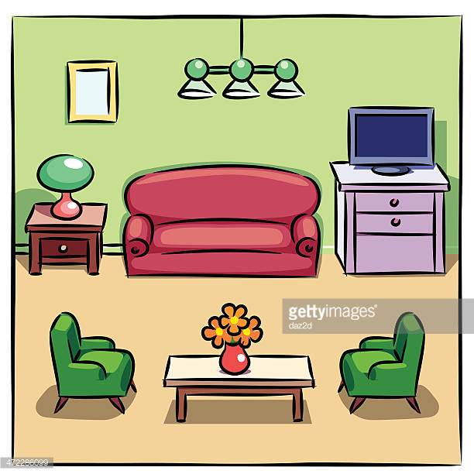  
1.- (Table / chairs) _________________________________________  
2.- (Flowers / table)  
_________________________________________  
3.- (Lamp / room)  
_________________________________________  
4.- (Drawer / TV)  
_________________________________________   
5.- (Sofa / TV) _________________________________________  
6.- (Papers / Drawers)  
_________________________________________

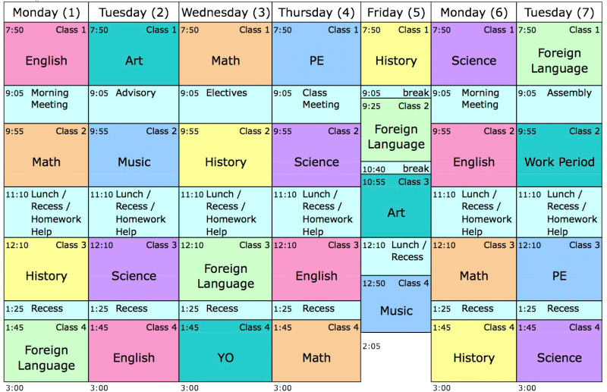

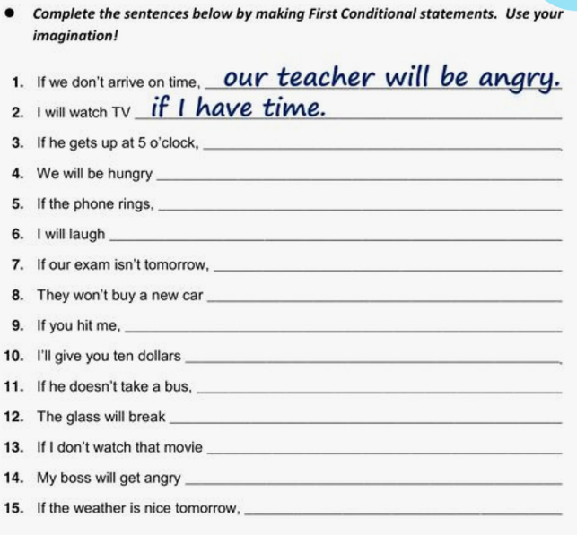

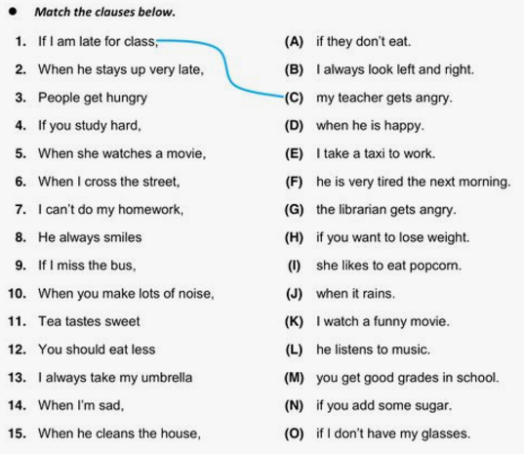

1. Reading: Read carefully the following dialogue and answer the questions below.

**Customer:** Hello?

**Receptionist:** Hello, Mr. Benjamin?

**Customer:** At last!

**Receptionist:** This is reception. We’ve just received a strange e-mail from you.

**Customer:** That’s right- The zero button on the phone doesn’t work. I couldn’t call you, so I sent an e-mail to the hotel. Luckily, the Wi-Fi is working.

**Receptionist:** I don’t understand. Why didn’t you just come downstairs?

**Customer:** That’s what I was trying to explain in my e-mail! The door to my room is stuck. I can’t open it.

**Receptionist:** Oh dear! From your e-mail, I thought your balcony door didn’t open.

**Customer:** No, no. I can’t get out of my room. I banged on the door for ten minutes, but nobody heard me. Then I decided to send an e-mail. Now, I’m late for a meeting. I’m not staying another night here. I want my money back.

**Receptionist:** Ok, calm down sir. I’m sending someone up right now, to fix the door. We can offer you a different room if you like.

**Customer:** Wait a minute! When I arrived, you said this was the only room you had. Suddenly, you’re able to move me to another room. Can you tell me how is that possible?

**Receptionist:** Well, a woman from the 5th floor left this morning.

**Customer**: Was her door broken too?

**Receptionist**: No, she just decided to go home earlier.

**Customer:** I see, well, I don’¿t think I want to stay because…

**Receptionist:** Just go, now! Come on!

**Customer:** I be your pardon!

**Receptionist:** I’m sorry, I was talking to the hotel caretaker. He’s going to fix your door now.

**Customer:** Ok,. Tell him to hurry, please!

**Receptionis**t: Of course. Now, when hefixes it, please come downstairs so we can discuss…

**Customer:** I’m sorry, butI’m already half an hour late for my meeting.

**Receptionist:** Oh, ok. Do you know when are you coming back?

**Customer**: Later this evening. But I’m not going to stay.

**Receptionist**: Ok, I’m very sorry about all of this.

Answer the following questions about the reading:

1. If the previous dialogue was part of a movie… Which would be a good title for it?
   1. Nightmare at the Holocaust.
   2. Disastrous Hotel
   3. Godzilla 3000
   4. Einstein going wild!
2. Write true or false.
   1. The man sent an e-mail to the hotel from his room. _____
   2. The receptionist tried to ring the man but the phone didn’t work __________
   3. The man couldn’t use the Internet in his room _________
   4. The receptionist didn’t understand the man’s e-mail_________
   5. The man wants to change to a different room _________
   6. There aren’t any other rooms available. ________
   7. The ma can’t talk to the receptionist because he has to go to a meeting _________