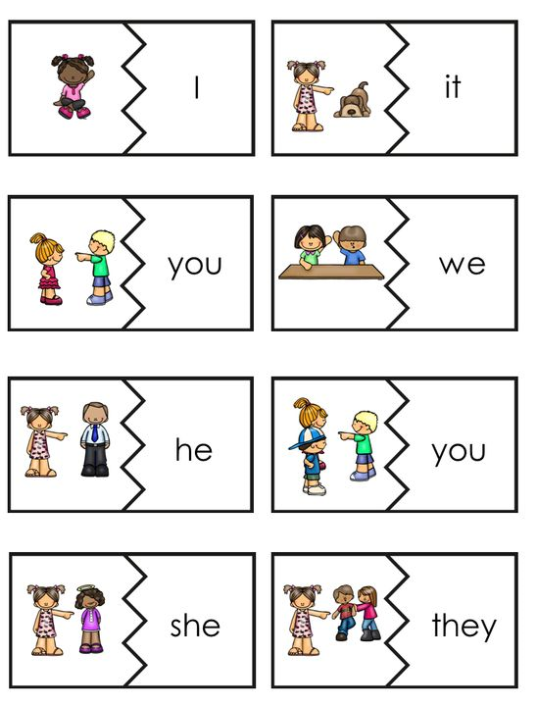

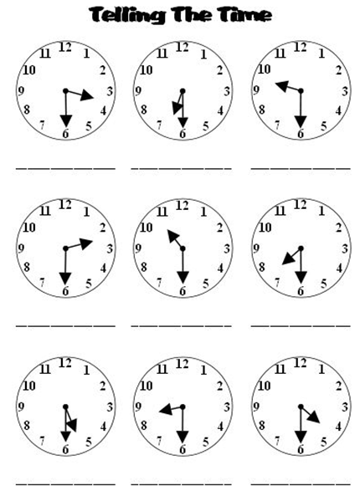



**Numbers**

|  |  |  |  |
| --- | --- | --- | --- |
| 1 - 12 | Teen | Ty | >99 |
| 1  2  3  4  5  6  7  8  9  10  11  12 | 13  14  15  16  17  18  19 | 20  30  40  50  60  70  80  90 | _00  _000  _,000,000 |

