1. Substitute the underlined words with
subject pronouns:
1. Peter and Paul ( ………) study French and
German.
2. The cat (……...

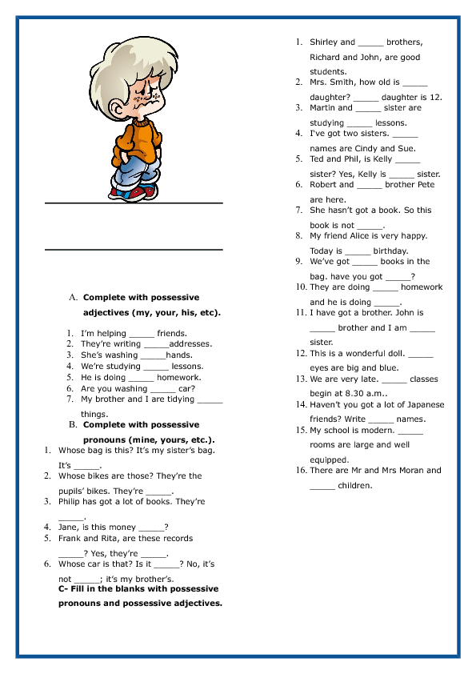

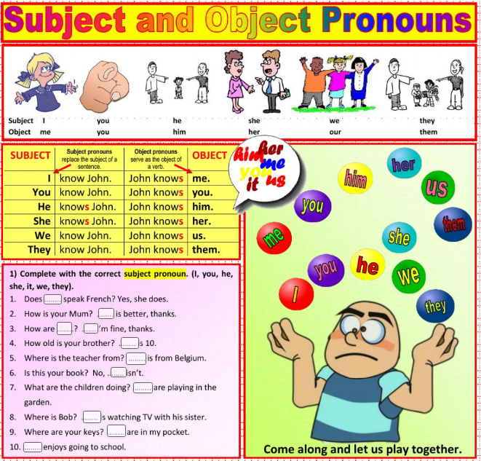

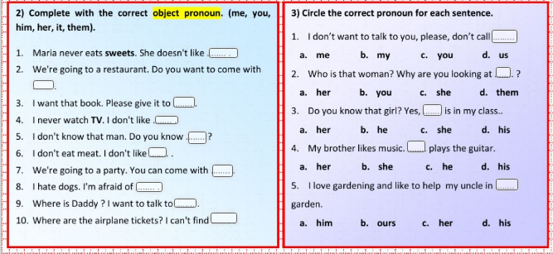

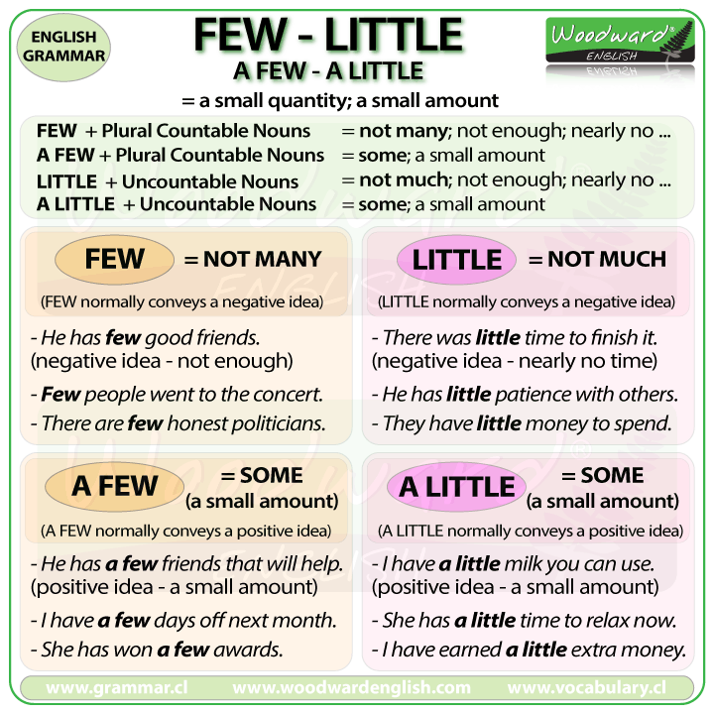

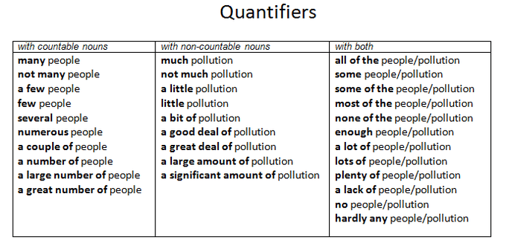

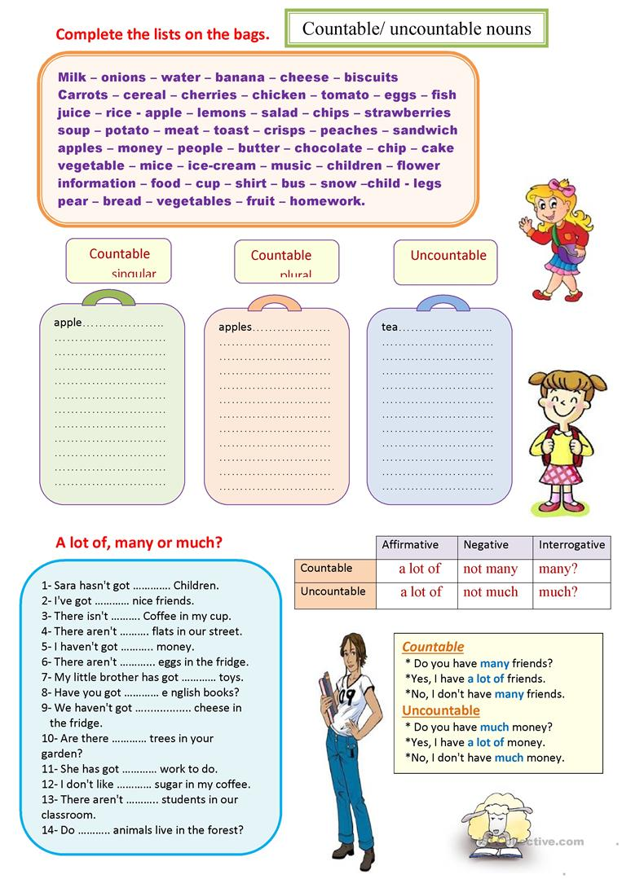

FOOD – COUNTABLE AND UNCOUNTABLE NOUNS
FOOD

COUNTABLE / UNCOUNTABLE NOUS
COUNTABLE NOUS
•

Nouns you can count

•

you ca...

b) Use a / an or some and write C for countable or
U for uncountable.

•
•

____sugar____

•

____ bar of chocolate____

•...

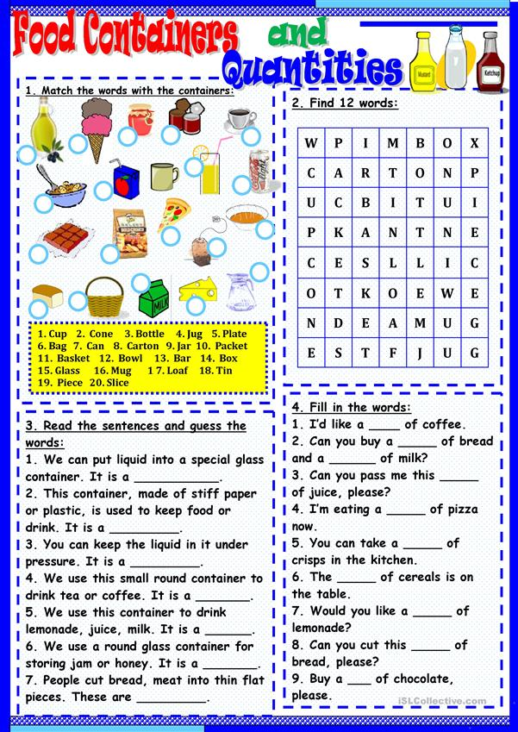

f) Fill in the gaps using any, some , a lot of, much, many, or no.

•

There is __________ high school in Florence.

•

He...

