**Vocabulary: House and Furnitures**

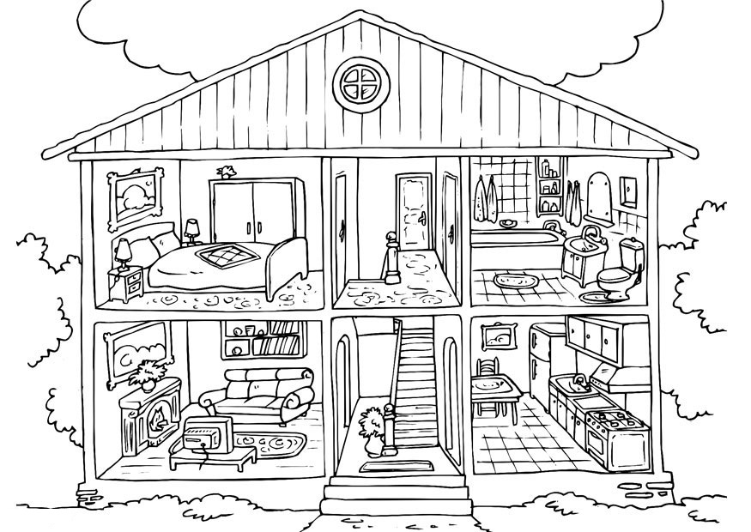

1. The kitchen is yellow
2. The livingroom is purple
3. The bathroom is blue
4. The bedroom is Green

|  |  |  |  |
| --- | --- | --- | --- |
| English | Spanish | English | Spanish |
| Bed |  | Stairs |  |
| Paintings |  | Door |  |
| Chimney |  | Toilet |  |
| Mirror |  | Bathtub |  |
| Table |  | Chairs |  |
| T.V. screen |  | Couch |  |
| Carpet |  | Wardrobe |  |
| Sink |  | Towel |  |
| Desk |  | Flower |  |

