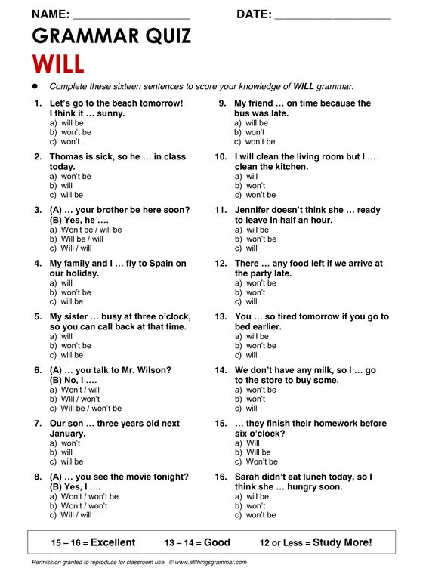



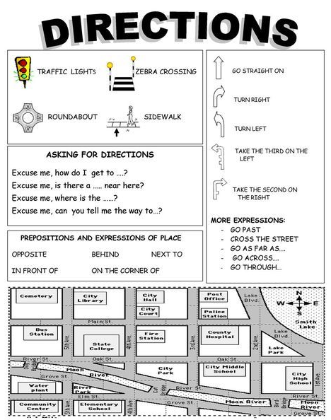



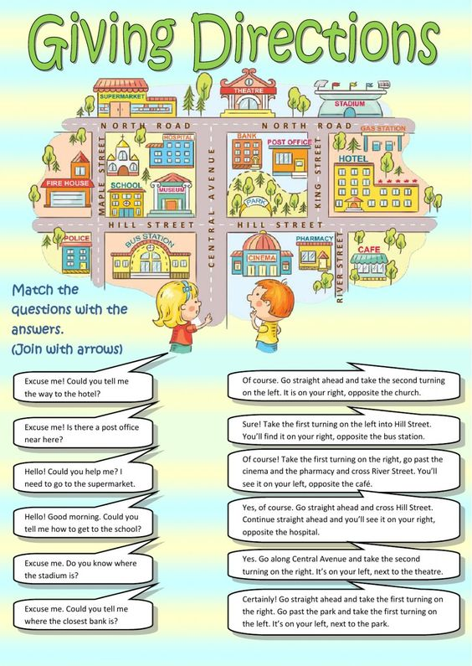



|  |  |
| --- | --- |
| Tú comerás en tu casa  Ella vive con su mamá  Nosotros vimos la TV  Ustedes jugarán soccer  Ellos caminan a casa  El corre en el parque  Tú comes en tu casa  Ella vivirá con su mamá  Nosotros veremos la TV  Ustedes juegan soccer  Ellos caminaron a casa  El correrá en el parque  Tú comiste en tu casa  Ella vivió con su mamá  Nosotros vemos la TV  Ustedes jugaron soccer  Ellos caminarán a casa  El corrió en el parque | She lived with her mother  He ran in the park  You eat in your house  They walked home  You ate in your house  You will eat in your house  They walk home  He runs in the park  We watch TV  She lives with her mother  You played soccer  He will run in the park  We will watch TV  We watched TV  They will walk home  You will play soccer  You play soccer  ______________________ |

|  |  |
| --- | --- |
| Tú comerás en tu casa  Ella vive con su mamá  Nosotros vimos la TV  Ustedes jugarán soccer  Ellos caminan a casa  El corre en el parque  Tú comes en tu casa  Ella vivirá con su mamá  Nosotros veremos la TV  Ustedes juegan soccer  Ellos caminaron a casa  El correrá en el parque  Tú comiste en tu casa  Ella vivió con su mamá  Nosotros vemos la TV  Ustedes jugaron soccer  Ellos caminarán a casa  El corrió en el parque | She lived with her mother  He ran in the park  You eat in your house  They walked home  You ate in your house  You will eat in your house  They walk home  ______________________  He runs in the park  We watch TV  She lives with her mother  You played soccer  He will run in the park  We will watch TV  We watched TV  They will walk home  You will play soccer  You play soccer |

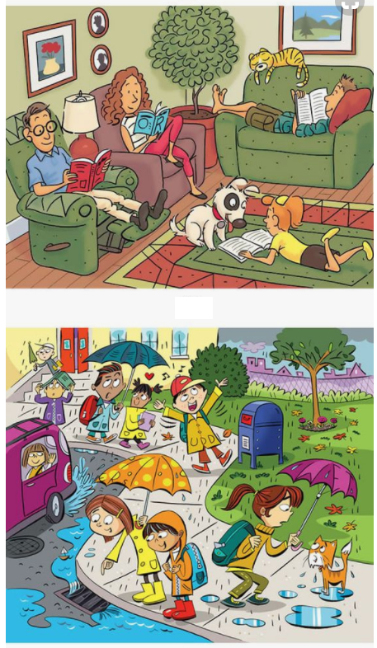

|  |  |
| --- | --- |
| He is Reading a novel  She has an umbrela  The dog is in the floor  The cat is wet  The girl is in the car  The cat sleeps | _________________________________  _________________________________  _________________________________  _________________________________  _________________________________  _________________________________ |