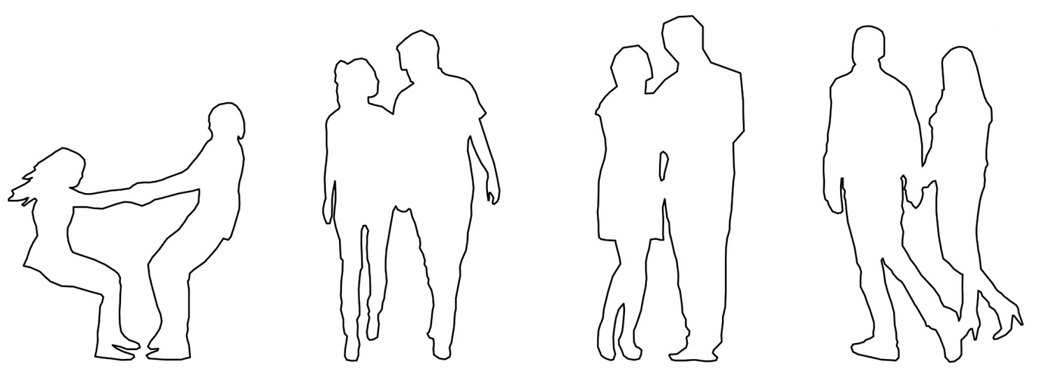

Blue jeans (for He)

Gray jacket (for He)

Green pants (for She)

Red jacket (for She)

Green tennis (for He)

Red pants (for She)

Red shoes (for She)

Glasses (for She)

Yellow hair (for She)

Yellow shoes (for She)

Red watch (for She)

Purple earings (for She)

Blue eyes (She)

Green eyes(He)

Pink skirt (for She)

Green pants (for He)

Red hair (for He)

Red tennis (for He)

Black hair (for She)

Black jacket (for He)

Purple hoodie (for She)

Black shoes (for She)

Green scarf (for He)

Purple hat (for She)

Black glasses (for He)

She is happy

He is happy