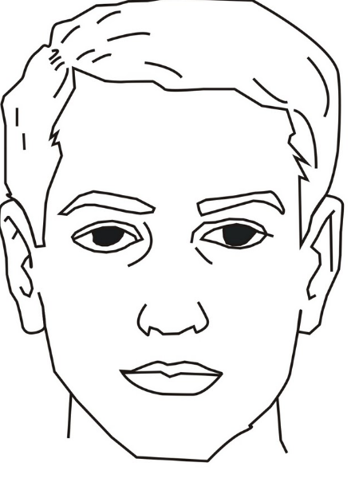

Black eyes

Brown Hair

Brown mouth

Red nose

Glasses

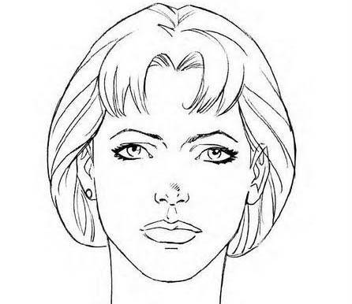

Red earings

Blue eyes

Red Lips

Red hair

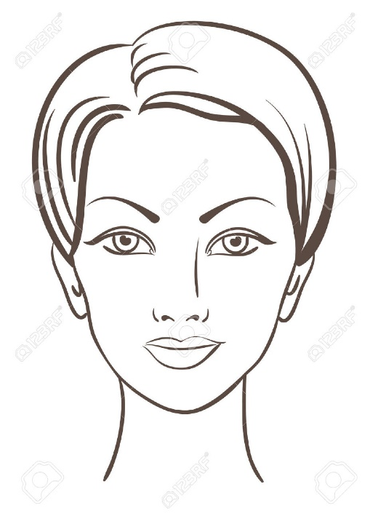

Purple hat

Green eyes

Pink mouth

Yellow Hair

Pink earings