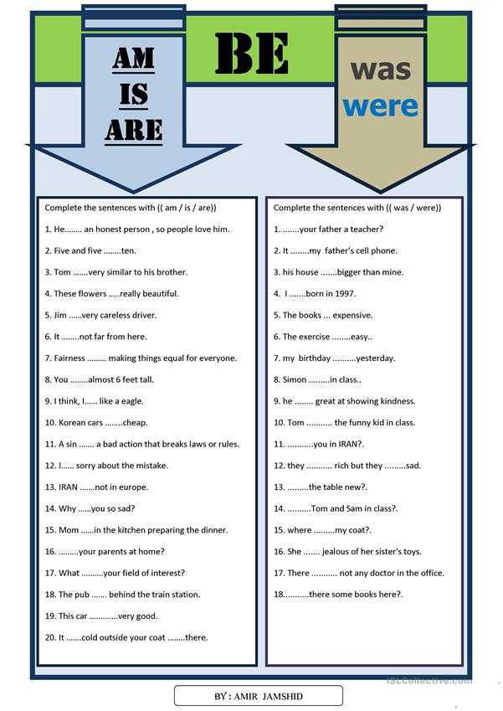

**Prepositions**

|  |  |  |
| --- | --- | --- |
| **Location** | **Time** | **Movement / Direction** |
| Above _________________  Behind __________________  Below __________________  Beside __________________  Between _________________  By __________________  In __________________  On __________________  Over __________________  Through _________________ | After _____________  Before _____________  During _____________  From _____________  Since ____________  By ______________  On ______________  Past ______________  Through ______________  To _______________  Until ________________  Upon ________________ | Against _____________  Along ______________  Down ______________  Up _________________  From _______________  Into ________________  Off ________________  On ________________  Onto ______________  Out of _____________  Towards _____________  Upon ________________ |
| ‘Look at the stars **above** you! They are beautiful!’  ‘**Behind** a great man, there is a great woman’  ‘On youtube, the comments always go **below** the main video’  ‘I’m not afraid because I know you will stand **beside** me’  ‘I have to choose **between** studying what you want and studying what will give you money’  ‘I live **by** the market’  ‘I live **in** Iztacalco’  ‘I live **on** Avenue Tea’  ‘The airplane can fly **ove**r the mountains and the ocean’  ‘We had to walk **through** the storm’ | ‘You can play **after** you do your homework’  ‘**Before** you go, clean the dishes’  ‘**During** World War II many lives were lost”  ‘The party is **from** 3 **to** 9’  ‘I go to school **since** I was 6 years old’  ‘I think I will finish it **by** tomorrow’s night’  ‘See you on Monday!’  ‘We were playing **past** midnight’  ‘I’ve been listening this **through** the day’  ‘I will exercise **until** I lose weight’  ‘We were playing **upon** midnight’ | ‘Superman fights **against** crime’  ‘I love to sing **along** the radio’  ‘Let’s go downstairs’  ‘Get **up from** the floor’  ‘I come **from** Mexico’  ‘I noticed him since he walked **into** the room’  ‘Get **off** my house!’  ‘Get **out of** my house!’  ‘The pencil is **on** the table’  ‘Put it **onto** the table, please’  ‘I was scared! He looked scary and kept walking **towards** me’  ‘The cereal is **upon** the fridge’ |

1. In - On – At = *“En”*
2. Of – From = *“De”*
3. From – Since = *“Desde”*

**Exercise**

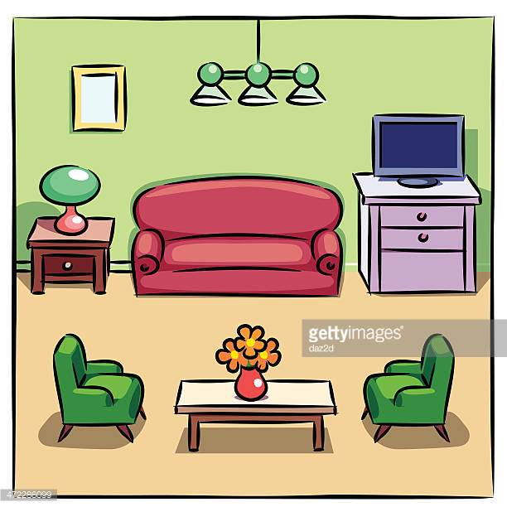  
1.- (Table / chairs) _________________________________________  
2.- (Flowers / table)  
_________________________________________  
3.- (Lamp / room)  
_________________________________________  
4.- (Drawer / TV)  
_________________________________________   
5.- (Sofa / TV) _________________________________________  
6.- (Papers / Drawers)  
_________________________________________

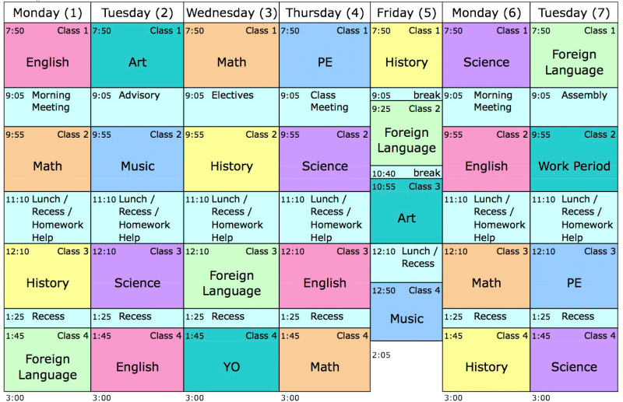

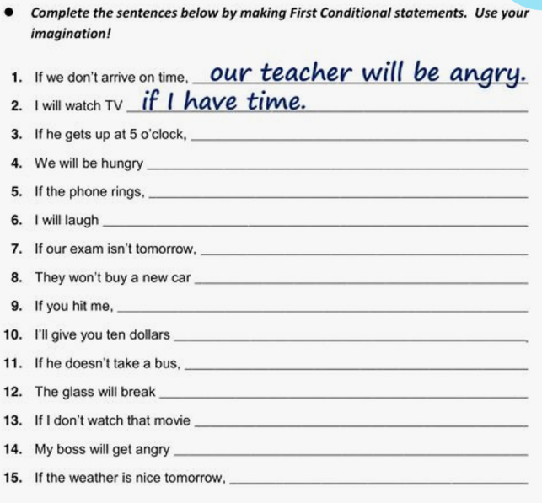

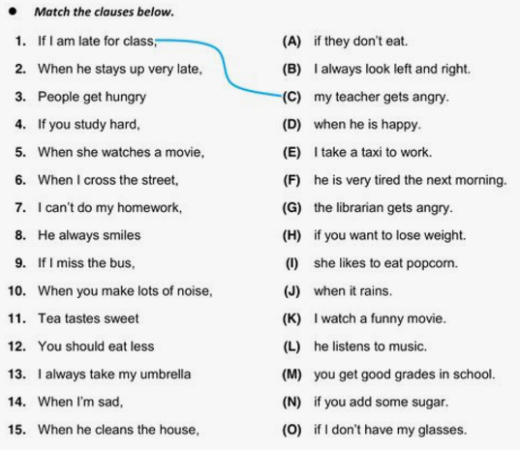

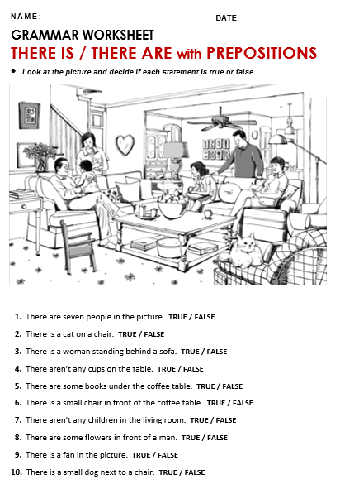

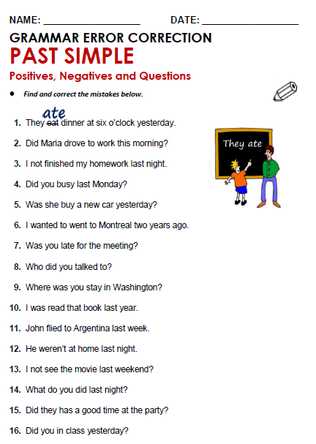

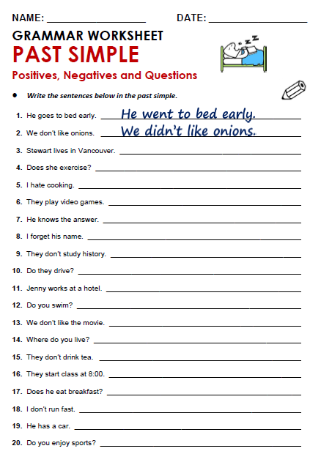

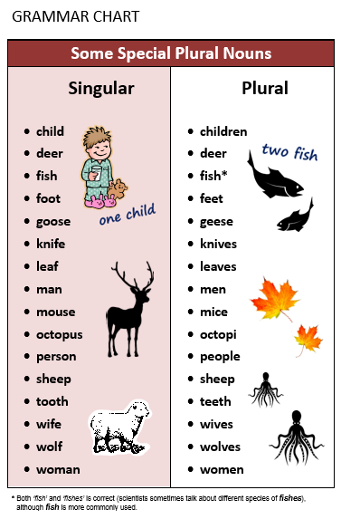

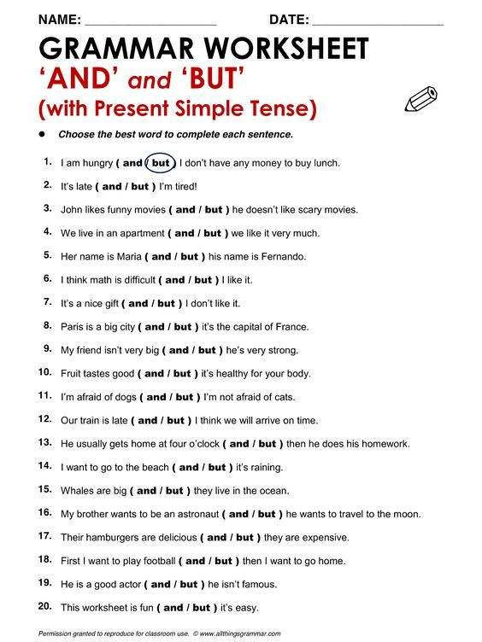

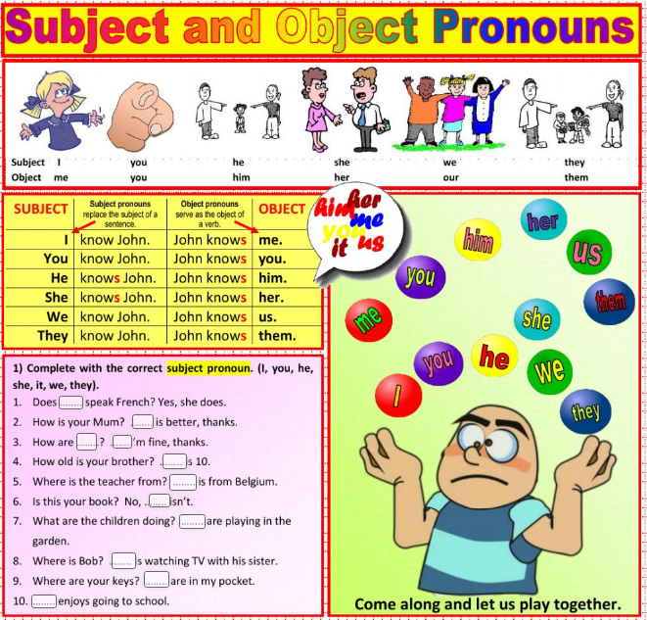

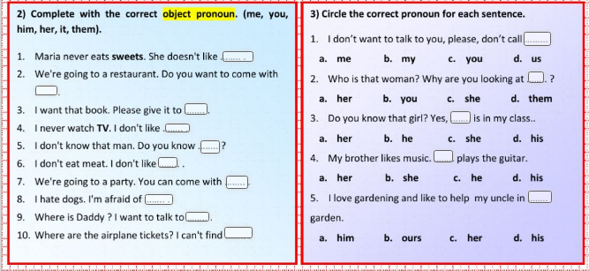

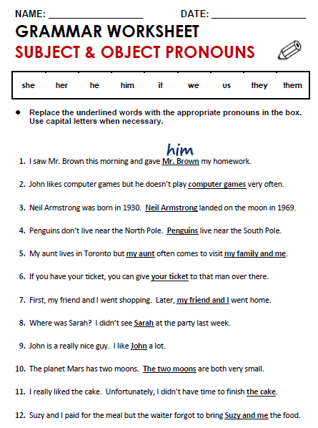

**Present Simple and Past Simple**

**Completa la siguiente tabla, escribiendo la forma afirmativa, negativa e interrogativa de las oraciones escritas en Presente Simple. Después, tomando en cuenta que todos los verbos utilizados son VERBOS REGULARES, transfórmalas a Pasado Simple.**

|  |  |  |
| --- | --- | --- |
| PRESENT Simple |  |  |
| + I walk to school every morning  -  ? | +  -  ? |
| +  - She doesn’t play the Banjo  ? | +  -  ? |
| +  -  ? Do we live in London? | +  -  ? |
| + She dances to jazz music  -  ? | +  -  ? |
| +  - We do not listen to pop music  ? | +  -  ? |
| +  - They don’t like potato chips  ? | +  -  ? |
| +  -  ? Do I wash the dishes? | +  -  ? |

**Completa la siguiente tabla transformando las oraciones según se te pida**

|  |  |
| --- | --- |
| Present Simple | Past Simple |
| He cleans his house |  |
| They look happy |  |
|  | She is telling a lie |
| It bites hard |  |
|  | They are singing a song |
|  | He is looking after you |
| She loves pizza |  |
|  | We are killing a cat |
|  | Daniel is cheating on you |
| I play the piano |  |

**Present Simple and Present Continuous**

**Complete the following chart with the affirmative, negative and/or interrogative form of the sentences in Present Continuous.**

|  |  |  |
| --- | --- | --- |
| + I am driving a car  -  ? | +  -  ? Is she planning a party? | +  - You are not listening to me.  ? |
| +  - She is not taking her medicine.  ? | +  -  ? Are you joking? | + It is raining.  -  ? |
| +  - It is not snowing  ? | + We are dancing tango.  -  ? | +  -  ? Is she making pizza? |
| +  -  ? Is he dancing with that girl? | + They are looking at us!  -  ? | + She is drinking coffee.  -  ? |
| +  - We are not making any noise.  ? | +  - I am not understanding you.  ? | +  -  ? Is he sleeping at night? |
| +  - She isn’t watching cartoons  ? | +  -  ? Are you talking to me? | + They are arriving at the party  -  ? |
| +  -  ? Is he washing dishes? | + She is playing with your heart  -  ? | +  - We are not taking this course.  ? |

**Complete the next chart by transforming the sentences**

|  |  |
| --- | --- |
| Present Simple | Present Progressive |
| He cleans his house |  |
| They look happy |  |
|  | She is telling a lie |
| It bites hard |  |
|  | They are singing a song |
|  | He is looking after you |
| She loves pizza |  |
|  | We are kissing a cat |
|  | Daniel is looking for you |
| I play the piano |  |

