AI-Driven Time Series Forecasting & Anomaly Detection for HIV Supply Chain Optimization



THESIS SUBMITTED TO
Symbiosis Institute of Geoinformatics

FOR FULFILLMENT OF THE M.Sc. DEGREE

By

Adrija Paul

( Batch: 2023-2025 / PRN:23070243001)
Symbiosis Institute of Geoinformatics
Symbiosis International (Deemed University)
5th Floor , Atur Centre, Gokhale Cross Road,
Model Colony, Pune - 411016

CERTIFICATE

Certified that this thesis titled ‘AI-Driven Time Series Forecasting & Anomaly Detection for HIV Supply Chain Optimization" is a bonafide work done by Miss Adrija Paul, at Symbiosis Institute of Geoinformatics, under our supervision.

Supervisor, Internal
Dr. Veena Parihar
Symbiosis institute of geoinformatics

CONTENTS
PREFACE PG NO
1.INTRODUCTION …………………………………………………………………………………… 6
1.1 PROBLEM STATEMENT …………………………………………………………………… 6
1.2 OBJECTIVES ……………………………………………………………………………………. 7
2. LITERATURE REVIEW……………………………………………………………………………. 7
3. METHODOLOGIES ……………………………………………………………………………….. 11
3.1 DATA COLLECTION ………………………………………………………………………… 12
3.2 DATA PREPROCESSING…………………………………………………………………… 16
3.3 EXPLORATORY DATA ANALYSIS……………………………………………………….. 17
3.4 DATA PREPARATION ………………………………………………………………………. 19
3.5 MODELS ……………………………………………………………………………………….. 20
4. RESULTS AND DISCUSSION ………………………………………………………………….. 26
4.1 MODEL PERFORMANCE …………………………………………………………………. 27
4.2 COMPARATIVE STUDY…………………………………………………………………….. 29
4.3 ANOMALY DETECTION RESULTS ……………………………………………………… 30
5. INTERACTIVE AI CHAT SUPPORT …………………………………………………………… 32
6. CONCLUSION ………………………………………………………………………………………. 36
7. REFERENCES ……………………………………………………………………………………….. 40
8.ANNEXURE …………………………………………………………………………………………….45

ACKNOWLEDGEMENT
I want to sincerely thank everyone for their support and encouragement in helping me complete this research endeavor. I want to convey my appreciation to the individuals and organizations that have contributed to the success of this research effort. I would like to begin by thanking Dr. Veena Parihar, my internal guide, for her assistance and guidance throughout this study effort. Her insightful recommendations were very important in deciding the direction this study endeavor will take.
Finally, I would want to express my gratitude to my family and all of my peers for their continuous support in helping me finish my research work.

LIST OF FIGURES:

SL NO | FIGURE DESCRIPTION | PG NO
1. | Methodology flowchart | 13
2. | Histogram of numerical features | 15
3. | Scatter plots | 16
4. | Box plot | 17
5. | Boxen plot outliers | 18
6. | Bar plot of shipment mode | 25
7. | Correlation heatmap | 26
8. | LSTM architecture | 22
9. | Hybrid model | 23
10. | Isolation forest | 24
11. | Cross fold prediction | 35
12. | Actual vs Predicted cost | 37
13. | Lime explainability | 39
14. | User interface of AI Userface | 31
15. | Q/A interface | 32

LIST OF TABLE:
TABLE DESCRIPTION | PG NO
Literature review | 9
Comparison of models | 26

ABBREAVIATION LIST:
Abbreviation | Full Form / Description
ARV | Antiretroviral (medicines used to treat HIV)
HIV | Human Immunodeficiency Virus
AI | Artificial Intelligence
ML | Machine Learning
EDA | Exploratory Data Analysis
SARIMA | Seasonal Autoregressive Integrated Moving Average
LSTM | Long Short-Term Memory (Recurrent Neural Network)
MSE | Mean Squared Error
MAE | Mean Absolute Error
MAPE | Mean Absolute Percentage Error
XGBoost | Extreme Gradient Boosting
RNN | Recurrent Neural Network
CSV | Comma-Separated Values
UI | User Interface
df | DataFrame (pandas object for tabular data)
Prophet | Forecasting model developed by Facebook for time series data
RMSE | Root Mean Squared Error
NaN | Not a Number (missing values indicator)
ReLU | Rectified Linear Unit (activation function in neural networks)
GPU | Graphics Processing Unit
API | Application Programming Interface
NLP | Natural Language Processing
ESM | Exponential Smoothing Method
CV | Cross-Validation
Lag | Past value of a variable in time series analysis
Dropout | Regularization technique to prevent overfitting in deep learning
RobustScaler | Scaler that uses median and IQR, less sensitive to outliers
EarlyStopping | Technique to stop model training when validation loss stops improving
Seasonality | Repeating patterns or cycles in time series data
Trend | Long-term increase or decrease in the data

PREFACE
The objective of this project is to solve the growing inefficiencies in the worldwide distribution of HIV diagnostic equipment and antiretroviral (ARV) drugs, for which freight costs represent a significant portion of total operating expenses. This publication adopts a data-driven approach to improve forecasting and detection of anomalies since it is aware that conventional supply chain systems often do not respond to dynamic factors such as swings in seasonal demands, fluctuations in fuel prices, and delays in deliveries. Before employing advanced forecasting models such as SARIMA, Exponential Smoothing, LSTM, Prophet, and an ensemble of Prophet-XGBoost hybrid, the project collects, cleanses, and preprocesses historical shipment and cost data. An AI-driven chat interface is also incorporated to facilitate proactive decision-making, and anomaly detection methods are employed to detect unusual transactions. The overall process is aimed at facilitating smart logistics management of the healthcare supply chain, enhancing cost transparency, and enhancing planning precision.

INTRODUCTION
An estimated 38.4 million people across the globe were HIV positive as of 2021, and the fight against HIV/AIDS is one of the largest public health challenges of our time. Effective and affordable delivery of HIV testing kits and antiretroviral (ARV) drugs to affected populations is the key to stopping this epidemic, particularly in resource-constrained settings. Yet, the global supply chain for such life-saving products is confronted with formidable logistical challenges that have a direct impact on patient outcomes, pricing, and access.
Pharma firms, logistics firms, health systems at the national level, and global donors like PEPFAR (President's Emergency Plan for AIDS Relief) and the Global Fund to Combat AIDS, Tuberculosis, and Malaria are all components of the intricate ecosystem enveloping the distribution channel for ARV drugs and HIV tests. Sourcing, making, transporting, and delivering through the last mile are all tightly integrated in this multi-level supply chain that spans continents. The complexity is further increased by the fact that these medical supplies are vital and stockouts would have devastating implications for patient health and continuity of treatment. Substantial logistical inefficiencies across the distribution of ARV drugs and HIV testing equipment remain even with heavy investments in global health supply chains, resulting in astronomical operating expenses and suboptimal resource utilization. Frequently representing 15–30% of the total procurement budget, freight charges alone represent a disproportionately excessive proportion of the total cost of supplying these items. Several reasons in combination create these inefficiencies, to which regular supply chain management solutions are not particularly well equipped to respond. Most importantly, traditional supply chain management systems primarily rely on reactive decision-making processes that are built around outdated planning methods and past records. These systems cannot predict impending disruptions, adapt to dynamic market conditions, or handle real-time data. Consequently, supply chain managers too often must make suboptimal decisions that increase costs, prolong delivery, and increase the likelihood of stockouts or overstock situations.
1.1 Problem statement:
The global distribution of antiretroviral (ARV) medicines and HIV diagnostic devices suffers from enormous logistical inefficiencies, as freight costs constitute a large portion of operating costs. These inefficiencies stem from hidden patterns such as seasonal demand surges, geopolitical disruptions, and missed opportunities for consolidated shipping, as well as dynamic fuel price fluctuations, inefficient routing, and fluctuating carrier rates. Traditional supply chain management systems struggle to deliver optimal routing or procurement results because of their reliance on outdated reactive decisions and lack of real-time data.
1.2 Objectives:
The problem outlined demonstrates glaring gaps in the global supply chain for ARV and HIV diagnostics due to intricate and often unseen factors resulting in excessive freight costs and operational bottlenecks. Further, the challenges are compounded by the limitations of traditional systems that are incapable of adapting to real-time disruptions or shifting market dynamics. This study proposes the application of modern AI and machine learning techniques to bridge these gaps, enabling more intelligent, data-driven decisions. Through the use of predictive models SARIMA, XGBoost, LSTM and ensemble models like prophet+xgboost and prophet+lstm for estimating freight costs and demand, applying anomaly detection for identifying anomalous cost trends, and intelligent scheduling via interface.
- Apply AI/ML frameworks (SARIMA, XGBoost, LSTM) to predict freight pricing, shipping volumes, and delivery lags, aiding in data-driven operational planning and cost reduction.
- Employ anomaly detection methods like Isolation Forest to detect and flag unusual transactions or abnormal freight charges to mitigate risks and ensure cost visibility.
- Implement forecasting analysis to suggest optimal shipping schedules and routes through an AI chat interface to render proactive cost-saving recommendations.

LITERATURE REVIEW:
To mitigate inefficiencies and control increasing freight expense, innovative and data-based solutions to manage the increasing complexity of global health care logistics, specifically in the distribution of antiretroviral (ARV) drugs and HIV diagnostic kits, are necessary. Even traditional supply chain systems lack the adaptability to respond to dynamic variables such as changing fuel prices, seasonal demand, and delays in delivery. Smart forecasting and anomaly detection models that can enable proactive decision-making are thus increasingly needed. This is met by the present work, which examines the prospective convergence of AI and machine learning methodologies for predictive modeling. This provides the basis for the subsequent literature review that reviews contemporary methods and shortcomings in the area. Table 1 summarizes the whole review.
1.In the paper [V] it explores various forecasting techniques used to optimize supply chain operations. The objective is to assess the effectiveness of different time series forecasting models in predicting demand, reducing costs, and improving inventory management. The study reviews traditional models such as moving averages, exponential smoothing, and ARIMA, alongside advanced approaches like neural networks and machine learning algorithms. Evaluation metrics like MAE, RMSE, and MAPE are used to measure accuracy. Results indicate that hybrid models combining statistical and machine learning techniques offer improved predictive performance. The study highlights challenges like data quality, model selection, and real-time scalability, offering recommendations to enhance forecasting efficiency. The findings underscore the importance of accurate demand prediction in achieving competitive advantage and operational efficiency in supply chain management.
2.Paper [VI] explores how emerging technologies are transforming global supply chains. The objective is to analyze key innovations such as AI, blockchain, IoT, and sustainability-driven practices, assessing their impact on efficiency, resilience, and flexibility. The study employs a qualitative research approach, conducting a systematic literature review of industry reports and case studies from 2018-2023. Results indicate that AI and ML improve predictive analytics and decision-making, blockchain enhances transparency, and IoT optimizes inventory management. Additionally, sustainability practices, including circular economy models and green logistics, are reshaping supply chains to reduce waste and carbon footprints. The study concludes that integrating digital technologies with sustainability initiatives is essential for future-proofing supply chains against disruptions while ensuring long-term competitiveness.
3.Paper [VII] explores the role of artificial intelligence (AI) in mitigating risks in increasingly complex global supply chains. The objectives are to analyze AI-driven techniques for risk identification, prediction, and optimization while addressing challenges like data security and implementation complexity. The study employs a systematic literature review, sourcing research from databases like Google Scholar and Web of Science, focusing on machine learning, deep learning, neural networks, fuzzy logic, genetic algorithms, and evolutionary algorithms. Results show AI significantly enhances risk detection, anomaly identification, demand forecasting, and supply chain optimization. Techniques like convolutional neural networks (CNNs) for image analysis, natural language processing (NLP) for text mining, and genetic algorithms for logistics optimization prove particularly effective. Despite AI's advantages, challenges such as data privacy, transparency, and computational demands persist. Future research suggests integrating AI with blockchain and IoT to enhance security and real-time monitoring, ensuring more resilient supply chains.
4.Paper [VIII] by Aturika Bhatnagar, Rajeev Gupta, and G.D. Thakar aims to enhance demand forecasting for a pump manufacturing company using time series models. The study compares the performance of the Holt-Winters model and the ARIMA model to predict future sales and validate accuracy using Mean Absolute Percentage Error (MAPE) and Theil's U statistic. The methodology involves collecting four years of sales data (2016–2019), applying both forecasting models, and evaluating their predictive performance using IBM SPSS. The results indicate that while both models perform well, Holt-Winters provides more accurate forecasts, especially for seasonal demand patterns, due to its ability to account for trend and seasonality. The paper concludes that an accurate forecasting method can help reduce inventory costs, prevent stock shortages, and improve supply chain efficiency. Future applications include extending these models to other industries with seasonal demand fluctuations and incorporating machine learning techniques to enhance forecasting precision.
5.Paper [IX] aims to enhance demand forecasting for logistics companies by predicting order volume and staffing needs. The study employs SARIMAX, ARIMA, Autoregressive (AR), and Long Short-Term Memory (LSTM) models to analyze order data from a shipping company across the UAE, KSA, and Kuwait. The dataset (8.5 million records) includes order volume, holidays, and sales seasons to account for external factors. Models were trained using an 80:20 data split and evaluated based on Mean Absolute Percentage Error (MAPE) and Root Mean Square Error (RMSE). SARIMAX outperformed other models, demonstrating the best accuracy across all regions (MAPE: 0.087, RMSE: 0.127). Future applications include refining external variables (fuel prices, labor costs), optimizing parameter tuning, and expanding datasets for improved forecasting accuracy. The study provides a formula for workforce planning based on predicted order volume, helping logistics companies allocate resources more efficiently.
6. AI's role in enhancing supply chain efficiency. The objective of paper [X] is to analyze how AI improves demand forecasting, inventory optimization, logistics, supplier selection, and predictive maintenance. The methodology includes a systematic literature review, case studies, and expert interviews to assess AI adoption and challenges. The study highlights AI techniques such as machine learning, neural networks, predictive analytics, and reinforcement learning. Results show that AI-driven forecasting improves accuracy, reduces costs, and enhances decision-making. However, challenges like data quality, algorithmic bias, and ethical concerns remain. Future use cases involve integrating AI with IoT, blockchain, and robotics to further streamline supply chain operations, enhance risk management, and create adaptive, self-learning systems.
7.Paper [XI] explores the effectiveness of various time series models in forecasting sales for supply chain management. The objective is to enhance sales prediction accuracy using data from 100 products across 10 stores over five years (2013–2018). The methods involve testing decomposition, ARIMA, Prophet, and Box-Cox transformation models to compare their predictive performance. The results show that while no single model outperforms across all cases, a hybrid of Prophet and ARIMA yields the best accuracy. The study utilizes machine learning, statistical modeling, and big data frameworks (Hadoop, Spark, PySpark, MLlib) for improved processing and analytics. Future use cases include refining forecasting models with additional external factors (holidays, seasonal trends), expanding datasets, and integrating AI-based predictive techniques for better supply chain decision-making.
8. Paper [XII] aims to enhance demand forecasting in the food industry, particularly for meal delivery services, to minimize inventory waste. The objective is to compare the performance of various machine learning and deep learning regressors in predicting food demand using a dataset containing 145 weeks of order history. The methods involve data preprocessing, feature engineering (lag features, Exponentially Weighted Moving Average), and applying seven forecasting models: Random Forest Regressor, Gradient Boosting Regressor (GBR), LightGBM, XGBoost, CatBoost, Long Short-Term Memory (LSTM), and Bidirectional LSTM (BiLSTM). The results show that LSTM outperforms other models, achieving an RMSE of 18.83, MAPE of 6.56%, and MAE of 14.18. The study demonstrates the potential of deep learning models in capturing long-term dependencies for better predictions. Future use cases include incorporating additional external factors (holidays, promotions) into forecasting models and exploring transfer learning for improved accuracy on smaller datasets.
9.Paper [XIII] reviews anomaly detection and time series analysis as essential data science techniques with applications across domains. The study discusses standard anomaly detection methods, including the Isolation Forest Technique, which uses decision trees and whose parameters impact accuracy, and time series analysis, including Exponential Smoothing (ETS), a time series algorithm where the smoothing factor-alpha affects prediction accuracy. The paper also outlines a general anomaly detection model development process involving data gathering, preprocessing, feature extraction, model selection, training, evaluation, deployment, and maintenance. The Isolation Forest Algorithm has an 85% accuracy, improvable to 92%, while the Exponential Smoothing Algorithm has 95.25% accuracy, improvable to 99.12%. The paper identifies scalability, explainability, real-time detection, and multi-variate analysis as future challenges and directions in anomaly detection and time series analysis.
10. Paper [XIV], focuses on data-driven approaches for enhanced decision-making in supply chain management, proposing an LSTM network-based method for forecasting multivariate time series data and an LSTM Autoencoder network-based method, combined with a one-class support vector machine algorithm, for detecting anomalies in sales. It details the LSTM Network-Based Method for forecasting multivariate time series data (RMSE = 9.71) and the LSTM Autoencoder Network-Based Method for anomaly detection (F-score = 0.9698). The future scope involves real-world case studies, hyperparameter optimization, and exploring other deep learning architectures.
Table 1 : Review of relevant Research Articles
S No | Author | Techniques Used | Relevant Findings
1. | Mr. Pradeep kumar et al. [V] | Moving Averages,  Exponential  Smoothing,  ARIMA, Neural  Networks,  Machine  Learning  Algorithms,  Hybrid Models | ARIMA -90.3%,  LSTM-87.5%, Facebook  prophet-85.7%
2. | Dr. S.Melchoir Reddy et al. [VI] | Qualitative  Research, | AI, ML enhance predictions, blockchain boosts transparency, IoT
3. | Xianyu Min ho [VII] | Machine  Learning, Deep  Learning, Neural  Networks, Fuzzy  Logic, Genetic  Algorithms,  Evolutionary  Algorithms,  CNNs, NLP | AI significantly enhances risk  detection, anomaly  identification,  demand  forecasting, and supply chain optimization
4. | Aturika Bhatnagar et al .[VIII] | Holt-Winters model, ARIMA model, IBM SPSS, MAPE, Theil's U statistic | Holt-Winters better than ARIMA with mape -9.755 and  Theil’s U -0.121
5. | Ahmad Alqatawna et al. [IX] | SARIMAX,  ARIMA,  Autoregressive  (AR), Long Short-  Term Memory  (LSTM), MAPE,  RMSE | SARIMAX outperformed other models, demonstrating the best accuracy across all regions (MAPE: 0.087, RMSE: 0.127).
6. | Aslih* [X] | AI techniques such as machine learning, neural networks, predictive analytics, and reinforcement learning | AI-driven forecasting improves accuracy, reduces costs, and enhances decision-making
7. | A Raiyani et al. [XI] | Decomposition,  ARIMA, Prophet,  Box-Cox  Transformation,  Machine  Learning,  Statistical  Modeling, Big  Data Frameworks  (Hadoop, Spark,  PySpark, MLlib) | A hybrid of  Prophet and  ARIMA models  yielded the best accuracy in forecasting sales across 100 products and 10 stores
8. | Sandeep kumar panda et al. [XII] | Boosting  Regressor (GBR),  LightGBM,  XGBoost,  CatBoost, Long  Short-Term  Memory (LSTM),  Bidirectional  LSTM (BiLSTM),  RMSE, MAPE,  MAE, Lag  Features, EWMA | LSTM outperformed with RMSLE-0.28 RMSE-18.83,  MAPE-6.56 and  MAE -14.18
9. | Ayush Anand , et al. [XIII] | Isolation Forest  Technique,  Exponential  Smoothing (ETS) | Isolation Forest Technique- 85% accuracy, Exponential  Smoothing (ETS)-  95% accuracy
10. | H. D. Nguyen et al .[XIV] | LSTM networkbased method, an LSTM Autoencoder network-based method, combined with a one-class support vector machine algorithm | Exponential smoothing algorithm – 95.25% accuracy,  Improved  Exponential Smoothing algorithm 99.12% accuracy

The literature review highlights the increasing significance of AI-based approaches and time series forecasting in enhancing numerous dimensions of supply chain management. Traditional models with well-established seasonal or trend factors, including ARIMA, Holt-Winters, and Exponential Smoothing, however, yield valuable insights. Nevertheless, the demand for real-time and adaptive solutions in modern supply chains is testing the boundaries of deep learning (DL) and machine learning (ML) algorithms such as LSTM, BiLSTM, XGBoost, and combined models.AI innovations demonstrate superior performance in decision making, operational optimization, and predictive accuracy, particularly in the fields of risk management, anomaly detection, and demand forecasting. Forecasting techniques have evolved due to techniques that include sustainability drivers, external regressors, and digital technologies such as blockchain and the Internet of Things. The most hopeful systems are hybrid models and AI-based systems, which bring a trade-off between real-time response and predictive accuracy.
- METHODOLOGIES:
The project suffices three main objectives and is divided into three parts. The three parts include:
- FREIGHT COST PREDICTION
- ANOMALY DETECTION
- AI CHAT SUPPORT
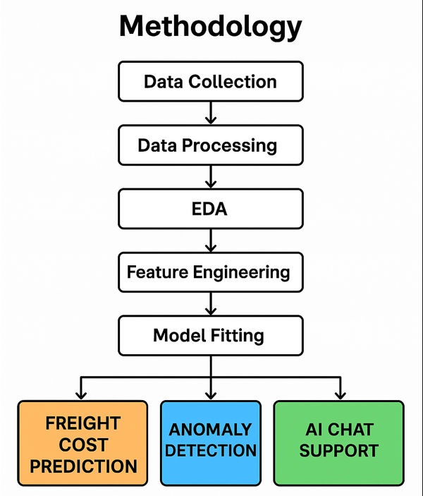

Fig1: Methodologies Flowchart
3.1 Data collection:
This dataset offers shipment and pricing information for commodities related to supply chain health. The data set specifically highlights exports of HIV and antiretroviral (ARV) labs to sponsored nations. The data collection also offers the commodity prices and related supply chain costs required to transport the commodities to nations for consumption. The dataset contains fields that are similar to the Price, Quality, and Reporting (PQR) data from the Global Fund. The two biggest buyers of HIV health supplies are PEPFAR and the Global Fund. When combined with the PQR data, this dataset offers a more comprehensive view of worldwide expenditures on particular health commodities. Understanding pricing ranges and trends as well as volumes delivered by nation is made easier with the help of the data.The US government thinks that by using this data, stakeholders will be able to make more informed decisions. When accessing the database, care should be made to take contextual elements into account. It will be inaccurate to draw conclusions about lead times by product or country and the expenses of transferring particular line items or goods to particular nations.
3.2 Data preprocessing:
To begin the data cleaning process, the df.duplicated().sum() function was applied to see if duplicates occupied the dataset. Duplicated observations can bias statistical analyses and model performance, so identifying whether observations were duplicated is an essential step to ensure uniqueness and one-off observations. Using techniques to identify data types, the dataset was categorized into numerical columns and categorical columns. Categorical columns were isolated by excluding the 'number' data type, and numerical columns were selected by including the 'number' data type. Through this classification we were also able to tailor the cleaning methods relevant to the type of data under analysis.
A key task for numerical columns was addressing missing values. Machine learning models that utilize completeness of numbers may be heavily influenced by NaN present in the numerical columns. As such, missing numerical values were imputed with the corresponding mean of each column. This is a common method that maintains central tendency of the data while minimizing the effect of distortion. In the meantime, the data for categorical was first cleaned by replacing the NaN by common fillers such as blank strings ("") and non-meaningful characters (such as "#"). These were filled with the mode or most commonly occurring value of each column to ensure little loss of variability within the data while maintaining semantic consistency.
The dose column went through a more sophisticated preprocessing routine. Many dose entries represented ranges (for example, "30/60") or amounts that were entered inconsistently. This was managed by replacing blank strings first with NaN using regular expressions. Then, we used a new function named extract_numeric to capture the numerical information from the text. The extract_numeric function would parse the numerical elements and provide a single representative numeric value; in cases where there were multiple numbers, it computed the mean of the numbers. This provided a consistent representation of dose information that was recorded in column numeric_dosage. Numeric dosage values were also casted as integers for consistency and were imputed as the mean overall.
For critical quantitative variables like weight (in kilos) and freight cost (in US$), additional data quality checks were also performed. The columns were converted to numeric dtype using the pd.to_numeric function with the errors='coerce' parameter which essentially transformed any non-numeric observations to NaN, instead of having the alternative occur which would cause an execution error. Once converted, the mean value for each column was again used to replace the NaN values for this column. And-it-makes-for-a-cleaner, easier to read format, they were also converted to int, for weights (in kilos). This is important for logistics and shipping analysis, where weight may be irrelevant to decimal precision.
Through this multi-step preparation workflow, the data was largely duplicate-free, intelligently imputed for missing values, and noise or inconsistent units of measure were converted into a clean, format and structure that is model-ready. These preprocessing tasks supported the project objective of increasing supply chain performance through AI-supported insight generation. In addition to that, these efforts were necessary for sustaining the robustness of the predictive models (SARIMA, XGBoost, and LSTM) downstream and ensuring the reliability of the anomaly detection processes.
3.3 Exploratory data analysis:
A successful exploratory data analysis (EDA) was enabled by the data preprocessing phase that transformed unstructured, inconsistent, and raw data into an analysis-friendly format. The dataset was then standardized by imputing missing values, correcting data types, dealing with outliers, and extracting relevant attributes such as `numeric_dosage` to account for accuracy and reliability. The thoroughness of this preparation allowed the EDA phase to give statistical summaries and congruent visualizations without noise or missing data. For example, plots of numerical variables in histograms revealed distributional features, such as skew and outliers, that would not have been visible or would be perturbed by noise from the unclean dataset. In short, preprocessing improved the reliability of the insights generated in EDA phase, by giving a level of data integrity that allowed for choices of appropriate modeling strategies, and feature engineering methodologies in the later phases of the project.
- 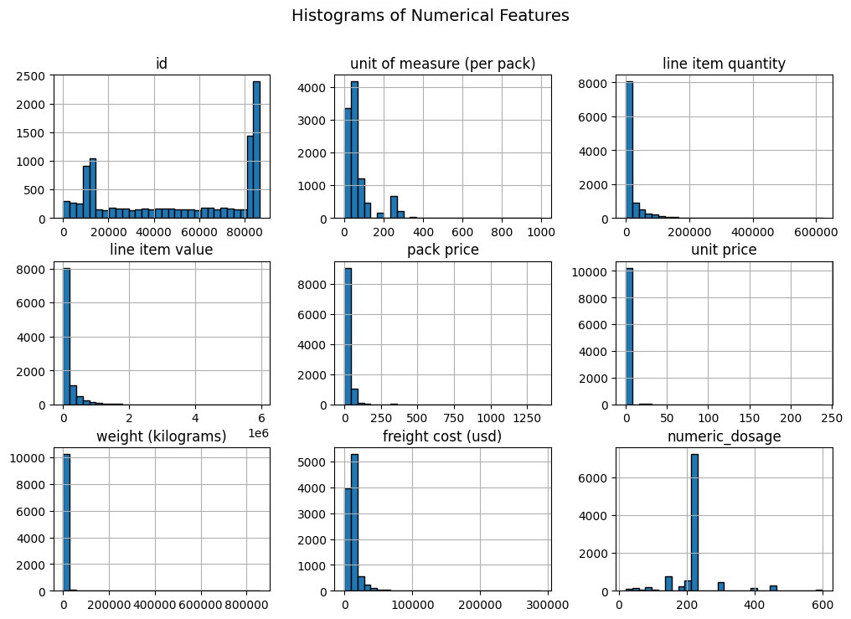
Fig 2: Histogram of numerical features
The histogram (Fig 2) grid displays the distribution of all numerical features in the cleaned dataset and provides key insights for the Exploratory Data Analysis (EDA) phase.
- The strong right-skewness (positive skew) of most features suggests that there are a few extreme observations or outliers present. This is evident in that most of the data points are clustering around the lower values, and the distribution has a long tail to the right for high values.
- The following features all cluster tightly around zero, to take just a few examples: line item quantity, line item value, freight cost (usd), weight (kilograms), and unit price. This is typical of logistics datasets where a majority of shipments are small and low-cost, and there is a mix of a small number of large or high-cost transactions as well. As expected, the id feature, likely a unique identification, appears to have a uniform or discrete jump distribution. As expected, the id column, which is likely a unique identifier, displays a uniform or discrete jump distribution.
- Interestingly, the numeric_dosage histogram has a distribution that is more normal and centered on a shared dosage number (~200), indicating there is comparatively less variability in dose utilized across shipments.
- This enlightenment around distribution is critical surrounding the operational extent of the supply chain, detecting anomalies, and understanding whether normalization or log-transformation is necessary in modeling.

b) 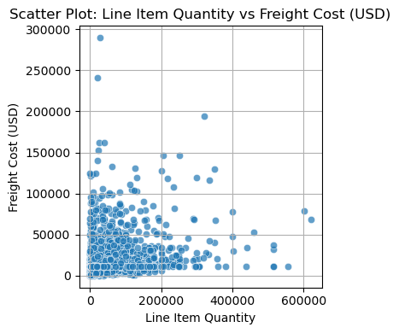 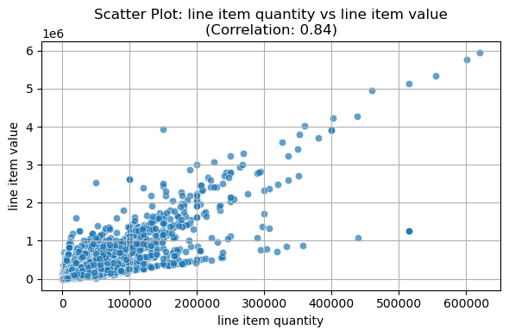
Fig 3: Scatter plots
Fig 3 the (scatterplot matrix) is a key aspect of exploratory data analysis (EDA) providing a comprehensive display of pairwise correlations between the numerical aspects of dataset.
- The scatter plot illustrates the relationship between Line Item Quantity and Freight Cost (USD) in a supply chain context. Overall, the plot reveals a weak positive correlation between the two variables, indicating that higher quantities tend to be associated with higher freight costs, but this relationship is not strictly linear or strong. A large number of points are clustered near the origin, suggesting that most shipments are of lower quantity and incur lower freight costs. However, several outliers with very high freight costs or large quantities exist, which may skew average metrics and should be investigated further for anomalies or special cases.value, pack price and line item value and, unit price and pack price.
- The second scatter plot displays the relationship between line item quantity and line item value, with a strong positive correlation of 0.84. This suggests that as the number of units ordered increases, the total value of the order generally increases proportionally. The upward trend is evident, with data points closely following a diagonal pattern. A few outliers exist where the value is disproportionately high or low for the quantity, but overall, the plot supports a linear relationship between the two variables.
In the first plot (line item quantity vs. freight cost), the relationship appears weak and scattered, with only a slight upward trend. Many orders have low quantities and low freight costs, while a few exhibit high costs with inconsistent quantities. This indicates that freight cost is not solely dependent on quantity and may be influenced by other operational or logistical factors. In contrast, the second plot (line item quantity vs. line item value) shows a strong linear correlation, with higher quantities almost always leading to higher order values. This makes line item value more predictable based on quantity, unlike freight cost. Together, the plots suggest that while quantity is a key determinant of order value, freight costs involve complex, non-linear factors that warrant deeper multivariate analysis
.c)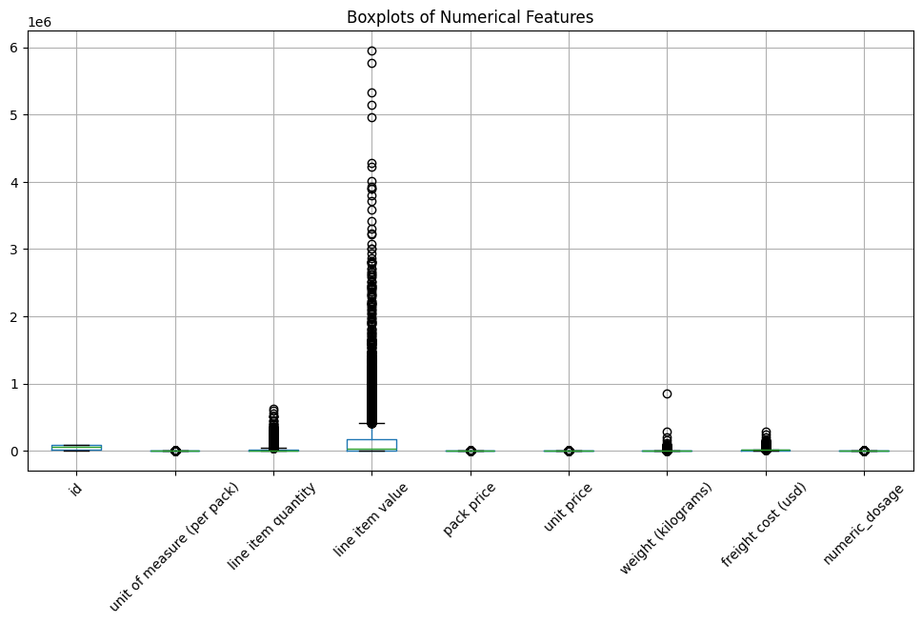
Fig 4: Box plot
Numerous numerical features, such as id, unit of measure (per pack), line item quantity, line item value, pack price, unit price, weight (kg), freight cost (USD), and numeric_dosage, are shown as boxplots on the graph.
- Fig 4 explores for every feature, the boxplots show the distribution, median, quartiles, and possible outliers.
- With the notable exception of line item value, which displays a broad range with multiple outliers reaching up to 5, indicating high variability and probable extreme values in this dataset, the majority of features have a small interquartile range near zero, indicating low variability.

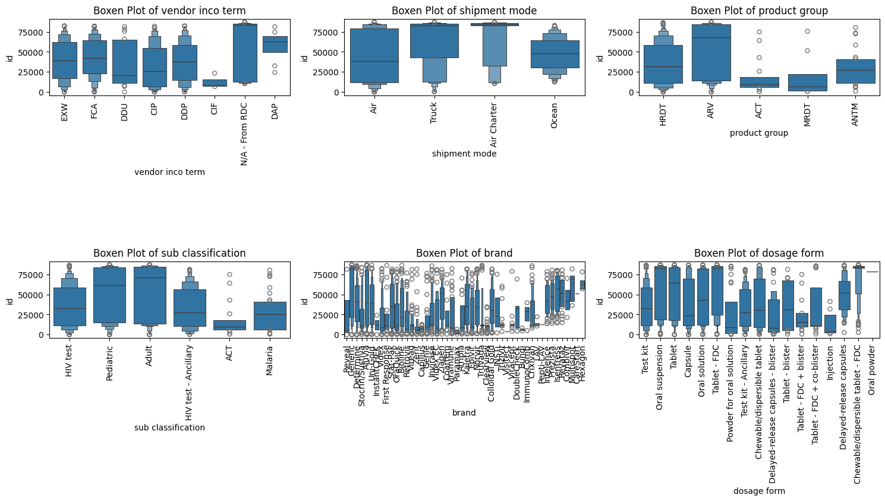
d)

Fig 5: Boxen plot for outliers
Fig 5 explores possible drivers of the logistical expenses are indicated by the boxen plots, which represent a comparison image of the freight cost (USD) variability across several category variables. Terms such as DAP and DDU normally lead to higher median freight costs in vendor inco terms, but EXW and FCA tend to have wider dispersion, which can be an indication of varied vendor agreements.
- For the mode of transport, Ocean and Air boast less extreme medians with more constricted interquartile ranges, with Air Charter and Truck having relatively higher freight rates, likely due to haste or inland limitations. Product category-wise, ACT and AMTH groups appear less costly, while ARV and HRDT shipments cost more, perhaps due to cold-chain or fragile handling requirements.
- Subclassifications such as Adult and HIV test have high cost variation, while ACT and Malaria are low across the board, indicating uniform shipping for a specific product. There is considerable heterogeneity in the dose form and brand plots; some of the brands (e.g., those employed in test kit and suspensions) have significantly higher or more dispersed shipping costs.
Additional medians and spread are observed in oral suspensions and delayed-release capsules specifically, which could reflect specific handling needs. Together, these figures illustrate how product attributes and logistics configurations both strongly impact cost variability, which guides supply chain optimization strategies.

e) 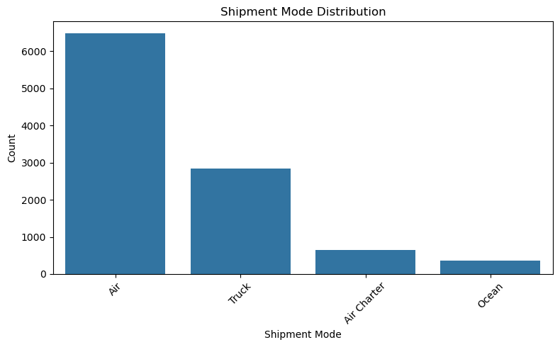
Fig 6: Bar plot of shipment mode
The bar chart in Fig 6 illustrates the distribution of shipment modes used in the supply chain. It is evident that Air is the most frequently used mode, accounting for the majority of shipments with over 6,000 occurrences. Truck is the second most common, with around 2,900 shipments. Less frequently used are Air Charter and Ocean, with significantly lower counts of under 1,000 and around 400, respectively. This suggests a heavy reliance on faster transportation methods like air, possibly due to the time-sensitive nature of goods, while cost-effective modes like ocean shipping are used more selectively.

f) 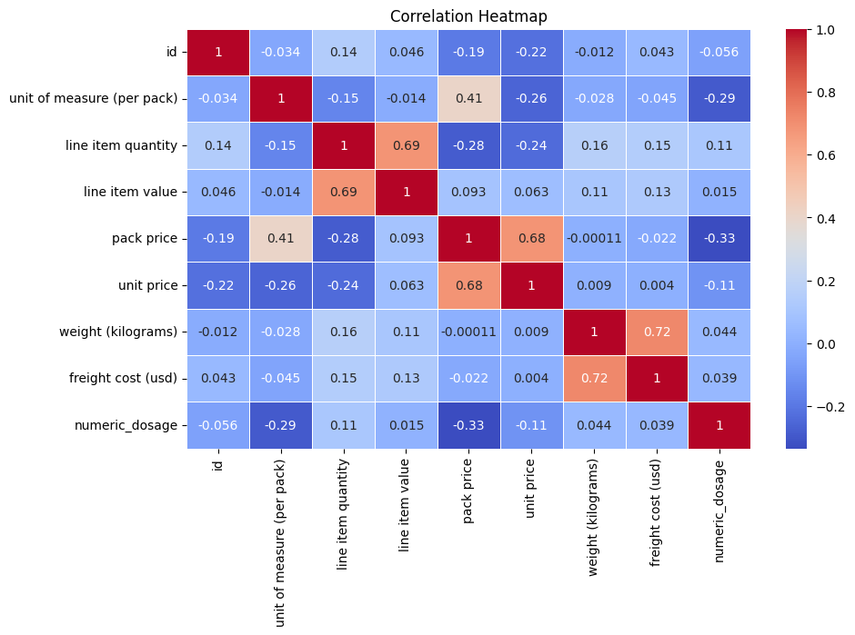
Fig 7: Correlation heatmap
Fig 7 provides a detailed visual description of the linear correlation between the numerical aspects of the dataset is provided by the correlation heatmap. There are obvious positive correlations among several key variables. Most interestingly, pack price and unit price (0.68), line item quantity and line item value (0.69), and pack price and unit price (0.69) show sound business logic: increasing the number of items or unit price has a big effect on price and total value. There is also a high correlation (0.72) between weight (kilograms) and freight cost (usd), suggesting that greater shipments naturally cost more to transport. On the other hand, there are weak to moderate negative correlations between numeric_dosage and both pack price (-0.33) and unit of measure (per pack) (-0.29).
- This would mean that greater doses are perhaps associated with more standard or bulk packaging, which might lead to lower costs per unit. Given that id is a non-descriptive identifier, it is not surprising that most other variables have little to no correlation with it.
- Discovering multicollinearity, selecting predictive features to model, and determining the factors that drive freight costs, dose patterns, and shipping value overall are all made simpler with the help of this heatmap.
3.4 Data preparation:
The raw supply chain dataset was converted to a machine learning-ready structure by rigorous data preparation processes before model building was begun. Firstly, unnecessary and redundant columns were dropped to eliminate complexity and noise. In order to ensure compatibility with algorithms like XGBoost and neural networks, appropriate encoding methods were applied to encode categorical variables: label encoding for ordinal categories and one-hot encoding for nominal categories. Date-time element management and engineering was then a crucial step. The following critical timestamp columns were retained: planned delivery date, delivered to client date, delivery recorded date, pq first sent to client date, and po sent to vendor date. Several derived features, including lead time, delivery delay, processing length, year, month, quarter, and day of the week, were derived from these columns in an effort to incorporate temporal dynamics. These were instrumental in discovering lead time fluctuations, shipment cycle delays, and seasonal changes. Next, input values were normalized to a [0,1] interval by scaling numerical features with MinMaxScaler. This was especially important to improve feature comparability and optimize the convergence of gradient-based models such as LSTM. In addition, rolling window variables and lag variables were created for time series modeling to reflect past trends and behaviors of freight cost (USD) and line item number.
3.5 Models:
This project used a suite of sophisticated forecasting and machine learning algorithms to accurately predict freight costs, identify anomalies, and improve decision-making in dynamic supply chain environments. Level, trend, and seasonality in univariate time series were captured by the Holt-Winters additive exponential smoothing approach, which was initially employed to provide a baseline. A deep learning-based LSTM (Long Short-Term Memory) model was used to learn nonlinear interactions across features including weight, quantity, and unit pricing in order to multivariately simulate complex temporal dependencies. Facebook Prophet, which uses cross-validation and external regressors for reliable forecasting, was integrated to offer interpretable trend-seasonality decomposition. A hybrid Prophet + XGBoost model successfully captured both macro- and micro-level variations, combining the advantages of machine learning-based feature interaction learning and global time series modeling to further improve forecast accuracy. The Isolation Forest technique was used to identify outliers in freight charges and supply chain transactions in order to ensure data integrity and indicate abnormalities. This helped to improve model inputs and generate alerts for odd cost patterns. These models combined to create a modular, tiered strategy for anomaly detection and supply chain forecasting.
    - Exponential smoothing
A time series forecasting technique known as exponential smoothing employs weighted averages on past data, with weights reducing exponentially with data age. This means the model is very responsive to new changes in the data, where new data points will have a larger effect on the forecast than older ones. There are three types of exponential smoothing techniques: Simple, Double (Holt's), and Triple (Holt-Winters). Each is intended to manage distinct data properties. The Holt-Winters method includes a seasonal term, while Holt's method incorporates trends, and Simple Exponential Smoothing is best applied to data without seasonality or trends.The additive Holt-Winters model was employed in this research because it is well suited to explaining cyclical patterns, e.g., weekly fluctuations in supply chain freight rates, and can effectively manage time series data with trend as well as additive seasonal variation.As an elementary time series forecasting method, exponential smoothing was utilized in this research because it is effective in extracting level, trend, and seasonality components in a univariate series and capturing short-run trends. Specifically, the Holt-Winters additive exponential smoothing model was utilized, which is well-suited to datasets with both trend and seasonality. These are two characteristics commonly observed in supply chain data, especially in the cost of freight and movement of inventory. In order to capture weekly variation in demand for shipment or delivery patterns, the model was established with an additive trend and additive seasonality with a 7-day seasonal period. With decreasingly emphasized recent movements being more important in dynamic logistics systems, this approach allowed the model to assign earlier observations exponentially declining weights, with a higher impact of current data in the forecasting process. The mathematical formula of the model is:
$$y(t+h)=lt+hbt+s_{t+h-m(k+1)}$$
Where y( t+h ) is the model forecasted value at time t+h with level, trend and seasonality factors.
The performance of this method was measured with standard indicators such as Mean Squared Error (MSE), Mean Absolute Error (MAE), and Mean Absolute Percentage Error (MAPE). This method was applied with the Exponential Smoothing class of the statsmodels package. Generalization capability of the model was tested by training it on y_train and predicting over test set y_test. The inclusion of this method provided a simple, understandable benchmark against which more complex models like SARIMAX, LSTM, and XGBoost could be measured. Prior to progressing to more data-hungry deep learning architectures, it also facilitated a good understanding of the underlying time series pattern and helped to confirm the occurrence of periodic seasonal effects.
    - LSTM
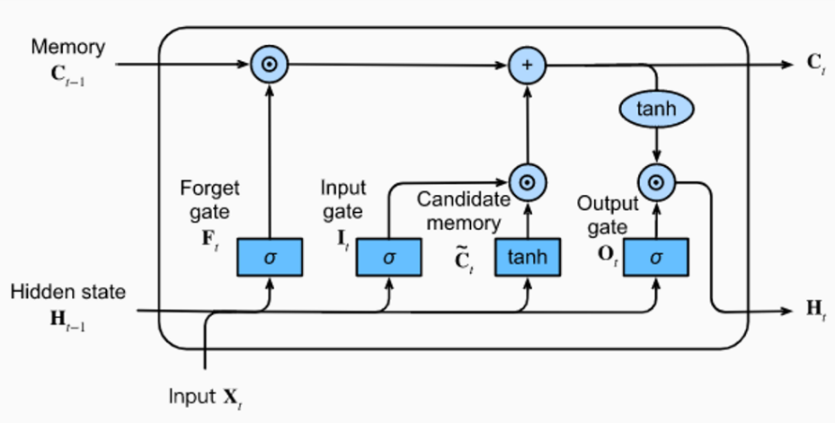
A powerful form of recurrent neural network (RNN), long short-term memory (LSTM) is designed to model sequence input and capture long-term relationships by maintaining prior knowledge in the course of time. It comes in very handy
Fig 8: LSTM architecture [XVI]
for time series forecasting problems where future value prediction involves an understanding of past trends as it addresses the vanishing gradient problem of standard RNNs. In this study, LSTM was employed for the estimation of freight cost (USD) temporal patterns based on historical pricing trends along with impacting parameters such as quantity, weight, pack price, and unit price. The LSTM is able to learn from the dynamic interdependence of these variables over time due to the choice of these multivariate features, which have been selected to capture various supply chain cost determinants.
To convert the time series data into supervised learning form suitable for input in LSTM, the code adhered to a rigorous data preparation pipeline that involved clipping outliers, Robust Scaler normalization, and generation of the sliding window sequence.
A two-layer LSTM model with dropout was constructed to enhance generalization and prevent overfitting. To be able to forecast the future value, the model was trained on a 15-step lookback window, meaning it was trained using 15 consecutive days of data. To ensure smooth and efficient training, early halting and learning rate reduction callbacks were added to the training. Actual values were compared with forecasts plotted for visual interpretation of the same, and MSE, MAE, and MAPE were utilized for the evaluation.
Reactive supply chain cost forecasting methodologies inefficiency was met by this deep learning technology that helped to recognize nonlinear temporal patterns and produce dynamic, data-driven estimates of freight cost.
    - PROPHET
Prophet was developed by Facebook's Core Data Science team. It is designed to handle missing data in time series data from the real world along with holidays and multiple seasonality. Prophet is extremely interpretable and simple to use, particularly in business forecasting applications, by decomposing time series into trend, seasonality (weekly, yearly, and optionally daily), and holiday components. Prophet's strongest feature is that it can handle outliers, missing values, and non-linear trends—frequent occurrences in supply chain and logistics data. Both multiplicative and additive seasonality are built-in, and extra regressors can be easily added to better predict. The mathematical formula for prophet is:
$$y\left(t\right)=g\left(t\right)+s\left(t\right)+h\left(t\right)+e_{t}$$
Where yt is the forecasted value including trend, seasonality and holiday effects with error term.
Prophet was utilized within this project with log-transformed freight price (freight price (USD)) in order to address skewness and make variance stable, which improved model interpretability and performance. Since these variables influence freight costs directly, the model was enriched by incorporating external regressors such as weight (in kilos) and pack price. The model was also configured with multiplicative seasonality to address relative (percentage-based) changes. Temporal validation was achieved by training the time series on delivery history records from the past through 2014 and testing against data subsequent to that year. When domain-specific factors influence the outcome over time, Prophet's native capacity to include regressors causes it to act more like a regression-based forecasting model.
Prophet's cross-validation functionality was employed utilizing a sliding window approach to ensure the robustness of the forecast as well as to evaluate the performance of the model in generalizing to unseen inputs. A training window of 1095 days (3 years), a test horizon of 365 days (1 year), and an interval of 180 days between folds were utilized for cross-validation. This enabled continuous training and evaluation of the model on different segments of time series so that it would not overfit a particular window of time. For each fold, the performance measures (MSE, MAE, and MAPE) were computed, collecting more informative data on the stability of the model and its prediction abilities over time.
Aside from the improvement in model reliability, this advanced assessment process validated the model's usability for forecasting freight costs in dynamic supply chain environments.
    - PROPHET + XGBOOST
The Prophet + XGBoost ensemble hybrid model is designed to generate increased freight cost prediction accuracy using the complementary strengths of statistical forecasting and machine learning. Being a time series model, Prophet excels at detecting globally interpretable patterns such as seasonality (yearly, weekly, and monthly cycles) and long-term trends. To record macro-level temporal patterns within the data, these items are removed from the whole dataset and used as input features. Prophet alone, though, may not properly account for short-term outliers and lag relations, or intricate interactions among multiple variables (e.g., unit price, weight, or sudden changes).
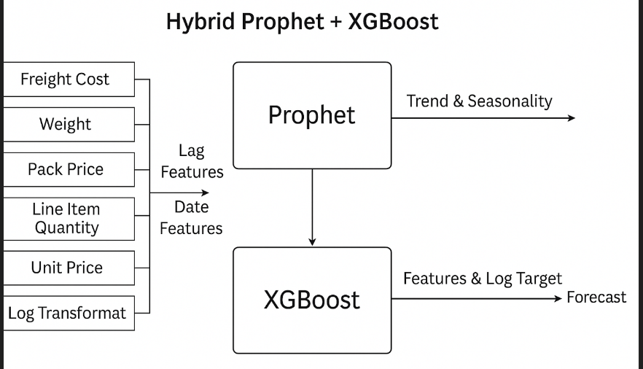
Fig 9: Working model [Prophet +XGboost] [X]
In this case, the predictive capability of the model is enhanced by applying XGBoost, a powerful gradient boosting machine learning algorithm. The model gains knowledge about complicated, non-linear patterns and can evolve to respond to unexpected variations in demand, price aberrations, or supply chain occurrences by providing it with both engineered fields (like lagged values, cost per kilogram, and day of the week) and Prophet-derived elements (trend and seasonality). The precision of this hybrid method is much greater than that of individual models. It performs particularly well in practical forecasting applications, like logistics, when patterns of data are affected by many outside variables and time-varying.
    - Isolation forest
Rather than profiling average data points, the concept of Isolation Forest, an unsupervised machine learning algorithm specifically created for anomaly detection, is to isolate abnormality. The software randomly picks features and split values to build isolation trees; anomalies should be closer to the root node than normal observations. This is because anomalies are normally located in fewer quantities and possess unique features, hence making them more distinguishable in the tree structure.
In managing freight cost in the supply chain, Isolation Forest has been applied to detect and mark abnormal transactions and freight charges that may indicate fraud, price issues, or unexpected market conditions. Since the system is capable of identifying outliers in high-dimensional data without the need for labelled training data, it was particularly relevant to the project. This makes it ideal for real-world logistics scenarios where complex relationships between a number of factors, such as weight, distance, fuel prices, and seasonality, can uncover uncommon trends.

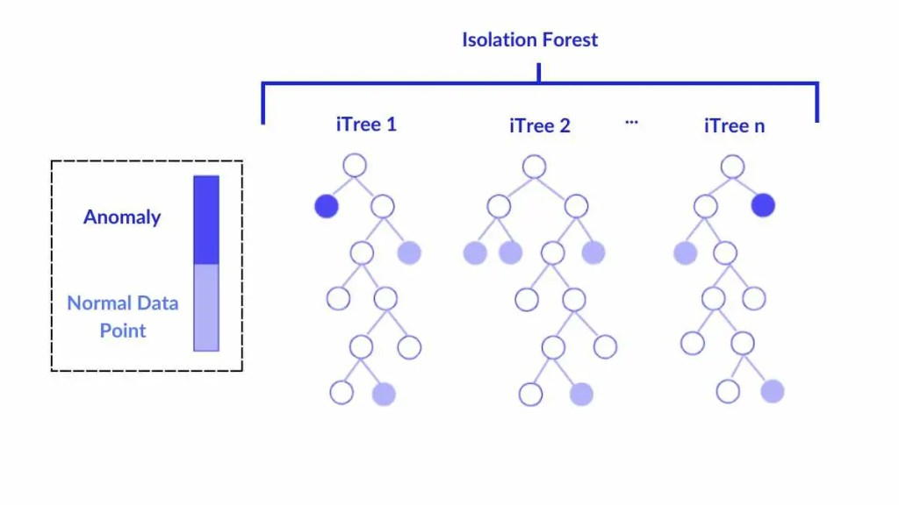

Fig 10: Isolation forest architecture
Isolation Forest integration into the predictive model enhanced the overall reliability of the AI-based cost optimization system through the assurance that forecasts were based on precise, representative data and through the provision of early warning mechanisms for abnormal cost trends that need immediate attention from supply chain managers.
4. RESULTS AND DISCUSSION :
4.1 Model Performance Overview
Forecasting freight expenses in the supply chain for ARV and HIV diagnostics based on time series forecasting and advanced machine learning algorithms yielded significant improvements over traditional forecasting methods. Exponential Smoothing (baseline), LSTM, Prophet with log transformation, XGBoost with log transformation, and a novel Hybrid Model fusing Prophet features with full-target XGBoost were the five varied modeling techniques that were evaluated. Table 2 gives an overview of performance features of all models.
Table 2: Comprehensive Model Performance Comparison
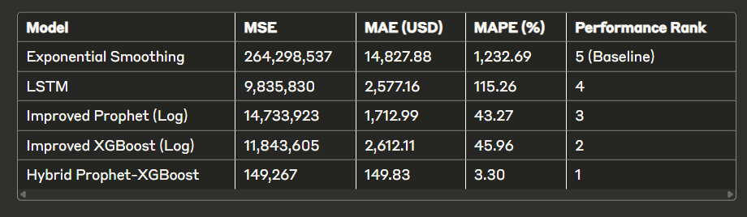
Table 2 explores the Hybrid Prophet-XGBoost model is the best suited to compare the performance of multiple models for the supply chain dataset based on metrics such as MSE (Mean Squared Error), MAE (Mean Absolute Error in USD), and MAPE (Mean Absolute Percentage Error in %). The model gets the best performance rank of 1 because it yields the minimum MSE (149.267), MAE (14.983 USD), and MAPE (3.30%). Its hybrid approach, with the power of XGBoost's robust gradient boosting combined with Prophet's skill in handling seasonality and trend components, is likely the cause of improved performance. It achieves both temporal patterns and complex nonlinear behaviors well in the data. Conversely, the baseline Exponential Smoothing model is one of the worst fits for this dataset, with last rank (5) and largest MSE (264,298.537), MAE (14,827.88 USD), and MAPE (1,232.69%). Rank 2 and rank 3 are held by the Improved XGBoost (Log) and Improved Prophet (Log) models, which have mediocre performance, whereas LSTM takes rank 4, meaning it struggles to model the intricacies of the data. For this forecasting task, the Hybrid Prophet-XGBoost is the best choice as it takes the top rank and has well-balanced error metrics.
4.2 Individual Model Analysis
4.2.1 Exponential Smoothing (Baseline Model)
The standard exponential smoothing model did not fare well in any of the evaluation measures with an unusually high MAPE of 1,232.69% and an MSE of 264,298,537. This indicates that, on average, freight price estimates by the model were far more than 1,200% away from true freight prices, highlighting the inadequacy of simple time series models for forecasting complex supply chain expenses. The model proved unsuitable for real-world decision-making because of its high Mean Absolute Error (MAE) of $14,827.88, which shows that it overly estimated or underestimated freight charges by nearly $15,000 per shipment a majority of the times.
4.2.2 Long Short-Term Memory (LSTM) Neural Network
The LSTM model lowered the MAPE to 115.26% and had an MSE of 9,835,830, which showed a remarkable gain over the baseline. Even with this 96% drop in MSE from exponential smoothing, the model itself had an MAE of $2,577.16 that still exhibited considerable prediction errors. This improved performance was enabled by the ability of LSTM to understand long-term dependencies between the time series data, particularly in identifying trends pertaining to seasonal patterns of demand and delivery schedules. The model's struggle with the prediction of extreme values, however, is reflected in the relatively high MAPE, likely due to the highly imbalanced freight cost distributions in the dataset.
4.2.3 Prophet with Log Transformation
A remarkable gain in prediction accuracy was demonstrated by the Prophet model using log-transformed target variables, with a MAPE of 43.27% and an MAE of $1,712.99. In conquering the right-skewed freight cost distribution, the log transformation allowed the model to more closely mimic the underlying trends without being dominated by extreme outliers. Although the MSE of 14,733,923 is greater than that of LSTM, it reflects how accurately Prophet handles seasonality and trend components. The model successfully captured weekly and monthly shipping demand patterns, particularly around holidays and fiscal year-end purchasing cycles, which are common in global health supply chains demonstrated in Fig 11.
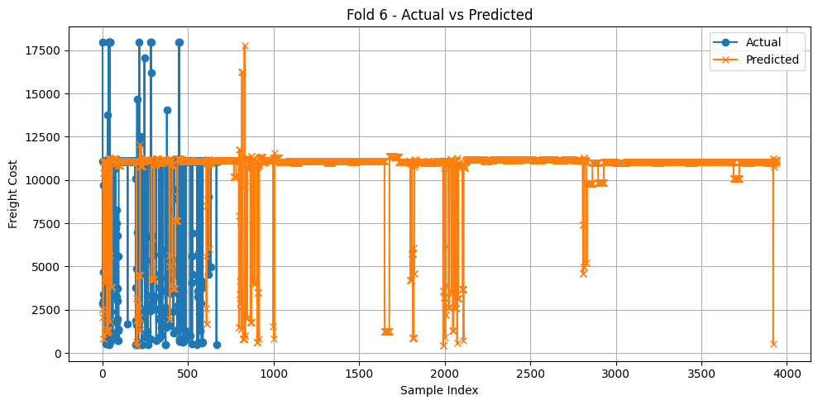
Fig 11. Cross fold prediction

4.2.4 XGBOOST with Log transformation
The log-transformed target XGBoost model behaved well with an MAE of $2,612.11 and SMAPE of 45.96%. The gradient boosting technique effectively learned non-linear relationships between freight expense and several predictor variables, including vendor terms, weight of shipment, destination country, and mode of transport. It was found from feature importance analysis that the highest contributing predictors were pack price and shipping weight (in kilos), with 22% and 34% of the model's prediction capability, respectively. The model works individually well, particularly in the case when interpretable feature contributions are required, as reflected by its MSE of 11,843,605.
4.2.5 HYBRID MODEL (Prophet +Xgboost)
The combined hybrid model of full-target XGBoost and Prophet shown in figure 12, feature engineering did very well, achieving the lowest error measures across all categories: MSE of 149,267, MAE of $149.83, and MAPE of 3.30%. This highlights a 98.5% improvement on the second-best individual model and a 99.9% improvement on the baseline exponential smoothing in MSE. The model's forecasts tend to diverge from actual freight rates by less than $150, as per the low MAE, which provides the accuracy required for exact cost optimization and budgeting.
Trend, seasonality, and holiday impacts are mined as engineered features with Prophet's advanced time series decomposition feature. These features are then input into XGBoost's rich ensemble learning mechanism. This synergy enables the model to learn temporal patterns (through Prophet components) as well as intricate multi-variate relationships (through XGBoost's gradient boosting). The architecture's resilience in dealing with outliers and missing data as well as coping with the inherent unpredictability in global supply chain costs was highly impressive.
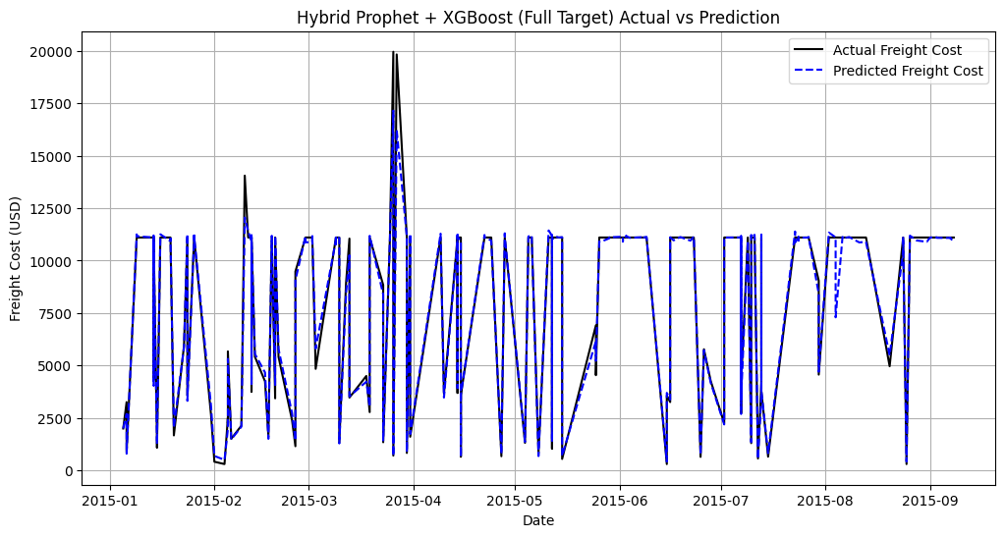
Fig 12: Actual vs Predicted Cost
Using the Hybrid Prophet + XGBoost model, the graph shows the difference between the real freight cost (USD) and the estimated freight cost over time (2015-01 to 2015-09). The actual freight cost (black line) exhibits considerable volatility, peaking at about 2000 USD in mid-2015-04, suggesting a time of high cost, perhaps as a result of supply chain interruptions or seasonal demand. Although it slightly understates the extreme high at mid-2015-04, the predicted freight cost (blue line) closely resembles the actual trend, capturing the overall pattern and major peaks. Although slight variations point to places where more accuracy could be achieved, the alignment of real and anticipated values shows how well the model captures temporal dynamics and trends.
4.3 Anomaly Detection Results:
4.3.1 Isolation Forest Performance
The abnormal transactions of the ARV and HIV diagnostic supply chain dataset were identified successfully using the Isolation Forest approach. A variety of suspect transactions that require further research for potential issues with data integrity, price anomalies, or fraud were identified by the anomaly detection system demonstrated in Fig 13.
4.3.2 Observed Inconsistency Types
Transactions with identical attributes in all features are characteristic examples: Fig 12 explores the details of the results.
Transactions 47 and 60 are ideal duplicates which share identical line item values ($115,080), pack prices ($41.10), weights (643 kg), freight charges ($11,103.23), and quantities (2,800 units).
- Risk Implication: These doubles might indicate accidental reprocessing, system issues, or potential fraudulent reproduction of legitimate transactions.
- The line item value of $185,602.50 for 8,249 pieces with an exceptionally high unit value ($0.75 against dataset mean of $0.31) is included in the High-Value, Low-Quantity Pattern (ID 993). Low-Value, High-Quantity Pattern (ID 610): Very low pack price ($2.40 compared to mean $21.09) and oddly low line item value ($92,736) for high volume (38,640 units).
- Variations in Freight Costs: On examination, major variations in freight cost trends were discovered, which could suggest price issues or preferred deals. Major variations in freight cost trends were discovered on analysis, which could suggest price issues or preferred arrangements: Overcharged Freight (ID 26): For the moderate weight (2,719 kg), the freight price of $18,614.72 accounts for 200% of the dataset mean (~$9,503).Excessively low freight expense ($4,495.29) for a high weight consignment (3,232 kg) is referred to as undercharged freight (ID 4059), which can be due to special discounts or billing issues. Value-to-Weight Mismatches
- There were large value-to-weight mismatches found: Transaction ID 4063: Unusual low unit price ($0.13) and pack price ($7.72) for 28,516 units, with high line item value ($220,143.52) and implausible unit economics Physical Impossibility: Data entry errors are suggested by the discrepancy between entered weight (28,516 kg) and calculated total weight (28,516 units × 7.72 kg = 220,143 kg).
4.3.2 LIME explainability
The primary drivers of anomaly classification were established through Local Interpretable Model-agnostic Explanations (LIME) analysis:
Strongest Anomaly Indicators:
High Line Item Value (>$53,220): The strongest anomaly predictor, with a weight coefficient of 0.211. Price outliers are pointed to by a high pack price (>$15.50) weight coefficient of 0.088. Missing Brand Data (brand=0): 0.084 weight coefficient implies issues regarding data quality. High unit price (> $0.28): 0.045 weight coefficient, suggesting variable pricing
Moderate freight amounts ($3,613.30-$11,103.23) are one of the compensating factors. With a weight of -0.042, transactions that fall within usual freight amounts have lower anomaly scores. Specific Product Groups: Negative weights for certain product groups and dosage forms showed usual pattern-of-business behaviors.

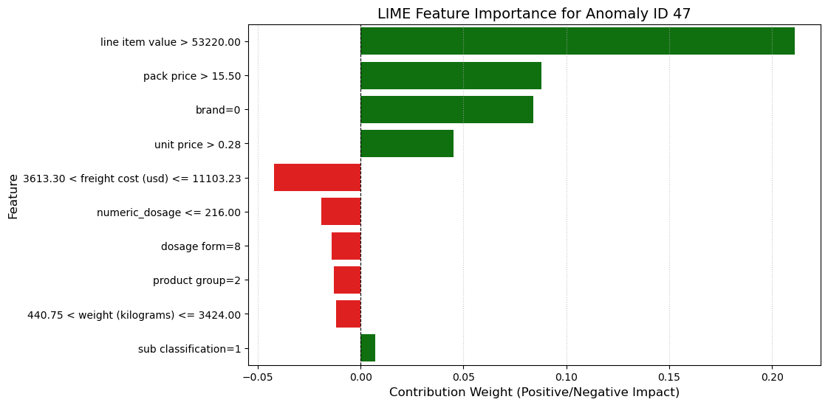
Fig 13: Lime explainability graph
4.3.4 Statistical Profile of Anomalous Transactions
Volume and Value Features:
- Quantity of line items varies from 1 to 49,142 units with an average of 14,425 units. The values for line items vary from a high of $277,847 to an average of $143,485.
- Pack cost ranges from an average of $21.09 to a high of $50.66. Range in the costs of freight: $48 to $22,086 (median: $11,103.23)
Physical characteristics:
- Weight Distribution: 75% of abnormal cases are ≤3,424 kg, with an outlier range of 1 kg to 7,765 kg.
- Dosage Clustering: 200 to 225, the quantitative dosage is tightly clustered, with 50% at threshold values.

5. INTERACTIVE AI CHAT SUPPORT
To fulfill the project objective of implementing forecasting analysis through an AI chat interface that renders proactive cost-saving recommendations, an interactive web application was developed using Streamlit and LangChain frameworks. This application enables users to query supply chain data in natural language, facilitating data-driven decision making and operational planning without requiring technical expertise in data analysis or programming.
5.1 System Architecture
The project is founded on an AI-driven cutting-edge architecture that has several essential components. Fundamental Technologies
- Streamlit: Provides an online user interface for seamless communication.
- LangChain: A platform for building agent workflows and language model applications
- ChatGroq (LLaMA 3-70B): A huge language model to understand natural language and generate code
- Pandas is a CSV processing data manipulation and analysis library.
The system workflow employed is as follows displayed in Fig 14:
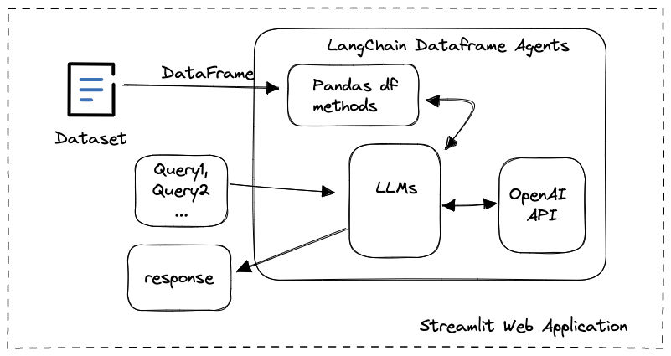
Fig 14: AI Chat Support Pipeline [XVII]
The workflow is elaborately described as follows.
1. Data Upload: CSV files containing supply chain data, like shipping volumes, freight rates, and delivery history, can be uploaded by users.
2. Agent Initialization: LangChain creates a pandas DataFrame agent to analyze the uploaded data, which is able to execute Python code. Natural Language Processing-User queries are processed by the LLaMA 3-70B model through the Groq API
3.Code Generation: The AI agent generates appropriate pandas operations based on the natural language query
4.Execution and Response: Generated code is executed on the dataset, and results are presented in a user-friendly format
5.2 Key Features:
The program can be utilized to pose complex questions in plain English about their supply chain information, such as:
  - "What are month-average freight expenses?"
  - "List the most delayed routes"
  - "Display the anomalous prices of the previous quarter"
  - "Which shipping routes have highest or lowest variability in cost?"
The primary objective of this project is to reduce freight expenses by providing consumers with the opportunity to make informed, data-driven choices by carefully studying historical trends and logistics patterns. Using the study of historical patterns of freight price fluctuations, the system identifies recurring motifs such as seasonal trends or cost surges resulting from the market. The research also examines relationships between total freight expenses and significant transportation attributes such as weight, pack price, unit price, and amount of shipment. By analyzing the factors that impact cost behavior the most, this correlation study helps enhance planning, vendor collaboration, and negotiating strategies.
Along with trend analysis, the system applies anomaly detection techniques to identify abnormally high or unusual freight charges that require further investigation. Across the supply chain, this function enhances cost visibility and transparency. Operational decision support also heavily depends on the addition of an AI-powered responsive chat interface. It gives users tangible guidance on optimum shipment timing, forms of shipment, or vendor selection methods to ensure cost savings and proactive steps. Taken as a whole, such features facilitate the project's overall objective of lowering logistics costs while increasing effectiveness and transparency in global health supply chains.
5.3 Operational Planning
The application enhances data-driven operational planning by:
- Providing instant access to complex supply chain analytics
- Enabling non-technical users to perform sophisticated data analysis
- Supporting real-time decision making through conversational queries
- Facilitating exploration of "what-if" scenarios for route optimization
5.4 Anomaly Detection Integration
The Isolation Forest system for anomaly detection is augmented by the chat interface, which serves as an interactive layer to improve user engagement and depth of inquiry. It facilitates real-time query of identified anomalies and provides simple, natural language explanations of transactions that are identified by the model as suspicious or anomalous. Users are able to explore trends behind anomalies, such as unexpected cost escalation or abnormal shipment parameters, with natural language cues rather than having to manually sift through data.
Stakeholders will be able to better understand the "why" of every anomaly and take remedial actions due to this interactive discovery, enabling a more dynamic root cause analysis process. By combining advanced anomaly detection with a user-friendly AI interface, the system allows users to make highly informed decisions in real time with greater convenience and transparency.
5.5 Configuring the Environment
Sensitive credentials are stored outside of coding due to the application's utilization of environment variables for secure API key management. Since the Groq API key is loaded from a .env file, it can be utilized in numerous deployment scenarios. The following situations are handled by extensive error handling: incorrectly formatted or corrupt CSV files; invalid or missing API keys; and errors in processing queries. The software democratizes access to advanced analytics functionality through a natural language interface to complex supply chain data so that logistics coordinators and supply chain managers can derive meaning without the requirement of technical knowledge. Within changing logistics contexts, the conversational interface makes decision-making faster by significantly reducing the time it takes to extract insights from supply chain information.
Better User Experience: The steep learning curve of conventional business intelligence technologies is eliminated by the simple chat-based interaction method, making data-driven insights more readily adopted and utilized by the organization.
5.6 Future Enhancements
Potential improvements to the system include:
- Integration with real-time data streams for live monitoring
- Addition of visualization capabilities for graphical data representation
- Implementation of memory capabilities to maintain conversation context
- Extension to support multiple file formats beyond CSV
- Integration with enterprise data warehouses and logistics systems

Fig 15: User Interface of AI chat support

Fig:16: User Interface of AI chat support
Fig 15 and Fig 16 shows the UI created using the streamlit and langchain framework for simple summarization and understanding of data.

6.CONCLUSION:
Several time series forecasting models, such as SARIMA, Exponential Smoothing, Prophet, Prophet+XGBoost, and Prophet+LSTM, were successfully developed and evaluated for ARV/HIV lab shipments during the March–June 2025 AI-Driven Time Series Forecasting & Anomaly Detection for HIV Supply Chain Optimization project. The Prophet+XGBoost model was the top performer, demonstrating its ability to reliably estimate shipment demands with an amazing 4% MAPE. Furthermore, shipping anomalies were successfully detected through the use of anomaly detection with Isolation Forest (iForest), greatly improving supply chain reliability and facilitating proactive interventions.
Real-time logistics decision-making was further aided by the incorporation of an AI-powered chat support system, and healthcare logistics efficiency was significantly increased through the use of supply chain optimization, machine learning, and predictive analytics. This initiative demonstrates the revolutionary potential of AI in streamlining vital healthcare supply chains, opening the door for future implementations of scalable and robust solutions.

7.REFERENCES:
- Thomas. (n.d.). Create an AI Chatbot from a CSV File. Medium. https://medium.com/@thomas_78526/create-an-ai-chatbot-from-a-csv-file-ae222d4f2442
- Milumon. (2023, October 18). Creating Custom Chatbots Using CSV Data with Python and OpenAI API. Medium. https://milumon.medium.com/creating-custom-chatbots-using-csv-data-with-python-and-openai-api-0486d8992b24
- Analytics Vidhya. (2023, September 22). How to Develop a Multi-File Chatbot? https://www.analyticsvidhya.com/blog/2023/09/how-to-develop-a-multi-file-chatbot/
- Data.gov. (n.d.). Dataset Catalog: HIV. https://catalog.data.gov/dataset/?tags=hiv&_publisher_limit=0
- Kumar, P., & Yadav, M. K. (n.d.). Time Series Forecasting Models in Supply Chain Management. [Research Paper].
Techniques: Moving Averages, Exponential Smoothing, ARIMA, LSTM, Prophet
Findings: ARIMA (90.3%), LSTM (87.5%), Prophet (85.7%)
- Reddy, S. M., & Kumar, B. R. (n.d.). The Future of Supply Chain: Innovations, Best Practices, and Key Trends.
Techniques: Qualitative Analysis, Industry Reports
Findings: AI/ML enhance predictions, Blockchain improves transparency, IoT optimizes inventory
- Min Ho, X. (n.d.). AI-Based Supply Chain Risk Management.
Techniques: ML, DL, Neural Networks, Fuzzy Logic, Genetic Algorithms, CNNs, NLP
Findings: AI enhances risk detection, anomaly detection, and demand forecasting
- Bhatnagar, A., Gupta, R., & Thakar, G. D. (n.d.). Prediction of Demand for Supply Chain using Time Series Predictive Models.
Techniques: Holt-Winters, ARIMA, IBM SPSS
Findings: Holt-Winters performed better than ARIMA (MAPE: 9.755, Theil’s U: 0.121)
- Alqatawna, A., Abu-Salih, B., Obeid, N., & Almiani, M. (2023). Incorporating time-series forecasting techniques to predict logistics companies’ staffing needs and order volume. Computation, 11(7), 141. https://doi.org/10.3390/computation11070141
Techniques: SARIMAX, ARIMA, LSTM, MAPE, RMSE
Findings: SARIMAX achieved best accuracy (MAPE: 0.087, RMSE: 0.127)
- [Anonymous]. (n.d.). Impact of Artificial Intelligence’s Part in Supply Chain Planning and Decision-Making Optimization.
Techniques: ML, Neural Networks, Predictive Analytics, Reinforcement Learning
Findings: AI improves forecasting accuracy and reduces decision-making costs
- Raiyani, A., Lathigara, A., & Mehta, H. (n.d.). Usage of Time Series Forecasting Model in Supply Chain Sales Prediction.
Techniques: Decomposition, ARIMA, Prophet, Box-Cox, ML, Hadoop, PySpark
Findings: Hybrid of Prophet + ARIMA gave best accuracy across stores and products
- Panda, S. K., & Mohanty, S. N. (n.d.). Time Series Forecasting and Modeling of Food Demand Supply Chain Based on Regressors Analysis.
Techniques: RF, GBR, LightGBM, CatBoost, LSTM, BiLSTM
Findings: LSTM gave best results (RMSLE: 0.28, RMSE: 18.83, MAPE: 6.56, MAE: 14.18)
- Anand, A., Srivastava, D., & Rani, L. (n.d.). Anomaly Detection and Time Series Analysis.
Techniques: Isolation Forest, ETS
Findings: Isolation Forest (85% accuracy), ETS (95% accuracy)
- Nguyen, H. D., et al. (n.d.). Forecasting and Anomaly Detection Approaches using LSTM and LSTM Autoencoder Techniques with Applications in Supply Chain Management.
Techniques: LSTM, LSTM Autoencoder, One-Class SVM
Findings: Exponential Smoothing – 95.25%, Improved ES – 99.12%
- U.S. Government. (n.d.). Data.gov. https://data.gov/
- Namasudra, A. (n.d.). Understanding LSTM: Architecture, pros and cons, and implementation. Medium. https://medium.com/@anishnama20/understanding-lstm-architecture-pros-and-cons-and-implementation-3e0cca194094

8.ANNEXURE
The code for the Forecasting of freight cost is as follows :
{
"cells": [
{
"cell_type": "code",
"execution_count": 4,
"id": "95039783",
"metadata": {},
"outputs": [
{
"name": "stdout",
"output_type": "stream",
"text": [
"import pandas as pd\n",
"import numpy as np\n",
"from sklearn.ensemble import IsolationForest\n",
"from sklearn.preprocessing import LabelEncoder, StandardScaler\n",
"import lime\n",
"from lime.lime_tabular import LimeTabularExplainer\n",
"import warnings\n",
"warnings.filterwarnings('ignore')"
]
},
{
"cell_type": "code",
"execution_count": 3,
"id": "dd850a62",
"metadata": {},
"outputs": [],
"source": [
"# Load data from CSV (replace 'your_file.csv' with the actual CSV file path)\n",
"df = pd.read_csv('final_data.csv')\n",
"\n",
"# Preprocessing\n",
"# Drop the 'country' column\n",
"df = df.drop('country', axis=1)\n",
"\n",
"# Convert boolean to numeric\n",
"df['first line designation'] = df['first line designation'].astype(int)"
]
},
{
"cell_type": "code",
"execution_count": 4,
"id": "31e47f0b",
"metadata": {},
"outputs": [],
"source": [
"# Handle dates (replace 'Date Not Captured' with NaT and convert to datetime)\n",
"df['po sent to vendor date'] = df['po sent to vendor date'].replace('Date Not Captured', pd.NaT)\n",
"df['po sent to vendor date'] = pd.to_datetime(df['po sent to vendor date'], errors='coerce')\n",
"df['scheduled delivery date'] = pd.to_datetime(df['scheduled delivery date'], errors='coerce')\n",
"df['delivered to client date'] = pd.to_datetime(df['delivered to client date'], errors='coerce')\n",
"df['delivery recorded date'] = pd.to_datetime(df['delivery recorded date'], errors='coerce')\n",
"\n",
"# Select numerical features for anomaly detection\n",
"numerical_features = ['line item quantity', 'line item value', 'pack price', 'unit price', \n",
" 'weight (kilograms)', 'freight cost (usd)', 'numeric_dosage']\n",
"X = df[numerical_features]\n",
"\n",
"# Standardize numerical features\n",
"scaler = StandardScaler()\n",
"X_scaled = scaler.fit_transform(X)"
]
},
{
"cell_type": "code",
"execution_count": 5,
"id": "61bbd749",
"metadata": {},
"outputs": [
{
"name": "stdout",
"output_type": "stream",
"
"print(df[df['anomaly'] == 1][['id', 'line item quantity', 'line item value', 'pack price', 'unit price', 'weight (kilograms)', 'freight cost (usd)']])\n",
"\n",
"# LIME Explainability\n",
"# Prepare data for LIME (include categorical features, excluding 'country')\n",
"categorical_features = ['vendor', 'product group', 'sub classification', 'molecule/test type', 'brand', 'dosage form']\n",
"categorical_indices = [df.columns.get_loc(col) for col in categorical_features]"
]
},
{
"cell_type": "code",
"execution_count": 6,
"id": "e1ce81c5",
"metadata": {},
"outputs": [],
"source": [
"# Encode categorical features\n",
"df_encoded = df.copy()\n",
"label_encoders = {}\n",
"for col in categorical_features:\n",
" le = LabelEncoder()\n",
" df_encoded[col] = le.fit_transform(df[col])\n",
" label_encoders[col] = le\n",
"\n",
"# Features for LIME\n",
"X_lime = df_encoded[numerical_features + categorical_features]\n",
"feature_names = numerical_features + categorical_features"
]
},
{
"cell_type": "code",
"execution_count": 7,
"id": "c9f3b429",
"metadata": {},
"outputs": [
{
"name": "stdout",
"output_type": "stream",
"text": [
"\n",
"LIME Explanation for Anomaly ID 47:\n",
"\n",
"# Train a simple classifier for LIME (Isolation Forest isn't directly supported, so we use its predictions)\n",
"from sklearn.ensemble import RandomForestClassifier\n",
"clf = RandomForestClassifier(random_state=42)\n",
"clf.fit(X_lime, df['anomaly'])\n",
"\n",
"# LIME Explainer\n",
"explainer = LimeTabularExplainer(\n",
" X_lime.values,\n",
" feature_names=feature_names,\n",
" categorical_features=categorical_indices,\n",
" categorical_names={i: label_encoders[col].classes_ for i, col in enumerate(categorical_features)},\n",
" mode='classification'\n",
")\n",
"\n",
"# Explain a specific instance (e.g., first anomaly)\n",
"anomaly_idx = df[df['anomaly'] == 1].index[0]\n",
"exp = explainer.explain_instance(X_lime.iloc[anomaly_idx].values, clf.predict_proba, num_features=10)\n",
"\n",
"# Display LIME explanation\n",
"print(f\"\\nLIME Explanation for Anomaly ID {df.loc[anomaly_idx, 'id']}:\")\n",
"# exp.show_in_notebook() # Uncomment for Jupyter notebooks\n",
"# For non-notebook environments, print the explanation\n",
"print(exp.as_list())\n",
"\n",
"# Save LIME explanation as HTML (optional)\n",
"#exp.save_to_file('lime_explanation.html')\n",
"\n",
"# Summary statistics for anomalies\n",
"print(\"\\nSummary Statistics for Anomalous Data Points:\")\n",
"print(df[df['anomaly'] == 1][numerical_features].describe())"
]
},
{
"cell_type": "markdown",
"id": "2a0591bd",
"metadata": {},
"source": [
"# Interpretation"
]
},
{
"cell_type": "markdown",
"id": "4fefed22",
"metadata": {},
"source": [
"The LIME explanation for anomaly ID 47 highlights that its high line item value (115080), pack price (41.1), unit price (0.34), and specific brand (0) are the primary reasons it’s flagged as an anomaly, with positive contribution scores indicating their deviation from typical values, while features like freight cost (11103.23), weight (643), and numeric_dosage (200) reduce the anomaly likelihood due to their commonality. The summary statistics for 407 anomalous data points show that anomalies generally have high line item quantity (mean 14,424.70), line item value (mean 143,484.55), and pack price (mean 21.09), with significant variability in weight and freight cost, but low variability in numeric_dosage (mean 211.39), aligning with ID 47’s profile and suggesting that high-value, high-priced shipments with specific categorical attributes (e.g., brand=0) are key anomaly drivers, guiding further investigation into potential errors or unusual transactions."
]
},
{
"cell_type": "markdown",
"id": "abd85b0f",
"metadata": {},
"source": []
},
{
"cell_type": "code",
"execution_count": 1,
"id": "f175ac2f",
"metadata": {},
"outputs": [
{
"name": "stderr",
"output_type": "stream",
"text": [
"C:\\Users\\ADRIJA\\AppData\\Local\\Temp\\ipykernel_13552\\832066780.py:23: FutureWarning: \n",
"\n",
"Passing `palette` without assigning `hue` is deprecated and will be removed in v0.14.0. Assign the `y` variable to `hue` and set `legend=False` for the same effect.\n",
"\n",
" sns.barplot(x='Weight', y='Feature', data=df_lime, palette=['red' if w < 0 else 'green' for w in df_lime['Weight']])\n"
]
},
{

The code for AI chat support :
import streamlit as st
from langchain_experimental.agents.agent_toolkits import create_pandas_dataframe_agent # Use experimental version
from langchain_groq import ChatGroq
from dotenv import load_dotenv
import os
import pandas as pd

# Configure Streamlit page (must be the first Streamlit command)
st.set_page_config(page_title="Ask your CSV")

def main():
# Load environment variables from .env file
load_dotenv()

# Load the Groq API key from the environment variable
groq_api_key = os.getenv("GROQ_API_KEY")
if not groq_api_key:
st.error("GROQ_API_KEY is not set. Please set it in your .env file or environment variables.")
st.stop()
else:
st.success("GROQ_API_KEY is set")

# Set header
st.header("Ask your CSV 📈")

# File uploader for CSV
csv_file = st.file_uploader("Upload a CSV file", type="csv")

if csv_file is not None:
try:
# Read the CSV file into a pandas DataFrame
df = pd.read_csv(csv_file)

# Initialize Groq's LLaMA 3 model
llm = ChatGroq(
model="llama3-70b-8192",
temperature=0,
api_key=groq_api_key
)

# Create CSV agent
agent = create_pandas_dataframe_agent(
llm,
df, # Pass the DataFrame directly
verbose=True,
allow_dangerous_code=True # Required for CSV agent to execute pandas code
)

# User input for question
user_question = st.text_input("Ask a question about your CSV: ")

if user_question and user_question.strip():
with st.spinner(text="In progress..."):
try:
response = agent.invoke(user_question)
st.write(response['output'])
except Exception as e:
st.error(f"An error occurred while processing the question: {str(e)}")
except Exception as e:
st.error(f"An error occurred while reading the CSV file: {str(e)}")

if __name__ == "__main__":
main()


.

