GENERATIVE-AI
Generative Artificial Intelligence (GenAI) is a branch of AI that can create new content such as text, images, videos, audio, code, presentations, and designs based on patterns learned from large datasets.
Unlike traditional AI, which mainly analyses or classifies data, GenAI generates new outputs that resemble human-created content.
Examples
- Text Generation: ChatGPT, Microsoft Copilot, Gemini
- Image Generation: DALL·E, Midjourney, Adobe Firefly
- Code Generation: GitHub Copilot, Amazon Code Whisperer
- Video Generation: Sora, Runway
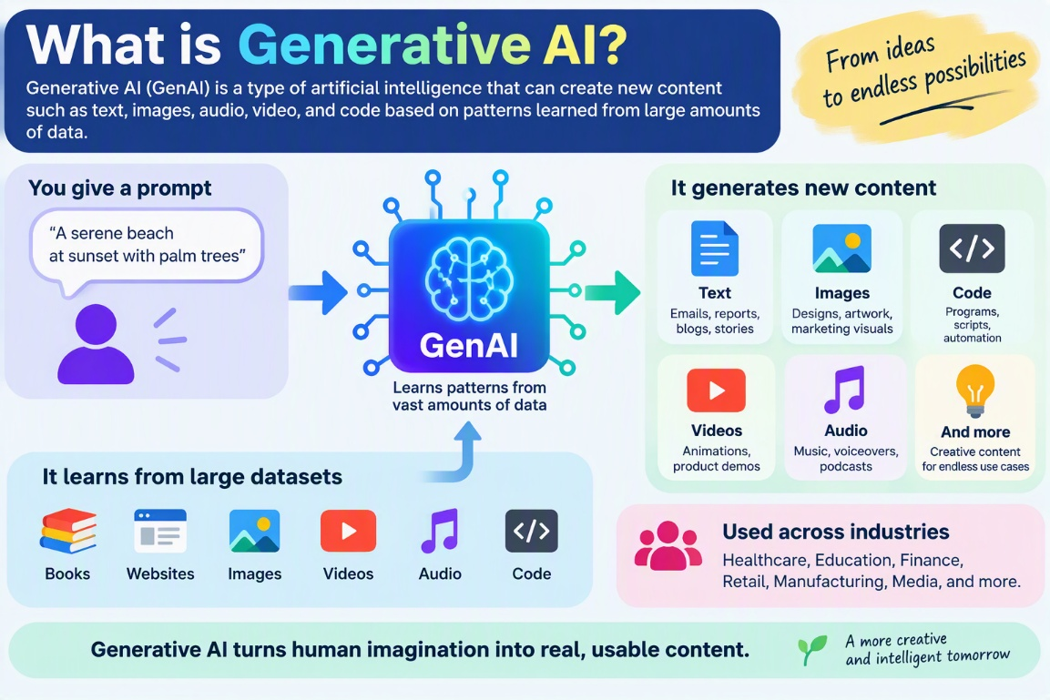
Music Generation: Suno, Music LM
How Generative AI Works
1. Data Collection
Large amounts of data are gathered:
- Books
- Articles
- Websites
- Images
- Videos
- Source code
2. Model Training
Deep learning models learn patterns and relationships from the data.
Common model architectures:
- Transformers
- Large Language Models (LLMs)
- Diffusion Models
- Generative Adversarial Networks (GANs)
3. Content Generation
When a user enters a prompt, the model predicts the most likely next words, pixels, sounds, or actions to produce relevant output.
Example:
Prompt:
Write an email requesting leave.
Generated Output:
Dear Manager, I would like to request leave from...
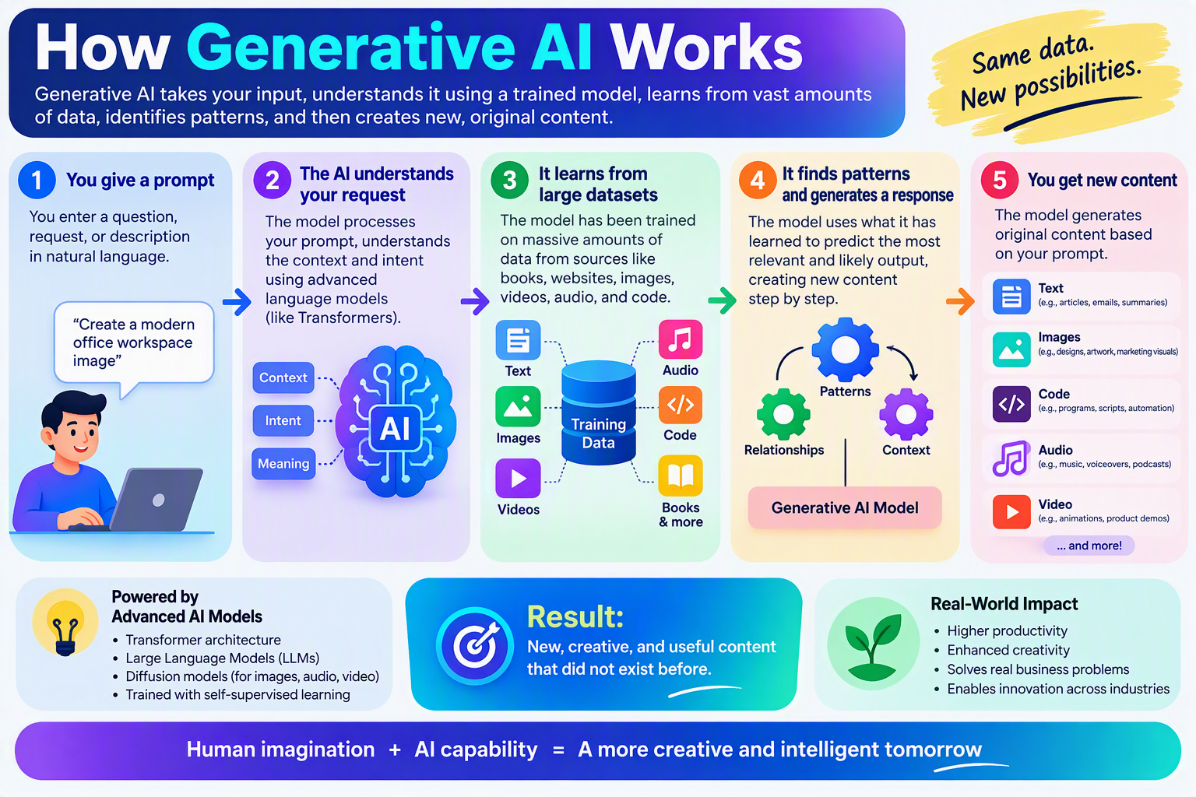
Key Technologies Behind GenAI
1. Large Language Models (LLMs)
LLMs are trained on billions of words and can:
- Answer questions
- Summarize documents
- Translate languages
- Generate content
- Write code
Popular LLMs:
- GPT-4/GPT-5 family
- Claude
- Gemini
- Llama
2. Transformer Architecture
Introduced in 2017 through the paper: "Attention Is All You Need"
Advantages:
- Understands context better
- Processes large amounts of text efficiently
- Forms the backbone of most modern AI systems
3. Neural Networks
GenAI uses artificial neural networks inspired by the human brain.
Components:
- Input Layer
- Hidden Layers
- Output Layer
These layers learn patterns and relationships from data.
Types of Diffusion Models in Generative AI
Diffusion Models are a class of generative models that create data (images, audio, video, etc.) by gradually removing noise from a random signal until a meaningful output emerges.
Think of it as:
- Forward Process: Add noise to an image step by step until it becomes pure random noise.
- Reverse Process: Train a neural network to reverse the noise and reconstruct the original image.
This technology powers many modern image generators such as Stable Diffusion and DALL·E.
1. Denoising Diffusion Probabilistic Models (DDPM)
DDPM is the foundational diffusion model introduced by researchers in 2020.
Working
Forward Diffusion
Original Image → Add Noise → More Noise → Pure Noise
Reverse Diffusion
Pure Noise → Remove Noise → Clearer Image → Final Image
Advantages
- High image quality
- Stable training
- Excellent diversity
Disadvantages
- Requires many denoising steps
- Slow generation process
Applications
- Image synthesis
- Medical imaging
- Scientific visualization

2. Denoising Diffusion Implicit Models (DDIM)
DDIM is an improved version of DDPM.
Key Idea
Instead of performing every denoising step, DDIM can skip steps while maintaining quality.
Benefits
✅ Faster image generation
✅ Less computational cost
✅ Deterministic sampling possible
Comparison
Feature | DDPM | DDIM
Quality | High | High
Speed | Slow | Faster
Sampling | Random | Can be Deterministic

3. Latent Diffusion Models (LDM)
This is currently one of the most popular diffusion architectures.
Used by:
- Stable Diffusion
- Many enterprise image generators
  - USE CASE FOR EACH SCENERIOS:
- Text Generation
Generative AI can create human-like text such as emails, reports, meeting summaries, blogs, and chatbot responses. It helps users save time by automatically generating clear and relevant content based on a prompt.
Eg. Create a marketing campaign description.

- Image Generation
Generative AI can create new images from text descriptions. It is widely used for marketing creatives, product designs, social media posts, artwork, architectural visualizations, and concept designs, reducing the need for manual design effort.
Eg. Generate campaign banners and product visuals.

- Code Generation
Generative AI can generate, debug, and optimize code in programming languages like Python, Java, and C#. It helps developers write functions, create applications, generate test cases, and automate repetitive coding tasks, thereby increasing development speed and productivity.
Eg. Build the campaign landing page and automate deployment.

- Advantages of AI
AI improves productivity by automating repetitive tasks, analysing large amounts of data quickly, and helping users make faster decisions. It also enhances creativity, enables personalized experiences, and supports 24/7 customer service.

- Disadvantages of AI
AI can sometimes generate incorrect or biased outputs, known as hallucinations. It may also raise concerns about job displacement, data privacy, security risks, and overdependence on technology. Additionally, AI systems often require significant computing resources and high-quality data.

- Future of AI
The future of AI is expected to focus on more intelligent, multimodal systems that can understand and generate text, images, audio, and video together. AI will play a major role in healthcare, education, finance, manufacturing, and scientific research, helping people work more efficiently while augmenting human capabilities rather than replacing them.

