PIZZA SALES
SQL QUERY & PERFORMANCE ANALYSIS

A KPI dashboard and query breakdown of pizza sales performance —
revenue, order trends, and top/bottom sellers, built entirely in SQL.

A. KEY PERFORMANCE INDICATORS
Five core metrics computed directly from the pizza_sales table.
1 Total Revenue  SELECT SUM(total_price) AS Total_Revenue  FROM pizza_sales;  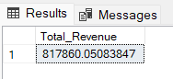 | 2 Average Order Value  SELECT (SUM(total_price) / COUNT(DISTINCT order_id))  AS Avg_order_Value FROM pizza_sales;  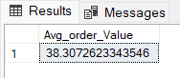
3 Total Pizzas Sold  SELECT SUM(quantity) AS Total_pizza_sold  FROM pizza_sales;  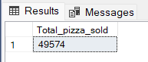 | 4 Total Orders  SELECT COUNT(DISTINCT order_id) AS Total_Orders  FROM pizza_sales;  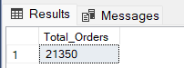
5 Average Pizzas Per Order
SELECT CAST(CAST(SUM(quantity) AS DECIMAL(10,2)) /
CAST(COUNT(DISTINCT order_id) AS DECIMAL(10,2))
AS DECIMAL(10,2)) AS Avg_Pizzas_per_order
FROM pizza_sales;
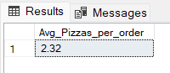

B. DAILY TREND FOR TOTAL ORDERS
SELECT DATENAME(DW, order_date) AS order_day,
COUNT(DISTINCT order_id) AS total_orders
FROM pizza_sales
GROUP BY DATENAME(DW, order_date);
OUTPUT
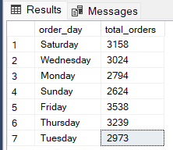

C. HOURLY TREND FOR ORDERS
SELECT DATEPART(HOUR, order_time) AS order_hours,
COUNT(DISTINCT order_id) AS total_orders
FROM pizza_sales
GROUP BY DATEPART(HOUR, order_time)
ORDER BY DATEPART(HOUR, order_time);
OUTPUT
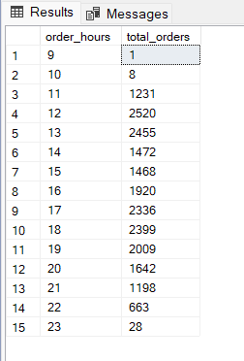

D. % OF SALES BY PIZZA CATEGORY
SELECT pizza_category,
CAST(SUM(total_price) AS DECIMAL(10,2)) AS total_revenue,
CAST(SUM(total_price) * 100 /
(SELECT SUM(total_price) FROM pizza_sales)
AS DECIMAL(10,2)) AS PCT
FROM pizza_sales
GROUP BY pizza_category;
OUTPUT
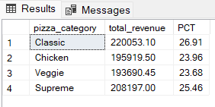

E. % OF SALES BY PIZZA SIZE
SELECT pizza_size,
CAST(SUM(total_price) AS DECIMAL(10,2)) AS total_revenue,
CAST(SUM(total_price) * 100 /
(SELECT SUM(total_price) FROM pizza_sales)
AS DECIMAL(10,2)) AS PCT
FROM pizza_sales
GROUP BY pizza_size
ORDER BY pizza_size;
OUTPUT
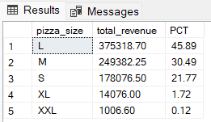

F. TOTAL PIZZAS SOLD BY PIZZA CATEGORY
SELECT pizza_category, SUM(quantity) AS Total_Quantity_Sold
FROM pizza_sales
WHERE MONTH(order_date) = 2
GROUP BY pizza_category
ORDER BY Total_Quantity_Sold DESC;
OUTPUT
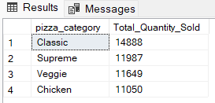

G. TOP 5 BEST SELLERS BY TOTAL PIZZAS SOLD
SELECT TOP 5 pizza_name, SUM(quantity) AS Total_Pizza_Sold
FROM pizza_sales
GROUP BY pizza_name
ORDER BY Total_Pizza_Sold DESC;
OUTPUT
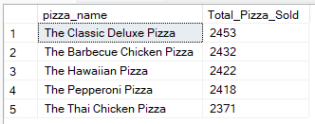

H. BOTTOM 5 BEST SELLERS BY TOTAL PIZZAS SOLD
SELECT TOP 5 pizza_name, SUM(quantity) AS Total_Pizza_Sold
FROM pizza_sales
GROUP BY pizza_name
ORDER BY Total_Pizza_Sold ASC;
OUTPUT
