ROAD ACCIDENT ANALYSIS
Interactive Excel Dashboard Project Report

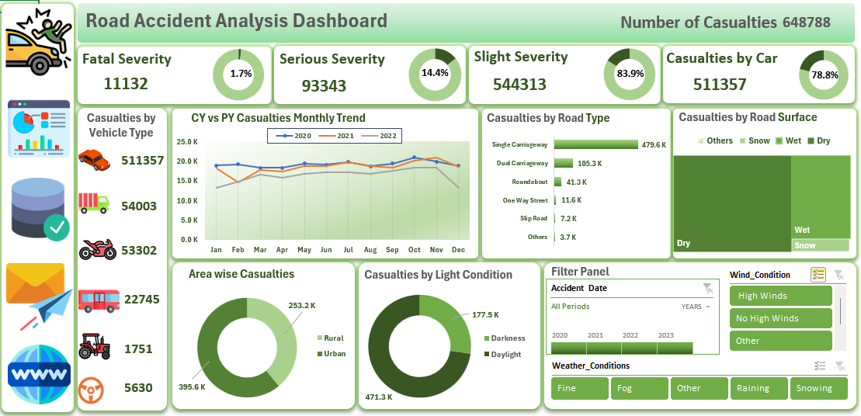
Prepared using Microsoft Excel, Pivot Tables, Pivot Charts and Slicers

1. Executive Summary
This project presents an interactive Road Accident Analysis Dashboard developed in Microsoft Excel to transform raw accident records into meaningful and easy-to-understand insights. The dashboard analyzes a total of 648,788 casualties across multiple dimensions, including accident severity, vehicle type, road type, road surface condition, area type, light condition, weather condition and wind condition. The purpose of the project is to provide a consolidated view of road safety patterns and support data-driven decision-making.
The analysis shows that slight-severity cases account for the largest share of casualties (544,313, 83.9%), followed by serious cases (93,343, 14.4%), while fatal cases account for 11,132 (1.7%). Cars are associated with the highest number of casualties at 511,357, and single carriageways contribute the highest number of casualties among road types at 479,641. The dashboard also highlights that dry road conditions, urban areas and daylight account for a substantial share of recorded casualties.

2. Project Objective
The main objective of this project is to analyze road accident data and present the results through an interactive Excel dashboard. The dashboard is designed to:
- Provide a quick overview of total and severity-wise casualties.
- Identify the vehicle categories associated with the highest casualty counts.
- Compare casualty trends across months and years.
- Analyze the effect of road type and road surface conditions.
- Compare casualty distribution between urban and rural areas.
- Examine casualty patterns under daylight and darkness.
- Allow users to interact with the dashboard through filters and slicers.

3. Dataset and Analytical Scope
The dashboard is based on a road accident dataset containing fields related to accident severity, accident date, year, light conditions, number of casualties, number of vehicles, road surface conditions, road type, urban or rural area, weather conditions, wind condition and vehicle type. The dataset was organized to support Pivot Table-based aggregation and dashboard reporting.
The analysis focuses on casualty counts rather than only the number of accident records. This makes it possible to compare the human impact of accidents across different categories and conditions.

4. Key Performance Indicators (KPIs)
Metric | Value | Share of Total Casualties
Total Casualties | 648,788 | 100.0%
Fatal Severity | 11,132 | 1.7%
Serious Severity | 93,343 | 14.4%
Slight Severity | 544,313 | 83.9%
Casualties by Cars | 511,357 | 78.8%

5. Dashboard Components
Primary KPI Cards: Display total casualties and severity-wise casualty counts using prominent number cards and percentage visuals.
Vehicle Type Analysis: Shows casualties by car, goods van, bike, bus, agriculture vehicle and other vehicle categories.
Monthly Casualty Trend: Compares monthly casualty patterns for 2020, 2021 and 2022.
Road Type Analysis: Uses a horizontal comparison to show casualty distribution across single carriageway, dual carriageway, roundabout, one-way street, slip road and other road types.
Road Surface Analysis: Highlights casualty distribution on dry, wet, snow and other surface conditions.
Area-wise Analysis: Compares urban and rural casualty counts.
Light Condition Analysis: Compares casualties occurring during daylight and darkness.
Interactive Filter Panel: Allows the dashboard to be filtered by year, wind condition and weather condition.

6. Key Findings and Insights
- Severity distribution: Slight-severity casualties are the largest category with 544,313 cases (83.9%). Serious casualties account for 93,343 (14.4%), while fatal casualties account for 11,132 (1.7%). This indicates that minor injuries occur far more frequently than fatal outcomes.
- Vehicle impact: Cars account for 511,357 casualties (78.8%), making them the most significant vehicle category in the analysis. Goods vans (54,003) and bikes (53,302) are the next major categories.
- Road type: Single carriageways record 479,641 casualties, substantially more than dual carriageways (105,328) and roundabouts (41,287). This suggests that single-carriageway roads should receive particular attention in road-safety analysis.
- Road surface: Dry roads account for 430,358 casualties (66.3%), followed by wet roads with 188,921 casualties (29.1%).
- Area type: Urban areas account for 395,580 casualties, compared with 253,195 in rural areas. Urban locations therefore represent the larger recorded casualty burden.
- Light conditions: Daylight accounts for 471,287 casualties (72.6%), while darkness accounts for 177,501 (27.4%). The larger daylight total should be interpreted together with traffic exposure and travel volume.
- Weather conditions: Fine weather records the highest number of casualties at 517,266. Raining conditions account for 89,179, while fog and snowing contribute comparatively smaller totals.
- Wind conditions: No high winds account for 596,173 casualties, showing that most recorded casualties in this dataset occurred under non-high-wind conditions.

7. Monthly and Year-wise Trend Analysis
The monthly trend section compares casualty counts for 2020, 2021 and 2022. Based on the dashboard summary, the annual totals represented in the trend are 230,905, 222,146 and 195,737, respectively. The peak month is Oct in 2020 (21,029), Nov in 2021 (20,975) and Nov in 2022 (18,439). The line chart makes it easier to identify changes over time and compare seasonal patterns between years.

8. Tools and Techniques Used
Tool / Technique | Purpose
Microsoft Excel | Main platform used for data analysis and dashboard development.
Pivot Tables | Used to aggregate and summarize casualty data across multiple dimensions.
Pivot Charts | Used to create dynamic visualizations linked to summarized data.
Donut Charts | Used for proportional comparisons such as severity, area type and light condition.
Line Chart | Used to compare monthly casualty trends across years.
Bar Chart | Used to compare casualty counts by road type.
Treemap / Category Visualization | Used to summarize road surface conditions.
Slicers | Used to provide interactive filtering for dates, weather and wind conditions.
Shapes and Icons | Used to improve visual storytelling and dashboard navigation.

9. Recommendations
- Prioritize safety analysis and improvement initiatives on single-carriageway roads because they contribute the highest casualty count in the dashboard.
- Investigate high-casualty vehicle categories, especially cars, goods vans and bikes, to identify whether exposure, traffic volume or specific risk patterns are contributing to the results.
- Strengthen road-safety awareness and traffic-management measures in urban areas, which account for a larger number of recorded casualties.
- Continue monitoring both dry and wet road conditions. A high count on dry roads does not necessarily mean dry roads are inherently more dangerous; traffic exposure should also be considered.
- Use the monthly trend analysis to identify recurring periods of higher casualties and plan targeted safety campaigns or enforcement accordingly.
- Extend the dashboard in future versions with accident counts, casualty rates, location-level analysis and exposure measures to support deeper root-cause analysis.

10. Conclusion
The Road Accident Analysis Dashboard successfully converts a large and multi-dimensional accident dataset into a clear, interactive and decision-friendly reporting solution. By combining KPIs, Pivot Table summaries, charts, icons and slicers, the dashboard enables users to quickly understand casualty patterns across severity, vehicle type, road conditions, geography, lighting and environmental factors.
The analysis identifies 544,313 slight, 93,343 serious and 11,132 fatal casualties out of a total of 648,788. It also highlights cars and single-carriageway roads as the largest contributors within their respective categories. Overall, the project demonstrates practical Excel data-analysis skills, including data summarization, KPI development, data visualization, interactive dashboard design and business-oriented insight generation.

