SUPERMART GROCERY
SALES DASHBOARD
Project Report | Interactive Business Intelligence Dashboard
Executive Summary
This project uses Microsoft Power BI to present a one-page view of Supermart grocery sales performance. KPI cards, time-series and comparison charts, a sub-category detail table, and interactive slicers help users explore sales, profit, orders, and profit margin across different segments.
1. Project Objectives
- Summarize overall business performance through key metrics.
- Track monthly sales patterns and compare sales and profit across regions and categories.
- Identify leading cities and profitable sub-categories.
- Provide interactive filtering by year, region, category, and city to support focused analysis.
2. Dataset Overview
The dashboard is built from the Supermart Grocery Sales dataset supplied for this project. The fields referenced in the report include Order Date, Order ID, Category, Sub Category, City, Region, Sales, Profit, and Discount. The dataset supports time-based, geographic, category-level, and sub-category-level analysis.
3. Tools and Approach
Tool / Feature | Use in the project
Microsoft Power BI Desktop | Dashboard design, interactive visuals, and report layout.
Measures / calculations | KPI cards for Total Sales, Total Profit, Total Orders, and Profit Margin.
Slicers | Interactive filtering by Year, Region, Category, and City.

4. Dashboard Preview
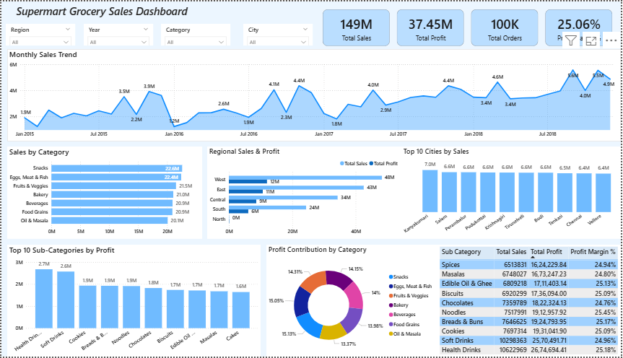
Figure 1. Current Supermart Grocery Sales Dashboard in Power BI.
5. Key Metrics and Visuals
Total Sales | Total Profit | Total Orders | Profit Margin
149M | 37.45M | 100K | 25.06%
Dashboard element | Purpose
Monthly Sales Trend | Shows how sales change over time.
Sales by Category | Compares sales across product categories.
Regional Sales & Profit | Compares sales and profit across regions.
Top 10 Cities by Sales | Highlights cities with the highest sales.
Top 10 Sub-Categories by Profit | Highlights sub-categories with the strongest profit contribution.
Profit Contribution by Category | Shows each category’s share of total profit.
Sub-category detail table | Lists sales, profit, and profit margin for sub-categories.
6. Business Questions Addressed
- What are the overall sales, profit, order, and profit-margin metrics?
- How do sales change month by month?
- Which product categories and cities generate the highest sales?
- How do sales and profit compare across regions?
- Which sub-categories contribute the most profit, and how is profit distributed by category?
7. Conclusion and Future Scope
The dashboard brings key grocery sales metrics and segment comparisons into one interactive page. Its slicers help users focus on a selected year, region, category, or city. Future improvements could include adding drill-through views for more detailed analysis, refining tooltips for clearer comparisons, and expanding the dashboard with additional business KPIs as needed.

