PROJECT REPORT
By Adrij Das
UPI Transactions Dashboard
Real-Time Analytical Overview of Unified Payments Interface Transactions
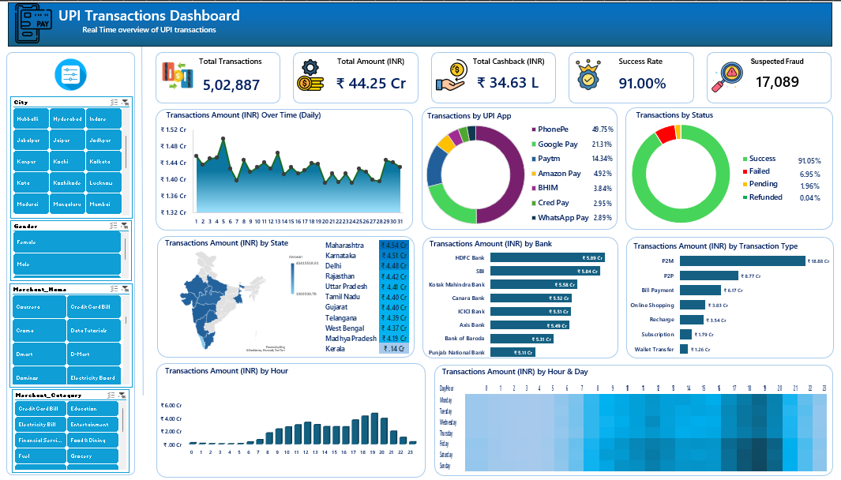
Figure 1: UPI Transactions Dashboard

1. Introduction
The Unified Payments Interface (UPI) has transformed digital payments in India by enabling real-time bank-to-bank transfers through mobile applications. This project presents an interactive Excel dashboard that provides a clear overview of UPI transaction performance. It consolidates key metrics, geographic distribution, app market share, bank performance, temporal patterns, and fraud indicators into a single interface for effective monitoring and decision-making.

2. Objectives
- Provide a real-time overview of UPI transaction volume, value, success rate, cashback, and fraud.
- Enable interactive filtering by City, Gender, Merchant Name, and Merchant Category.
- Analyze performance across UPI apps, banks, states, transaction types, and time periods.
- Support operational monitoring and risk identification through visual analytics.

3. Tools Used
Tool | Purpose
Microsoft Excel | Data modeling and interactive dashboard
Pivot Tables & Charts | Aggregations and visualizations
Slicers | Dynamic multi-dimensional filtering

4. Key Performance Indicators
Metric | Value | Description
Total Transactions | 5,02,887 | Total UPI transactions processed
Total Amount | ₹ 44.25 Cr | Aggregate transaction value
Total Cashback | ₹ 34.63 L | Cashback distributed to users
Success Rate | 91.00% | Successfully completed transactions
Suspected Fraud | 17,089 | Transactions flagged as potentially fraudulent

5. Dashboard Components

5.1 Filters
The dashboard includes slicers for City, Gender, Merchant Name, and Merchant Category. These filters update all KPIs and charts dynamically.

5.2 Visualizations
Chart | Insight
Transactions Amount Over Time | Daily trend of transaction value
Transactions by UPI App | Market share of PhonePe, Google Pay, Paytm, and others
Transactions by Status | Success, Failed, Pending, and Refunded split
Amount by State | Geographic performance with India map and ranking
Amount by Bank | Top banks: HDFC, SBI, Kotak, Canara, ICICI, Axis, BoB, PNB
Amount by Transaction Type | P2M, P2P, Bill Payment, Online Shopping, Recharge, etc.
Amount by Hour | Peak transaction hours during the day
Amount by Hour & Day (Heatmap) | Weekly patterns and high-activity time slots

6. Key Insights
- PhonePe leads UPI app usage with 45.75% share, followed by Google Pay (21.31%) and Paytm (14.34%).
- Maharashtra records the highest transaction value among states.
- HDFC Bank processes the largest share of transaction amount among banks.
- P2M (Person-to-Merchant) transactions contribute the highest value.
- Transaction activity peaks in evening hours, with clear weekday and weekend patterns visible in the heatmap.
- Success rate stands at 91%, with 17,089 transactions flagged as suspected fraud.

7. Conclusion
The UPI Transactions Dashboard consolidates complex transactional data into a clear and interactive interface. It enables stakeholders to monitor performance, identify risks, and make informed decisions. Built entirely in Excel, the solution is accessible, portable, and suitable for further analytics work in the digital payments domain.

