CUSTOMER CHURN ANALYSIS
Key Insights from the Python Notebook
Notebook-derived charts with concise business descriptions
10,000  Customers | 2,774  Churned | 27.74%  Churn Rate | 39,894.72  Revenue at Risk

Executive Summary
Theme | Notebook finding
Overall churn | 27.74% of the 10,000 analyzed customers are marked as churned.
Contract pattern | Monthly-contract customers show a 36.39% churn rate versus 17.13% for annual contracts.
Risk segmentation | Observed churn rises from 22.97% in the low-risk group to 52.14% in the high-risk group.
Customer satisfaction | Observed churn falls across the CSAT bands, from 47.03% for 0-20 to 13.79% for 81-100.
Complaint pattern | The notebook shows higher observed churn rates at higher complaint counts, with very small groups producing extreme rates at 10 and 12 complaints.
Revenue exposure | Monthly revenue at risk from churned customers is 39,894.72; Standard contributes the largest plan-level amount.
Customer value | Average CLTV is 464.22 for retained customers and 249.75 for churned customers.
Cancellation reasons | No longer interested and Too expensive are the two largest recorded cancellation-reason groups.
Escalation relationship | Escalation and churn have a weak positive correlation of 0.06 in the notebook data.
Trend | Recorded churn volume increases strongly by cancellation year, reaching 1,144 in 2026.

Insight 1: Yearly Churn Trend
Recorded churn volume rises substantially over the observed cancellation years, from 3 churned customers in 2021 to 1,144 in 2026.
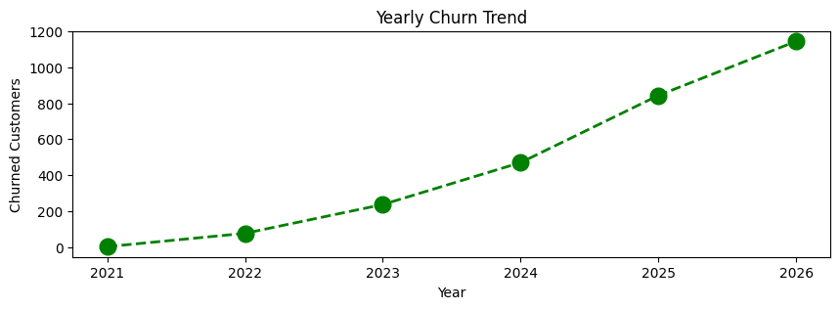
Figure: Yearly Churn Trend - notebook-generated visualization
- 2021: 3 churned customers.
- 2022: 77 churned customers.
- 2023: 237 churned customers.
- 2024: 470 churned customers.
- 2025: 843 churned customers.
- 2026: 1,144 churned customers.
Note: This chart shows churned-customer volume by cancellation year, not a year-by-year churn rate. Yearly volumes can also reflect differences in the amount of recorded activity.

Insight 2: Churn Rate by Plan Type
Churn rate varies by plan type in the notebook data, with Premium showing the highest observed churn rate and Basic the lowest among the three plans.
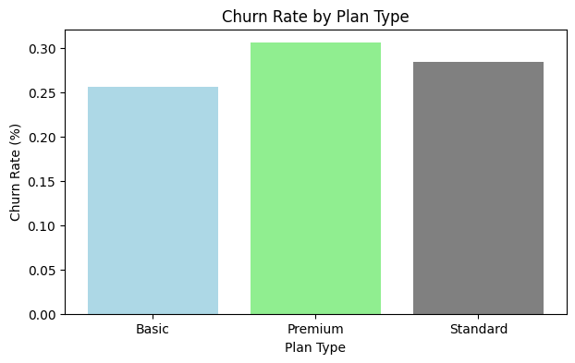
Figure: Churn Rate by Plan Type - notebook-generated visualization
- Basic: 25.59% churn rate.
- Standard: 28.38% churn rate.
- Premium: 30.56% churn rate.

Insight 3: Churn Rate by Contract Type
The notebook shows a clear difference in observed churn rate between monthly and annual contracts.
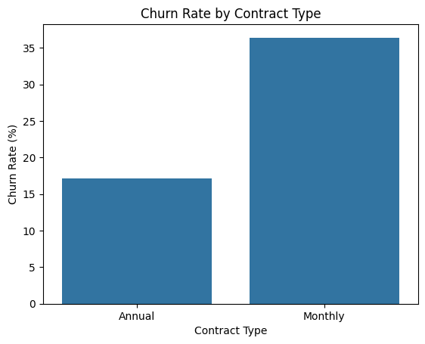
Figure: Churn Rate by Contract Type - notebook-generated visualization
- Monthly: 36.39% churn rate.
- Annual: 17.13% churn rate.
- Difference: 19.26 percentage points between the two contract groups.

Insight 4: Churn Rate by Tenure Group
Observed churn decreases consistently as tenure increases in the notebook analysis. The newest customers have the highest churn rate, while customers with 4+ years of tenure have the lowest.
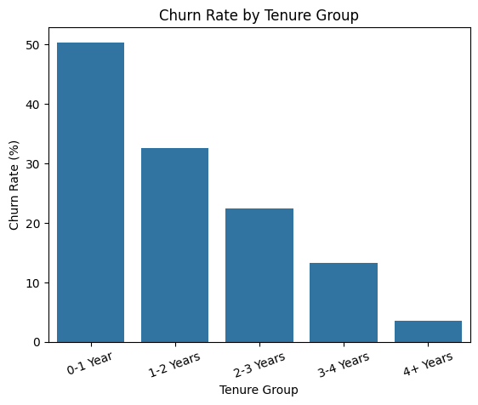
Figure: Churn Rate by Tenure Group - notebook-generated visualization
- 0-1 Year: 50.37% churn rate.
- 1-2 Years: 32.61% churn rate.
- 2-3 Years: 22.50% churn rate.
- 3-4 Years: 13.34% churn rate.
- 4+ Years: 3.55% churn rate.

Insight 5: Churn Rate by Churn Risk
The churn-risk segmentation created from churn score shows progressively higher observed churn rates from low to medium to high risk.
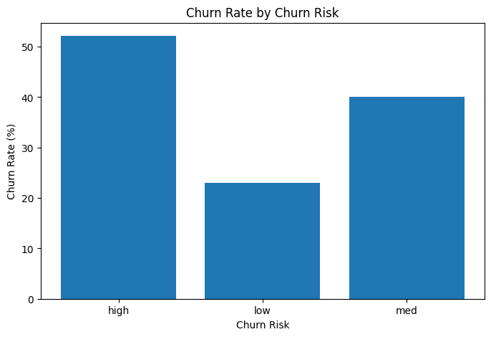
Figure: Churn Rate by Churn Risk - notebook-generated visualization
- Low: 22.97% churn rate across 7,836 customers.
- Med: 40.06% churn rate across 1,278 customers.
- High: 52.14% churn rate across 886 customers.
Note: Churn risk is derived from churn score in the notebook, so the two measures are closely related by construction.

Insight 6: Churn Rate by CSAT Score
The observed churn rate declines across higher CSAT score bands. The lowest CSAT band has the highest churn rate in the notebook analysis.
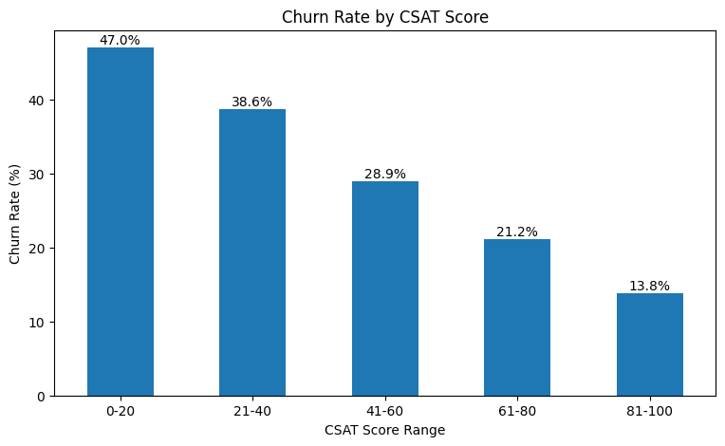
Figure: Churn Rate by CSAT Score - notebook-generated visualization
- 0-20: 47.03% churn rate.
- 21-40: 38.64% churn rate.
- 41-60: 28.91% churn rate.
- 61-80: 21.15% churn rate.
- 81-100: 13.79% churn rate.
Note: The notebook excludes missing CSAT scores from this grouped analysis.

Insight 7: Churn Rate by Complaint Count
The notebook shows an overall upward pattern in observed churn rate as the number of recorded complaints increases.
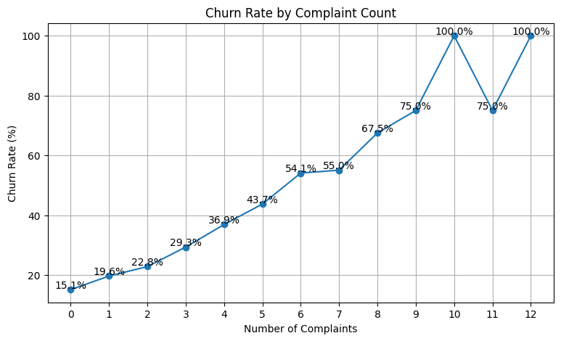
Figure: Churn Rate by Complaint Count - notebook-generated visualization
- 0 complaints: 15.08% observed churn rate.
- 4 complaints: 36.85% observed churn rate.
- 6 complaints: 54.07% observed churn rate.
- 8 complaints: 67.50% observed churn rate.
- 10 complaints: 100.00% observed churn rate.
- 12 complaints: 100.00% observed churn rate.
Note: The extreme 100% values occur in high-complaint groups with relatively small customer counts, so these endpoints should be interpreted cautiously.

Insight 8: Cancellation Reason Analysis
Among churned customers, a small number of cancellation reasons account for most of the recorded churn-reason distribution.
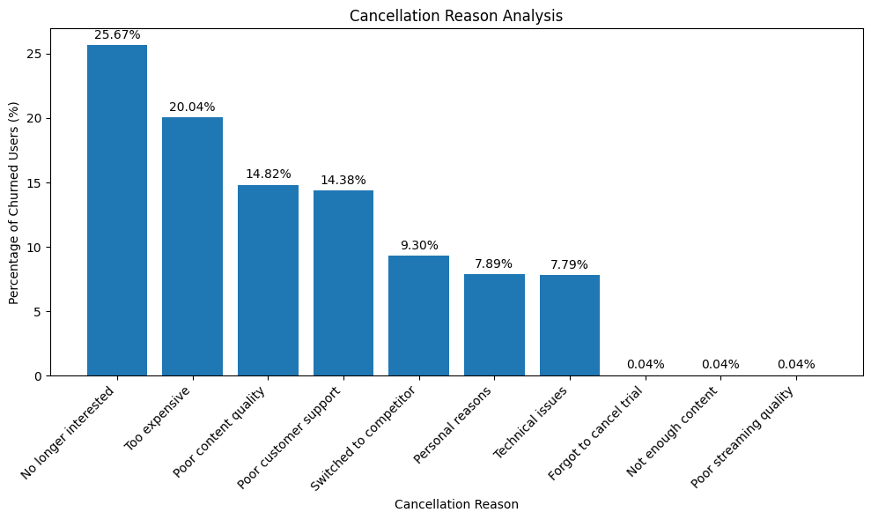
Figure: Cancellation Reason Analysis - notebook-generated visualization
- No longer interested: 25.67% of churned customers.
- Too expensive: 20.04%.
- Poor content quality: 14.82%.
- Poor customer support: 14.38%.
- Switched to competitor: 9.30%.
Note: These are reported cancellation reasons in the dataset. They describe observed reasons and do not by themselves establish causal drivers of churn.

Insight 9: Revenue Lost by Plan Type
The monthly revenue exposure associated with churned customers differs across plan types. Standard contributes the largest plan-level amount of revenue at risk in the notebook data.
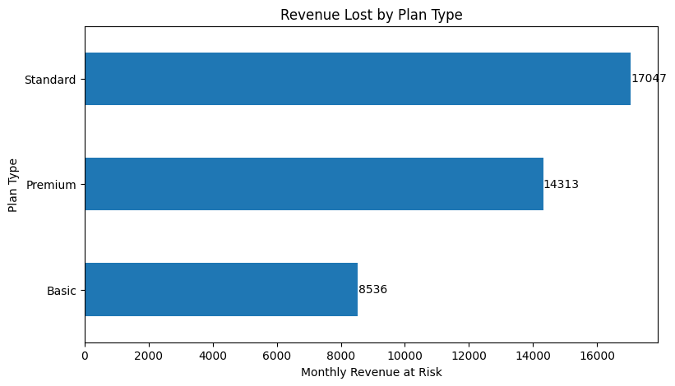
Figure: Revenue Lost by Plan Type - notebook-generated visualization
- Standard: 17,046.51 in monthly revenue at risk.
- Premium: 14,312.60.
- Basic: 8,535.61.
- Total: 39,894.72 across all churned customers.

Insight 10: Average CLTV by Churn Status
Average customer lifetime value differs substantially between retained and churned customers in the notebook analysis.
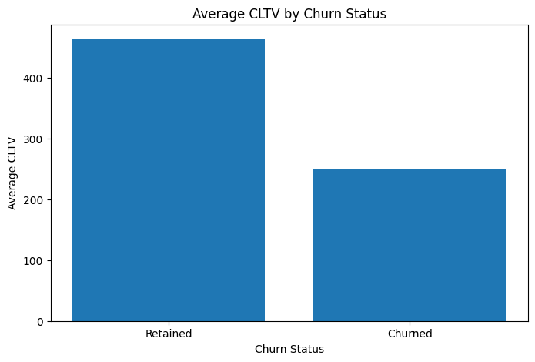
Figure: Average CLTV by Churn Status - notebook-generated visualization
- Retained: Average CLTV of 464.22.
- Churned: Average CLTV of 249.75.
- Gap: 214.47 lower average CLTV for churned customers.

Insight 11: Escalation and Churn Relationship
The correlation matrix shows a weak positive correlation between escalation status and churn status, while churn score has a stronger positive relationship with churn flag.
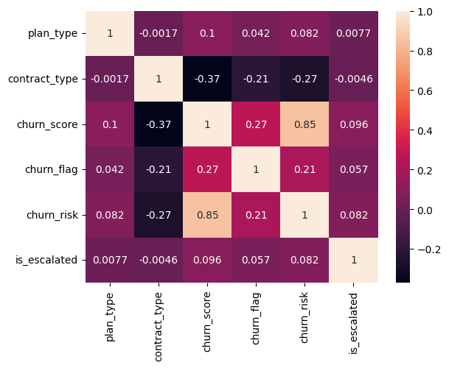
Figure: Escalation and Churn Relationship - notebook-generated visualization
- Escalation vs churn: Correlation approximately 0.06.
- Churn score vs churn: Correlation approximately 0.27.
- Churn score vs churn risk: Correlation approximately 0.85.
Note: The correlation values depend on the notebook's numeric encoding of categorical variables. Correlation indicates association, not causation.

Key Takeaways for the Project
Retention pattern
Churn is higher among newer-tenure customers and monthly-contract customers in the analyzed dataset.

Customer experience
Lower CSAT bands and higher complaint counts are associated with higher observed churn rates.

Risk segmentation
The churn-risk groups provide a clear descriptive separation in observed churn rates.

Financial impact
Churn is linked to 39,894.72 of monthly revenue at risk in the processed dataset.

Customer value
Retained customers have higher average CLTV than churned customers.

Reason distribution
The largest recorded cancellation reasons are No longer interested and Too expensive, followed by content and support-related reasons.

Source: churn_analysis notebook and its generated visualization outputs.

