Project Planning Phase
Project Planning Template (Product Backlog, Sprint Planning, Stories, Story points)

Date | 06 October 2026
Team ID | SWTID-2026-9818
Project Name | Script-Controlled Record-Level Security in ServiceNow using ACLs (Institution Details)
Maximum Marks | 5 Marks

Product Backlog, Sprint Schedule, and Estimation (4 Marks)
Use the below template to create product backlog and sprint schedule
Sprint | Functional Requirement (Epic) | User Story Number | User Story / Task | Story Points | Priority | Team Members
Sprint-1 | User & Role Management | USN-1 | As an admin, I can create the test user EEE User (User ID, first name, last name, email). | 3 | High
Sprint-1 |  | USN-2 | As an admin, I can create the custom roles bb1, bb2, bb3 and bb4. | 3 | High
Sprint-1 |  | USN-3 | As an admin, I can assign all the roles (bb1–bb4) to EEE User. | 2 | High
Sprint-1 | Custom Table Creation | USN-4 | As an admin, I can create the custom table Institution Details (u_institution_details) that does not extend any table. | 4 | High
Sprint-1 |  | USN-5 | As an admin, I can add the fields Student Roll Number, Student Name, Faculty Name, Branch (ECE, EEE, CSE), Email, Phone Number and Description to the table. | 5 | High
Sprint-1 |  | USN-6 | As an admin, I can create sample records with different Branch values (ECE, EEE, CSE). | 3 | Medium
Sprint-2 | Read Access Control (bb1) | USN-7 | As a security admin, I can elevate the security_admin role and create a record-level READ ACL on u_institution_details (Active, Advanced). | 5 | High
Sprint-2 |  | USN-8 | As a security admin, I can require role bb1 and add the data condition Branch is EEE on the READ ACL. | 4 | High
Sprint-2 |  | USN-9 | As a security admin, I can add the ACL script that allows admin and bb1 users and denies everyone else. | 5 | High
Sprint-2 |  | USN-10 | As a tester, I can impersonate EEE User and Admin to verify that bb1 sees only EEE records, users without the role see none, and admin sees all. | 6 | High
Sprint-3 | Create & Write Access Control (bb2, bb3) | USN-11 | As a security admin, I can create a CREATE ACL on u_institution_details that requires role bb2. | 5 | High
Sprint-3 |  | USN-12 | As a tester, I can verify that users with bb1 and bb2 see only EEE records and the New button. | 5 | Medium
Sprint-3 |  | USN-13 | As a security admin, I can create a WRITE ACL on u_institution_details that requires role bb3. | 5 | High
Sprint-3 |  | USN-14 | As a tester, I can verify that users with bb1, bb2 and bb3 can view and edit EEE records and see the New button. | 5 | Medium
Sprint-4 | Delete Access Control (bb4) | USN-15 | As a security admin, I can create a DELETE ACL on u_institution_details that requires role bb4. | 5 | High
Sprint-4 |  | USN-16 | As a tester, I can verify that users with bb1–bb4 can see, create, edit and delete EEE records. | 5 | High
Sprint-4 | Testing & Conclusion | USN-17 | As a tester, I can run an end-to-end check of all ACLs for Admin, EEE User and a user without roles across lists and forms. | 5 | Medium
Sprint-4 |  | USN-18 | As a team member, I can document the results and conclude the project with the key learnings on script-controlled ACLs. | 5 | Low

Project Tracker, Velocity & Burndown Chart: (4 Marks)
Sprint | Total Story Points | Duration | Sprint Start Date | Sprint End Date (Planned) | Story Points Completed (as on Planned End Date) | Sprint Release Date (Actual)
Sprint-1 | 20 | 6 Days | 5 Oct 2026 | 10 Oct 2026
Sprint-2 | 20 | 6 Days | 12 Oct 2026 | 17 Oct 2026
Sprint-3 | 20 | 6 Days | 19 Oct 2026 | 24 Oct 2026
Sprint-4 | 20 | 6 Days | 26 Oct 2026 | 31 Oct 2026

Velocity:
Imagine we have a 10-day sprint duration, and the velocity of the team is 20 (points per sprint). Let’s calculate the team’s average velocity (AV) per iteration unit (story points per day)

For this project: sprint duration = 6 days and team velocity = 20 story points per sprint, so average velocity AV = 20 / 6 ≈ 3.33 story points per day (4 sprints, 80 story points in total).

Burndown Chart:
A burn down chart is a graphical representation of work left to do versus time. It is often used in agile software development methodologies such as Scrum. However, burn down charts can be applied to any project containing measurable progress over time.
Planned (ideal) burndown for this project: 80 story points across 4 sprints of 20 points each.
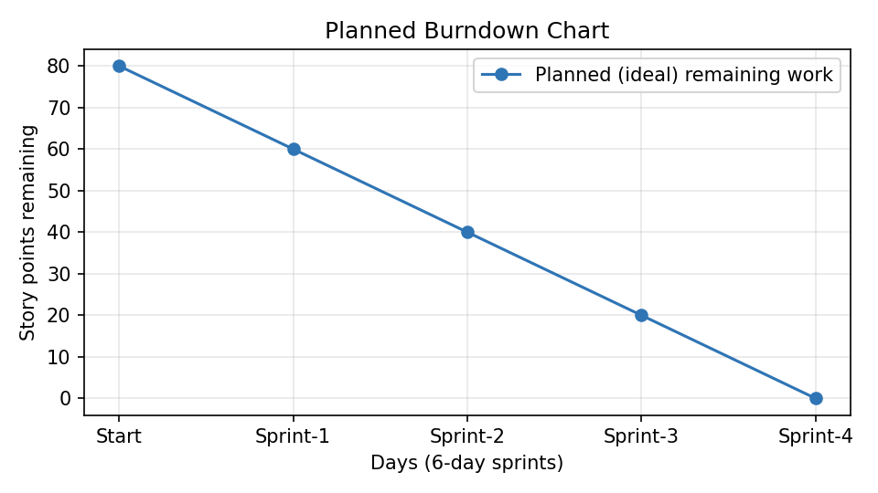

https://www.visual-paradigm.com/scrum/scrum-burndown-chart/
https://www.atlassian.com/agile/tutorials/burndown-charts

Reference:
https://www.atlassian.com/agile/project-management
https://www.atlassian.com/agile/tutorials/how-to-do-scrum-with-jira-software
https://www.atlassian.com/agile/tutorials/epics
https://www.atlassian.com/agile/tutorials/sprints
https://www.atlassian.com/agile/project-management/estimation
https://www.atlassian.com/agile/tutorials/burndown-charts

